1st Year Business
Please develop a research presentation in groups of 4 on one of the following topics
You may have to do some of your own research so use Google to see what you can come up with, and refer to Ireland mostly, but you can use other countries. Remember- this is an Economics task.
Group 1
3.1 Explain how scarcity of economic resources results in individuals having to make choices, predict possible consequences for these choices
- Scarcity and Choice
-Needs v Wants
-Opportunity Cost
- Who gets what in the economy?
Example taken from Irish Times Website if you Google ‘Economic Choices Ireland’

Group 2
3.3 Evaluate how changes in supply and demand of services in different markets can affect prices.
- Look at inflation in more detail
-Research supply and demand and how it affects price
Example taken from Irish Times Website if you Google ‘Ireland Supply and Demand’
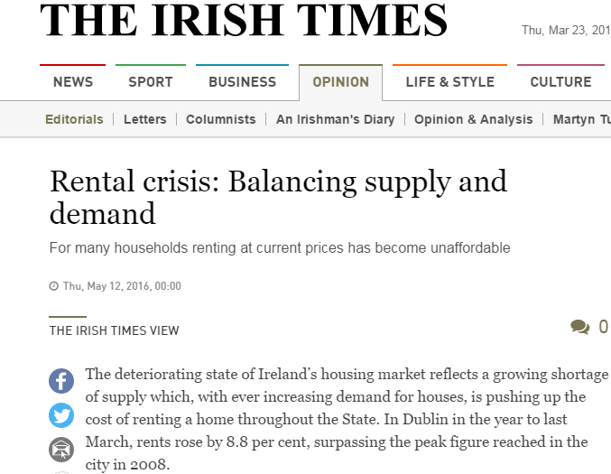

In your group, try include some of
- Videos
- YouTube
- Voice Overs
- Animation
- Pictures
- Posters
- Quizzes
- Memes
- Music
- Games
- Props
- Role Play

