The Management of Change

All businesses at some stage may need to change. For example, the government banned smoking in 2004 and so pubs had to cope with this. Many now have outdoor seated areas to cope with this change.
Facebook aquired Instagram and made numerous changes to its design to compete with Snapchat.
Change is all around businesses and they must be able to adapt to this to be successful. However, in some businesses there is a resistance to change- do you wish you could stay in a non-exam year?
Workers fight change for a number of reasons:
- Fear of losing their jobs – technology replacing people, making skills obsolete
- Fear of losing power
- Fear of failure
- Laziness
Therefore, businesses come up with the following strategies to try and manage change:
How to Manage Change
- Management commitment: to the change process. Leading by example is one way of showing this commitment to change
- Communication: between all parties throughout the change process. This will reduce uncertainty and tensions.
- Funding: for the proposed changes/ funding of new technologies and staff involvement/training.
- Consultation & Negotiation –consultation with trade unions and employee representatives regarding the proposed changes/involve all in the decision making process. Negotiation will be needed to determine remuneration packages, productivity agreements, changes in work practices etc.
- Reward: reward employees for accepting and adopting change. E.g. bonus.
- Train Employees: in order to overcome their fear of failure employees must be retrained to ensure they can still do their job to the best of their ability

The following are the main Strategies for Managing Change in a business
- Move from controller to facilitator
- Employee Empowerment
- Job rotation/Job enlargement/Job enrichment
- Total Quality Management
- Team work
- Quality Circles
AND
The impact of technology

Change from controller to facilitator- Table
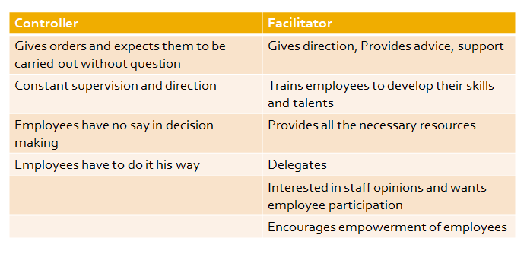
All these factors contributed to a significant change in management that can still be seen in operation today. The old authoritarian style of management that used to exist does not work in business any more. Because employees will no longer put up with always being told exactly what to do with no freedom, Irish managers have had to change the way they deal with workers. They have changed from the old style controller to more of a facilitator style of management.
vs.
Nowadays, a facilitator is more like a coach who trains and developes the employees with strategies such as empowerment and teamwork, encouraging and rewarding workers for work done.
The objective of a controller was autocratic- catch where the employee went wrong and teach them not to do that again. It is very much Theory X v Theory Y.

Facilitator Managers operate a theory Y management style.
Facilitator Management: The approach recognises that employees will contribute more of their talent and abilities to the firm if they are given:
- Encouragement and Responsibility
- Training
- Advice and Support
- Recognition and Reward
Employee Empowerment
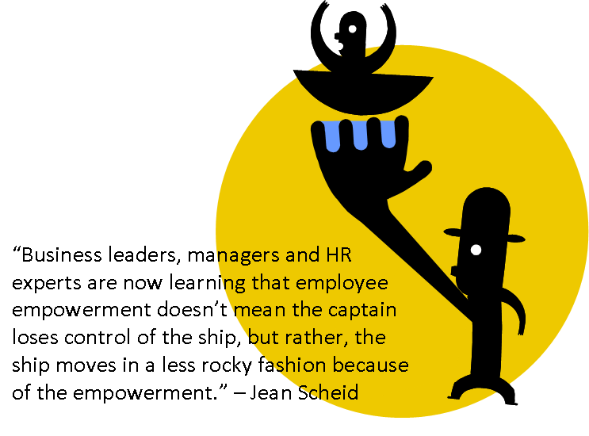
Employee Empowerment involves The empowerment of workers means placing real power, which includes decision-making, and full responsibility in the hands of those workers where it is most effective, i.e. as close as possible to the customer. Empowerment is far more than delegation.
Workers who deal with the organisation’s customers every day are given great influence over the operation of the enterprise. Decision-making and control is in the hands of workers who use their skills and knowledge in the interests of the organisation
Benefits of Employee Empowerment
- The business gives a better service to customers. If a customer has a query or problem, the employee has the power to deal with it there and then. There is no waiting for managers
- Employee’s morale and motivation increase- they are part of the team. Think Maslow and Esteem needs.
- Employees don’t have to always bring employers away from more important jobs, and so their time can be spent on that
Problems of Empowerment
- Angry workers who may not want extra responsibility or feel that they are giving the extra responsibility without adequate remuneration
- Angry middle managers whose power has been taken away
- Mistakes due to lack of training or supervision
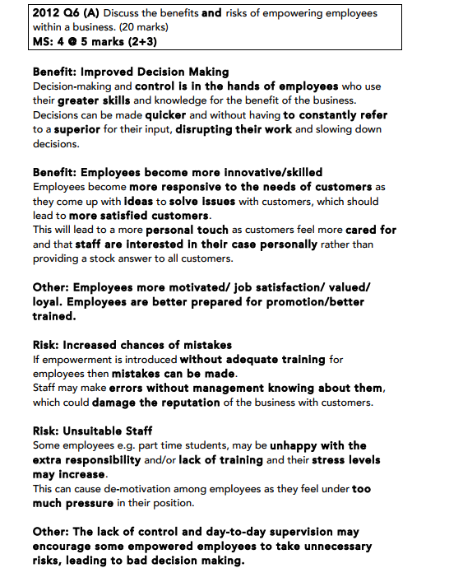

Job Rotation/Enlargement/Enrichment
Job rotation is the process of moving employees around an organisation so that they can develop and gain experience in different jobs. This adds to their skills profile as well as benefiting the organisation with fresh ideas that may be generated and reducing boredom or lack of motivation amongst staff.
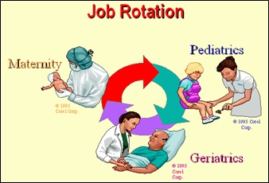
Job enlargement means giving people extra responsibility to make their job more challenging and interesting. Examples would include solo projects or becoming team leaders for a task.

Job enrichment is concerned with adding to responsibilities and giving the employee freedom to make choices. Examples could be not only becoming team leader of a project, but also allowing the employee the freedom to make all decisions about the project on behalf of the organisation.
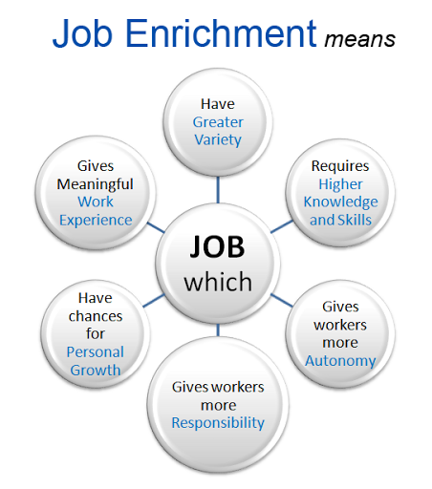

Total Quality Management
TQM is a management strategy designed to ensure 100% perfection and 100% customer satisfaction. It says that every person in the business is responsible for delivering quality to the customer. If a business follows the TQM principle, it will have perfect quality products.
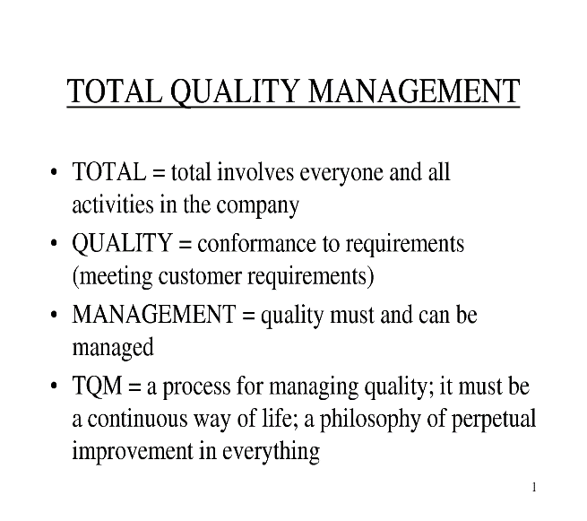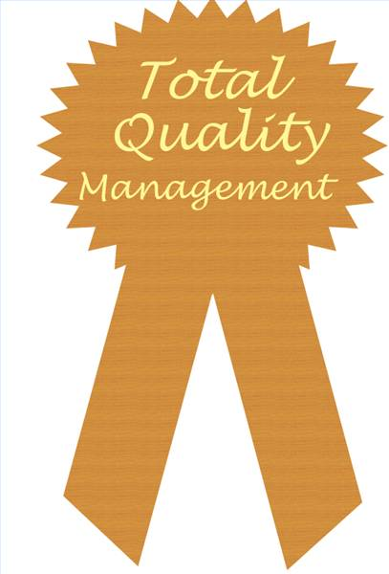
Benefits of TQM
Improved Quality
Continuous Improvement means the business tries each time to dobetter than the previous time when manufacturing products. A business using TQM will strive for ‘zero defects’ in production. The benefit is less products will be returned for a refund, reducing costs.
Increased Sales
The focus is on the customer, so a manufacturing business will conduct market research in to what the customer requires from their product. The benefit is that sales will increase as consumer satisfaction is improved. This will also prevent a firm producing lots of an unwanted goods as they will have checked what the consumer wants before production starts.
Job Satisfaction
Employees are empowered, allowing them to make decisions, increasing trust from management and allowing them satisfy esteem needs (Maslow). They also work in teams, increasing productivity and satisfaction. The benefit for the manufacturing business is that there would be more energized and productive staff, and lower staff turnover.
Meet Legal Requirements
Under the Sale of Goods and Supply of Services Act 1980, all products must be fit for purpose and of merchantable quality. The benefits to a manufacturing business are that TQM will help ensure standards are high enough so that they fulfill their legal requirements to consumers.

Problems of TQM
- TQM does not produce instant results as it is a long term strategy
- The role of managers and workers must be clearly defined
- Training must be on-going so that staff are provided with the skills needed to work in teams and managers learn how to cope with people who are empowered
- Time needs to be spent informing staff about the TQM approach and its implications for work practises, rewards and job control

The aims of TQM:
- High Quality products and services to satisfied customers
- Zero Defects in products and services including delivery
- Right the first time production and delivery
- Benchmarking at least equal to competitors
- Strive to continuously make improvements
Setting up TQM
- Planning, consultation and agreement on objectives at all levels of the firm
- Setting up of systems such as team work and delegation that will involve everyone in the process
- Provide training for all staff members to buy in and incorporate the process
Operating TQM
- Quality control at all phases- purchasing/production/delivery
- Shared responsibility- everybody has vision for quality
- Constant measurement of performance
- Constant check on customer satisfaction
- Constant review of TQM process
- Reward and motivate employees

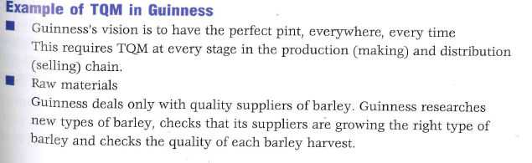

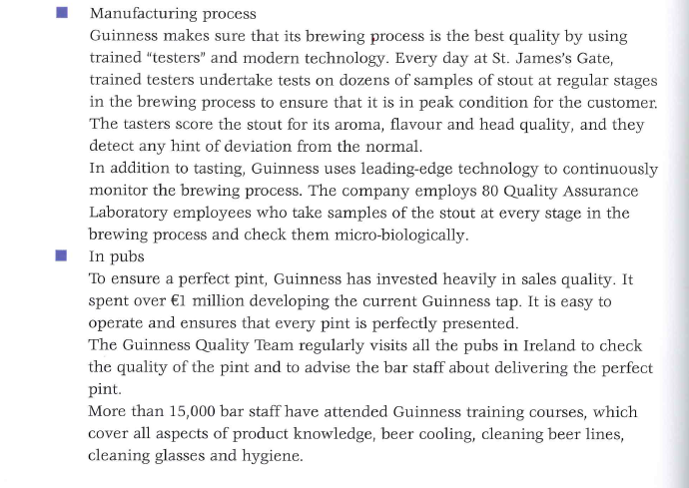

Team Work
"Talent wins games, but teamwork and intelligence wins championships." --Michael Jordan
Team work involves a group of people working co-operatively towards achieving a common goal. A team combines the various talents of its members, who work together in some way to produce better results for a business and achieve a common goal. A team will communicate and co-operate with each other over a period of time.

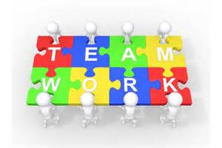

The team should have the following to perform the job effectively:
- Set objectives
- Deadlines
- Appropriate resources
- The right team members who share vision
- A team leader
Before the forming of a team, certain issues need to be decided such as

- The task to be undertaken
- The size of the team
- The individual skills required
- The role to be played by each member of the team
- The standards expected of each team member in carrying out his/her task

Teams go through 5 stages in their development:
- Forming
- Storming
- Norming
- Performing
- Mourning/Transforming

- Forming
This is when the team comes together for the first time
- Storming
This is when members compete for roles within the team and disagreements break out
- Norming
This is when members settle into their roles/responsibilities
- Performing
This is when the team performs together so as to achieve the objectives
- Mourning/Transforming
This is when the team breaks up or a member leaves and a new team is formed
The Team leader will allow workers to take on responsibility, authority and freedom to work in whatever manner they see fit in order to achieve the objectives. These workers are given knowledge and power to operate on their own initiative and be enterprising. Such workers are said to be empowered.

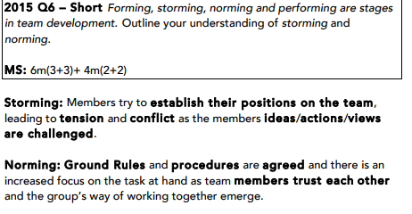

Selecting Team Members
- When one is employed, they are hired based on their skills, qualities, qualifications, experience, personality traits, attitude, but also based on their ability to work as part of a team.
- What does one need to be a good team player?
- Ability to communicate
- Ability to co-operate
- Ability to listen to other people’s views
- Ability to be adaptive
- Willingness to achieve success for the team as opposed to personal success
- A sense of responsibility for team decisions (even though he/she may not have agreed with those decisions)
Benefits of Teamwork
The work is shared among individuals. People can see and appreciate other team member’s efforts. No one individual bears sole responsibility for a project/task.

- Many hands make light work. Using teamwork can result in work being completed faster as different talents are utilised, there is less stress on one individual, responsibilities/duties are shared and there will be increased creativity in terms of how to complete a project efficiently.

- Teams can encompass all individuals employed in an organisation (workers and managers can work in the same team). This speeds up the decision making process as staff no longer have to go through the chain of command to the top of the organisation for approval before making decisions. Workers from different departments work together as part of teams. This helps reduce internal barriers and makes work more meaningful.

- Pressure and responsibility on certain employees falls as a result of teamwork; for others who weren’t really included and involved in the operation of a business, they now play a greater role; their skills are utilised, they are involved in the decision making process. Thus moral increases. Workers are thus more motivated and happier in their jobs. Symptoms of employee unhappiness such as absenteeism, sabotage, etc. are significantly reduced. Productivity increases. Quality of work improves.

Quality Circles
A quality circle is a volunteer group composed of workers, usually under the leadership of their supervisor, who are trained to identify, analyze and solve work-related problems and present their solutions to management in order to improve the performance of the organization, and motivate and enrich the work of employees. When matured true quality circles become self-managing, having gained the confidence of management.
Some firms introduce quality circles. These are teams of managers and workers which meet regularly to discuss quality issues and problems and recommends solutions. The purpose is to let people who come into contact and deals with the issues regularly are the ones who solve it. The members of a Quality Circle may be from different sections of a business and operate at different levels.

The Impact of Technology on Change
Business Opportunities For Managers
Production: Some new products owe their existence and success to technology e.g. reserving seats on airlines and making hotel reservations from any part of the world at any time. Businesses also use CAD (Computer Aided Design) and CAD (Computer Aided Manufacturing) which saves money and problems by having computers assist in producing products

Marketing: Many businesses now use the internet to market their goods and services. By creating a website a large number of potential customers can be reached at minimal cost/e-marketing/e-selling
Decision- Making: information on businesses, people, countries, products, in the world at the touch of a button. Leads to more informed decision making

Communications: Management & staff can be equipped with laptops, mobile phones and e-mail links which enable instant communication leading to increased business efficiency/global communications
Spans of control can be widened. Ability to monitor larger groups or groups which are geographically apart

Impact of Technology on Staff
Tele-Working: With the use of broadband it is not necessary for employees to work together in the same building. This leads to savings on office costs and allows a business to hold on to staff who may prefer to work from home

Training: In many occupations the training of workers can be done by or with the help of computers and the different software packages available

Redundancies: fewer employees needed due to technology. Some skills or industries are becoming obsolete.

New opportunities: new types of jobs have been created, such as web developers and computer programmers

Impact on Business Costs
Capital Costs: There is huge capital costs associated with technology development. There is an increased risk to the enterprise because costly equipment has to be bought prior to selling the goods and creating cash flow e.g. robotics for example, is a very expensive process involving a very complex production line.

Labour Costs: Changing technology reduces the number of workers required, e.g. using robotic equipment instead of people in automated production facilities. The emphasis is on quality and a far higher level of skill is required of the personnel. Multi-skilling (where people have a wide variety of job skills) is common in technologically advanced enterprises, and can reduce costs as fewer staff is required

Training Costs: Decision-making at all levels, from top management down, is helped. Communications between the functions in the enterprise and between the people in the enterprise are improved. Training costs in the organisation must increase to help the process

R&D Costs: Modern technology increases the speed of innovation and therefore shortens the life cycle of products, requiring new products or new developments/applications of old products. The associated research and development costs can be daunting. More personnel are required in this area.

