Bookkeeping
Bookkeeping is concerned with accurately recording a business’s money coming in and out. In doing so, we will return to the Analysed Cash Book which we would have looked at in First Year, but this time from the point of view from a business.
Once they have completed Analysed Cash Book, a business will then have to post these total figures for each debit and credit to General Ledgers. The final step in Bookkeeping is to then post these figures to a Trial Balance.

1. The Analysed Cash Book
Why does a business need to prepare an Analysed Cash Book?
The Analysed Cash Book is used by households and businesses to record all money coming in (debits), and all money going out (credits).
Take a look at the question from the 2019 Junior Cert exam.
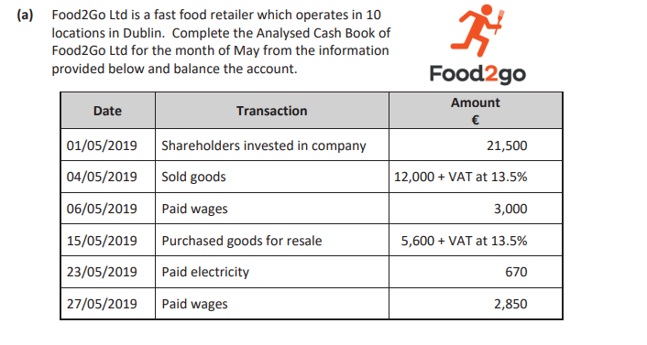
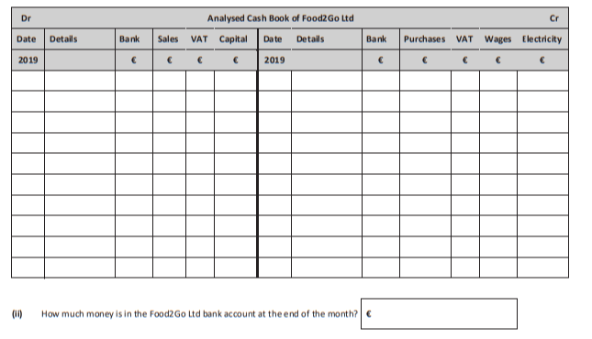
In this particular question, we take the information given and post to the relevant accounts. We first need to establish what a debit and credit is for the business.
We also will be working with both Sales and Purchases that will include VAT. VAT will need to be calculated on these figures.
The total figure will go into the Bank column, but we separate the VAT in both Sales and Purchases. (This will make sense with practice).
When we have all our totals, we will return to how to balance these accounts.

2. The General Ledger
Once the Analysed Cash Book has been completed, the individual accounts are opened in the General Ledger and these figures are posted from the Analysed Cash Book.
The headings of each of the columns in the Cash Book, e.g. Sales, VAT, Wages etc… make up the headings for the General Ledgers.
The Debit side of the ledgers are used for recording assets and expenses.
The Credit side of the ledgers are used for recording incomes, gains, and liabilities.
Let’s continue the 2019 question
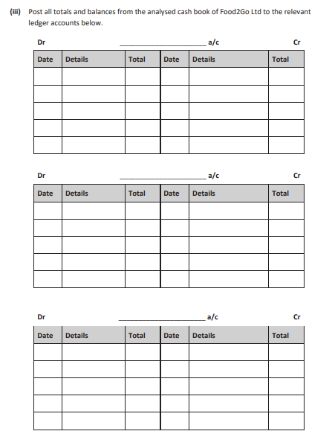
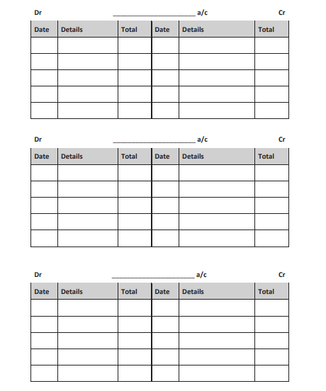
We must balance each of these accounts. These balances will be used for the last section, which is posting these figures to the Trial Balance.

The Trial Balance
The Trial Balance shows a list of all the balances brought down (Balance b/d) from the Analysed Cash Book and General Ledgers.
The Trial Balance total should be the same, and will show that the accounts have been prepared accurately.
Any balance b/d from the General Ledgers will go on the Debit side of the Trial Balance.
Any balance c/d from the General Ledgers will go on the Credit side of the Trial Balance.
Let’s complete a Trial Balance the 2019 question
