Now we will examine a Case Study of Brian Lee and his business ‘Chopped’ and answer it from a LC Business perspective:
Let’s see if you can see evidence of the following skills/characteristcs based on the videos in the notes
- Self-Confidence
- Risk Taking
- Realistic
- Creative
- Goal Setting
- Networking
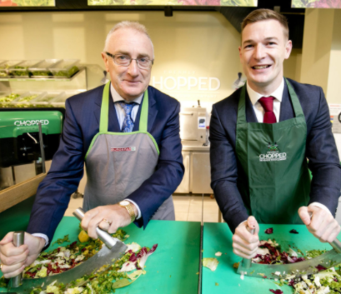

Evidence of Brian Lee’s Entrepreneurial Skills/Characteristics
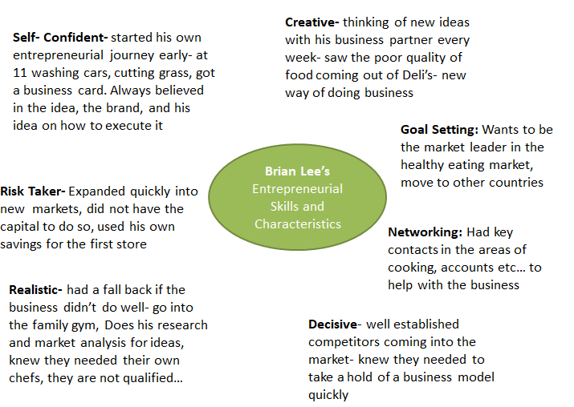

How to answer this question:
Illustrate the entrepreneurial skills/characteristics of a named entrepreneur from a question (20)
Or
Illustrate the entrepreneurial skills/characteristics of an entrepreneur of your choice (20)

As it is a 20 Mark Question- 4 points needed. We need to make sure to State/Explain/Example
Creative/Innovative
This is the ability to come up with new ideas or new ways of doing things- ‘thinking outside the box’ to bring fresh ideas to the market- Example: Brian Lee was constantly thinking of new ideas with his business partner every week- saw the poor quality of food coming out of Deli’s- new way of doing business was Chopped
Risk Taker
Entrepreneurs are generally people who are risk takers rather than risk avoiders/risk averse. They take both calculated personal and financial risks to bring a product to the market- Example: Chopped expanded quickly into new markets, did not have the capital to do so, and used his own savings for the first store.
Realistic
The entrepreneur will have good judgement and take a realistic view of what is possible. They are ambitious but will also have an honest view of their own capabilities and seek help and guidance when required- Example: Brian Lee knew he did not have the necessary skills for all areas in setting up Chopped and so brought in qualified chefs and business people to help him.
Decisive
Decisions are made quickly and entrepreneurs take responsibility for any decisions that they make. They are able to adapt to circumstances that can change instantly and are flexible about this. Example: With well established competitors coming into the market- Brian knew they needed to take a hold of a business model quickly to make Chopped a success.
Other possible points:
Self-Confident
Self-confidence is concerned with how a person feels about their ability. You are not scared to explore un-chartered territories, take risk and take difficult decisions. Example: Brian Lee always believed in his idea, the brand, and his idea to execute it to make Chopped a success and expand into new markets abroad such as the UK.
Goal Setting
This is concerned with having both short and long term goals for the business to be a success. It involves planning for the future as well as having strategies in place to meet the here and now. Example: Brian Lee wanted to set up a business that could offer a healthy alternative to fast food, and his future plan is to expand into the UK and world markets.

