Planning a Business Strategy and
Cash Flow Forecasts
Just as individuals have goals and plans for the future, so do businesses. By making plans, a business can establish clear goals and how they are going to achieve them.
Effective Plans are SMART:
Specific
Measurable
Agreed
Realistic
Timing
Example of SMART PLANNING: Coca-Cola
Specific
There are very clear and specific aims. Everybody understands exactly where the business is going and there is no confusion in the direction the business is headed.
Example: To be the market leader in soft drink distribution in Ireland for Coca-Cola is a specific aim.

Measurable
The target set can be evaluated- are we successful or not. In the business world you cannot afford to be making losses so you need to have measurable plans in place.
Example: Coca Cola examine statistics against the industry average to analyse business performance.

Agreeable
All members of staff support the plan and so everybody involved is moving in the same direction. Performance Appraisal for hitting targets will help support this.
Example: Coca- Cola outlines their targets to staff at the beginning of the year.

Realistic
Objectives and targets that are too difficult to reach can de-motivate your staff if there is only a small chance that you can be successful.
Example: Coca-Cola asks their sales team to try and get 10 new clients in Ireland to sell their products in each county over the next month, rather than 100.

Timing
Setting a clear time frame for achieving your goals are important. Plans should not be open ended as this can cause delays for decisions.
The Business Plan
The Business Plan is a written document made by a business when seeking finance from a financial institution.
Below are some of the key headings in a Business Plan
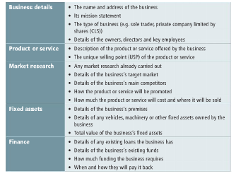

Cash Flow Forecasts
Along with the Business Plan, financial institutions also need evidence of financial planning for the future. This is done in the form of a Cash Flow Forecast.
Cash Flow Forecasts are financial plans showing all the cash receipts and cash payments in a business over a period of time (similar to a budget for a household)
Reasons for preparing them:
- To project future receipts
- To project future payments
- Identify monthly surplus/deficits
- Identify times of needing to borrow/invest
- Assist in applying for a loan from the bank

What can a business do if it has cashflow problems?- This may form part of the advice you may give a business in a question if it is struggling
Increase Income- look for ways to increase sales, sell off slow moving stock, increase finance, increase prices
Reduce payments- Cut back on non essential costs, improve credit control, buy from cheaper suppliers, reduce staff

Let’s look at a sample Cash Flow Forecast together in class. Please note that there is a video to support this question on the website.
