Business Documents and Business Transactions
Effective Purchasing
Purchasing the right good at the right quantity for the right price at the right time will ensure a business purchases effectively.
Purchasing and Selling Process using Business Documents
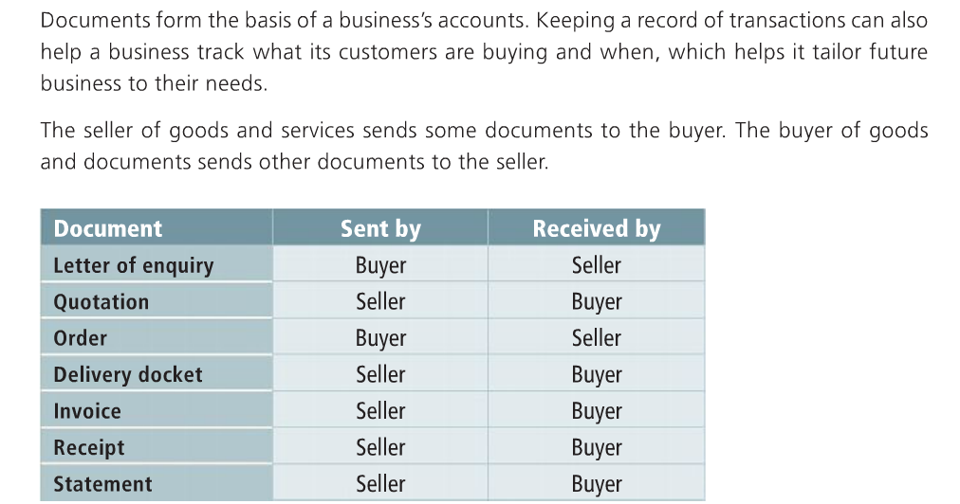
1. Letter of Enquiry- BUYER to SELLER
Find a suitable supplier and make an Enquiry. An enquiry is a request from a buyer to a seller for the price and terms of sale of certain goods. When the enquiry is received, the seller checks the current price of goods, checks if they are in stock, and if so prepares a quotation.
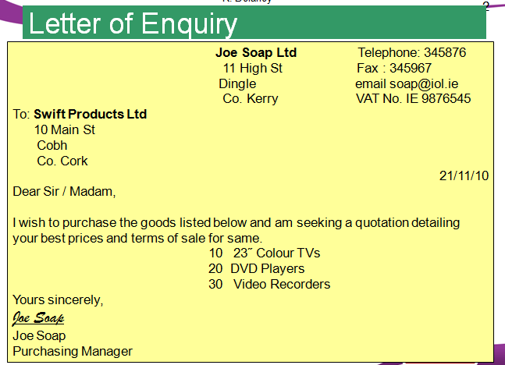

2. Quote- SELLER to BUYER
If happy, then get a Quote and use this information to make a decision about purchasing goods. A quote is a document sent by the seller to the buyer that shows the price of goods and terms of sale. When purchasing, a business should always shop around for the best quote.
A quotation may include cash discounts for paying before a certain date, or trade discounts if you regularly buy from that particular supplier.
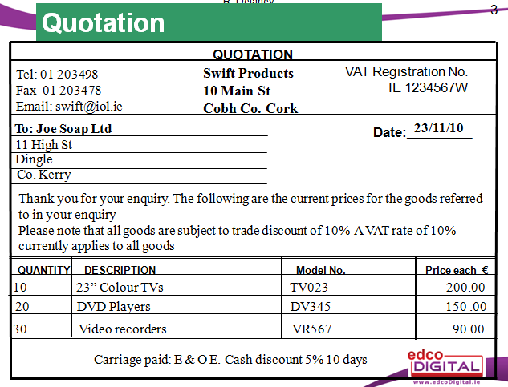
When Processing Quotations, it is important to:
- Check all details, including name, address etc… are correct
- File the quotation properly

3. Orders- BUYER to SELLER
An Order is a standard document from buyer to seller to order goods.
You may order and pay now or order on credit. When you order a good on credit, it means you buy now and pay later. A business may do this:
- To increase sales as it allows you to sell more goods to customers now and pay for them after you have sold them
- Be competitive, it may allow you to attract more customers as you can sell more goods than the competition and meet your customer demand
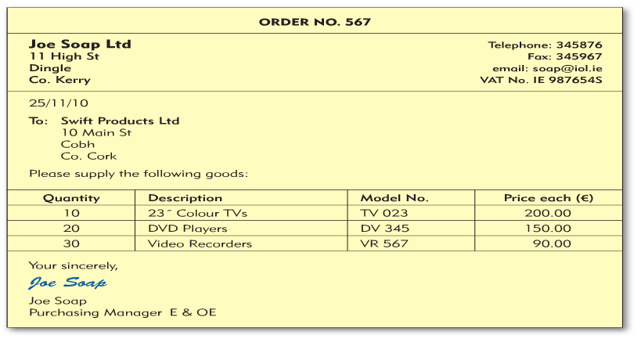
Credit Worthiness:
As a business, if a someone wants to order from you you should check their credit rating. You can do this by:
- Asking them to get a trade reference
- Asking them to get a bank reference

4. Delivery Docket- SELLER to BUYER
The Delivery Docket accompanies an Invoice and it shows the quantity and description of the goods. The buyer is asked to sign for delivery as proof they have been received.
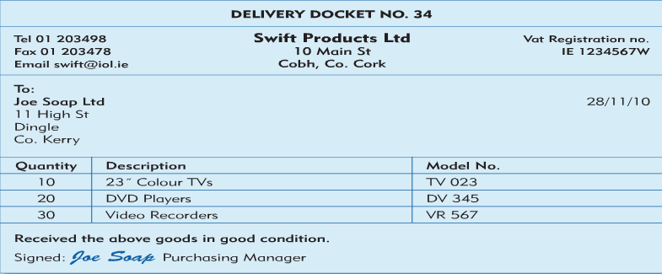
5. Invoice- SELLER to BUYER
An Invoice accompanies a Delivery Docket and it is a bill sent by the seller giving details of how much the buyer owes and the other terms relating to the transaction.
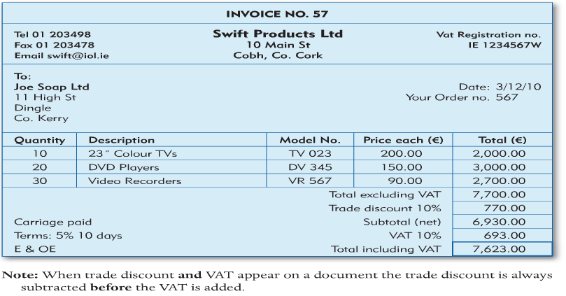
When processing invoices:
- Check the name and address of the receiver are correct
- File a copy of the invoice
- Record it correctly in your sales records

6. Receipt- SELLER TO BUYER
When the buyer has paid for the goods, they will be issued with a receipt as proof of purchase. It is important for the business to file this receipt properly and make sure all details are correct.
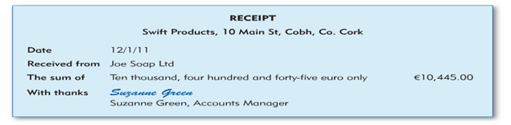
7. Statement-SELLER to BUYER
A statement will show the balance owed by a buyer to a particular business over a period of time. It is the norm for businesses to use regular suppliers and so this will show an account of transactions over time, including good purchased and payments made.
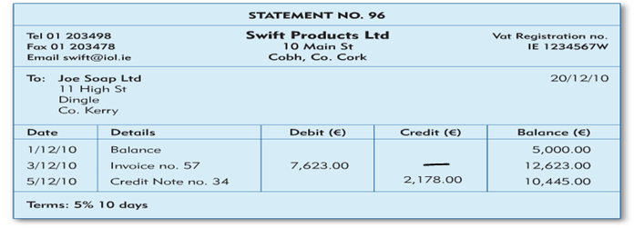
The Importance of EDI for Businesses
It is more common now for businesses to engage in effective purchasing online. Therefore, the electronic exchange of documents between businesses is known as Electronic Data Interchange.
Advantages of EDI
- Fast as documents are received immediately
- Reduces admin costs
- Better stock control- items ordered automatically
- Easy to store records

