Business Ethics and Social Responsibility

Business Ethics
Business Ethics is the set of moral rules and standards that provide guidelines for right and truthful behaviour in business situations with their various stakeholders such as their employers, community etc..
Ethics helps a business decide whether a business decision is right or wrong, regardless of whether it generates a profit or not.
Business Ethical Scandals 2020
https://www.theladders.com/career-advice/the-10-biggest-company-scandals-of-2020
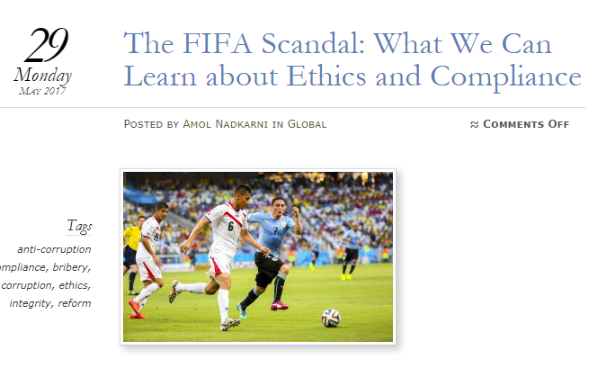
Some Types of Unethical Business Practices
- Bribery and Corruption- making illegal payment to win contracts and influence decision makers
- Exploitation of Workers- Child Labour, unsafe working conditions, long hours, underpaying staff
- Dumping toxins into air and water
- Unsafe or substandard products being sold- example cars with defects
- Overcharging for products and service
Why does a business act unethically?
- Greed- the desire for more profits, wealth, and power
- Fear of losing jobs and so cut costs
- They are allowed get away with it in some places- lack of regulation
- Corporate culture
- Low ethical standards among individuals

How ethical behaviour can be encouraged
Encourage Whistleblowing
If business management want their business to behave in an ethical way, they must have a culture where unethical behaviour is reported. Employees are encouraged to report any instances of unethical behaviour. This is known as whistleblowing.
http://www.businessinsider.com/9-famous-whistle-blowers-2013-6?IR=T
Staff Training
When staff is inducted, a code of ethics of the business operations should be given to them. Also, existing staff need to be retrained in ethical practices and this should form part of their appraisal interviews
Lead by example
If managers and owners are consistently behaving in an ethical way and promoting a culture of ethical business practice, this should filter down to the rest of the staff
Ethical Audit
An ethics auditor can be hired by a business to examine how it operates, and create a report to management of unethical behaviour that a business can use to change its practices. This recommendation is not legally binding
**Develop a Code of Ethics**
A code of ethics is a formal written statement created by a business setting out the behaviour that is expected of its managers and employees when dealing with the other employees, customers, and its business community.
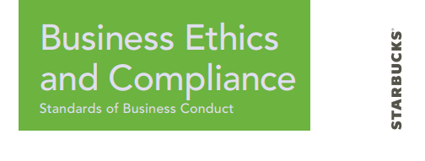
Benefits of Having a Code of Ethics
Decision-Making
A code of ethics can provide a foundation on which to base all decisions that affect internal and external stakeholders, such as employees or residents in the local community. Having a solid code of ethics in place from the beginning can help to guide a business as it expands
Day-to-Day Decisions
A code of ethics helps employees to fully understand the expectations of the company and the ethical guidelines in which to make decision when dealing with customer complaints. This will ensure that customers are treated fairly
Business Reputation
Displaying the business code of ethics on its website or in press releases, while taking care to ensure that the business actions are always in line with the words on the code, can create a positive image among consumers and job-seekers, creating a loyal customer base, good employees and helping to develop the brand image
Encourages whistle blowing
The code of ethics may include a “whistle blowing” clause which encourages any wrong doing to be reported to management. Staff members are encouraged to report unethical behaviour by creating an environment where whistle blowing is rewarded
Challenges of Having a Code of Ethics
Regularly Reviewed
The Code of Ethics must be updated regularly and kept up to date to include new behaviours which are considered unethical. E.g. use of the company social media account/company emails
Enforcement
Enforcing a code of ethics can also present challenges. Sanctions given to employees may damage the industrial relations climate in the business and reduce morale
Training Costs
Staff training must be provided on an on-going basis to ensure the code is understood and is not ignored. This will involve financial costs for the business
Culture
Often, newly implemented codes of ethics may not immediately gain the respect or support of employees or management. They may see it as a critique of their personal morals.
Corporate Social Responsibility
Social Responsibility is the businesses duty to respect all its stakeholders in a morally and fair way. This is often referred to as Corporate Social Responsibility.
Responsibilities to various stakeholders- You know this already! Be able to put 4/5 paragraphs together using the points below
Stakeholder | Responsibility
The Government | - Pay all taxes when due PAYE, VAT and Corporation Tax- avoid tax evasion  - A business needs to comply with various legislation – for example Employment Equality Act 1998  - Use government finance provided as intended (Grants)
Employees | - No discrimination/harassment  - Fair wages( at least minimum wage) and fair promotion system  - Safe work conditions
Investors | - Do not conceal information – be honest and transparent with  - investors at all times and maintain proper set of accounts  - Use investment capital appropriately – investors’ funds must be spent in the manner for which they are given  - Give reasonable return on investment – investors are taking a risk when providing capital and should be given a fair return if profits are made
Customers | - Truthful and accurate advertising  - Products that are safe and reliable  - Complaints must be dealt with speedily  - Provide an after sales service
Suppliers | - Pay bills on time  - Honour contracts  - Fair negotiations
Community | - Avoid pollution  - Provide employment  - Support local suppliers  - To keep them informed
The Environment
Linked closely to ethical and corporate social responsibility is the importance of environmental responsibility.
Some issues affecting businesses and the environment today
- Climate Change
- Air, noise and water pollution
- Diminishing resources
- Waste disposal.
- Deforestation (which can result in desertification).
The following are the different environmental characteristics of environmentally responsible firms
- Being aware of Climate Change and Energy Resources
The use of fossil fuels such as coal and peat in business means that the business has a responsibility to use these fuels as efficiently as possible. A business could become more sustainable by introducing cleaner production methods, substituting raw materials for materials from more renewable sources and changing to energy sources that are renewable
- Waste Management
A business could try to improve its waste disposal. The 3 R’s of waste management- Reduce, Reuse, Recylce- could be adapted and encouraged by the business. The idea would be to reuse rather than dispose if possible. The business should also ensure safe disposal of waste- no illegal dumping in the local river for example, reusable shopping bags
- Pollution prevention
The use of processes, practices, materials, products or energy sources that avoid or minimise the creation of pollutants and waste, and thereby reduce the risk to human health and the environment- The idea is pollution prevention rather than pollution control
- Having a Written Statement (Code of Ethics)
The business could establish a code of ethics which is a formal written statement setting out the modes of behaviour expected from a business in its dealings with the environment and the wider community in which it operates, encouraging a culture of openness, consultation, honesty and awareness of environmental issues etc..
- Environmental Audits
This is an an independent study of the impact of the business on the environment. It focuses on what is produced, how it is produced and how it is marketed
- Honesty and Openness
The company tells the truth and is honest in all dealings affecting the environment- for example it does not hide industrial actions from its external stakeholders
- Consultation/Advice
Consultation with all the interested parties when developing and implementing policies that affect the environment- Consultation also involves getting the most up- to- date information on environmental issues
- Sustainable Development
The needs of future generations should be taken into account when using natural resources. Businesses should adopt an environmentally friendly approach when using natural resources. This is especially important because of the potential for climate change. Greater use could be made of wind and sunshine to create energy, and businesses should use this energy more efficiently (e.g. energy saving lightbulbs).

Effects on Cost and Revenue of meeting Ethical, Social, and Environmental Responsibilities
Some of the following are cost effects associated with meeting these responsibilities-Be able to expand if asked in an exam, we will refer in class discussion
- Staff training and induction costs
- Capital costs of more friendly technology/assets
- Safe waste disposal costs
- Audit and on-going monitoring costs
- Sourcing of more environmentally friendly materials

Some of the following are revenue effects associated with meeting these responsibilities-Be able to expand if asked in an exam, we will refer in class discussion
- Less legal costs for unacceptable behaviour
- Less staff turnover leads to less induction costs
- More efficient production could lead to higher sales
- Can be used as positive marketing tool
- Greater consumer loyalty as people are environmentally aware
- 3 R’S- less material costs
- Staff morale higher meaning more productivity

