Business Finance
In this chapter, we will examine:
- Types of Finance
- Why a business needs Finance
- Debtors v Creditors
- What a business needs in applying for a loan
- Sources of Finance
Types of Finance
(Recap from the Borrowing Money Chapter)
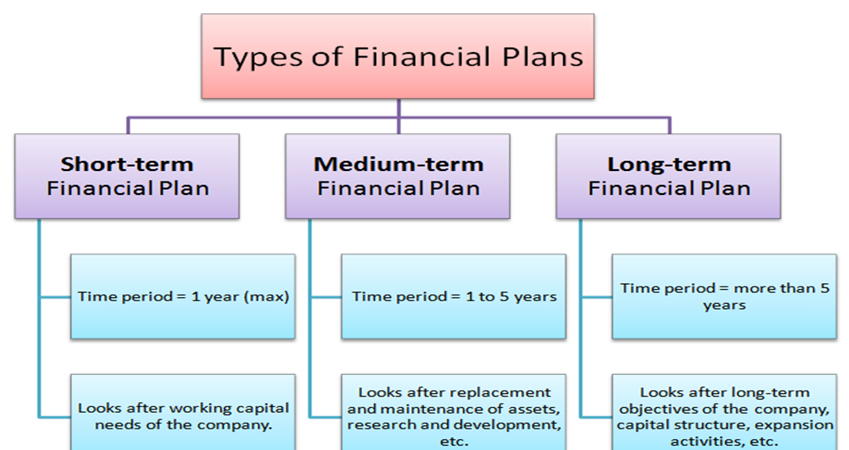
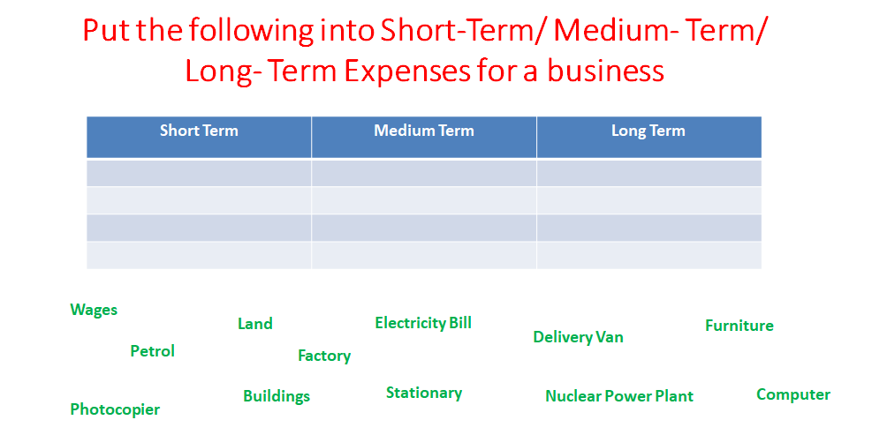
Why does a business need finance?
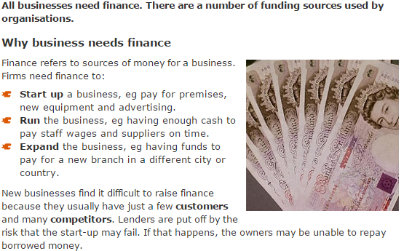
Debtors v Creditors
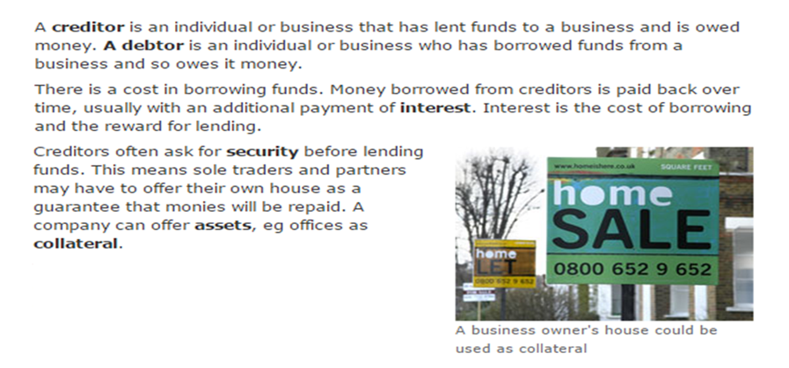
What does a business need to apply for a loan?
Before a business can get a loan, the bank will look at some of the following:
- Credit Rating
- Amount and Duration of loan
- Purpose of the loan
- Ability to meet repayments
- Business Plan
- Collateral
Sources of Finance
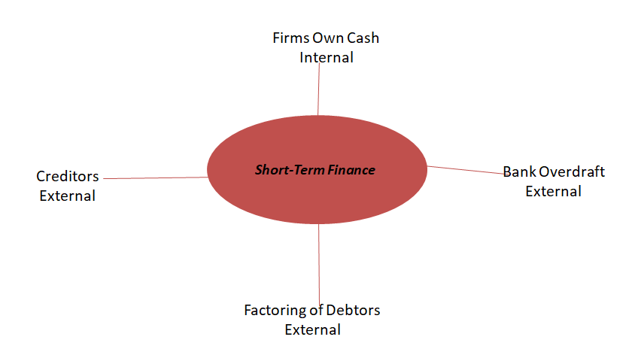
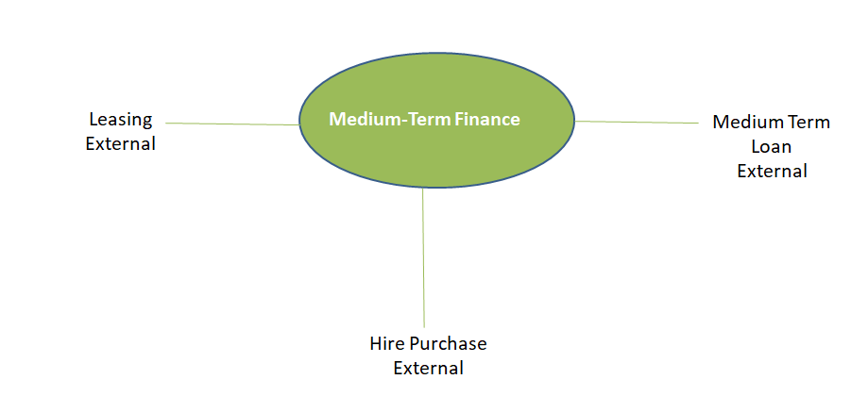
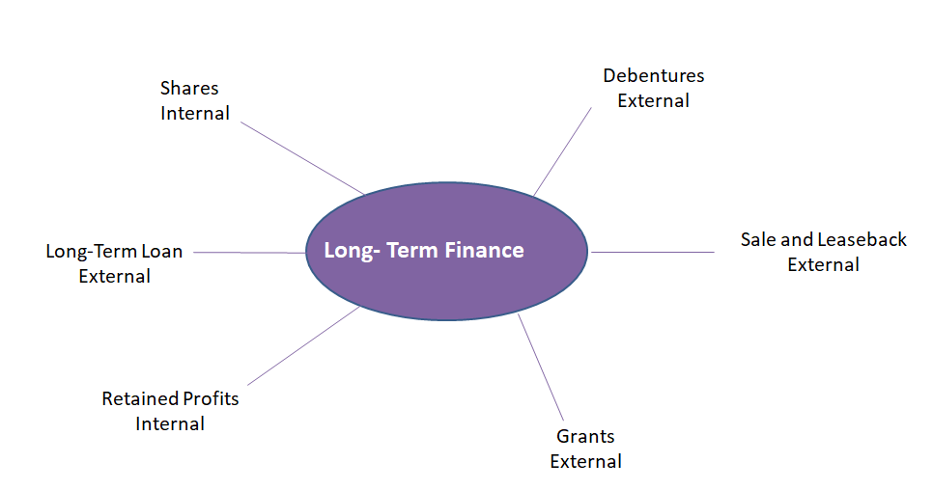
Long Term Sources Explained
Shares: The firm sells shares to the public and uses the cash to pay for things.
Long-Term Loans: This would be like a mortgage over a period of over 20 years. Repayments would need to be paid.
Retained Profits: This is placing profits back into the company.
Debentures: A certificate issued that is secured against a long term debt. Interest is also paid.
Sale and Leaseback: This is the selling of an asset and leasing back over time. The firm receives a large injection of cash and rents back the property.
Grant: This comes from the government. It is used to set up or expand the business. It does not have to be repaid as long as strict terms and conditions set out in the grant are met.

