Identifying Business Opportunities

The Business Needs: Coming up with new ideas
When starting a new business, an entrepreneur will need an idea to start up their new business that stands out from what is already out there, or an existing business may also need to generate a new idea for business growth and development.
These ideas can come from either internally (inside the business), or externally (outside the business).

Internal vs External Ways of Generating Business Ideas
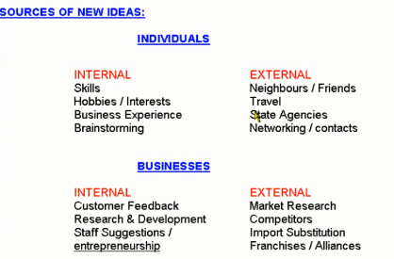
Internal
- Brainstorming: This involves people from different areas of the business who come together to generate a list of ideas on a given topic. Diverse ideas and approaches are encouraged, and will lead to creative suggestions. Once this list has been drawn up, it will then be shortlisted to move with the best ones.
Google Brainstorming Session
Companies like Google could have regular meetings between different members of teams e.g. sales, IT development etc.. to brainstorm new ideas.
- Research and Development Department: The R&D department may work on discovering a new product or work on improving an existing product to extend it’s product life cycle.
Companies like Google spend billions each year on their R&D.
- Hobbies and Skills: An entrepreneur may turn their own hobbies or skills into the best business opportunity. They themselves may come up with a more unique production technique or finish to an already existing product/service, or have a passion in a particular field and develop this passion into an idea.
Brian Lee set up Chopped in 2012 based on his interest in health and fitness.
Other internal ways: Suggestion Box, Internal Competition (Facebook Like Button), Customer Feedback
External
- Competitors: A business could monitor close competitors and look at copying some of their product ideas, without copying them directly (patent)
Companies like Google constantly have to keep a close eye on the likes of Bing and Yahoo
- Trade Shows: Business would regularly attend trade shows such as the Dublin Web Summit to inspire them to make a new product for the domestic market or search for gaps in the market
Companies like Google could travel to America to attend trade shows over there to see if there is an opportunities for an alliance on a new product etc…

Other External Ways: Family/Friends, Media, Import Substitution, Business Alliances
Market Research
Market Research is the process of gathering and analysing information on order to identify the needs of customers.
MR is important because:
- Reduces development costs. (removes trial and error)
- Helps to identify the target market- who will buy our product or service
- Helps to identify strengths and weaknesses of competing products. This means that we don’t have to waste money or resources and will be able to get a lot of useful information such as trends, prices, and product ranges
- It will be able to show future trends, such as what is popular now that may not be popular in the future, such as World Cup jerseys if Ireland qualify etc..

Types of Market Research: Field v Desk
Field Research- Going out and asking the public information (going into the field)- Examples include questionnaires, taste tests, direct observations

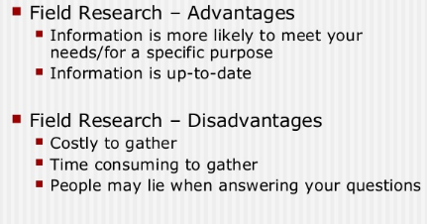

Desk Research- Information is collected using other sources already collected, for example by looking up reports and the internet (at a desk) - Examples include trade journals, media reports, competitor websites

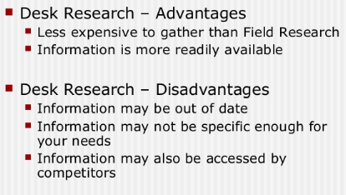
**The Product Development Process**
Note: You will generally be asked to complete this using a product or service of your choice, or differentiate between different stages as a short question

Step 1: Idea Generation
This involves the search for possible product ideas which the Company feels it will want. Many ideas must be generated to find a few that will be successful. The sources may be within or outside the business and brainstorming is one technique which is often used. You can also use any of the other ideas that we discussed at the start of this chapter

Step 2: Product Screening
This involves selecting the product ideas which have the best potential for sales. The products that are selected at this stage have the greatest potential for development. However, care must be exercised not to reject products which if developed could be marketed successfully. Market research will be conducted to determine the response of customers, such as further SWOT Analysis

Step 3. Concept Development
This involves developing basic ideas into a detailed version of the new product. The emerging product should be capable of satisfying basic consumer needs. The features of the product which make it different from other products on the market is called its unique selling point (USP).

Step 4: Feasibility Study
This looks in detail at the product’s commercial feasibility. Can the product be produced at a cost and sold at a price, which will enable a profit to be made?
Consumer demand must be analysed through market research and the type of marketing mix for the product will be considered.

Step 5: Prototype Development.
This stage involves the production of one of a small number of units of the product. It can be an expensive and tedious phase of the process as production difficulties and modifications to the product are identified and clarified.

Step 6: Test Marketing
The new product is released on the market on a small scale to the target market. Consumer reaction is compiled and any necessary changes to the marketing mix must be made. If the test marketing proves unsuccessful a decision to postpone the launch or abandon the project could be taken.

Step 7 Product Launch
Assuming the test marketing goes well the business will commence production and the advertising and promotional campaign will be implemented.

Evaluation
Although it is a lengthy and expensive process, The Product Development Process is definitely an essential one. The costs of launching a product that does not successfully go through these stages will far outweigh the costs involved in the process. It is not just a financial cost, as customers may also move to competitors if they are not satisfied with what you are offering.
Many products and services break down across the stages, either the idea itself does not become possible or it becomes too costly along the way. Still though, it is very necessary for successful businesses such as X.

Break Even Analysis
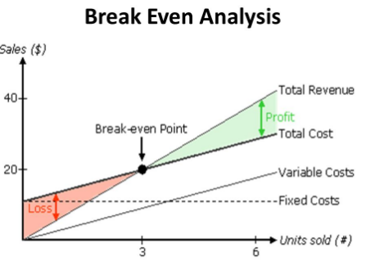
In order to survive businesses must at least break even, which means they need to generate enough income to cover all of their costs.
Break-even analysis is a financial tool that can be used by managers to determine the impact of costs and revenues on profitability. It will illustrate the number of products that must be sold in order to cover all the costs associated with production.
The Margin of Safety on a break even chart is also very important as this shows how much output or sales level can fall before a business reaches its break-even point. It is the quantity by which the product’s sales can fall before the firm starts to lose money on the product.
Calculating the Break-Even Point
In order to work out the break-even point a business will need to know its Fixed Costs, Variable Costs per unit, and its Selling Price.
Fixed Costs (FC): These are expenses that do not change as output changes. Examples include rent and insurance
Variable Costs (VC): These expenses will change as the level of output changes. Examples include wages, light and heat
Total Costs (FC): This is when you add all fixed and variable costs together
We use the following formula to calculate Break Even Point:
Fixed Costs
Divided by
(Selling Price- Variable Costs per Unit)

Be careful- there are limitations to Break Even Analysis: (Know 3/4)
- Break-even analysis assumes Fixed Costs are constant – FCs can vary as output changes
- It assumes that the business knows all its costs and can break them down into fixed and variable
- Variable costs may increase/decrease as output increases – business may be able to purchase larger amounts of raw materials at lower prices (economies of scale from bulk buying)
- Assumes that firm sells all its output – in times of low demand a firm may have difficulty in selling all its products
- Assumes a firm sells all its output at a single price -firms may offer discounts for bulk purchases/ may produce more than it can sell and may have to sell the surplus at a discounted price
- Ignores the effect that a change of price may have on sales-price increase fall in demand for the product and vice versa.
- Most businesses sell more than one product, so break-even becomes harder to calculate
We will do sample questions from the textbook and Exam Papers in class to demonstarte how to complete these diagrams.

2008 Leaving Cert Q.7
