Business Opportunities Rapid Revision
Ainm:

A.
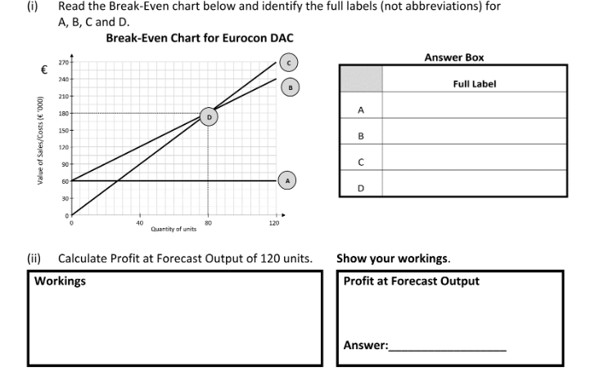
B. Explain what is meant by the term ‘Margin of Safety’.

C. Give two limitations of Break Even Analysis.
1.

D.
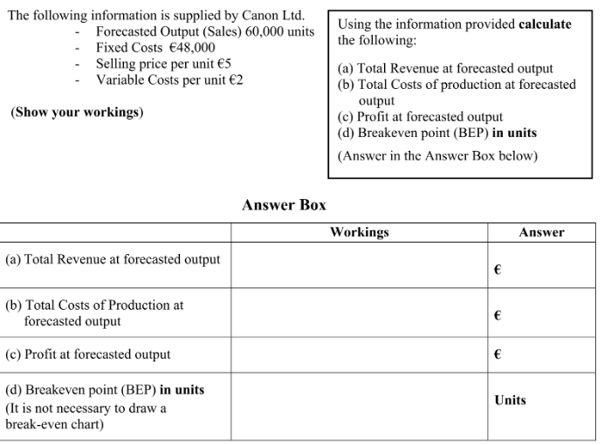
- Put the stages of the product development process in the correct order using the definitions below.
Search for possible product ideas, brainstorming is a tactic that is often used
Selecting the product ideas which have the best potential for sales. The products that are selected at this stage have the greatest potential for development. Care must be exercised not to reject products which if developed could be marketed successfully. SWOT Analysis can be used.
Developing basic ideas into a detailed version of the new product- USP needed.
This looks in detail at the product’s commercial possibility. Can the product be produced at a cost and sold at a price, which will enable a profit to be made? Consumer demand must be analysed.
Sample or mock up product, the product is tested to see how it works and is then refined to eliminate any bugs.
The new product is released on the market on a small scale to the target market. Consumer reaction is compiled and any necessary changes to the marketing mix must be made.
Assuming the test marketing goes well the business will commence production and the advertising and promotional campaign will be implemented.

- List three internal and three external sources of business ideas.
Internal | External

- Explain three benefits of Market Research for a business.

5.Name on advantage and one disadvantage of both Field and Desk Research below.
Field Research | Desk Research
Adv: | Adv:
Disadv: | Disadv:

