Business Planning
- What is a business plan?
- Why is a business plan important?
- How is a business plan prepared
- Unit Costing’s
- CBA 1
The Business Plan
Any individual or group looking to set up or expand a business will need to prepare a Business Plan. A Business Plan acts as a management tool that can be referred to regularly to ensure the business is on course with meeting goals, sales targets or operational milestones.
The most important task when setting up a business is to plan.
Reasons why you need a business plan
- To apply for a loan
- Raise finance from investors or get a grant
- To establish goals
- To set targets
- Map of how the business will be run
A Business Plan will set out the following:
- Who is running the business
- What is being made or produced
- How it will be produced
- Marketing Plan
- Financial Plan- where the money will come from
- Sales Plan- Forecast
- Profit margin expected
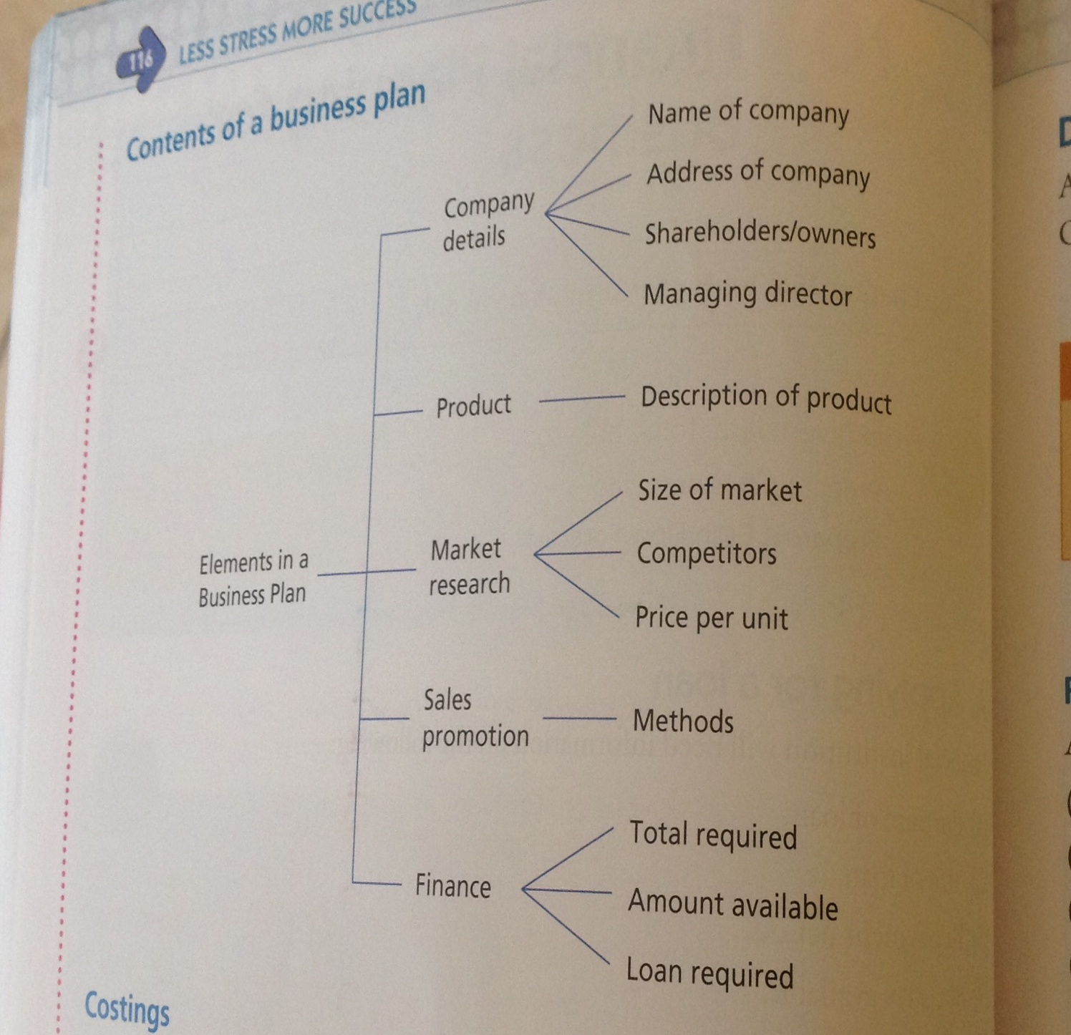
Sample Business Plans will be given to students in class and we will practice Business Plans as part of our studies.
Costings
There are two types of costs for a business
Fixed- Stay the same
Variable- change upon usage- increase or decrease depending on production
Fixed Costs + Variable = Total Cost
Cost per unit = Total Cost/ Unit Produced
Example
Fixed Costs = 20, Variable Costs = 30, Total Units Produced =100, Calculate cost per unit.
20 + 30 = 50
100/50 = €2 per unit

CBA 1
This is a group task but students will have to provide an individual reflection as part of their grade for this assignment. This task is due in by Friday March 16th.
