Business Start Up

Why start up a business?
Think back to Unit 2 and the reasons why people start up a business:
Why become an Entrepreneur?
People often decide to become an entrepreneur for the following reasons:
Income: Potential to make a profit and support yourself financially- to potentially earn more than an employee wage
Independence: Be your own boss, work for yourself and make all key business decisions
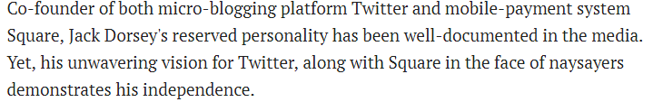
Challenge: Some people get bored easily and like to challenge themselves to be successful
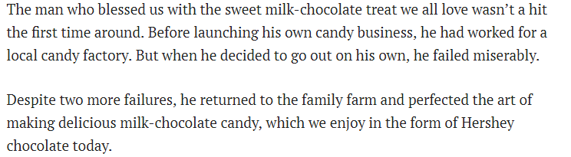
Creativity: They have the ability to constantly come up with new ideas
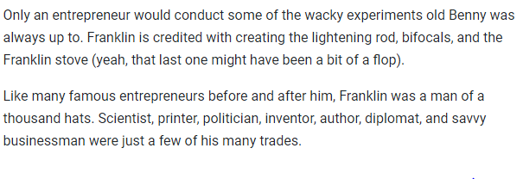Redundancy: They have been laid off from work and need a source of income for themselves
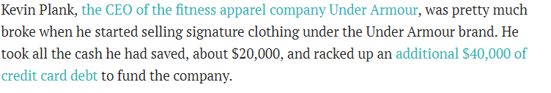

Key issues for Business Start Ups
- The ownership structure that needs to be adapted
- The location of the business
- Finance
- The choice of production methods
- Developing a Business Plan

- Ownership Structure
- Sole Trader
- Partnership
- Private Limited Company
- Co-operative
- Franchise
Note- We will examine all of the Ownership Structures a lot closer in Unit 6.

- The Sole Trader
The Sole Trader owns and runs their own business. The Sole Trader is the one who makes all decisions and provides the money in their business
This type of ownership model is typical in small retail and service sectors.
The owners have UNLIMITED LIABILITY!!!!
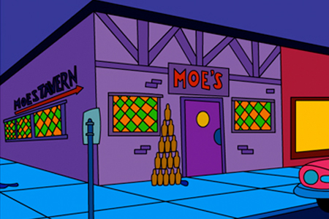

- Partnership
A partnership is a business where between 2 and 20 people come together to set it up and share control of the business. A set of rules and responsibilities for the company are agreed and written down in a partnership deed
Partnerships are common in types of businesses such as private medical practices and solicitors
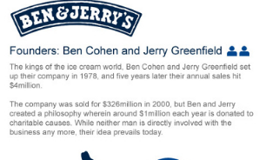

- Private Limited Companies
Formed when between 2 and 99 people put together money to start a new business. The people who put money in are called shareholders.
If the company makes a profit, shareholders receive a dividend. The dividend received depends on the amount of shares you invest. 1 share = 1 vote, the more shares, the more votes.
Shareholders have Limited Liability, and the words ltd come after the company name. In Ireland, Private Limited Companies must be registered with the Companies Registration Office

- Co-Operative
Co-operatives pool resources to achieve common goals, which as individuals they may not achieve alone. The people who set it up are called members and all profits go to the members
Each member has one vote regardless of the amount of shares they own
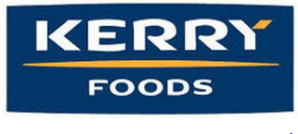

- Franchise
Franchising is a business arrangement whereby one person (franchiser) sells the right to use their name, idea or business to others (franchisees) and allows them to set up an exact replica of that business.
A franchise is effectively a licence to produce and/or sell another well- known company’s products and use the company’s name in return for a fee
- Business Location
The location of the business will play a key role in both the visability and profitability of a business. The following factors are important when selecting business location:

- Accessability
Location is of utmost importance to businesses that sell goods or services directly to customers. The business needs to be accessable to its target market
For example, a book shop in Navan Town Centre is more likely to attract customers than a similar shop located in a less busy area.

- Competition
A business's location can affect the competition it faces from businesses that sell similar products and services.
A book shop could be very close to Eason’s, and so starting a business in an area with few direct competitors can increase the likelihood of attracting customers.

- Operating Expenses
The location of a business can influence the total cost of operation. Renting a storefront on a popular street shopping centre is likely to be more expensive than opening a store in a small commercial district in a residential area.
A business could be better off opening its doors in an area that is cheap, even if it results in fewer total sales`

- Availability of Workforce
Businesses that need skilled workers will have to locate to a place that s accessable for workers. Very often, businesses will locate close to transport links so the workers can reach the job on time. This may however have an impact on start up and running costs

- Sources of Finance
Think back to Sources of Finance in Unit 3. The entrepreneur has to decide where to get the money from
3 types:
- Short Term (0-1 years)
- Medium Term (1-5 years)
- Long Term (5 + years)
Short Term Finance | Medium Term Finance | Long Term Finance
Bank Overdraft | Medium Term Loan | Owners Capital
Credit Card | Hire Purchase | Share Capital
Trade Credit | Leasing | Debentures
Accrued Expenses |  | Grants
 |  | Secured Long Term Loan

- Production Methods
If a new business is involved in manufacturing it will need to use one of the following Production Methods:
- Job Production
- Batch Production
- Flow Line Mass Production

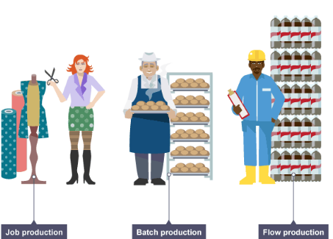
Job Production
This involves making products one at a time. Each product is both individual and unique, like a customised suit, wedding dress, or birthday cake.
Job production use highly skilled workers to make the products, and is generally considered more expensive due to this fact

Batch Production
This involves making a large amount of products in one go. The product is the same for all customers. Because it is the same, it can be made in batches, in advance, and ready for the customers when they need it. These products are less expensive than job production
A typical example would be cakes in a bakery or newspapers in a shop.

Mass Production
Mass Production is making the product continuously, 24/7/365. Therefore, you use mass prodcution for proucts that will be in high demand. The product is the same and made in advance, and the product is also the same for all customers.
Generally, unskilled workers are used, and products are produced using machines. It is generally the least expensive form of production, however very diffcult for a start up business
By producing in such a large scale, the manufacturer benefits from Economies of Scale, which are cost savings from large scale productions, as it costs less the more you produce and therefore savings can be made vs one off production
Examples include pens, toilet roll, Coca-Cola.

- The Business Plan
A business plan is a written document prepared by the entrepreneur
about the business and its objectives (where it wants to go) and strategies in areas such as marketing (analysis and plan), ownership, production, finance and the identifying of opportunities.

The Main Sections of the Business Plan are as follows:

Nature of the Business: This is the idea behind the business, what the business will be about. It will set out the type of business as well as what its main intention will be

Ownership: This will outline the type of business it will be, e.g. Sole Trader/Franchise/Private Limited Company, the name of company directors and shareholders, as well as the skills and experience of these owners
Marketing Plan and Market Analysis: This contains the 4 P’s (Product, Price, Place, Promotion). It shows important information such as the branding of the product,how it will promote its product through advertising etc.., as well as its pricing strategy. The size of the market, the demographs such as age, gender, income levels, the different target markets. It also shows current competitors and segment preferences

Production Plan: This will give production details such as what machines, labour, and raw materials are needed to produce a product, as well as time and costs to do so also. Production targets and types of production (e.g. batch etc…) are also outlined

Financial Plan: The financial plan contains details of how the business will be financed, its ratio analysis, cash flow forecasts, and financial statements and projections that will show where its money comes from and also that the business will not run out of money as it begins trading

The Importance of the Business Plan
Seeking Finance/Investors
It is a vital document (helps to ‘sell’ the idea to investors) when approaching any financial institution, grant agencies or other investors seeking funds (capital) for the enterprise

Sets Targets
A business plan well set out it’s targets and strategic objectives. All key areas of success are focused on which should increase the chance of business success.

Gives Focus
A business plan allows all stakeholders in the business to be on the same page when it comes to business activities. All stakeholders have a clear blueprint to follow and so time is not wasted

Viability
The business plan would usually include financial projections, ratios, cash flow forecasts and break even charts. This will measure the viability of the business moving forward

Business Plans for Stakeholders

Employees
Employees are interested in a business plan to confirm if the business is going to survive so they can have employment security. They may also be interested to see if the business is going to expand
and possibly offer opportunities for promotion in the future.

Investors (the profitability)
Investors will be interested in a business plan to see if the business is capable of making a profit and offering a good return on their investment. Projected sales and market research results may persuade investors to provide capital to a business.

Financial institutions (the cash position)
Financial institutions require business plans from a business when they are seeking loan capital. It helps finance providers to make a decision regarding finance approval as they can see the experience of the owners/management and analyse their ideas. It is the primary tool to convey the potential viability of the business to finance providers.

Management/employer
Management will use a business plan as a source of control. They will use it to measure actual performance against goals and see if the business has progressed satisfactorily. The management have goals to be reached and the business plan provides benchmarks which they can use to monitor actual business performance against the set targets in the business plan.

Suppliers
Suppliers will be interested in a business plan of one of its customers to ensure that the business is viable and can sustain any line of credit that is offered to them.

