Business Start Up

Why start up a business?
Think back to Unit 2 and the reasons why people start up a business:
Why become an Entrepreneur?
People often decide to become an entrepreneur for the following reasons:
Income: Potential to make a profit and support yourself financially- to potentially earn more than an employee wage
Independence: Be your own boss, work for yourself and make all key business decisions
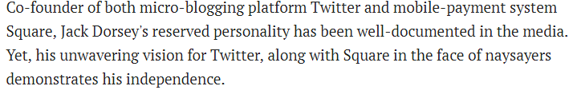
Challenge: Some people get bored easily and like to challenge themselves to be successful
Creativity: They have the ability to constantly come up with new ideas
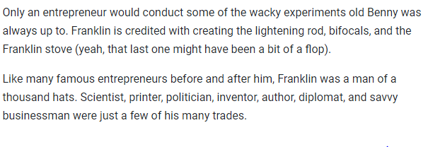Redundancy: They have been laid off from work and need a source of income for themselves
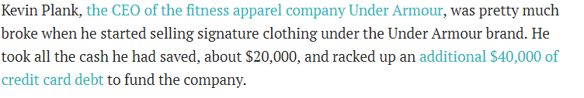

Key issues for Business Start Ups
- The ownership structure that needs to be adapted
- The location of the business
- Finance
- The choice of production methods
- Developing a Business Plan

- Ownership Structure
Choosing the best ownership structure is a common challenge for a new business. They must take into account the type of business they are operating in, the number of owners they want to be involved in decision making, access to capital, profit sharing etc..
There are different type of ownership structures available to a new business:

- The Sole Trader
The Sole Trader owns and runs their own business. The Sole Trader is the one who makes all decisions and provides the money in their business
This type of ownership model is typical in small retail and service sectors.
The owners have UNLIMITED LIABILITY!!!!- If the business goes bankrupt and owes a lot of money, the sole trader is personally liable for paying back all the business’ loans. If debts are still owed after selling the business, the sole trader has to sell off their personal assets to pay back these loans. Thus, it’s a huge risk since the sole trader can lose everything; business, house, other assets.
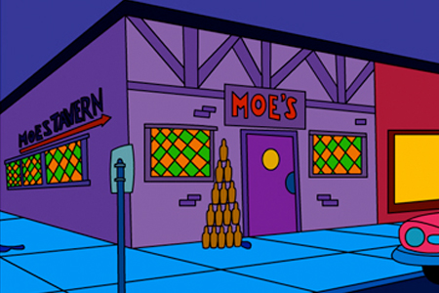
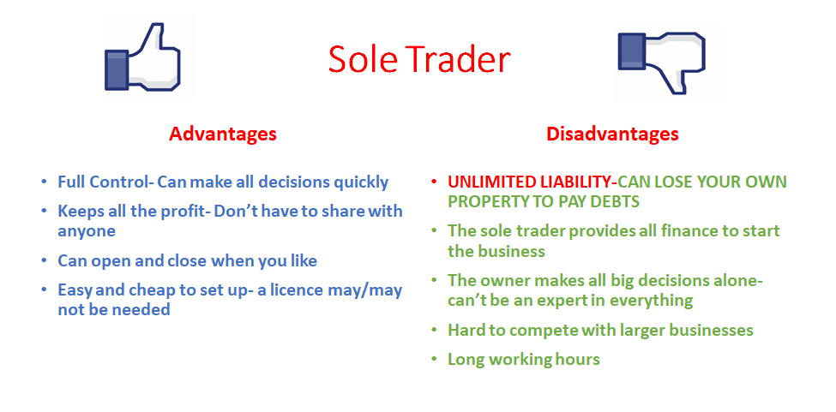
- Partnership
A partnership is a business where between 2 and 20 people come together to set it up and share control of the business. The owners have UNLIMITED LIABILITY!!
A set of rules and responsibilities for the company are agreed and written down in a partnership deed
The Deed of Partnership will include:
- How profits are to be shared
- How capital will be provided
- Duties and tasks of each person within the partnership
- Rules for new partners
- What happens if the business closes down/someone leaves
Partnerships are common in types of businesses such as private medical practices and solicitors
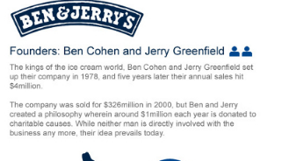
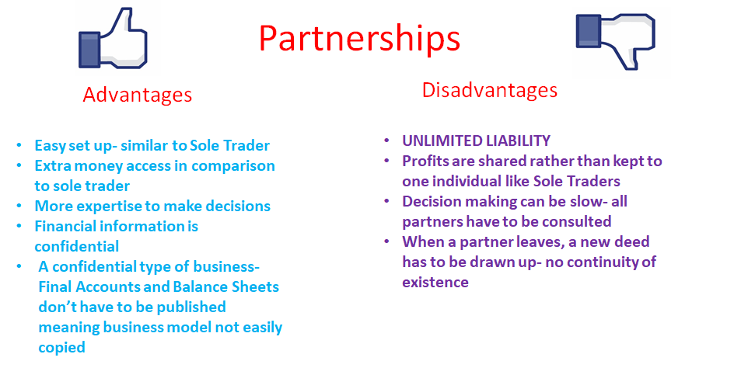
- Private Limited Companies
Is formed when between 1 and 149 people put together money to start a new business. The people who put money in are called shareholders. You must be invited to invest in this type of business.
If the company makes a profit, shareholders receive a dividend. The dividend received depends on the amount of shares you invest. 1 share = 1 vote, the more shares, the more votes.
Shareholders have Limited Liability meaning only money invested in the business is lost if it fails. In Ireland, Private Limited Companies must be registered with the Companies Registration Office
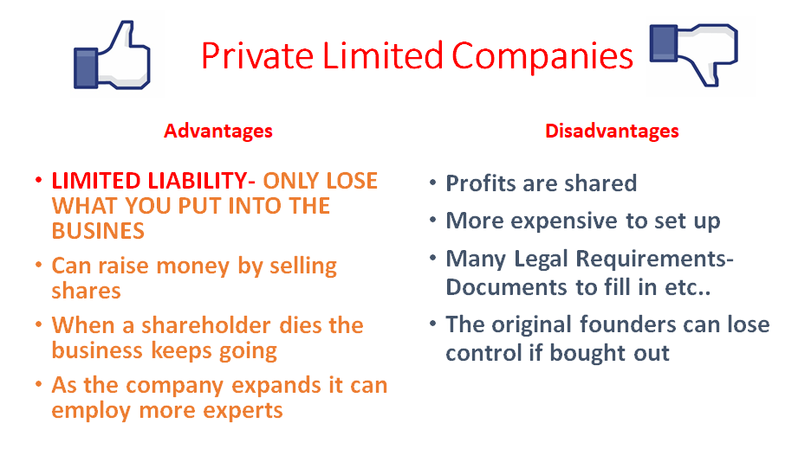
- Co-Operative
Co-operatives pool resources to achieve common goals, which as individuals they may not achieve alone. The people who set it up are called members and all profits go to the members
Each member has one vote regardless of the amount of shares they own
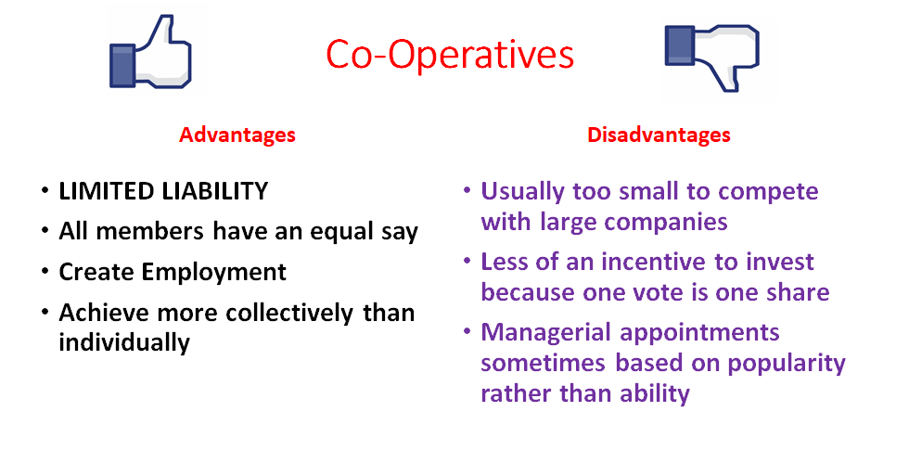
- Franchise
Franchising is a business arrangement whereby one person (franchiser) sells the right to use their name, idea or business to others (franchisees) and allows them to set up an exact replica of that business.
A franchise is effectively a licence to produce and/or sell another well- known company’s producs and use the company’s name in return for a fee.
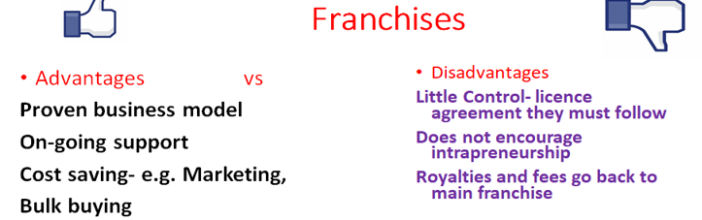
- Business Location
The location of the business will play a key role in both the visability and profitability of a business. The following factors are important when selecting business location:
- Accessability
Location is of utmost importance to businesses that sell goods or services directly to customers. The business needs to be accessable to its target market
For example, a book shop in Navan Town Centre is more likely to attract customers than a similar shop located in a less busy area.
- Competition
A business's location can affect the competition it faces from businesses that sell similar products and services.
A book shop could be very close to Eason’s, and so starting a business in an area with few direct competitors can increase the likelihood of attracting customers.
- Operating Expenses
The location of a business can influence the total cost of operation. Renting a storefront on a popular street shopping centre is likely to be more expensive than opening a store in a small commercial district in a residential area.
A business could be better off opening its doors in an area that is cheap, even if it results in fewer total sales`
- Availability of Workforce
Businesses that need skilled workers will have to locate to a place that s accessable for workers. Very often, businesses will locate close to transport links so the workers can reach the job on time. This may however have an impact on start up and running costs
- Sources of Finance
Think back to Sources of Finance in Unit 4. The entrepreneur has to decide where to get the money from.
It can be very difficult for a new business to raise finance and this is often a common challenge as they may be unproven in the market place.
A business will have to try and ensure they have adequate working capital to cover the day-day needs of the business and will need to acquire both short and long term capital. Banks/investors are often hesitent to lend/invest in a new business as they look to get finance through equity/debt capital.
3 types:
- Short Term (0-1 years)
- Medium Term (1-5 years)
- Long Term (5 + years)
Short Term Finance | Medium Term Finance | Long Term Finance
Bank Overdraft | Medium Term Loan | Mortgage
Credit Card | Hire Purchase | Savings
Accrued Expenses | Leasing | Retained Earnings
Factoring |  | Equity Capital
Trade Credit |  | Grants
 |  | Debentures
 |  | Venture Capital
Typically, this question looks for a matching principle, meaning you will be asked to identfiy needs of a business and match what type of finance is suited and why- e/g stock- trade credit, new machine- hire purchase etc…
Example: 2019 Question
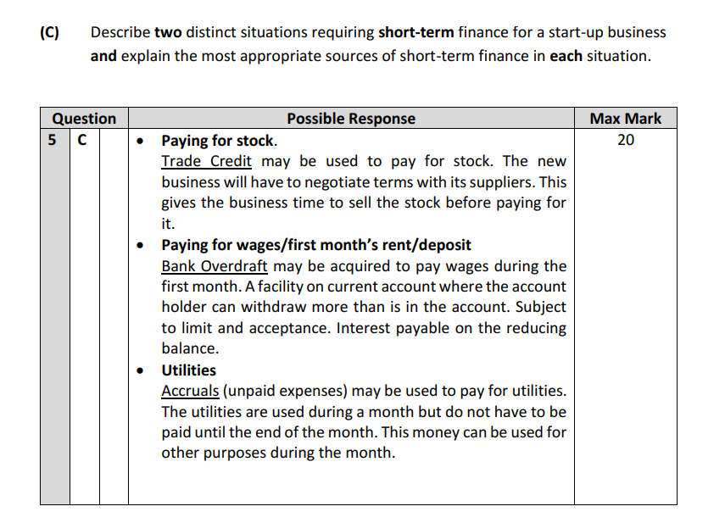

- Production Methods
If a new business is involved in manufacturing it will need to use one of the following Production Methods:
- Job Production
- Batch Production
- Flow Line Mass Production
We will also look at the implications for changing production methods
And
Outsourcing
Production methods are a common challenge, depending on the type of good a business wants to produce as well as type of workers, economies of scale etc… should be considered.
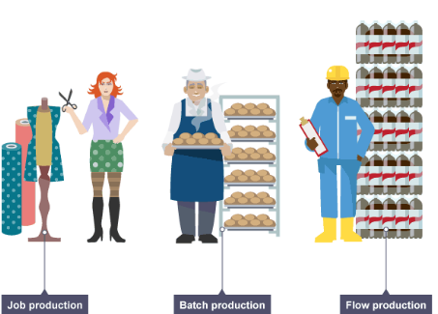
Job Production
This involves making each product one at a time. Each product is individual and unique and custom made for the buyer. A customer comes in and sets out exactly what they want. Then the business makes that product to the exact specifications of the customer.
Because it is not producing large amounts of the same products, the business does not enjoy many economies of scale. Therefore, products made this way tend to be expensive.
Generally, job production uses very skilled workers to make the products. This increases the wages bill for the business as highly skilled workers command high wages.
Job production usually uses machines that are flexible and capable of doing many jobs. This is because each customer will ask for something different and the machines must be capable of doing any job needed.
A typical example would be a wedding dress.
Batch Production
Batch production involves making a limited amount of the product, in groups, all in one go (production run). The product is the same for all customers.
Because it is the same product for all customers, it is made in advance and in stock and ready for the customer when she comes into the shop looking for it. The business must therefore implement a stock control system.
Generally, batch production uses workers who are not as highly skilled as those involved in job production. In batch production, the workers are not creating one-off unique products from scratch.
Batch production is capital intensive. This means that it mainly uses machines in the factory rather than workers. These machines are flexible and capable of doing many jobs.
It is cheaper to make each product using batch production. This is due to economies of scale. This means that the more products a business makes at the same time, the lower the cost of making EACH individual product becomes.
Therefore products that are batch produced tend to be less expensive than those that are job produced.
A typical example would be cakes in a bakery or newspapers in a shop.
Mass Production
Mass production involves making the product continuously, 24 hours a day, 7 days a week, 365 days a year. Therefore, mass production is suitable only for products that are in continuous demand by consumers.
Because it is the same product for all customers, it is made in advance and in stock and ready for the customer when she comes into the shop looking for it. The business must therefore implement a stock control system.
Mass production is capital intensive. This means that it mainly uses machines in the factory rather than workers. These machines are very specialised. This means that they normally do just one job.
Generally, mass production uses unskilled workers in an assembly line to make the products.Because of huge economies of scale, mass production tends to have the lowest cost of all the three production options and therefore the price is lower under mass production than either job or batch production.
Examples include pens, toilet roll, Coca-Cola.
-Changing Production Methods
If a business wishes to change its production method, the implications would be:
Change Ownership Structure- A business may need to alter their ownership, for example a sole trader to private limited company, to increase investment. This can have implications for control, however it will be unlimited liability
Marketing Plan- A revised marketing plan will beed to be developed and implemented to cater for the increased level of goods produced
Investement- Batch and Mass production may need investment to purchase machines and buildings, and complete regular health and safety and quality checks. This will of course cost more money for the business and so investment will be needed. This will come in the form of a long term finance option
Stock Control- If a business alters from job production, they will no longer be making goods to order, and so an efficient stock control system will need to be developed, increasing costs for the business

Outsourcing
Advantages | Disadvantages
Less money needed to purchase large machinery | Loss of control, particularly over production quality
Can meet demand if demand is greater than what business can supply | Industrial Relations issues- staff may fear for jobs
Less money needed to pay staff | Subcontractor may decide to enter business themselves and so become competitor
This means that a business employs another firm to manufatcure or produce part of the product or whole product. In order to reduce costs, many large multinational companines outsource some of their production.
Nike is currently outsourcing to multiple countries including: China, Indonesia, and Vietnam. Half a million people throughout the world have been hired to help produce their products

The Business Plan
A business plan is a written document a businessperson uses when starting a major business venture. In it she sets out the objectives she intends her business to achieve and the strategies she proposes to use to achieve them. It describes the USP and also describes how the entrepreneur is going to make and sell the product and how she intends to finance the business.
The Main Sections of the Business Plan are as follows:
Description of the Business: This is the idea behind the business, what the business will be about. It will set out the type of business as well as what its main intention will be.
Ownership: This will outline the type of business it will be, e.g. Sole Trader/Franchise/Private Limited Company, the name of company directors and shareholders, as well as the skills and experience of these owners.
Marketing Plan: This contains the 4 P’s (Product, Price, Place, Promotion). It shows important information such as the branding of the product,how it will promote its product through advertising etc.., as well as its pricing strategy.
Market Analysis: The size of the market, the demographs such as age, gender, income levels, the different target markets. It also shows current competitors and segment preferences
Production Plan: This will give production details such as what machines, labour, and raw materials are needed to produce a product, as well as time and costs to do so also. Production targets and types of production (e.g. batch etc…) are also outlined.
Financial Plan: The financial plan contains details of how the business will be financed, its ratio analysis, cash flow forecasts, and financial statements and projections that will show where its money comes from and also that the business will not run out of money as it begins trading.

The Importance of the Business Plan
Seeking Finance/Investors
It is a vital document (helps to ‘sell’ the idea to investors) when approaching any financial institution, grant agencies or other investors seeking funds (capital) for the enterprise.
Sets Targets
A business plan well set out it’s targets and strategic objectives. All key areas of success are focused on which should increase the chance of business success.
Gives Focus
A business plan allows all stakeholders in the business to be on the same page when it comes to business activities. All stakeholders have a clear blueprint to follow and so time is not wasted.
Viability
The business plan would usually include financial projections, ratios, cash flow forecasts and break even charts. This will measure the viability of the business moving forward.

Business Plans for Stakeholders
Employees
Employees are interested in a business plan to confirm if the business is going to survive so they can have employment security. They may also be interested to see if the business is going to expand and possibly offer opportunities for promotion in the future.
Investors (the profitability)
Investors will be interested in a business plan to see if the business is capable of making a profit and offering a good return on their investment. Projected sales and market research results may persuade investors to provide capital to a business.
Financial institutions (the cash position)
Financial institutions require business plans from a business when they are seeking loan capital. It helps finance providers to make a decision regarding finance approval as they can see the experience of the owners/management and analyse their ideas. It is the primary tool to convey the potential viability of the business to finance providers.
Management/employer
Management will use a business plan as a source of control. They will use it to measure actual performance against goals and see if the business has progressed satisfactorily. The management have goals to be reached and the business plan provides benchmarks which they can use to monitor actual business performance against the set targets in the business plan.
Suppliers
Suppliers will be interested in a business plan of one of its customers to ensure that the business is viable and can sustain any line of credit that is offered to them.

