Business Technology
Business’s are able to use technology in a number of ways. Below are some common forms of Business Technology:
Word processing: Writing reports, letters, business plans, minutes of meetings etc.
Spreadsheets: Recording employees’ wages/ salaries, recording cash flow, budgets, preparing accounts, creating charts, etc.
Databases: Recording employee, customer and supplier details, stock items, to create reports that show, for example, best-selling products. They make it easy to find information quickly
Presentation packages (e.g. PowerPoint): Creating slideshows for meetings, etc.
Email: Communicating both internally and externally with suppliers, customers, banks and other stakeholders.
The internet: Website for promoting and/or selling products/services and communicating with existing and potential customers. Many people use their smartphones to buy products – this is called mobile commerce, or m-commerce
Wi-Fi: Allows computers, tablets, smartphones and other devices to connect to the internet wirelessly. Broadband allows information to be transferred between computers at a high speed. Many consumers expect businesses such as libraries, transport services, shops, cafés, restaurants and hotels to provide free WiFi; businesses that do not may lose customers.
Video conferencing (e.g. Skype, Zoom): Allows people in different locations to communicate using audio and video
Social media: Keeping in touch with customers and promoting products and services to a potential global market.
Electronic point of sale (EPOS): Scanning barcodes, printing till receipts, taking payments by debit cards, credit cards and digital wallets, updating stock records and providing sales reports
Text Messages: Communicating directly with customers to encourage them to buy products, inform them of sales, remind them of appointments

Computer Hardware and Software
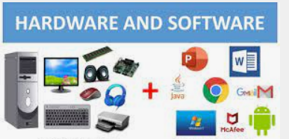
- The hardware It is the set of physical parts that make up the body of a computerized system: the plates, circuits, mechanisms and electrical devices, as well as processing, support and connection. For example: monitor, keyboard, printer.
- The software it is the intangible content of the system: the set of programs, instructions and languages ​​that carry out the tasks and serve as an interface with the user.For example: Microsoft Word, Excel, PowerPoint
How has technology affected consumer choice:
- Businesses have tried to use our obsession with technology to sell us more goods and services 24/7- online, in store etc…
- The use of social media, influencers, push notifications and personalised content are all ways in which businesses try to influence our buying decisions.
- Social media influencers are often paid to promote products to their followers e.g. Molly Mae and Pretty Little Things
Advantages of Digital Technologies in Business:
- Improves Communication: Many businesses are using various business communication technologies to change the way their employees interact and communicate while at work, as well as engaging with their customers.
Business’s can advertise jobs online and use videoconfercing to schedule interviews as part of staffing and use calendars and emails as reminders for important meetings and events.
Employees from different departments in a company can use e-mails, Facetime, WhatsApp, Skype, teleconferencing when communicating. In reaching customers, they have websites and social media channels.
In many industries during Covid, workers were able to use platforms like Teams to reach customers.

- Finance and Administration
Graphs and charts can be presented to workers as part of important financial information and platforms like Excel can speed up calculations.
Decision making is much faster for administration as information can be accessed much quicker online and the use of databases can easily store this information.
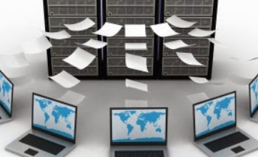

- Speed of Work: People work faster using ICT and can produce more. Think about the trip to the Coca-Cola company (that you have heard about- sorry about that!)

- Manufacturing/Production: Programmes such as Computer Aided Design (CAD) and Computer Aided Manufacturing (CAM) make the manufacturing and distribution of goods and services a lot easier.
Suppliers can be researched online to find the cheapest providers, and stock can automatically be reordered using EPOS (Electronic Point of Sale) when they run low
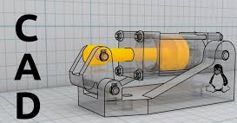

- Improves Mobility: The use of internet and computers to work has eliminated space and time boundaries. Employees can work from anywhere at any time, this mobility makes employees stay in control of their job using phones, I Pads, Laptops (a portable computer) etc.

- E-Commerce/Marketing: Using the internet to sell to consumers, more sales targets can be reached, 24/7 shopping and this ability to reach your customers.
The use of loyalty cards for repeat purchases as well as online surveys and cookies to remember returning customers can be used for marketing purposes.
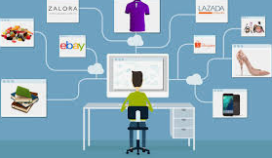
Disadvantages of Digital Technologies in Business:
1. Maintenance Costs: It is expensive to buy technology, but it is also costly to maintain it.
2. Human Obsolescence: Many jobs are becoming less valuable due to technology. HR can face issues of worried workers and job security issues which may impact on staff morale
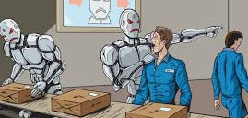
Security Risks: IT Security is critical. Businesses must ensure data is secured and protects against cybercrime and viruses. Security (Phishing) is an attempt to gain access to sensitive information from unsuspecting users. Many customers have fallen victim to these scams and as a result will not trust ICT

Interesting uses of technology:
- Development of new Apps/Computer games- more realistic game play like virtual reality/FIFA/Pokemon Go
- New ways to pay- tap and go with your phone
- Bluetooth- connect your phones to cars, other technologies, use of Siri App for questions and instructions

