Business Transactions and Business Documents
Purchases and Sales
Effective Purchasing
Purchasing the right good at the right quantity for the right price at the right time will ensure a business purchases effectively.
Purchasing and Selling Process using Business Documents
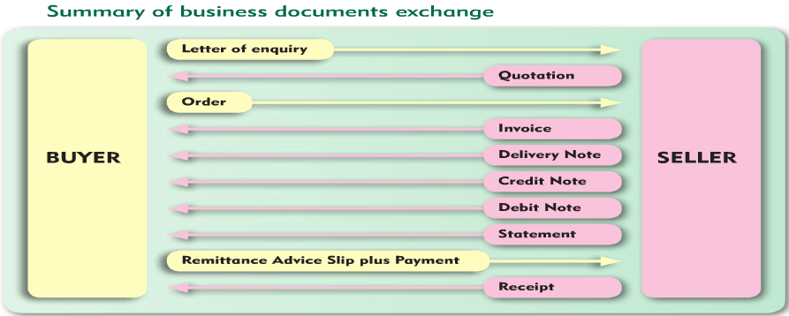
Letter of Enquiry- BUYER
Find a suitable supplier and make an Enquiry. An enquiry is a request from a buyer to a seller for the price and terms of sale of certain goods. When the enquiry is received, the seller checks the current price of goods, checks if they are in stock, and if so prepares a quotation.
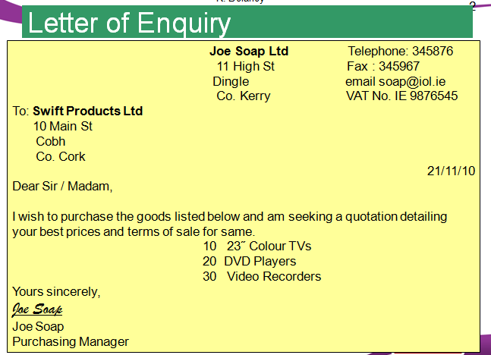
Quote- SELLER
If happy, then get a Quote and use this information to make a decision about purchasing goods. A quote is a document sent by the seller to the buyer that shows the price of goods and terms of sale.
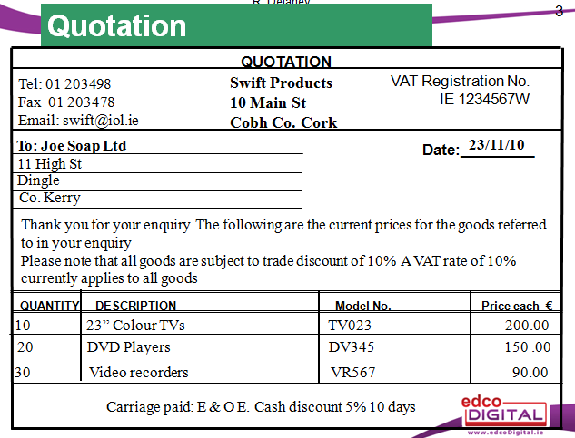 Key Terms on Quotation:
Vat Reg No: | Value Added Tax on goods and services. The number is provided by the tax office to each business that charges VAT
Trade Discount: | A reduction/discount in the price given to trade customers
Carriage: | Cost of transporting goods from seller to buyer
Carriage Paid: | Transport cost included in the price
Cash Discount: | Discount for paying cash- encourages quick payment
Ex Works: | Buyer must pay for transportation of the goods
CWO: | Cash With Order- Payment of goods is required at the time of ordering the goods
COD: | Cash on Delivery- Payment required in cash on delivery
E &OE | Errors and omissions expected

Orders- BUYER
An Order is a standard document from buyer to seller to order goods.
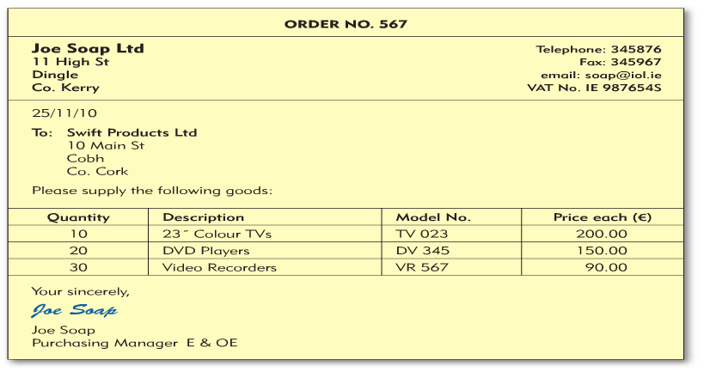
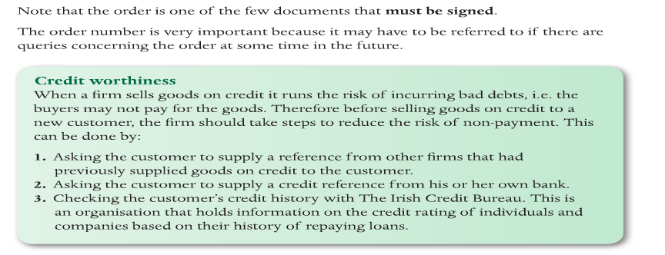
Invoice- SELLER
An Invoice accompanies a Delivery Docket and it is a bill sent by the seller giving details of how much the buyer owes and the other terms relating to the transaction.
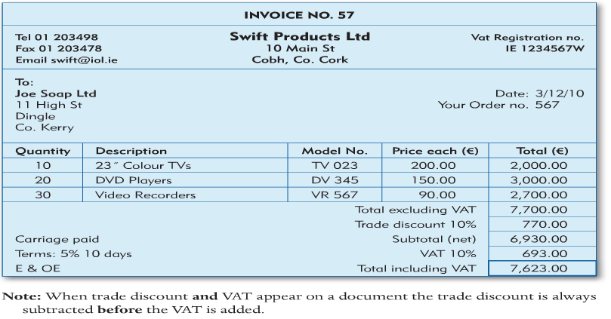
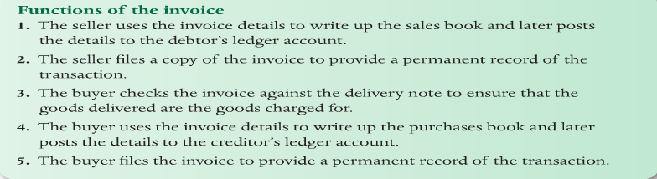
Delivery Docket- SELLER
The Delivery Docket accompanies an Invoice and it shows the quantity and description of the goods. The buyer is asked to sign for delivery.
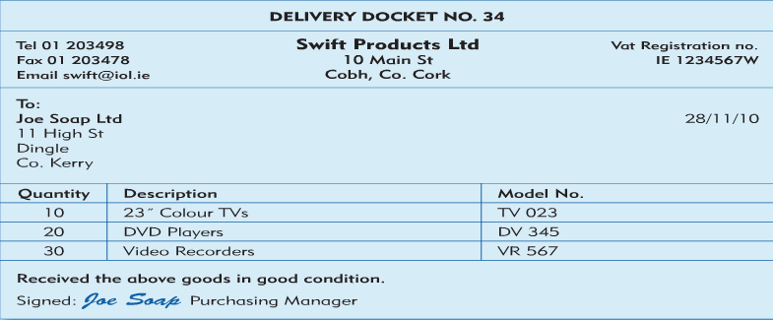
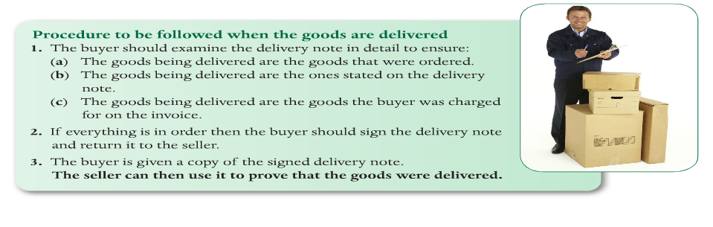Credit Notes- SELLER
A Credit Note reduces the amount the buyer owes the seller.
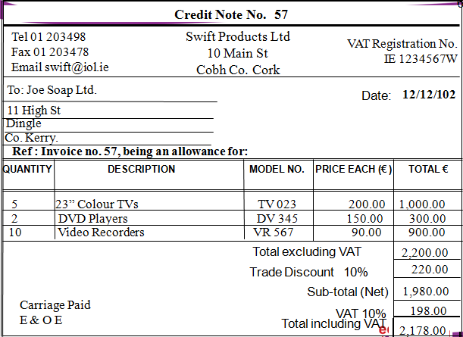
When does the seller issue a credit note?
- If goods are returned for any reason- e.g. Faulty or damaged
- Overcharging- Incorrect pricing/ calculation error
- If the buyer was invoiced for goods that were not delivered
What is the use of a credit note?
- Keep a permanent record of transactions
- To correctly enter and record their day books and ledgers
Debit Notes-SELLER
A Debit Note is issued by the seller if the customer was undercharged for any goods delivered to him/her- which means the buyer owes the seller.
It is issued when:
- The buyer was undercharged- €20 instead of €25
- If the buyer received goods but was not charged for them on the invoice
Statement-SELLER
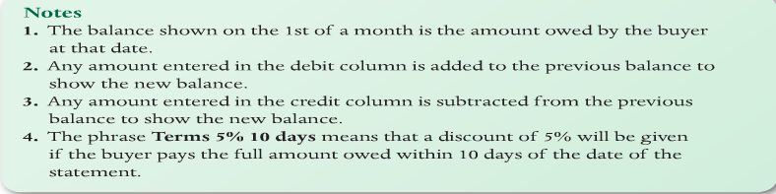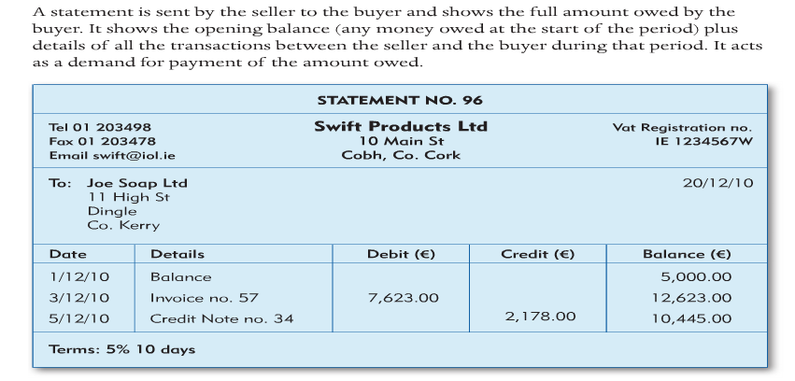
Remittance Advice Slip-BUYER
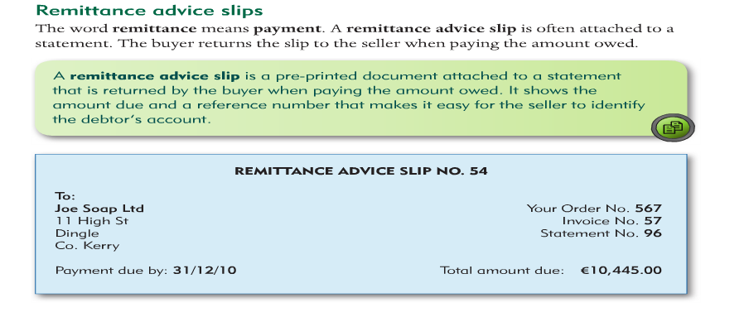
Receipt-SELLER
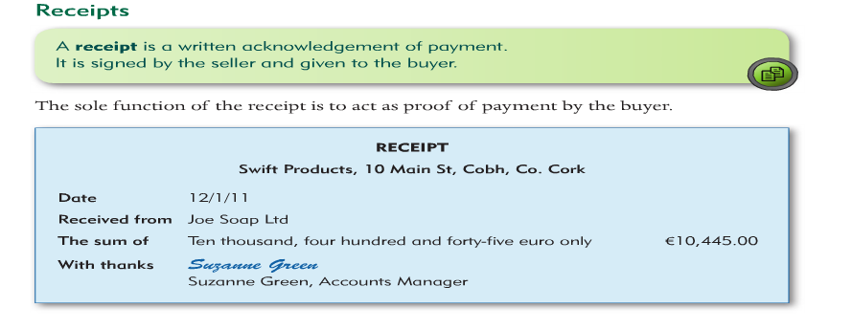
Sales and Selling Price
This involves revisiting Mark Ups and Margins
Mark Up= Profit/ Cost Price x 100 (Profit as % of Cost)
Margin= Profit/Selling Price x 100 (Profit as % of Selling Price)
Questions
- Cost Price = €200, Selling Price = €40, Profit = €40
- Cost Price = €50, Selling Price =€25, Profit = €10
- Cost Price = €600, Selling Price = €500, Profit = €100

