Business Transactions and Business Documents
Purchases and Sales
Effective Purchasing
Purchasing the right good at the right quantity for the right price at the right time will ensure a business purchases effectively.
Purchasing and Selling Process using Business Documents
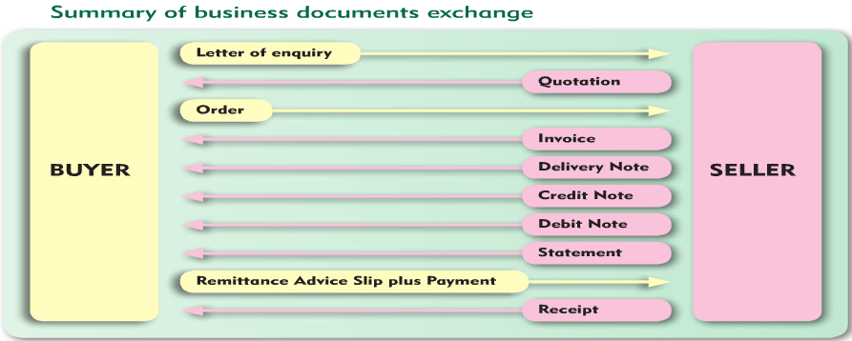
Letter of Enquiry- BUYER
Find a suitable supplier and make an Enquiry. An enquiry is a request from a buyer to a seller for the price and terms of sale of certain goods. When the enquiry is received, the seller checks the current price of goods, checks if they are in stock, and if so prepares a quotation.
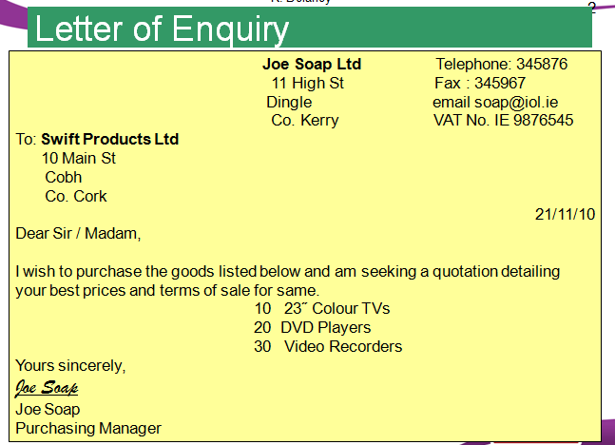
Quote- SELLER
If happy, then get a Quote and use this information to make a decision about purchasing goods. A quote is a document sent by the seller to the buyer that shows the price of goods and terms of sale. When purchasing, a business should always shop around for the best quote.
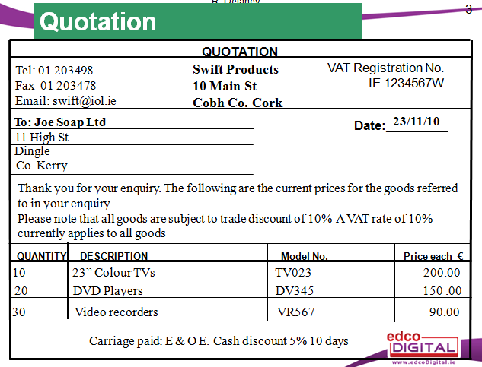
When Processing Quotations, it is important to:
- Check all details, including name, address etc..are correct
- File the quotation properly
Orders- BUYER
An Order is a standard document from buyer to seller to order goods.
You may order and pay now or order on credit. When you order a good on credit, it means you buy now and pay later. A business may do this:
- To increase sales as it allows you to sell more goods to customers now and pay for them after you have sold them.
- Be competitive, it may allow you to attract more customers as you can sell more goods than the competition and meet your customer demand
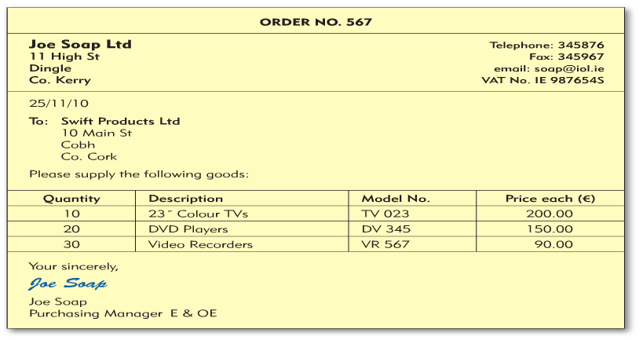
Credit Worthiness:
As a business, if a someone wants to order from you you should check their credit rating. You can do this by:
- Asking them to get a trade reference
- Asking them to get a bank reference
Invoice- SELLER
An Invoice accompanies a Delivery Docket and it is a bill sent by the seller giving details of how much the buyer owes and the other terms relating to the transaction.
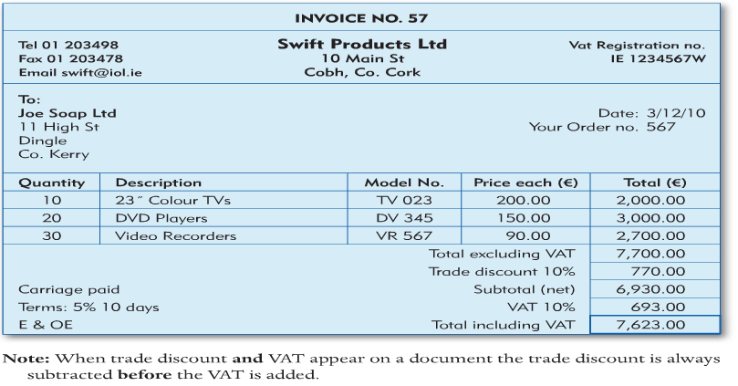
When processing invoices:
- Check the name and address of the receiver are correct
- File a copy of the invoice
- Record it correctly in your sales records
Delivery Docket- SELLER
The Delivery Docket accompanies an Invoice and it shows the quantity and description of the goods. The buyer is asked to sign for delivery.
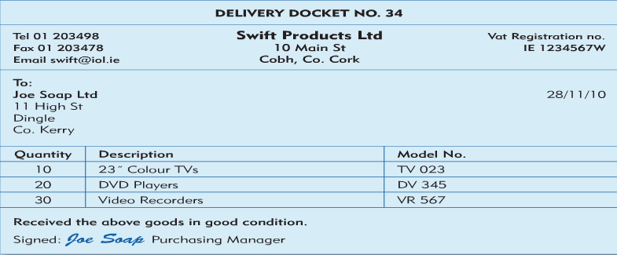
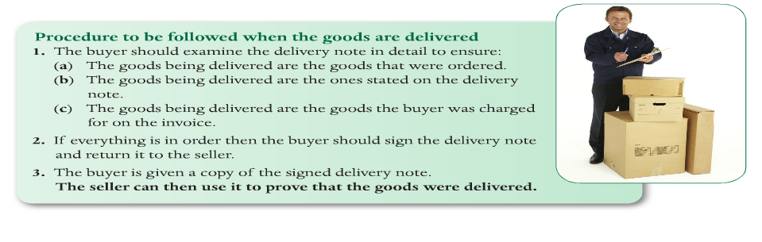Credit Notes- SELLER
A Credit Note reduces the amount the buyer owes the seller.
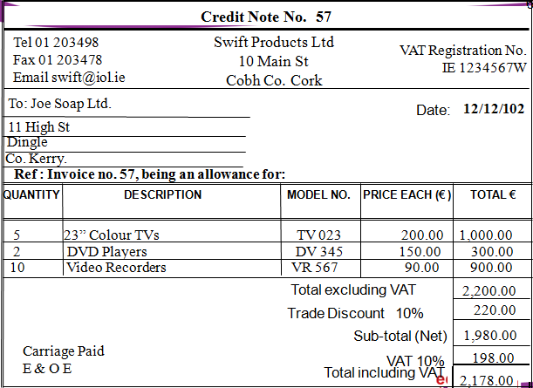
When does the seller issue a credit note?
- If goods are returned for any reason- e.g. Faulty or damaged
- Overcharging- Incorrect pricing/ calculation error
- If the buyer was invoiced for goods that were not delivered
What is the use of a credit note?
- Keep a permanent record of transactions
- To correctly enter and record their day books and ledgers
Debit Notes-SELLER
A Debit Note is issued by the seller if the customer was undercharged for any goods delivered to him/her- which means the buyer owes the seller.
It is issued when:
- The buyer was undercharged- €20 instead of €25
- If the buyer received goods but was not charged for them on the invoice
Statement-SELLER
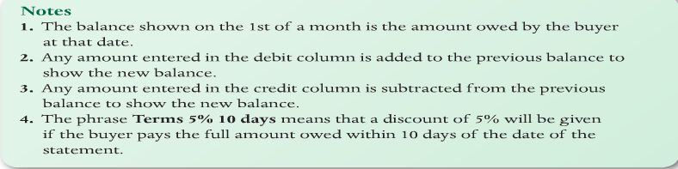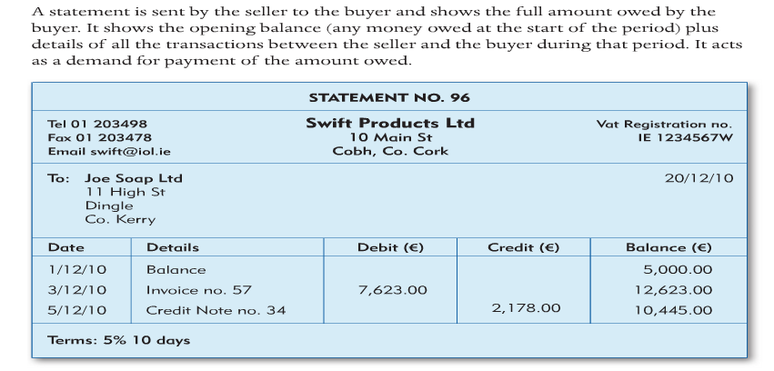
Remittance Advice Slip-BUYER
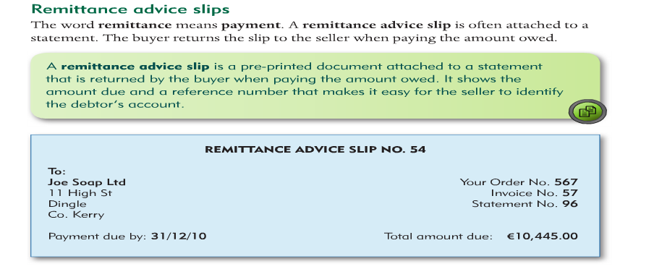
Receipt-SELLER
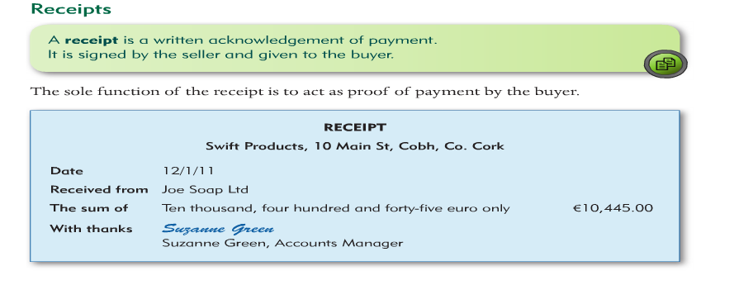
Sales and Selling Price
This involves revisiting Mark Ups and Margins
Mark Up= Profit/ Cost Price x 100 (Profit as % of Cost)
Margin= Profit/Selling Price x 100 (Profit as % of Selling Price)
Questions
- Cost Price = €200, Selling Price = €40, Profit = €40
- Cost Price = €50, Selling Price =€25, Profit = €10
- Cost Price = €600, Selling Price = €500, Profit = €100

