- Cash Flow Management For The Household and Business
Cash Flow Forecasts for Households and businesses
Households generally budgets to predict future incomes and future expenditures in order to have enough cash to cover costs. This budget includes the money the household expects to make (income) and payments (expenditure). There are three types of expenditure- Fixed, Irregular, Discretionary.
Businesses use cash flow forecasts to predict how much money a business will have in the future. It does this by subtracting expected future payments from expected future income. Money coming in is called receipts, and money going out is called payments. This cash flow forecast is an invaluable part of Financial Control- link back to Management Activities.
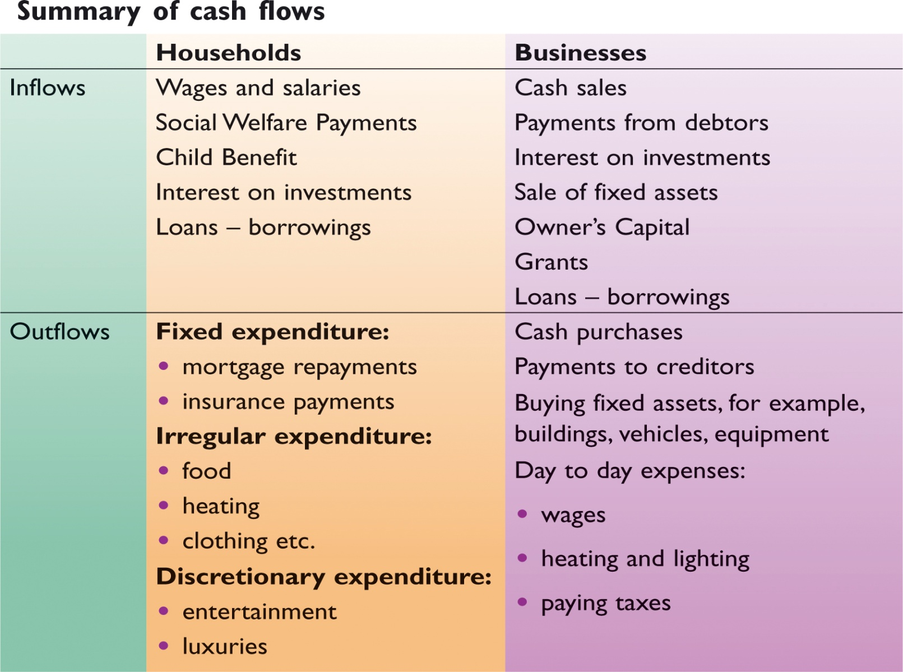
Why does a household/business need cash flow management?
- A cash flow forecast acts as a financial control mechanism that can be used to measure actual cash flow against planned cash flow encouraging a company to plan its finances sensibly and live within its means and not to overtrade (e.g. buy/sell too much on credit)

- It helps avoid cash flow problems as costs are considered in advance, so they can ensure it has sufficient funds when the time comes

- It lets us know in advance when there will be a deficit. This will give time to source short term finance such as a bank overdraft to deal with the deficit. For a business it will ensure that the company pays its bills on time and will not go bankrupt.

- It lets us know in advance when there will be a surplus.
A business could then make plans to invest the money and gives the business an opportunity to earn interest on this surplus as a form of capital.

- Identifies times when high expenditure may be needed (Christmas for the household/ excess supplies for a business) and therefore the opportunity to plan and set aside cash for such occasions. For the household a budget also shows the family exactly where money is going and highlights particular areas of overspending that can be cut back.

- It can set a target for where the cash flow situation should be in the future. The household/business can look at the cash flow forecast eventually and measure the forecast against actual performance.

- The cash flow forecast can be used as a tool in applying for a loan. This will show the bank that the books are appropriately in order.

Note: If you get asked a question asking you to give your advice as to how to make improvements on a firm’s cash position, look for:
- Avail of a short-term source of finance: Company X could arrange a bank overdraft facility with its bank to finance problem months where the business is running a deficit. The overdraft facility provides extra flexibility for Company X when it needs it most.
However, care should be taken because the rate of interest charged on a bank overdraft is high. Other short term sources could be considered such as trade credit (delaying payment to creditors/ seeking an extension period of credit from creditors).
- Adjust receipts: Its receipts could be increased by changing its marketing mix, e.g. lowering price to sell more, increasing the price depending on elasticities, designing new products or more effective promotion campaigns/reducing period of credit given to debtors/cash sales only.
- Adjust payments: The business could decrease its cash payments by sourcing cheaper suppliers, restructuring loan repayments or asking employees to take a wage decrease etc…
- Look to sell of an asset to raise capital. Company X could look to sell an asset such as a machine that is now obsolete to get an instant cash injection into the business

Sample Question: Cash Flow Forecast for Time Space Ltd for the following 3 months
 | October | November | December | Total
Total Receipts | 7000 | 7000 | 9000 | 23000
Total Payments | 6500 | 8000 | 12000 | 26500
Net Cash
Opening Cash | 100
Closing Cash
Questions to answer:
- Complete the cash flow forecast using the above figures.
- In which months has the business got a problem? Use your figures to explain your answer.
- Outline the reasons why a cash flow forecast would be prepared.
- What can we learn from this cash flow forecast and what actions can be put in place?

2. Business Finance
Sources of Finance
3 types:
- Short Term (0-1 years)
- Medium Term (1-5 years)
- Long Term (5 + years)
Short Term Finance | Medium Term Finance | Long Term Finance
Bank Overdraft | Medium Term Loan | Mortgage
Credit Card | Hire Purchase | Savings
Accrued Expenses | Leasing | Retained Earnings
Factoring |  | Equity Capital
Trade Credit |  | Grants
 |  | Debentures
 |  | Sale and Leaseback
 |  | Venture Capital

Short-Term Sources of Finance
Short Term Source of Finance | Business | Use | Household | Use | Collateral | Control | Cost
Bank Overdraft | YES | Wages/Salaries, Suppliers | YES | Holiday | NO | NO | YES
Credit Card | YES | Insurance | YES | New tv | NO | NO | Free if paid in full
Accrued Expenses | YES | Electricity | YES | Electricity | NO | NO | NO
*Factoring | YES | Bills- e.g. rent | *NO | xxx | NO | NO | YES
*Trade Credit | YES | Buying stock | *NO | xxx | NO | NO | Free if paid in full

1. Bank Overdraft (Business and Household)
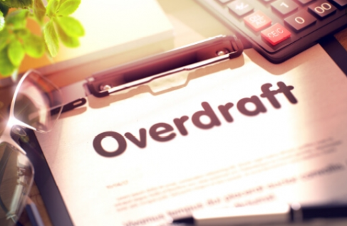
- This is a short-term loan given to a current account holder for a period of less than one year. The current account holder gets permission from the bank to withdraw more money from their account than they have in it (up to a certain limit).
- Interest is charged on the amount outstanding every quarter (i.e. every three months) and this interest is calculated on a daily basis.

Why do households need overdrafts?
Many bills might be incurred at once (in September with kids going back to school or at Christmas time with presents, decorations, light and heat, etc.). Income received in later months allows households to pay off the overdraft.
Why do businesses need overdrafts?
It may allow businesses to pay suppliers if their own customers delay payment to them. Their own customers pay them later and the income received from these customers can be used to pay off the overdraft
Advantages | Disadvantages
Interest is paid only on the amount you use, and not the agreed limit | The interest rates can be high
No collateral required | There can be financial penalties for failure to pay back
Fast application and approval process | Possible damage to credit rating

2. Credit Cards (Business and Household)
- A customer will pay for goods and services using credit cards at the point of sale
- The credit card company pays the supplier, and the customer will pay the credit card company at the end of the agreed period with interest charged if the full balance is not paid
Advantages | Disadvantages
No interest charged if the balance is paid off in full in the agreed period | High interest rates can be charged on outstanding balance
Credit cards are secure methods of making payments, particularly online | Overspending and damage to credit rating
Widely recognised and accepted worldwide | There is an annual government tax of 30e per card payable on April 1st each year

3. Accrued Expenses (Household and Business)
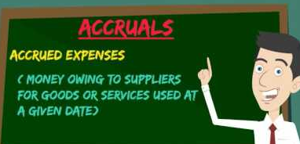
- Accruals are services which we have the use of now but which we pay for later, eg. telephone, electricity, or gas bills. It is essentially the delaying of the payment of bills to free up money to spend on other items.

- No extra costs are attached to these expenses however you would need to be careful not to overdo this as the supplier may cut off the services until you pay.

Advantages | Disadvantages
Free source of finance | Services can be cut off if bills unpaid
No collateral required | Loss of reputation to service providers if not paid on time
Improves cash flow as cash can be used elsewhere | Discounts can be lost for paying on time

4. Factoring (Business Only)
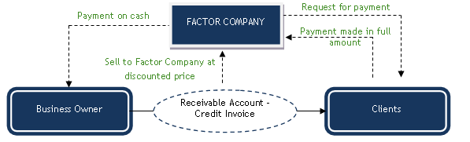

- A Debtor is someone who we sell goods or services to now, but who we receive payment from later.
- Debtors pay us at different times, some in two weeks, some in a month, some in two months; this makes it difficult to plan expenditure.
- Firms can thus sell their debtors to a factoring firm and factors charge for the service
- E.g. If a company is owed €100,000 by debtors, but needs cash now, they can sell the debt to the factoring company. They may pay say €90,000 to the business now for instant cash and then collect the full debt of €100,000 when it is paid
- Factoring without recourse will mean the original company will not have to pay the amount owed back to the factoring company if the debtor fails to pay, but factoring with recourse means that they will

Advantages | Disadvantages
No collateral required | High fees charged
Finance received immediately | If the debts are factored with recourse- there is still a chance of high debts
No loss of control | Reputation damage, supplier may not like dealing with factoring company

5. Trade Credit (Business Only)
(Creditors-BUY NOW PAY LATER)
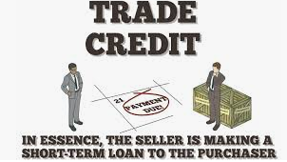
- Purchasing goods now and paying for them later is called buying on credit
- Selling goods now and receiving payment for them later is called selling on credit
- Trade Credit gives a company time to manufacture, sell and get paid for their products before they have to pay their creditors
Example

SMYTHS BUY NOW FROM EA SPORTS PAY LATER WHEN STOCK IS SOLD

Advantages | Disadvantages
Free finance- no interest charged if paid on time | Cash discounts may be lost for paying on time
No collateral required | May damage credit rating if not paid in full
The business gets immediate use of the goods | Not offered by all suppliers
Sample Question
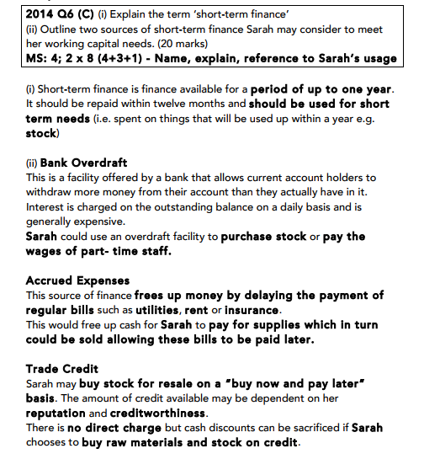
Medium Term Sources of Finance
Medium Term Source of Finance | Business | Use | Household | Use | Collateral | Control | Cost
Medium Term Loan | YES | Delivery Van | YES | Car | Dependent on amount borrowed | NO | YES
Hire Purchase | YES | Machine | YES | New bathroom | NO | NO | YES
Leasing | YES | Company Car/ Premises | YES | Apartment | NO | NO | YES

1. Medium Term Loan (Business and Household)
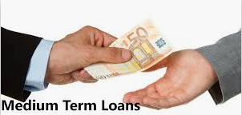
- Here, a borrower takes out a loan from a financial institution and repays it with interest over an agreed period of time
- The interest repayments can be fixed or variable and it is important for the household or business to shop around for the best rate
- Loans given to households are called personal loans
- Loans given to businesses are called medium term loans
- The higher the risk category of the borrower, the higher the interest rate charged, the bank will check the banking record of the customer to ensure they are reliable.
Lenders rate the credit worthiness of their customers on CAPS which is obtained from the loan application form.

Character | What is their past record?
Ability to repay | Do they/will they have the finances to pay off the loan? What is their credit rating?
Purpose | What is the purpose of the loan and what will the money be used for?
Security | What collateral do they have/what can they use as

Advantages | Disadvantages
Lower interest rates compared to Hire Purchase | Interest charged- additional expense
No collateral required unless for huge amount | Failure to meet repayments on any assets requiring collateral means repossession and damage to credit rating
No loss of control | Interest rates can fluctuate meaning they can increase

2. Hire Purchase (Business and Household)
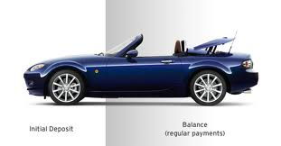
- This is a form of credit which allows customers to have immediate use of goods while paying for them over an agreed period of time in instalments. The customer pays an initial deposit and then instalments. The customer only owns the asset when the last instalment has been paid
- It is used to buy assets such as motor vehicles, equipment, etc…
- It carries a high rate of interest and is thus an expensive form of finance
- There are strict conditions attached to Hire Purchase which are set down in a written contract for the customer
Advantages | Disadvantages
Immediate use of good | The buyer will only ever own the asset when the last payment has been paid
No collateral required | There are high rates of interest to be paid
The firms capacity to expand increases | Risk of repossession if not paid

3. Leasing (Business and Household)
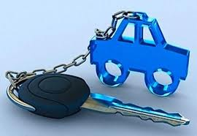
- Leasing is like renting. The asset acquired is at all times owned by the lessor who rents it to the lessee over an agreed period of time in return for regular payments. Ownership thus never passes to the person renting it (the lessee). Leasing is cheaper than hire purchase as no change of ownership is involved
- A lease agreement involves the payment of a deposit and a number of fixed deposits being paid (the number of which is agreed in advance. At the end of the agreement the asset is returned to the seller
Advantages | Disadvantages
Immediate use | Will never own the asset
Cheaper than Hire Purchase | Can be more expensive in the long run
No collateral needed | Risk of repossession

Long Term Sources of Finance
Long Term Source of Finance | Business | Use | Household | Use | Collateral | Control | Cost
Mortgage | NO | xxx | YES | Buying a home | YES | NO | YES
Savings | NO | xxx | YES | Buying an asset | NO | NO | NO
Retained Earnings | YES | Pay off loans | NO | Electricity | NO | NO | NO
Equity Capital | YES | Expansion | NO | xxx | NO | YES | NO
Grants | YES | Set up a new business | NO | xxx | NO | NO | NO
Debenture | YES | Buy new premises | NO | xxx | YES | NO | YES
Sale and Leaseback | YES | Buying an asset | NO | xxx | NO | NO | YES
Venture Capital | YES | Expansion | NO | xxx | NO | YES | NO

1. Mortgage (Household)
- A Mortgage is a loan to buy a house or property that can be repaid over a period of 20 – 35 years. The borrower repays the loan and interest by the end of this time. This type of finance doesn’t relate to the businesses
- The mortgage is secured on the house or property (a farm). If the borrower fails to repay the loan, the title deeds of the house or property are given to the lender. The House/property can be sold and the proceeds used by the lender to pay off the loan.
- A Type of life assurance policy (called a mortgage protection policy) is taken out on the value of the mortgage so that if the borrower should die, the insurance company will repay the loan to the bank or building society
Advantages | Disadvantages
Large amount can be borrowed | Risk of repossession
Repayments can be spread over a long period | The overall cost can be very high over the period of the loan
Low rate of interest compared to other finance options | Collateral may be required

2. Savings (Household)
- Savings is money the household has not spent but saved for the future. A household will usually put their savings in a financial institution to earn interest, with the savings used to purchase assets like an extension to the house
Advantages | Disadvantages
No collateral required | DIRT must be paid on interest earned
No interest payments | Time consuming to build up and may not have enough to buy asset immediately
No application process | Opportunity cost of spending the money elsewhere

3. Retained Earnings (Business)
•These can be known as reserves and mean that profits are ploughed back into the business to assist its growth
•When a business makes profit, these profits don’t have to be paid to the directors or paid to the shareholders; they can be put on deposit or invested. These profits build up over a period of time, and are effectively the same as savings for a household.
Advantages | Disadvantages
Large amount can be available if the business is profitable | Reduces dividends- may not please investors
No cost in using own money | Can take a long time to build up
No collateral required | Opportunity cost of spending the money elsewhere

4. Equity Capital (Business Only)
- Equity is funds that have been invested in the business by shareholders with the hope of a future dividend
- Business owners sell shares to investors to raise more capital, and the investors have a say in the running of the business
Advantages | Disadvantages
No collateral required | Loss of control
No interest payments as no money borrowed | Disputes with shareholders
Large amounts of finance can be available | Shareholders may sell shares if they do not receive sufficient dividends

5. Grants (Business Only)
•Government grants are non-repayable amounts of money given to enterprises by state agencies which aid certain activities such as purchasing factories and machinery or train workers that help develop the business
• With increasing Government cutbacks, conditions are imposed when issuing grants. These can come in the form of performance targets. E.g. a certain amount of money can be given to a company provided a specified number of people are employed. Failure to meet these targets can result in the demands for the grant to be repaid.
Advantages | Disadvantages
Large sums can be made available to support business | Slow application process
No interest repayments | Partial funding may only be available
No collateral | May have to be repaid if strict conditions are not met

6. Debentures (Business Only)
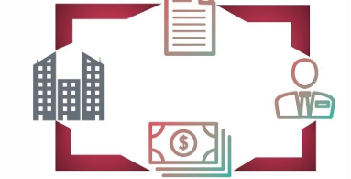
- This is long term finance similar to a loan. A firm will use their assets to borrow a large sum and pay interest only on that sum for a period of time. At the end of that time, they then pay the full amount back in one lump sum
Advantages | Disadvantages
Fixed interest rates means the business knows how much they must repay | Interest must be paid-added cost
Large amount of cash instantly available | Risk of business failure if cannot repay
No loss of control | Collateral- Deeds of Property

7. Sale and Leaseback (Business Only)
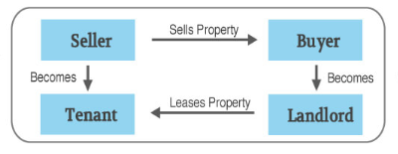
- This is when a business sells an asset and then leases it back from the buyer
- This will allow the business to still use the asset while at the same time getting extra finance
Advantages | Disadvantages
Large amount of capital raised quickly | Value of firms assets reduced
Can continue operating as normal | Rent must be paid- additional expense
No loss of control | It may take time to find a buyer for the asset

8. Venture Capital (Business Only)
- This is provided as start-up (seed) capital for new business enterprises and as development capital for existing businesses in which there is a higher than average degree of risk. The risk will be high but the possible returns on profit will also be high
- The venture capital company will usually want to place members of its own staff on the board of directors to oversee the new firm’s progress. This is known as a partnership approach and raises the image of the business with customers, suppliers and banks
- Once the business becomes successful, the venture capital company sells its shares for a profit
Advantages | Disadvantages
Expertise and knowledge brought into business | Control is lost
No interest payments | Profits must be shared
Large amounts of finance available | All funds provided by the venture capital firm not always put in immediately

Comparing the cost of different sources of finance
•Borrowers should shop around to try and obtain the cheapest sources of finance. The cost of borrowing is an important factor to be considered when one is borrowing.
•APR (Annual Percentage Rate) is calculated by an agreed formula, and must, by law be shown on advertisements for loans. It reflects the true cost of borrowing. Since all lenders must follow the same rules to calculate it, the APR allows direct comparison of the cost of borrowing for different lenders.
How Should the Source of Finance be selected? (Popular Exam Question)
Firstly, a business needs to match the source of finance with its use- e.g. short term source with short term use. It then needs to examine the following criteria:
  - Amount - €100 or €100,000
  - Purpose - Paying an E.S.B. Bill or buying land
  - Cost - One should try to obtain the cheapest source of finance eg.: the lowest A.P.R.
  - Collateral - What collateral is needed to acquire that asset?
e.g.: could my home be re-possessed
  - Timing of Repayments - Spread repayments over time and try avoid large swings between positive and negative cash flows.
  - Conveniance – Can the source of finance be easily arranged? Or will there be difficulty in obtaining the loan.
  - Control -Will the source of finance affect the control of the business, e.g. issuing new shares might mean more votes at AGM.

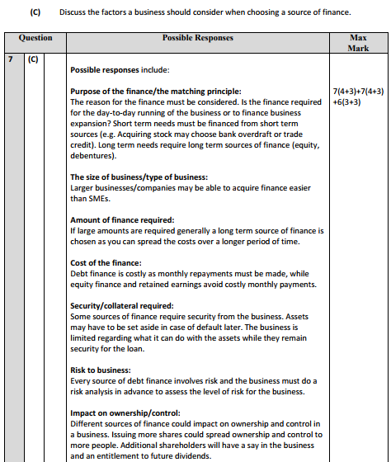

Banks Criteria for Loan Applications
Purpose of the loan | If it is productive and low risk, the bank will look more favourably on the loan.
Ability to repay | Examine the income- p60 for house/profits for business.
Security for the loan | Look at collateral- e.g. title deeds of property, share certificates in company.
Banking record | A good banking history will be looked upon favourably.
Credit rating | The bank may check a borrower’s credit rating with a reputable agency that specialises in this area. If the rating is good, the bank will advance the loan.
Business plan | Case of a business- growth potential will be looked upon favourably.
Own investment | A bank which is asked to loan money will be more assured if the person is investing a significant amount themselves.

Current Accounts
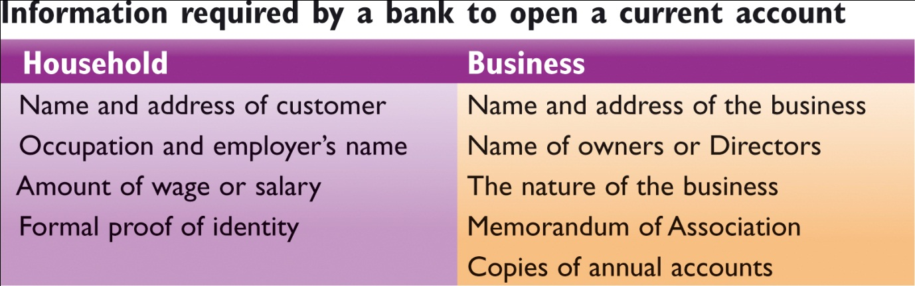
Features of Current Accounts
Cheque Books | Writing cheques ordering the bank to make payments out of the account.
Laser Cards | Instant payments for goods and services directly out of the bank using a chip and pin card.
Standing Orders | Automatic payment of fixed amounts at fixed times directly from one account to another. E.g. rent.
Direct Debits | Automatic payment of varying amounts at fixed times. E.g. telephone bills.
Credit Transfer (bank giro) | Allows one off payments directly into a current account.
Paypath –used by eBay. | Allows businesses to pay wages from their account to employee accounts.
Automated Teller Machine | Allows user to insert card and withdraw money, check account balance, lodge money, change pin, top up their mobiles, order a cheque book and pay bills. Access 24 hours a day.
Overdrafts | Take more money out than is in the account at a given time.
Interest and Charges | Take these extra charges out of the accounts at fixed periods for interest due and also the costs of opening the account.

