Cash Flow Forecasts and Business Finance: Rapid Revision
Ainm:
Q.1 (i) Fill in the missing figures for the Cash Flow Forecast below and show your workings.
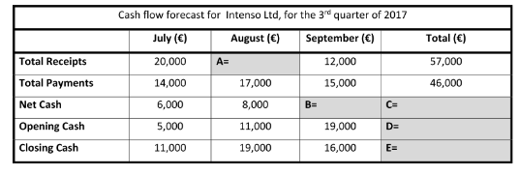
Workings

(ii) Give two reasons why Intenso would prepare a cash flow forecast.
2.

- (i) Fill in the missing figures for the Cash Flow Forecast below and show your workings.
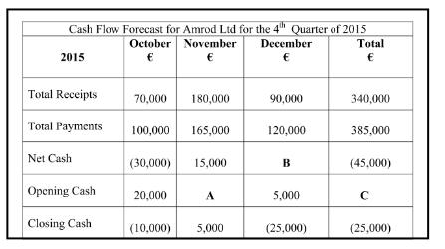
Workings
(ii) Give two pieces of advice based on the above Cash Flow Forecast.
2.

- List four factors that need to be considered before choosing a source of finance.

- Match the following sources of finance to their correct definitions.
- Trade Credit | - This is a medium-term source of finance, it is paying for an asset in installments and you only own it after the last installment has been paid.
- Accrued Expenses | - This is short term finance, it is permission from the bank to go over your limit, you must be aware of interest, it can be used to pay staff wages.
- Bank Overdraft | - This is a long-term source of finance, it impacts on ownership and is raising finance through investment, can be used for expansion,
- Leasing | - This is a short-term source of finance, it is the delaying of payments until the last moment, it is used for bills/utilities.
- Medium Term Loan | - This is a long-term finance option, it must be repaid with interest, no effect on ownership but collateral may be needed, can be used for expansion.
- Hire Purchase | - This is a non-repayable long term source of finance, given by bodies such as Enterprise Ireland to help a business export into new markets.
- Debt Capital | - This is a long-term loan to buy a house.
- Equity Capital | - This is a short-term finance used for stock, it is buy now, pay later.
- Mortgage | - This is a medium-term source of finance, it is paying for an asset over a 1–5-year period, you get this from the bank, can be used to purchase a new printer, car etc…
- Grant | - This is a medium-term source of finance, it is like renting, you never get to own the asset, can lease cars etc…

