In groups of four you must conduct research on a new chocolate bar that you are planning to bring to the market, or modify an existing chocolate bar in the Irish Market.

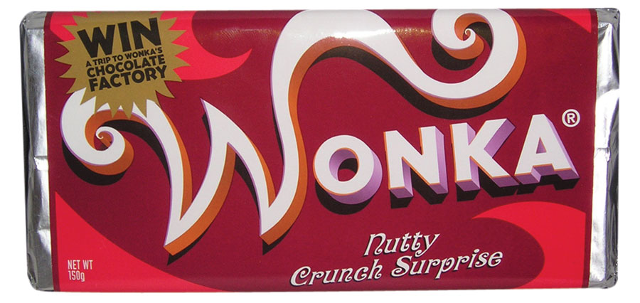

Steps to follow

- You must do desk research only on an individual basis. Try and find out: (10 Mins)
- The size of the Irish market for chocolate bars
- Examples of competition
- The Chain of Production and Channels of Distribution for chocolate bars
- The most popular types of chocolate bars
- The target market for chocolate bars
- Any other relevant information

- Then you must bring your findings back to the group. Decide on what research you will use as a group (5 mins)

- Brainstorm now and use the research to help you decide on what type of chocolate bar you will produce (5 mins)

- Use an A3 size paper to put all your information down. Start with the name of the chocolate bar in the centre and use lines to show the information below in a clockwork direction.

- Compile a marketing plan; (25 mins)
  - This plan will contain sections on the
    - USP (Unique Selling Proposition) Why will a consumer buy our product? We are either the best, most fashionable, unique or the cheapest.
    - Target Market - Who am I selling to? Everyone or Young People or Males only or people in Carlow??
    - Product (What will it look like, what packaging, what is the name of the product?)
    - Price (How much will we sell it for?. Why sell at this price?)
    - Place (How will we get the product to the consumer? Direct sales from internet or use a wholesaler or supply direct to shop, again say why you chose each option)
    - Promotion (This means how will we communicate our message to the consumer? Could be through advertising, sponsorship, direct sales, sales promotion)

- Each group must now go through their plan in front of the class and each person should have a section they talk about. (10 mins)

