Conflicting Interests:
Industrial Relations

VS.
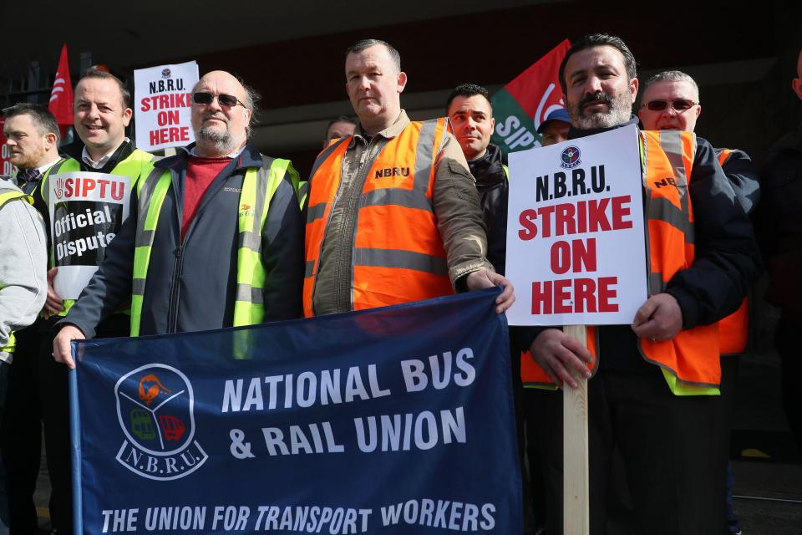
We will look at:
- What is Industrial Relations
- The importance of good Industrial Relations
- Why Industrial Relations are bad
- Types of Industrial Action
- Solving Industrial Disputes- Non Legislative and Legislative

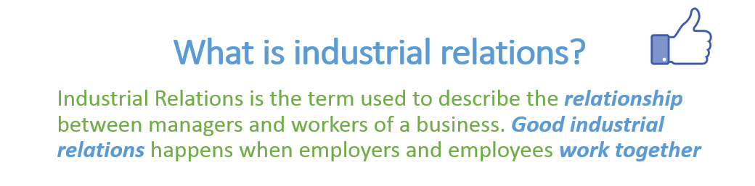
Maintaining good Industrial Relations can lead to the following:
1. Increased Morale and Productivity
Good industrial relations lead to happy workers. Happy workers with high morale are normally more productive than unhappy workers. Think of the jobs with great perks like working in Facebook
2. Less Absenteeism
When workers are happy in their job they are less likely to call in absent. A good employee/employer relationship is vital for this reason
3. Lower Staff Turnover
Staff turnover is the rate at which employees leave a business. Employing new workers is expensive because of high training costs. Good industrial relations result in decreased staff turnover. Think of when Máistir worked in his jobs when in college. There was always a high staff turnover and as a result people were not that motivated in their jobs
4. Customer Loyalty
When there is a good employee-employer relationship there is a smaller chance of constant industrial action. Customers don’t enjoy strikes and may take their business elsewhere
5. Encourages Investment
Shareholders are more likely to invest in a business that that has positive Industrial Relations and therefore it will be easier for a business to raise capital
When Industrial Relations go bad: Industrial Relations Disputes
The most common causes of Industrial Relations Disputes are:
- Pay and Working Conditions
- Discrimination
- Redundancy
- Promotion
- Demarcation

Pay and Working Conditions
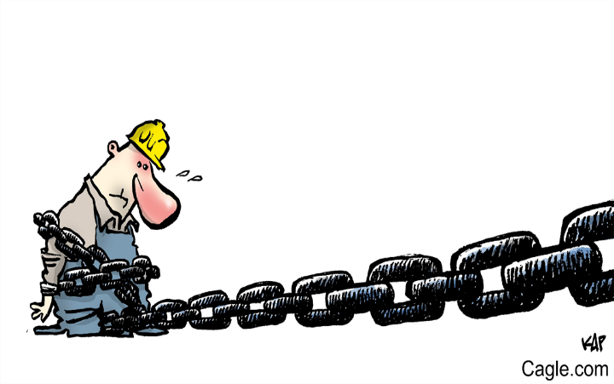
The Economic downturn will have seen many employees pay and working conditions change. In some cases this has been accepted but in others there have been noticeable disputes around this (Bus Eireann, Teachers etc..)
There are 4 reasons an employee may ask for a pay increase:
1. Productivity Increase
If an employee is asked to work harder by a manager they make look for compensation in the form of a pay increase. This is known as a productivity claim
2. Cost of Living Increase
Workers will often make a claim for a pay increase in an effort to keep up with general rising prices and inflation. This is known as a cost of living claim
3. Comparability Increase
This is where employees ask for a pay increase when they see workers from different business doing similar jobs but earning more
4. Relativity Increase
Sometimes people’s jobs are linked with each other. If one person receives a pay increase then the other person may also seek one

Discrimination
Examples of discrimination would be paying men more than women for doing the same job or not treating new staff fairly. Discrimination of workers is illegal under the Employment Equality Act 1998.

Redundancy
Redundancies happen when staff lose their jobs usually through cutbacks in a job. Trade Unions will try to ensure redundancies are voluntary. Sometimes staff can deem redundancies unfair and as such form a dispute against their employer,
Promotion
This is when somebody gets an upgraded position in the workplace, and can be a massive source of conflict in the workplace. Reasons can include seniority and experience lead to promotion but this may not always be the case. It can cause particular unrest in a job.

Demarcation
This is a dispute about who does what in a particular job. You should only do the work you are qualified to do and not be asked to do duties that you are not supposed to do. For example if your teacher was constantly being asked to man the office reception as well as teach classes they might have a dispute with management over this.

Types of Industrial Action
Illegal
- Official Strike
- Lightning/Wildcat Strike
Unofficial Strike
An unofficial strike is one where employees don’t hold a secret vote and/or don’t give their employer 7 days’ notice. The trade union doesn’t recognise unofficial strikes and will not pay workers strike pay
https://www.independent.ie/irish-news/threat-of-unofficial-strikes-across-all-ci-companies-35488688.html
Lightning/ Wildcat Strike
This is a sudden strike where no prior notice has been given. Employees literally walk out of the job. This sort of a strike is illegal in Ireland
https://www.thejournal.ie/wildcat-strike-could-happen-again-3316941-Mar2017/

Legal
- Official Strike
- All out Strike
- Work to rule
- Overtime ban
- Token Stoppage
Official Strike
An official strike is legal in Ireland. First employees must hold a secret vote. If 51% of people want to go on strike they give their employer 7 days ‘notice. The trade union instructs employees to cease working. They will pay workers strike pay.
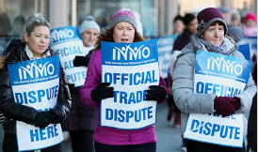
All-out Strike
This is where every single employee in the business goes on strike. For an all-out strike to be legal the workers must get the approval of the Irish Congress of Trade Unions
https://www.thejournal.ie/inmo-strike-4325520-Nov2018/
Work to rule
This is where workers do the least amount of work possible under the terms of their employment contracts. An overtime ban or go slow may be part of “working to rule”.
https://www.rte.ie/news/education/2018/0918/994521-lecturers-at-wit-and-it-carlow-set-to-take-action/
4. Token Stoppage
Workers temporarily stop work for a short period of time. This is an attempt to get the employer to listen to the workers and solve industrial disputes
https://www.irishtimes.com/news/ireland/irish-news/dublin-bus-staff-to-hold-three-48-hour-stoppages-in-september-1.2772899
Overtime Ban
This is when employees refuse to do any overtime for the employer.
https://www.irishtimes.com/news/health/psychiatric-nurses-begin-overtime-ban-over-pay-1.3777250

Solving Industrial Disputes
Non-Legislative v Legislative
Non-Legislative
1. Negotiation
This is where an employer/ manager and representatives of the employee (trade union) sit down with one another. They will discuss the reason for the dispute and attempt to come to a solution. Any deal that is agreed is known as a “collective agreement”. This collective agreement holds no legal power.

2. Conciliation
This is where a third party known as a conciliator attempts to bring the employee and employer to a mutual solution. The conciliator is independent of the employee and employer.
Steps involved in conciliation:
1. The conciliator listens to the employee/ employer discuss the industrial conflict
2. The conciliator will give their opinion on how best to resolve the conflict. This will come in the form of a formula of protocol to be followed
3. Both parties can accept/ reject the conciliators formula of protocol

3. Arbitration
This is where a third party known as an arbitrator investigates an industrial dispute. The arbitrator will make a judgement on the matter.
Steps involved in arbitration:
1. Firstly the employee and employer can agree beforehand as to whether the judgement will be legally binding. If they both agree it will be this is called “binding arbitration”
2. The arbitrator listens to both parties side of the story
3. The arbitrator gives a ruling on how best to resolve the conflict. This ruling is called a judgement

4. Trade Unions
When employees begin work they enter into a contract with their employers. Over time it may be necessary to change the terms and conditions of a contract and both sides negotiate the changes. It is most common in these circumstances for the employees to be represented by a Trade Union.
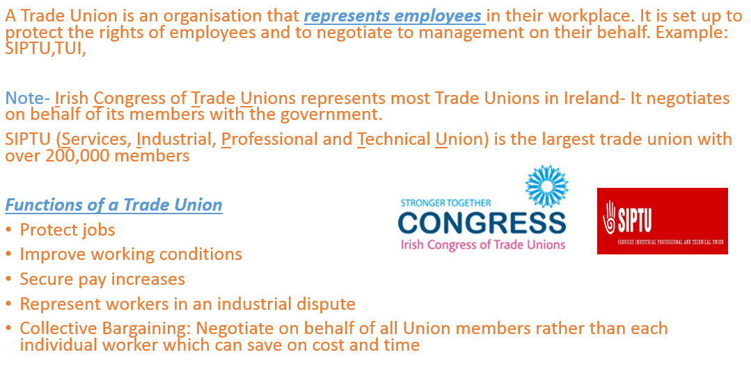
YouTube Link for more information about a Trade Union: http://youtu.be/4fe1ud7jlqk

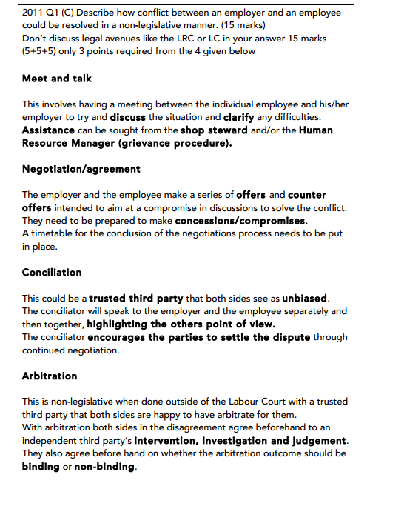
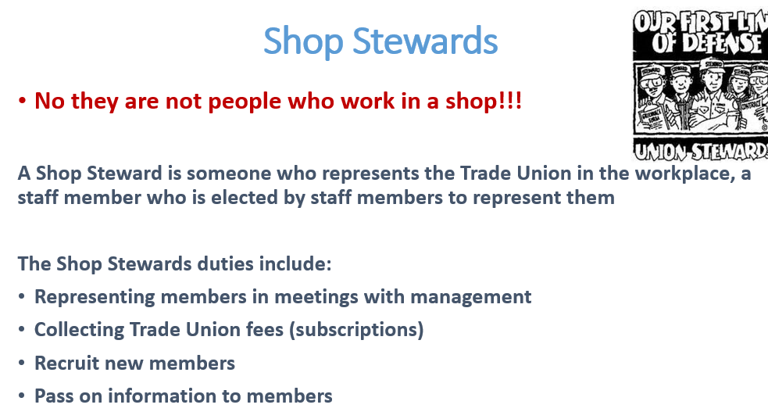

Legislative-Very Important!! Acts must be learned and Evaluated
This is where industrial conflicts are solved by using Irish law.
There is a number of acts that are used as legislative methods of solving conflicts:
1. Industrial Relations Act, 1990.*
2. The Workplace Relations Commission.
3. The Labour Court.
4. Employment Equality Act, 1998.
5. Unfair Dismissals Act, 1977 & 2007.

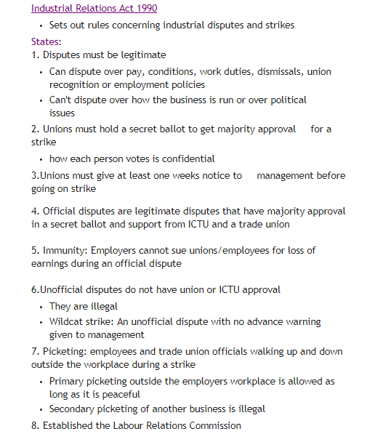
Evaluation of the Industrial Relations Act
Very effective because it makes employers not recognising at least one trade union a legitimate trade dispute

Workplace Relations Commission
The Industrial Relations Act 1990 gave legal status to The Workplace Relations Commission. The Workplace Relations Commission was set up to promote and improve industrial relations in a timely and effective way and reduce the number of industrial conflicts brought to the Labour Court.
Functions of the Workplace Relations Commission
- Information
The WRC provides information on employment law and industrial relations to employers and employees through its website
2. Advisory Service
The WRC works with businesses to build and maintain positive industrial relations in the workplace, often visiting businesses and provide workshops and training.
3. Conciliation service
The WRC employs an Industrial Relations Officer (I.R.O.) who provides a conciliation service. Their job is to try and solve any disputes between employers and employees and reach a mutually accepted agreement.
4. Mediation/Adjudication
The WRC offers a mediation service, and if successful it becomes legally binding. If it is unsuccessful, it is referred to an Adjudication Officer who will then hear both sides and give a recommendation. Decisions made by the AO can be appealed at the Labour Court.
5. Codes of Practice
The WRC consults with the ICTU and designs codes of practice. These codes of practice make it clear for employees/ employers what they should do in specific situations of industrial conflict
Evaluation of WRC
Despite the fact that the LRC’s agreements are often not legally binding they are still very effective because they have a Rights Commissioner who strives to resolve conflicts between employees and employers. The Rights
Commissioner achieves this through a private hearing where they hear both the employee and employers point of view. They give a recommendation as to how best solve any conflict.

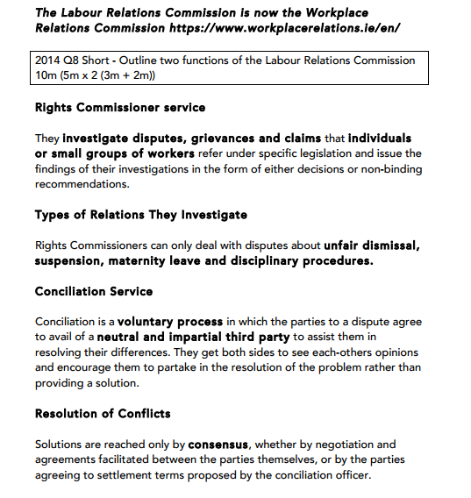

The Labour Court
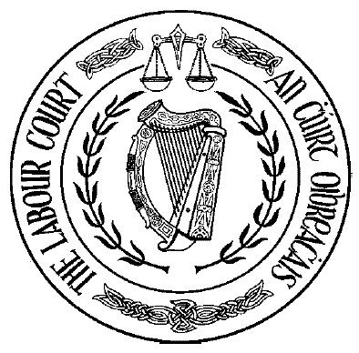
Why is it called the court of last resort?
Because disputes are referred to the labour court if:
1. The W.R.C. can’t resolve the dispute
2. A decision by the rights commissioner is appealed
3. A decision by the equality officer is appealed

Functions of the Labour Court
1. Investigate disputes
The Labour Court investigates disputes between employers and employees. It gives a non-legally binding recommendation to both parties. If neither side is happy with their recommendation they can appeal to the High Court.
2. Hear Appeals
If either party rejects the recommendation of the WRC, the case will be sent to the Labour Court. The Labour Court issues a binding judgement to the case.
3. Register Employment Regulation Orders
The Labour Court draws up an ERO to fix pay and working conditions for people in certain industries that become legally binding, e.g. window cleaners
4. Interpret Codes of Practice
The Labour Court interprets the Labour Relations Commissioner’s codes of practice. It will also investigate any breach of these codes of practice
5. Joint Labour Committees
Establishes Joint Labour Committees which produce employment regulation orders enforceable by law. They regulate industries where workers have no union, to discuss issues such as pay etc..
Evaluation of the Labour Court
Because the Labour Court is a court of last resort for solving industrial conflicts most employees and employers accept their recommendations. The Labour Court also has the respect of all parties in Industrial relations and the majority of their recommendations are accepted

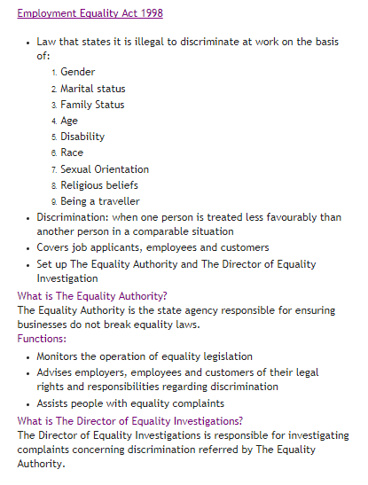
Will generally ask for 5 in a question if asked to give some of the ways employers can discriminate.
Evaluation of Employment Equality Act
This act does a good job of protecting employees because there is a government backed official who’s RULING MUST BE OBEYED.
Credit: Ronan Murdock

Exam Question Solution
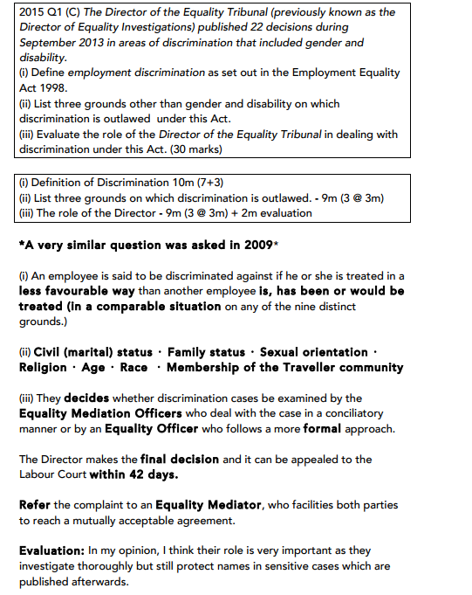

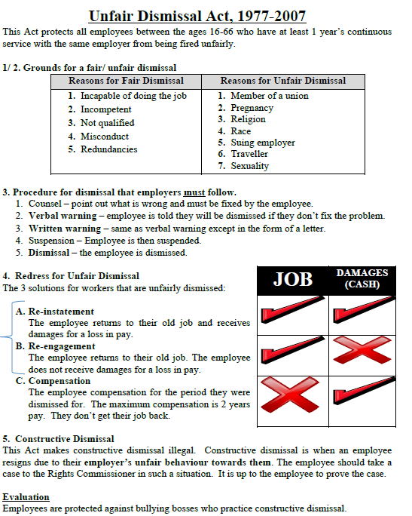

2016 Exam Question Solution
