Economic Systems
Types of Economic Systems: Revision
Economic Systems
As countries have developed over time, they devise different economic systems in organising their economic activities.
These economic systems include:
- What goods and services will the country produce?
- How will the goods and services be produced?
- Who is the benefit from the production of these goods and services?
Over time three systems have evolved:
- Free Market Economy 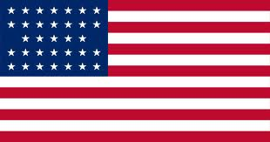
- All resources are owned by private sectors or by companies and used for their benefit only. The entrepreneurs are motivated by profit. The government plays a limited role in this type of economy. The free enterprise system allows any individual or group of people to start and operate a business with minimal government regulation or interference.
- Free enterprise systems are run on the basis of consumer sovereignty, which means that consumers are the ones that drive demand and the products and services that are sold. Businesses that cannot satisfy this demand will close down, and ones that can may expand
- A free enterprise economy is the most efficient and cost-effective way of doing business. There is less waste in the use of natural resources because everything is driven by consumer demand.
- The biggest drawback is that free markets create wealth gaps between what rich and poor people can afford, for example education
- Though free enterprise economies run on their own with little government intervention, the government will intervene if antitrust laws are violated or when natural resources are limited.
2. Centrally Planned Economies (communism) 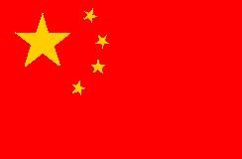
- All resources are publicly owned by the government on behalf of all citizens. The government controls all of the economy. There is no private sector
- The wealth and equality is divided among the people in which no man is richer and no man is poorer. No one is left behind
- Mixed Economies 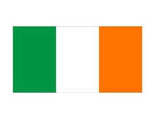
Mixed economies allow most of the major economic decisions to be made by the private sector, but the government intervenes to ensure the supply of essential goods to everybody. It is the most popular government system
- In a typical mixed economy, the government may run such things as the postal service, rail lines, libraries, and in some cases, the health care service. Even in industries which are not owned or run by the government, its influence is very noticeable in the form of taxes and regulations like wage controls. –Minimum wages.

Each of the above economic systems operate in an economy where people or businesses buy goods and services. Economies can be small, like Navan, or big, like Ireland, The EU etc..
Unfortunately, no economy will have enough resources to satisfy all needs and wants, and so must allocate resources effectively
How does an economy decide production?
What to produce? What is a country good at producing- what is Ireland good/bad at producing?
How to produce? What skills are needed, what people do we need? What factors of production do we require?
Who to produce it for? Who is the good for? Should everyone get an equal share?
In Ireland- decisions can be made using the Public and Private Sector.
From our classroom discussions, what examples can you think of?
How does an economy work?
Simple circular flow of income 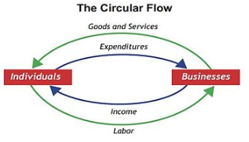
Money flows in a circle between businesses and households. Households work for wages, and that income us used to buy goods and services from that and other businesses.

Circular Flow of Income including the government
The government takes money out of the circular flow in an economy (leakage), as well as putting money into an economy (injection)
