Ireland: The Government and the Economy
We have previously learned that Ireland operates in a Mixed Economy. This means that although the private sector controls the production of most goods and services, the government also has some involvement in how the economy works.
Let’s revise what we know about mixed economies:
- Mixed economies allow most of the major economic decisions to be made by the private sector, but the government intervenes to ensure the supply of essential goods to everybody.
- In a typical mixed economy, the government may run such things as the postal service, rail lines, libraries, and in some cases, the health care service. Even in industries which are not owned or run by the government, its influence is very noticeable in the form of taxes and regulations like wage controls. –Minimum wages.

The reasons as to why the government is involved in the Irish economy:
- To provide MERIT GOODS and SOCIALLY DESIRABLE GOODS: Goods that are essential and should be obtained by everyone in an economy are Merit Goods Examples- shelter/education. 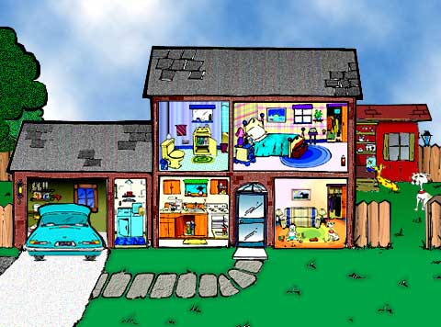
Goods that are not supplied by private businesses as it would be unprofitable to do so are Socially Desirable Goods. Examples would be parks and libraries.
- PROVIDE INCOME: There are those in the economy who cannot afford an income. There are social welfare benefits such as Jobseekers Benefit. Here, the government tax individuals and some of this income is then given to the less well off as payment.
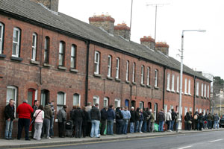 Dole Queue in Dublin.
- SERVICES that are too IMPORTANT to be provided by the private sector- Examples would be Guards and The Army.
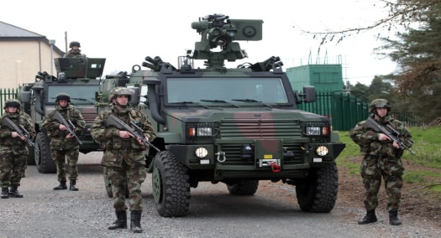

- Make REGULATIONS and PROMOTE FAIRNESS- Examples would be minimum wage, health and safety regulations. The tax system should also be a fair one, providing incentives in business and wealth distribution from budget
€9.80 MINIMUM WAGE!
- Provide FINANCE AND ADVICE: Government initiatives such as Enterprise Ireland were set up to give investment to new start ups.
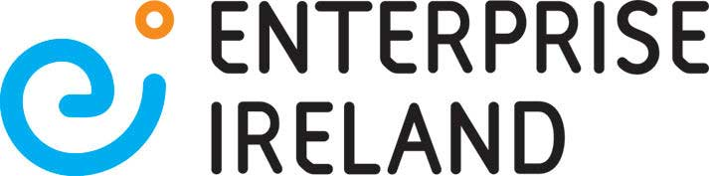
- Other Reasons-
PROMOTE ECONOMIC GROWTH to make an economy stronger
MONITOR INFLATION AND UNEMPLOYMENT- Keep as low as possible
Central and Local Government
The government is involved in economic decisions at national level through the Dail with the budget and at local level with county council expenditure. The government will want to control the economy in terms of income and expenditure.
At a central level the government is responsible for the national economy in areas such as national roads, electricity systems, An Post, schools, and hospitals. On a local level, the government is involved in the maintenance of local roads, public housing and libraries.
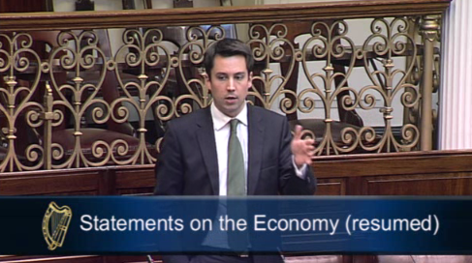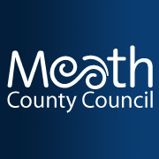
Many of the goods and services provided by the government are called public utilities because they are used to benefit the general public. Public utilities are part of the infrastructure of the country. The infrastructure is made up of the CAPITAL GOODS that do not directly produce goods and services but the necessary for efficient production to take place.
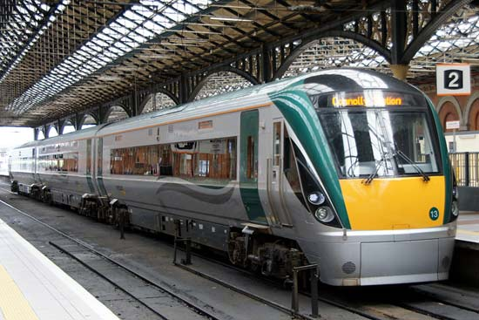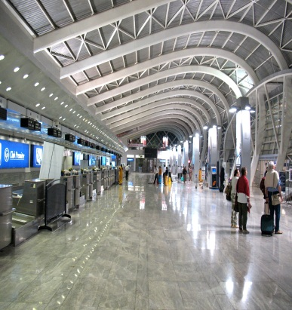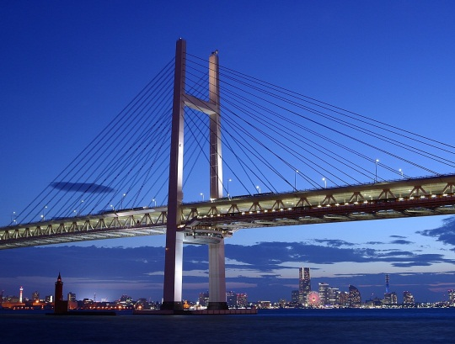

How does a government intervene in an economy?
Governments around the world use the following policies to run an economy. These policies are:
- Fiscal Policy
- Monetary Policy
- Regulatory Policy
- The Fiscal Policy
Fiscal policy is the collective term for the taxing and spending actions of governments. The government will prepare a budget for the coming year outlining its Fiscal Policy, with both Current and Capital Incomes, and Current and Capital Expenditures. In other words, it sets out what taxes and other incomes will be collected, and where the money will be spent.
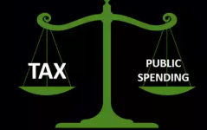
Sources of Current Government Income Examples
- PAYE
- VAT
- Income Tax
- Corporation Tax
- DIRT
- Excise Duties (Taxes on petrol, alcohol)
- National Lottery
Sources of Capital Government Income Examples
- EU Grants
- Budget Surplus from last year
- Sale of State Assets
- Dividends from state companies
- Borrowings

Sources of Current Government Expenditure Examples
- Social Welfare Payments
- Payments for the running of schools and other departments- e.g. light + heat
- Government salaries
- Day to day running of the health service
- Debt Servicing –payment of interest on the national debt

Sources of Capital Government Expenditure Examples
- Building new schools
- Building new hospital
- Buying long term assets for state departments- e.g. new computer for a school
http://www.thejournal.ie/government-money-website-3333906-Apr2017/
The Budget
The national budget details Ireland’s income and expenditure for the year. It is published in October each year by the Minister of Finance Pascal Donohoe. He will ask all other Ministers (e.g. Education, Sport) to submit their estimates (how much money their department will need) and then presents the actual budget.
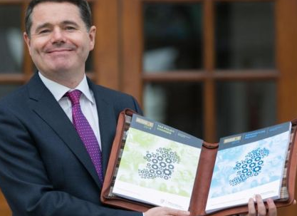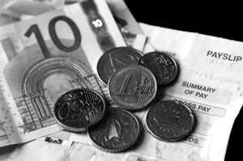
Some Key Terminology about the Budget
The Exchequer Balance: The difference between government revenue and expenditure.
The National Debt: This is the total amount of money owed by the central government at any given time.
The General Government Debt: This is the national debt plus the government debt at any given time.
Debt Servicing: This is the payment of interest off the national debt.
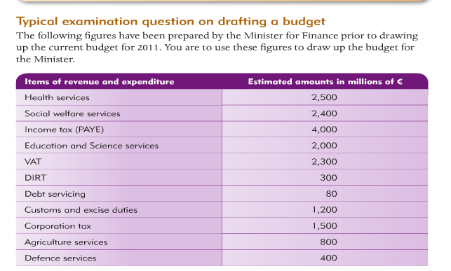
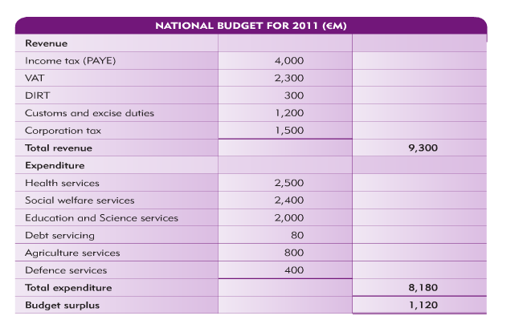
Budget Surplus | Budget Deficit
Reduce tax rates such as PAYE- people will have more money to spend | Increase taxes
Improve Infrastructure such as roads | Decrease spending
Increase spending on public services such as schools and hospitals | Borrow form ECB

Effects of taxes as part of Fiscal Policy
Taxes in Ireland can be described as Progressive or Regressive.
A progressive tax takes a higher rate from people earning higher incomes- for example, the PAYE rate in Ireland has different levels the more income you earn
A regressive tax takes a higher rate of tax from people on lower incomes. VAT will be an example, as VAT is the same for every consumer so it will be a higher amount of overall income for a lower income earner
The effects of taxes
- Financial- What happens when the government increase/reduce taxes?
- Social- Income from taxes helps fund schools and hospitals. Without these taxes such services may not be provided
- The Black Market- Illegal and Unethical
- Ethical- Higher taxes on cigarettes, plastic bag tax etc..

- The Monetary Policy
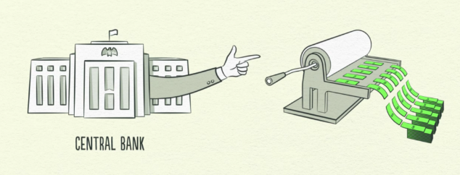
The Monetary Policy looks to control the supply of money in an economy through the setting of interest rates and the management of money supply (printing of money). The European Central Bank is responsible for the monetary policy of all EU member states, and so they control the interest rates and money supply for Ireland

- Regulatory Policy
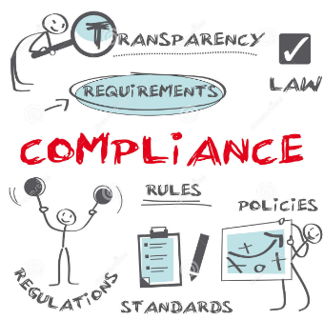
A Regulatory Policy means the rules a government puts in place to control a specific market or population. These laws may be introduced by the Irish Government or the European Union for Ireland to follow.
For example:
Regulation on banks and Financial Markets- Due to reckless lending in the past, new laws have been introduced, such as housing deposit requirements which we spoke about numerous times in class
Licence Laws: Taxi drivers, pubs etc.. must have a licence, you must pay your tv licence to make markets competitive
Labour markets: For example discrimination is illegal, minimum wages etc..

