Enterprise and the Entrepreneur
An Entrepreneur is someone who spots a gap in the market, takes both a personal and financial risk, and sets up a business. They can either make a profit or a loss, depending on how successful their enterprise is. Eg. Mark Zuckerberg
Enterprise is a person or group being innovative/creative/using their initiative, while taking on a risk (personal/financial risk) in order to achieve a goal or make a profit.
E.g. Business Enterprise: Mark Zuckerburg taking the risk of setting up Facebook in 2004
So essentially, enterprise is the opportunity, and an entrepreneur is the person who takes the risk in setting this opportunity up.
Famous Entrepreneurs
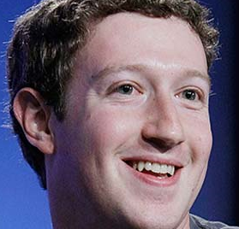
Steve Jobs-
Founder of Apple in 1976
Bill Gates-
Founder of Microsoft in 1975
Mark Zuckerberg
Founder of Facebook in 2004

Beyoncé Knowles Carter- Founder of shop.beyonce.com in 2012
Bobby Murphy/ Evan Spiegel- Founders of Snapchat in 2011

Oprah Winfrey- Founder of Harpo Productions in 1986
These above people are examples of an entrepreneurial talent for spotting a gap in the market and setting up an enterprise.
Types of Enterprises
There are three main types of Enterprise:
- Financial Enterprise
- Cultural Enterprise
- Social Enterprise

1. Commercial/Financial Enterprises
The most popular types of enterprises, these are goods and services set up to make a profit. Most are owned by entrepreneurs.
`
Financial Enterprises main purposes are to:
- Create employment
- Provide services to customers and businesses
- Generate taxes that can be used to run the country
- Generate economic growth

2. Social Enterprises
Not all enterprises that are set up are set up to make money. They were set up and sometimes have paid members but their goals are not to make profit, rather to help other people and society, such as the homeless or those in poverty. These are known as Social Enterprises.
They are not charities as they do not depend on donations, their income comes from selling goods and services, but any extra revenue generated is reinvested back into the business and the community.
Social Enterprises main purposes are to:
- Create employment
- Provide much needed services to a community that are not being offered by the government or financial businesses
- Raise awareness of social issues
- Bring about change

3. Cultural Enterprises
Some businesses are set up to promote the arts and culture such as art galleries or music centres. Although the businesses make a profit, it is not their main aim. These are known as Cultural Enterprises.
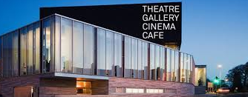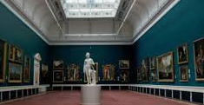
Cultural enterprises main purposes are to:
- Create employment
- Bring in revenue to a country through tourism
- Encourage Irish innovation
- Give people access to arts and culture

Why do people become Entrepreneurs?- Exam Q.
People often decide to become an entrepreneur for the following reasons:
Income: Potential to make a profit and support yourself financially- to potentially earn more than an employee wage
Independence: Be your own boss, work for yourself and make all key business decisions
Challenge: Some people get bored easily and like to challenge themselves to be successful
Creativity: They have the ability to constantly come up with new ideas
Redundancy: They have been laid off from work and need a source of income for themselves

The Importance of Enterprise in an Economy
- Enterprise creates jobs for local people and gives higher standard of living and quality of life
- It increases the production of goods and services in an economy and creates competition which is good for consumers
- It creates new breed of entrepreneurs, acting as a role model for others
- Government can use taxes to spend on education, hospitals etc.
- Not for Profit Enterprises provide many socially desirable places like Sports Clubs and charities
- Creates the need for other service providers like banks and Building Societies

Characteristics and Skills of Enterprising People-
Typical Exam Question
Below are some examples of skills/characteristics you may be familiar with
(*Note: You will need to know 5 and be able to State, Explain, and Example/Refer*)
- Risk Taker- Ability to take a chance
- Decisive- Ability to make decisions
- Networking- Ability to set up contacts
- Goal Setting- Ability to have a vision
- Creative/Innovative- Ability to come up with new ideas
- Realistic- Ability to use correct judgement on what’s possible
- Self-Confident/Inner Belief- Ability to back themselves and their concept
- Resilient- Ability to take a setback and keep going
- Proactive- Ability to keep moving and not stand still

Now we will examine a Case Study of Brian Lee and his business ‘Chopped’ and answer it from a LC Business perspective:
Let’s see if you can see evidence of the following skills/characteristcs based on the videos in the notes
- Self-Confidence
- Risk Taking
- Realistic
- Creative
- Goal Setting
- Networking

Evidence of Brian Lee’s Entrepreneurial Skills/Characteristics
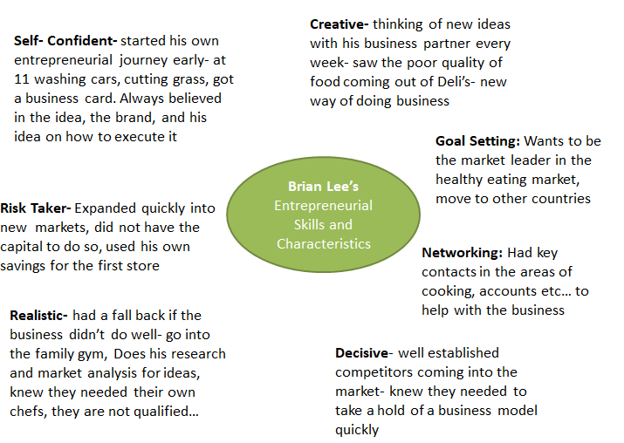

How to answer this question:
Explain the entrepreneurial skills/characteristics of Brian Lee (20)
Or
Explain the entrepreneurial skills/characteristics of an entrepreneur of your choice (20)

As it is a 20 Mark Question- 4 points needed. We need to make sure to State/Explain/Example
Creative/Innovative
This is the ability to come up with new ideas or new ways of doing things- ‘thinking outside the box’ to bring fresh ideas to the market- Example: Brian Lee was constantly thinking of new ideas with his business partner every week- saw the poor quality of food coming out of Deli’s- new way of doing business was Chopped
Risk Taker
Entrepreneurs are generally people who are risk takers rather than risk avoiders/risk averse. They take both calculated personal and financial risks to bring a product to the market- Example: Chopped expanded quickly into new markets, did not have the capital to do so, and used his own savings for the first store.
Realistic
The entrepreneur will have good judgement and take a realistic view of what is possible. They are ambitious but will also have an honest view of their own capabilities and seek help and guidance when required- Example: Brian Lee knew he did not have the necessary skills for all areas in setting up Chopped and so brought in qualified chefs and business people to help him.
Decisive
Decisions are made quickly and entrepreneurs take responsibility for any decisions that they make. They are able to adapt to circumstances that can change instantly and are flexible about this. Example: With well established competitors coming into the market- Brian knew they needed to take a hold of a business model quickly to make Chopped a success.
Other possible points:
Self-Confident
Self-confidence is concerned with how a person feels about their ability. You are not scared to explore un-chartered territories, take risk and take difficult decisions. Example: Brian Lee always believed in his idea, the brand, and his idea to execute it to make Chopped a success and expand into new markets abroad such as the UK.
Goal Setting
This is concerned with having both short and long term goals for the business to be a success. It involves planning for the future as well as having strategies in place to meet the here and now. Example: Brian Lee wanted to set up a business that could offer a healthy alternative to fast food, and his future plan is to expand into the UK and world markets.
Intrapreneurship
This refers to an existing employee who acts as an entrepreneur inside a business. They come up with new ideas and solutions to problem that already exist. Most businesses like Facebook and Google encourage this amongst their staff.
The intrapreneur will take a personal but not financial risk as generally capital is provided by the business.
Examples of Intrapreneurship
- New ideas- e.g. a new sandwich on the menu in Subway selected by employees
- New production process- e.g. a tailor coming up with a cheaper way to make suits
- New work methods- a different way to chop meat in the deli

Let’s examine one of the most famous examples of intrapreneurship- Ken Kutaragi and the Playstation.
https://youtu.be/Y0kpYoGJE0k

Other Famous Examples of Intrapreneurship
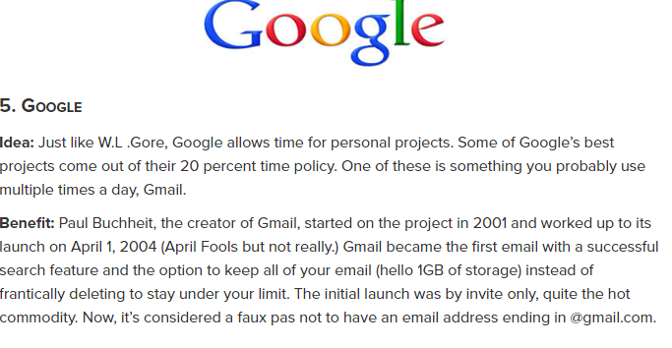
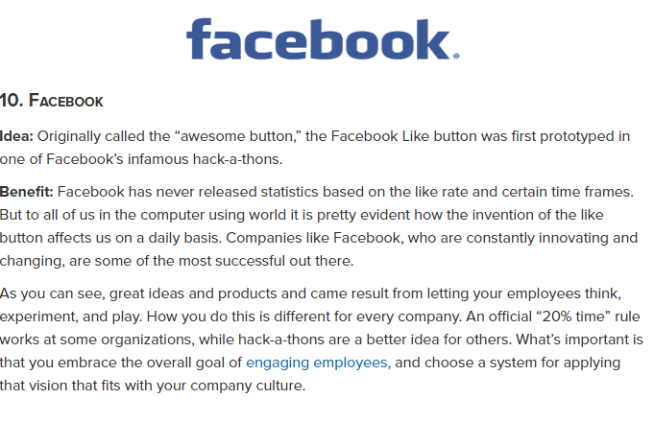
Ways to Promote Intrapreneurship
- Empowerment/employee participation encourages creativity as it allows employees greater freedom on how to do their job by placing real power, responsibility and authority in the hands of employees
- Create a culture within the organisation where it’s okay to make mistakes
- Financial rewards for effort and creativity. These rewards could involve a mixture of pay, incentives and benefits
- Teamwork encourages creativity among employees as it facilitates brain storming sessions as part of the product development process.
- Training program for employees and management, training them on the implementation of an intrapreneurial culture within a business

