Factors of Production and Categories of Industry

A combination of four basic Factors of Production are needed by all businesses while attempting to produce goods and services.
The 4 factors of production are: (CELL)
- LAND
- LABOUR
- CAPITAL
- ENTERPRISE
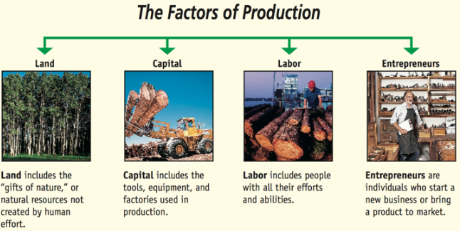
- Land: Anything provided by nature that helps to produce the good or service. Payment made to suppliers of land is rent. Examples of land items would be
- Agriculture- Farming crops.
- Fishing
- Mining
- Oil Production
- Climate- Think of sunny holidays or snow for skiing. Many countries use the weather as a natural resource to attract tourists
For example, Cadbury’s use milk to make chocolate such as Dairy Milks. The milk is the land.
- Labour: This would be any human effort that helps to produce the good or service. Payment made to suppliers of labour is wages. Examples of labour would be:
- Teachers
- Dentists
- Doctors
- Sales Assistants
- Carpenters
For example, the factory workers who use ingredients such as milk to create chocolate is labour.

- Capital: Anything made by humans that are used to assist in producing the good and services. The money invested by the business is often loaned from a bank to buy the good and services that are used in this production. Therefore the people who loan the money receive interest on repayments. Thus, the payment for capital is interest.
Examples of capital would be:
- Trucks
- Computers
- Machines
- Factories
For example, the machines used to in the production process to turn the ingredients into the final product is Capital.

- Enterprise: This is the special form of human activity that organises the other three factors of production and bears the risk involved in production. Think about products that go through a process and then end up on Dragons Den. The payment is profit/loss.
- Bill Gates- Microsoft
- Joe Murphy-Tayto
For example, Cadbury’s selling the finished product to the market.
Categories of Industry
Industry in Ireland can be classified under three headings:
- Primary- The Extractive Industry using natural resources- 5/6% of Economy
- Secondary- Manufacturing and Construction Industry-24/25% of economy
- Tertiary- Service Industries- Irelands most popular sector, with over 70% of employment.
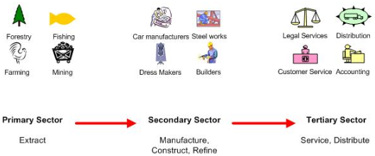
We have to note that in 2021, the effect of Brexit and Covid-19 will undoubtedly have huge implications for the different sectors in Ireland’s economy.
Primary Sector
Primary producers take raw materials/natural resources from the land or sea to make a product.
The main industries involved in primary production are:
- Agriculture
- Forestry
- Fishing
- Mining
- Oil Production
Some of these materials are used in their raw state, but most are passed onto the secondary sector for production. This increases its importance to the Irish economy in trying to minimise imports and maximise exports as well as providing employment.
Importance of the Primary Sector
Employment: Many people in Ireland work in agriculture, fishing, forestry and mining. They pay taxes on their wages and this gives the government more money, so it can improve Ireland’s economy by reducing taxes, increasing grants and improving infrastructure.
Consumer of Irish products: Primary industries are a major consumer of Irish products, so they pump money into the ecomony. Farmers use farm machinery, fertilisers, chemicals, animal feed, vets etc. This has a spin off effect for these businesses, increasing their profits.
High level of exports: The primary industry exports a huge amount of raw materials abroad, thus improving our Balance of Payments. This brings money into the country and creates wealth. E.g. forest sector exports value €350 million p.a.
Provide food: Much of the primary industry is concerned with providing food here in Ireland. This makes us less dependent on foreign imports, thus improving our balance of payments.
Current Trends affecting the Primary Sector- Including Brexit and Covid-19

Brexit-

Challenges
- The loss of Britain to the EU equates to approximately 66 million people or 12.85% of total population. This will bring with it trade issues in sectors such as farming, fishing etc… 50% of beef and 30% of dairy exports pre Brexit went to the UK- Trade issue agreed on December 24th 2020, but still concern about keeping trade flowing
- Delay at ports causing delivery issues to and from the UK, fresh produce going out of date before reaching supermarkets
- Uncertainty in employment in this sector with such huge reliance on the UK market for exports
- Loss of tax revenue for the government due to possible effects of trade issues

Opportunities
- Could lead to an increase in demand for Irish produce rather than UK products In Ireland
- Opportunity for Irish produce to be exported to new and emerging markets

Covid 19-

Challenges
- The effect on demand for Irish produce as meat factories closed in certain areas, lockdown of restaurants, McDonalds for example only drive through in lockdown 3, they typically spend more than €160m on beef each year so nowhere near this number required
- Funding- For example, government had to give €50m support package to farming sector in first lockdown
- Job uncertainty as not as much demand for products in restaurants, pubs etc… due to lockdown
- Loss of tax revenue as spending on this sector is down
Opportunity
- Increase in demand of supermarkets (20% surge in demand for supermarkets products since lockdown)- effect on primary sector to service this demand
Other trends
- EU milk quotas have recently been abolished. Dairy farmers in Ireland are now free to produce as much milk as they can which enables Ireland to export more in emerging markets such as Africa and Asia
- Ireland exports 90% of its beef output, making it the largest exporter of beef in the EU and one of the largest in the world
- Ireland has green image worldwide, and with the increase demand for organic food from consumers both in Ireland and around the world, more and more farmers markets and setting up providing organic food to meet this demand
- Some fish stocks have been depleted due to overfishing. The CFP sets out very strict rules and quotas designed to prevent overfishing and preserve fish stocks
- Farm numbers in Ireland declined continuously over recent decades. Over half of all farmers are over 55 years old. Demographic and lifestyle changes make it more difficult to attract young people to agricultural careers

Secondary Sector
These manufacture and process the raw materials supplied by the primary producers.
Some examples would be:
- The Building Industry
- Technological and Pharmaceutical Firms
- Food Processing
- Clothing
The manufacturing sectors in Ireland include:
Agri-business- These take raw materials from the agricultural sector to make products (cereals, meat, milk, vegetables etc…) By processing raw materials from the primary sector, a manufacturer adds value to the goods and creates jobs in the industry. The agribusiness sector in Ireland exports over 50% of its output.
Examples of Agri-business in Ireland include Glenisk, Kerry Group, and Glenbia.
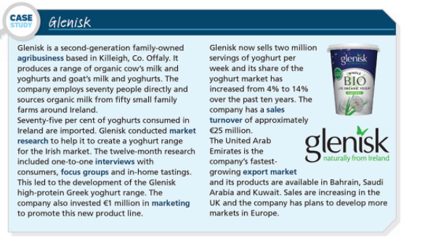
Construction Industry- Provides Ireland with housing, businesses and infrastructure like roads. It is a very labour intensive industry. In 2021, there is still a massive demand for houses, but Covid-19 has slowed construction
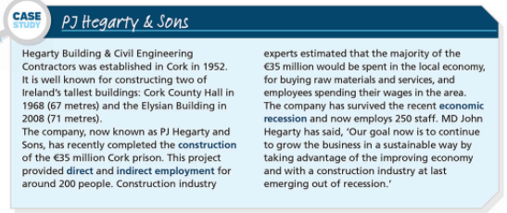
Manufacturing Industry: Manufacturing in Ireland is mainly focused on pharmaceuticals, food and beverages, and computers. Approximately 400,000 people are directly or indirectly employed by this sector.
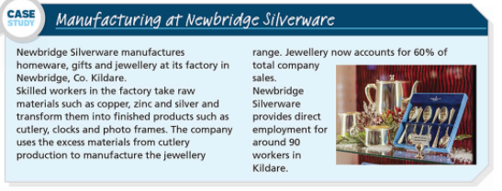

Importance of the Secondary Sector:
High Level of Exports: New high tech manufacturing have set up in Ireland including chemicals, pharmaceuticals, medical supplies, electronics and computer equipment. Most of these are foreign owned and export from Ireland. These therefore improve our balance of payments.
Employment: Manufacturing creates direct and indirect employment. These people pay taxes on income earned and spend their disposable income.
Consumer of Raw Materials: Manufacturing companies buy the output of the primary industry and turn it into finished goods. This provides income to those in the primary industry and raises the standard of living. E.g. Ribena buys 95% of Irelands blackcurrants.
Current Trends affecting the Secondary Sector- Including Brexit and Covid-19
Brexit-
Challenges
- A drop in demand for Irish products may impact on jobs in this sector as UK one of Ireland’s main trading partners
- Delay and expense in getting raw materials needed from the UK- this expense may also need to be passed onto Irish consumers
Opportunities
- Opportunity for indigenous businesses to service demand previously provided by UK businesses
- Be more competitive in other EU countries who previously bought products from the UK
Covid 19-
Challenges
- Many meat factories had to close, Covid outbreaks in Kildare and Offaly, delay in getting produce to consumers
- A huge amount of workers cannot work from home, construction slowed down…still a huge demand for houses
- Cost to the government in supporting sector and PUP payments

Opportunities
- More people are shopping local and buying from Irish/local suppliers due to restrictions

Other trends
- Manufacturing creates a lot of employment in Ireland. These jobs result in fewer people claiming social welfare payments and more income tax for the government. However, the manufacturing industry is becoming more capital intensive, meaning more jobs for machines and less for people
- There is such a demand for houses in the economy at present meaning more construction jobs will be created
- There is increased competition to indigenous producers, the likes of Aldi and Lidl give consumers choice to shop around meaning Irish made products will suffer
- Competition from low wage countries, together with demand for wage increases in Ireland, led to the closure of many Irish manufacturers who move their businesses to low wage economies for cost saving

The Tertiary Sector
The Tertiary sector is businesses that provide a service in an economy. They do not make products or work in the manufacturing sector.
Examples include:
- Insurance
- Banking
- Doctors
- Solicitors
The service industry is by far Ireland’s biggest employer- and thus is where most of the tax needed to run a country comes from. Ireland also exports billions of euro worth of services such as software, improving our balance of payments, and the Irish workforce is seen around the world as very well educated which attracts foreign businesses here to set up their operations.
Importance of the Tertiary Sector:
Biggest Employer: this sector is the biggest employer of Irish people. People employed in this sector pay taxes on their income and spend disposable income, which are beneficial to the economy
Exports: Ireland exports financial services thus improving our Balance of Payments. This brings money into the country
Attractive to TNCs: A well-developed service sector is attractive to TNCs that are looking for a country to locate in, e.g. telecommunications and transport services, highly educated workers, access to EU markets

Current Trends affecting the Tertiary Sector- Including Brexit and Covid-19
Brexit-
Challenges
- Added cost of imports from goods and services being bought from the UK
- The uncertainty of Brexit has added to the challenge faced by businesses when trading between the UK and Ireland, especially in relation to currency volatility where fluctuations in Euro-Sterling rates may have a significant adverse impact on company profitability
- Delay in UK goods delivered to Ireland
Opportunities
- Increased demand for Irish goods and services as UK goods become more expensive
- UK companies may relocate to Ireland for access to EU market if uncertainty over how trade deal impacts profits
Covid 19-
Challenges
- Sector of the economy most hit, huge number of jobs lost in hospitality, lots of people on PUP, job uncertainty…
- Financial cost to government, over €4 billion spend on PUP alone in 2020
- Loss of profits and cost of reopening for businesses in this sector, cost of employees working from home needs to be absorbed, retrain staff
- Less time for people in store meaning less impulse buying
- Spin off enterprises, e.g. taxis, small coffee shops, less demand for these businesses
Opportunities
- Growth in online market for consumers and businesses- more shopping being done here
- Supermarkets have seen 20% increase in demand for products, more employment opportunities
Other trends
- Ireland has a booming financial services sector, half of the world’s top banks and insurance companies have located in the IFSC in Dublin. Thousands of people work here and it deals with billions of euro worth of investments yearly
- Consumers look to shop around- this has resulted in more shops like Aldi and Lidl coming to Ireland to meet this need
- Increased taxes such as Propery Tax has meant consumers have less disposable income, as demand for goods and services reduce, the amount of retail service providers close down
- E-Business is becoming increasingly popular, more and more consumers are switching to online shopping to meet their consumer needs. You can do your grocery shopping in the likes of Tesco for example without leaving your home
- Big businesses are benefiting from economies of scale making it very difficult for smaller businesses to compete. Example- 3 grows as Just Mobile fails
- The minimum wage increases and pay rise requests in the service sectors means increased costs for businesses

