Final Accounts 2: The Income Statement 2

The Profit and Loss Account
The Income Statement 2 shows a business’s total expenses for a trading period and is used to calculate Net Profit or Net Loss.
To get this Net Profit we will show that:
Gross Profit - Expenses = Net Profit
The layout for these accounts must be learned off by heart
-Continue on from Income Statement 1
These expenses are not exhaustive and there may be more.

Calculate Net Profit Using the following figures:
Gross Profit | 6,000
Office Expenses | 1,000
Travel Expenses | 2,000
Tax | 700

Gross Profit | 204,000
Wages | 96,000
Depreciation on Van | 2,000
Carriage Outwards | 1800
Rent and Rates | 14,000
Postage | 6,000
Cleaning | 6,000

Gross Profit | 150,000
Office Expenses | 30,000
Wages | 80,000
Depreciation on Machine | 16,000
Carriage Outwards | 800
Tax | 25,000
Postage | 11,100
Stationary | 7,500
Bank Interest Paid | 1,000

Working out Depreciation
Depreciation is when a Fixed Asset loses value over time, usually down to reasons such as old age or obsolescence.
To work out Depreciation, it is always cost multiply by the % given. We always take Depreciation away as it reduces the value of a Fixed Asset.
Net Book Value means the value of the asset right now.
Example:
Depreciation on Buildings and Machinery for XYZ Ltd is 10%.
Fixed Assets | Cost | Depreciation | Net Book Value
 | € | € | €
Buildings | 100,000 | 10,000 | 90,000
Machinery | 50,000 | 5,000 | 45,000
Total | 150,000 | 15,000 | 135,000

Now draw these tables and try the following questions in your copy.
A. Depreciation is 10% on all Fixed Assets for WER Ltd
Fixed Assets | Cost | Depreciation | Net Book Value
 | € | € | €
Buildings | 200,000
Machinery | 150,000
Total

B. Depreciation on Buildings is 8% and Depreciation on Delivery Vans is 5% for GTY Ltd
Fixed Assets | Cost | Depreciation | Net Book Value
 | € | € | €
Buildings | 160,000
Delivery Vans | 40,000
Total
Combined Income Statement 1 and Income Statement 2
Once you have mastered both the Income Statement 1 and Income Statement 2, the next step is to combine these together to complete the overall Income Statement for a business. In other words, the first figure you start with will be Sales, and the final figure will be your Net Profit.
Sample Combined Income Statement
Income Statement for QWE Ltd for year ended 31/12/2019
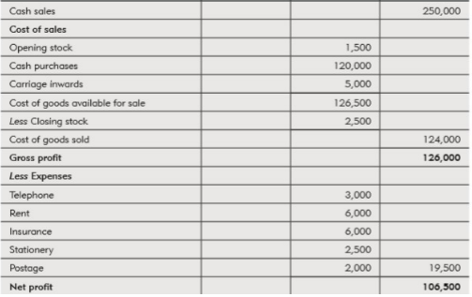

The Appropriation Account
The final part of the Income Statement will be to work out how the profit of the business is distributed. The final figure will be known as the Closing Reserves figure.
To work out Closing Reserves:
Net Profit
– Dividends paid to shareholders
+ Opening Reserves
= Closing Reserves
