Final Accounts 3: The Balance Sheet
A balance sheet is a statement of the assets and liabilities and share capital of a business on a particular date. It shows the wealth of the business and is made up of two parts — Total Net Assets and ‘Financed by’. Note that a Balance Sheet may also be referred to as a ‘Statement of Financial Position’ of a Business
The Total Net Assets is the amount a business owns after allowing for current liabilities. It is calculated by adding Current Assets minus Current Liabilities (Working Capital) to Fixed Assets.
The Financed By section of the balance sheet shows where a business obtains its finance. This can include share capital, reserves and long-term loans.
Assets
Fixed Assets: An asset whose value is not directly affected by the normal daily transactions of a business- e.g. Machinery, Motor Vehicles, Land, Buildings.
Current Asset: An Asset whose value is directly affect by the normal daily transactions of a business- e.g. bank, cash, stock, debtors- any money owed to us by customers
Note*Any Gain Due or Expense Prepaid will also be a Current Asset in the Final Accounts- Examples Commission Receivable Due or Wages Prepaid and must be shown in the Balance Sheet.
Liabilities
Current Liabilities: A debt owed by a business that is due for repayment within one year. The most common are creditors and bank overdradft.
Long Term Liability: A debt that is not due for repayment in the coming 12 months- e.g. 5 year loan, Issued Share Capital or Profit and Loss Balance/ Reserves.
Note*Any Gain Prepaid or Expense Due will also be a Current Liability in the Final Accounts- Examples Commission Receivable Prepaid or Wages Due and must be shown in the Balance Sheet.
And so:
Current Assets- Current Liabilities = Working Capital
Fixed Assets + Working Capital =
Total Net Assets
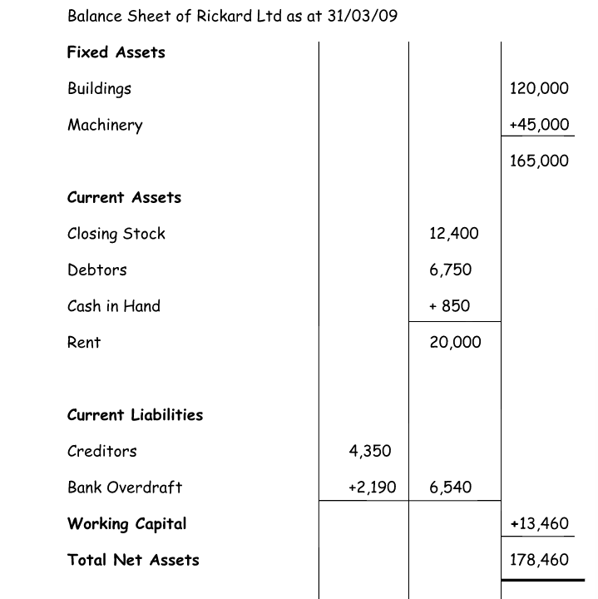

Financed by...
This section shows where a business obtains its finance.
Share Capital + Reserves+ Long Term Liabilities = Capital Employed
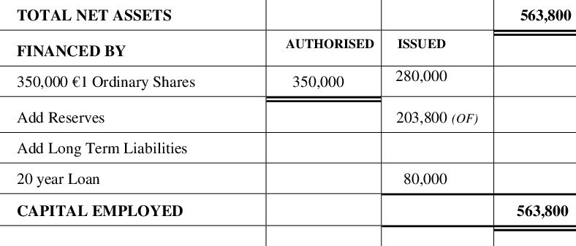

Sample Question:
Authorised Share Capital 300,000
Land 120,000
Cash 80,000
Closing Stock 40,000
Bank Overdraft 15,000
Issued Share Capital 235,000
Closing P & L 70,000

Solution
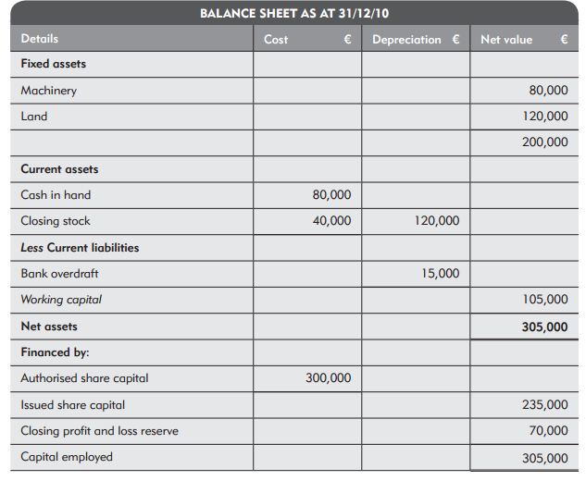

This should take you up to the ordinary level of the Trading, Profit and Loss and Balance Sheet Question. We will attempt sample questions from the textbooks in class from this point.

