Final Accounts 3: Statement of Financial Position
The Statement of Financial Position for a business is the final step in presenting a business’s Final Accounts. It presents a list of the business Assets, Liabilities, and Capital for a given period.
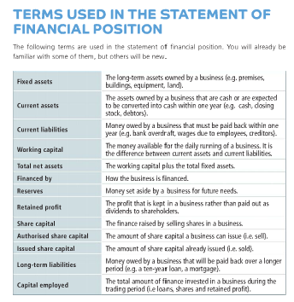

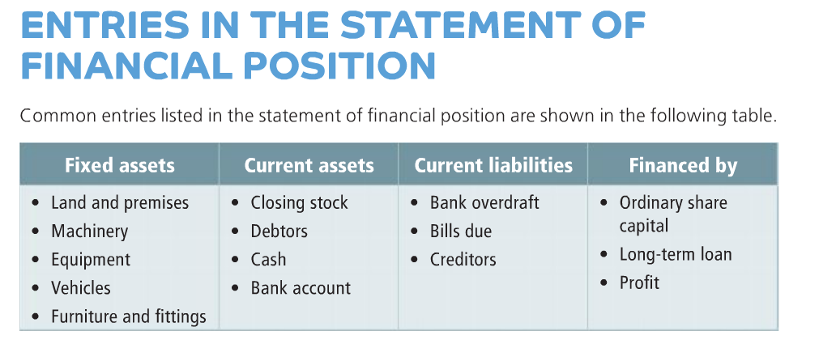

Sample solution for the Statement of Financial Position
