Globalisation and Transnational Companies
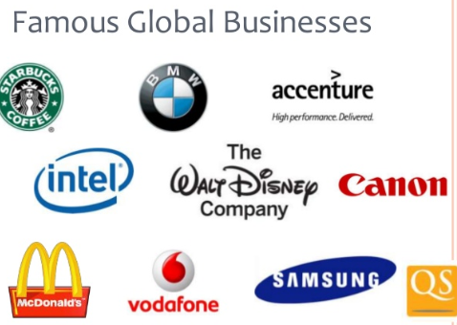
Globalisation is the process by which the world becomes interconnected as a result of increased trade and cultural exchange.
In effect, the world is seen as one big marketplace and production location by global businesses that provide the same product worldwide. They use a global Marketing Mix for their brand worldwide.
Examples of global businesses include Coca Cola, Dell, Nike, Toyota, Microsoft, Intel, HP, Google, Apple, etc.…
The Effect of Global Businesses on Stakeholders
Global business affects consumers as:
- They give greater choice of products and services in the market place- e.g. Samsung and Apple offer different types of phones
- Increased competition can also lead to lower prices in the market place as businesses compete for customers
- Provides familiarity and trust for customers in certain brands when abroad
- Increased employment opportunities
Global business affects businesses as:
- There is a greater market to sell products and therefore increase profits. (Think of the EU- more export opportunities
- They can take on more workers in an economy that contributes to wealth in the economy and consumer spending in other businesses
- Irish businesses will have to work harder to compete with global businesses, and try to develop a USP that allows it to survive against the threat of global businesses
- Successful small businesses can be taken over by larger global businesses
Global business affects government as:
- More tax wealth through taxes such as income tax and corporation tax
- Less people need to be paid social welfare
The Growth of Global Firms
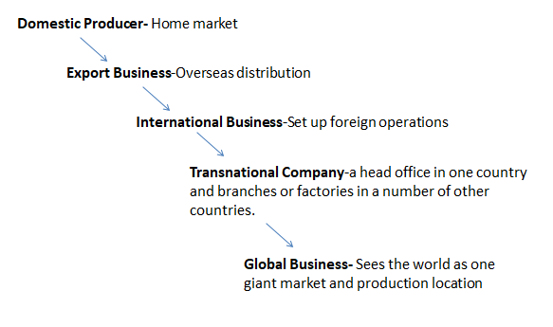
Global Businesses and The Marketing Mix
Standardised Marketing Mix
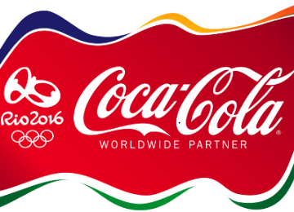
When a global business- e.g. Nike/Coca-Cola, treat the world as one market and take an undifferentiated approach to their marketing worldwide- this is known as a Standardised Marketing Mix. This reduces costs- which increases profits as they don’t have to change anything for local markets.
Example- Coca-Cola used their logo to sponsor the Olympics- same product is sold all over the world
Adapted Marketing Mix
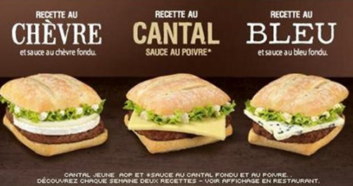
When certain elements of a marketing mix have to be changed to reflect local market needs- this is known as the Adapted Marketing Mix. A business must change some of the 4 P/s to reflect differences like language, cultures, or values in different markets.
Example- McDonald’s in France has adapted to the local tastes of its consumers. While McDonald’s maintains its overall brand image; logo, store layout, main menu items, the French brand of McDonald’s caters to the locals taste; it offers burgers with French cheeses. They also provided freshly baked baguettes for their McBaguette sandwiches.
The Reasons for Global Businesses
Increase Sales- The ability to make more profits in multiple markets
Mass Production- The ability to produce at economies of scale which reduce production cost per item
ICT Developments- Skype, Zoom, Teams etc… make it easier to manage and communicate globally
Transnational Companies
These businesses have their head office in one country and factories in other countries, i.e. IBM, Volkswagen, Siemens, Nestle, Intel, and Guinness. The head office controls the entire business, while these branches around the world carry out jobs.
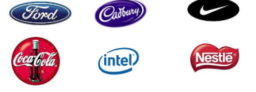
Transnational Companies coming to Ireland is seen as something positive and negative to the Irish economy.
Positive:
- Corporations are paying Corporation tax, and hiring Irish Employees for their businesses. This boosts the government’s revenue
- Spin off firms needed, like deli’s for lunch, taxi’s for transport etc..
Negative
- Send most of their profits out of Ireland
- Less loyal to Ireland- if it is cheaper somewhere else they might just move

Why do Transnational Companies come to Ireland?
Corporation Tax Rate
UK corporation tax is 20%, Germany, France and Italy are 30-33%, and in Ireland Multinational Companies pay 12.5% corporation tax on their profits. This low rate of corporation tax is a key Government strategy in attracting Foreign Direct Investment
E.g. Google can pay only 12.5% corporation tax on profits through their Dublin based offices.
IDA Ireland
IDA Ireland is responsible for the attraction and development of foreign direct investment in Ireland. Companies such as Apple, Microsoft and Facebook etc. have all interacted with the IDA and approximately 150,000 people are directly employed by foreign multinationals in Ireland.
E.g. IDA Ireland helped attract Apple to set up their European HQ in Cork.
Highly Skilled Workforce
The availability of a highly skilled and well-educated workforce attracts MNC’s. Our workforce is also very experienced with the likes of Intel and
E.g. Google established here with lots of Irish staff. MNC’s will set up here knowing they can access lots of 3rd level educated graduates
Access to Large Market
The creation of the Single Market eliminated trade barriers within the EU, allowing for the free movement of goods, services, labour and capital between member states. (MNCs) that locate in Ireland have access to a huge EU market of over 500 million people, whilst being able to deal in the international business language, English.
E.g. Pharmaceutical Companies like Pfizer use Ireland as a stepping stone to the larger EU market

