Budgets

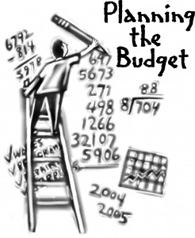

What is a budget?
A budget is a money plan where you can organise and control your finances. It will allow you to plan for the future and recognise times of surplus cash (extra money left over) or when you are in a deficit (negative) with your finances.

Before we look at each type of budget, it is important to look at reasons why creating budgets are important.
- Take control of your finances- Know what is going on and what to do with your money

- It will help you identify times of surplus or deficits when it comes to times of big purchases, e.g. buying a house or car

- Examine your spending habits, e.g. are you spending too much on discretionary items

- Enabling you to plan for the future. E.g. have enough money left over to go on holiday

- Assist in applying for a loan. A bank or other financial institution will look at your budgets to see if you are able to meet repayments

What a budget tells us…
- Budget Surplus- More income than expenditure. This is a positive for the household.
They could look to:
- Save to earn interest in a savings account rather than just sit at home
- Invest this money, but beware of the risks

- Budget Deficit- More expenditure than income. This is a negative for the household.
They could look to:
- Reduce discretionary expenditure
- Source extra income- e.g. overtime or extra part time work
- Apply for a short term loan, but beware of risks

Preparing and Analysing Household Budgets
In first year we would have briefly looked at the importance for a household in planning their income and expenditure. A budget will now require us to use projected figures to see whether a household is able to live within its means.
In doing so, we will look at:
1. How to record income
2. How to record expenditure
3. Opening Cash/Closing Cash/Net Cash
4. Analysing the budget

In demonstrating how to prepare a household budget, we are going to look at a sample budget for the Keane family.

The Keane Household Budget

The Keane have the following income and expenditure for the months January to April:
Opening Cash is €250
Income:
  - Robbie earns €1800 net per month
  - Claudine earns €1600 net per month
  - Child Benefit is €40 per month for each child

Expenditure:
  - House Mortgage is €450 per month
  - House Insurance is €150 per year payable in March
  - Car Loan Repayments is €100 per month
  - Telephone bills are €50 in Feb and €70 in April
  - Groceries will cost €220 per month (€240 in Feb)
  - ESB Bills are €90 in January and €110 in March
  - Petrol costs will be €40 in Jan, €30 in Feb, €35 in Mar and €50 in April
  - In April, presents for will be €90 for each child
  - Robbie pays €20 per month for newspaper deliveries
  - Claudine has her hair done in Feb and March for €30 each month

Using the table on the next page, prepare a Household Budget for the family.

1. How to record Income
The first part of a budget is concerned with the income section.
Income:
  - Robbie earns €1800 net per month
  - Claudine earns €1600 net per month
  - Child Benefit is €40 per month for each child

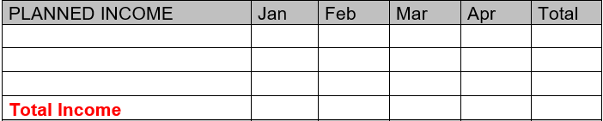

- How to record Expenditure

This part of the budget is concerned with the expenditure section. Remember there are 3 types of expenditure, Fixed, Irregular, and Discretionary.
Expenditure:
  - House Mortgage is €450 per month
  - House Insurance is €150 per year payable in March
  - Car Loan Repayments is €100 per month
  - Telephone bills are €50 in Feb and €70 in April
  - Groceries will cost €220 per month (€240 in Feb)
  - ESB Bills are €90 in January and €110 in March
  - Petrol costs will be €40 in Jan, €30 in Feb, €35 in Mar and €50 in April
  - In April, presents for will be €90 for each child
  - Robbie pays €20 per month for newspaper deliveries
  - Claudine has her hair done in Feb and March for €30 each month
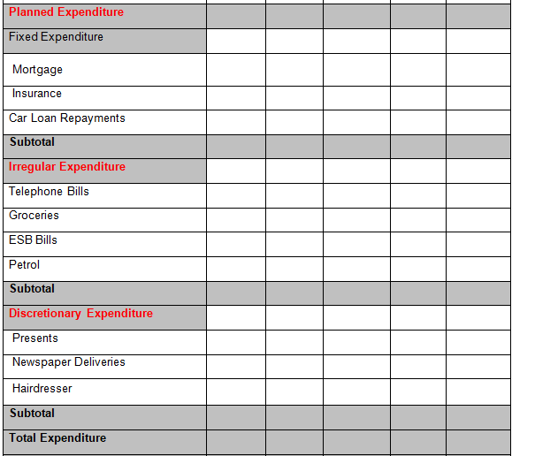
3. Net Cash/Opening Cash/ Closing Cash
Net Cash: This is the difference between Income and Expenditure- the money you are left with. Can be positive or negative.
Opening Cash: The money you bring forward from last month- last month’s Closing Cash. Month one is always given in the question.
Closing Cash: When we add Net Cash and Opening Cash together. The final figure for that time period.
Please note the following rules for this section
- Total Income – Total Expenditure = Net Cash
- The opening cash for the first month is the opening cash in the total column also
- The closing cash in a month becomes the opening cash in the next month
- The last two closing cash figures should be the same- this shows that the budget has balanced
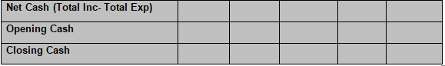

Analysing the budget- sample questions
1. Do you think this is a good budget? Why/ why not?
2. What advice would you give to the Keane family?
3. Why do the Keane family need to prepare a budget?
4. Identify figures, e.g. how much is closing cash, what is the total income for the four months etc…
5. Draw a bar chart showing income/expenditures

