Business Technology
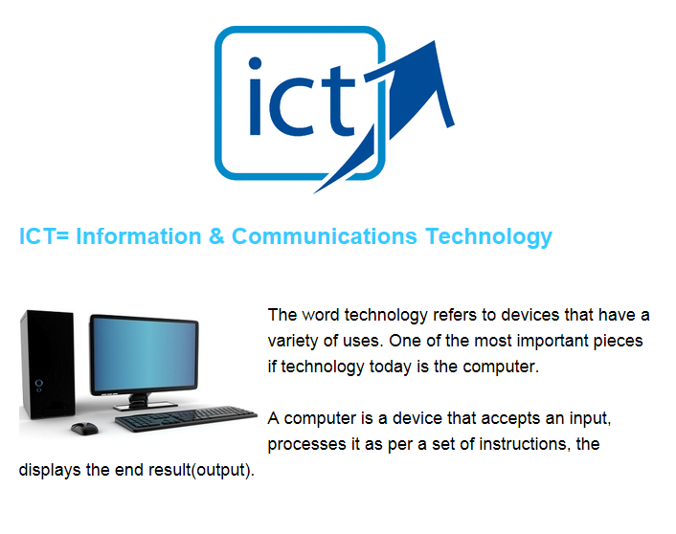

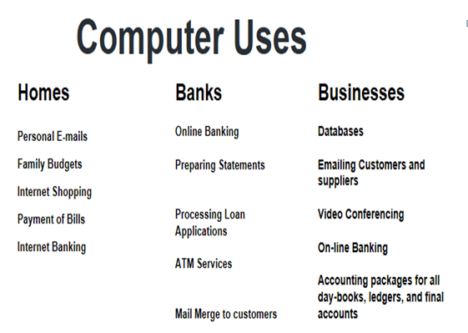

The three main elements of digital Technologies are:
- Computer Hardware
- Computer Software
- The Internet
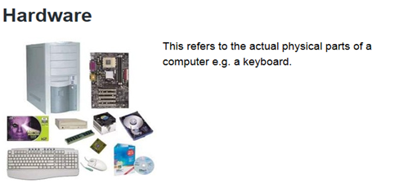
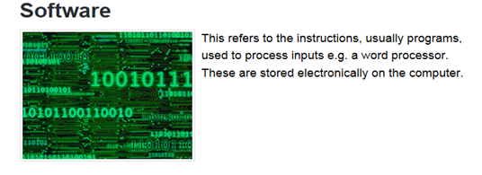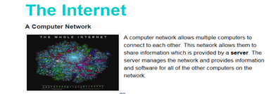

Inputs v Outputs
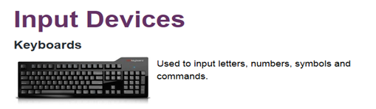
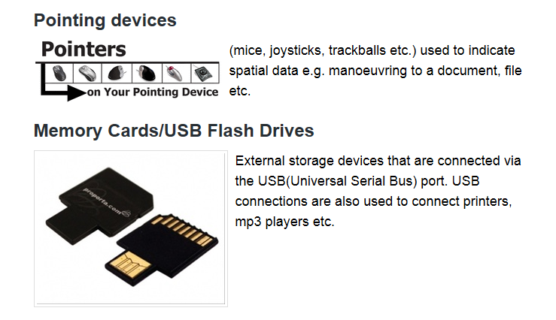
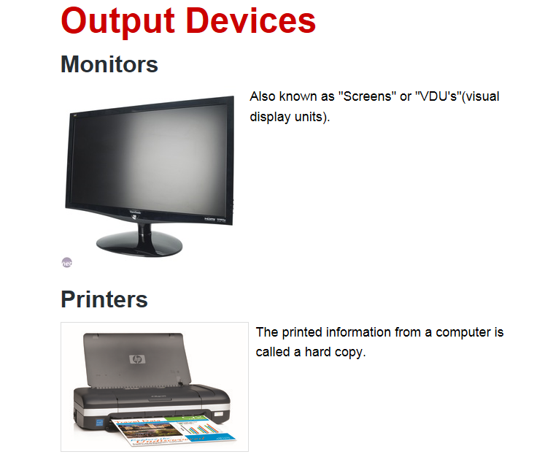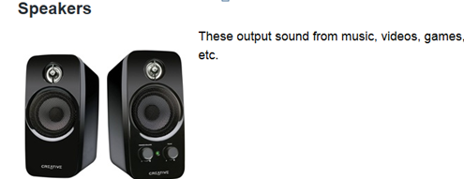
How Digital Technologies help businesses:
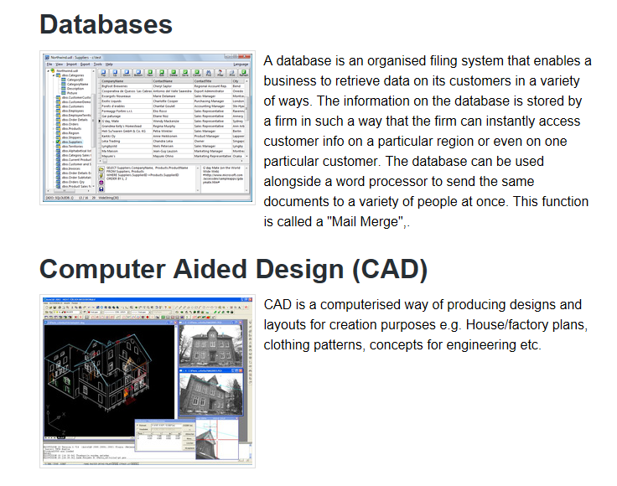
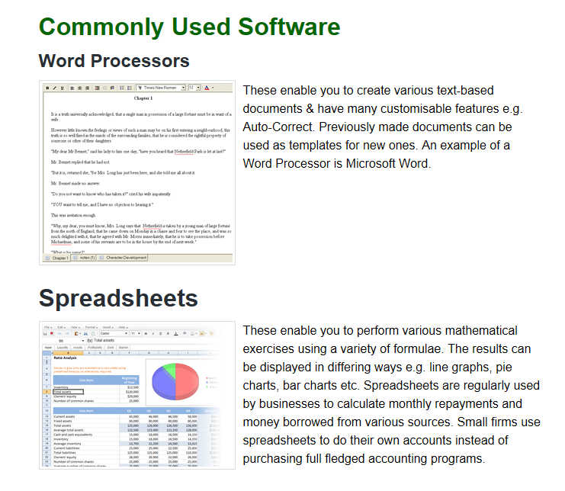
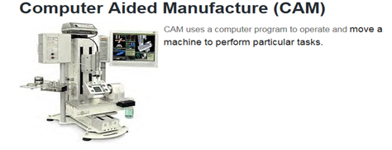

Email The Cloud
Advantages of Digital Technologies in Business:
- Improves Communication: Many businesses are using various business communication technologies to change the way their employees interact and communicate while at work. Employees can use various communication tools to interact or exchange information at work. For example, employees from different departments in a company can use text messaging services or video conferencing tools like Skype to share and exchange information
- Speed of Work: People work faster using ICT- information can be accessed immediately, responses gathered quickly
- Business Marketing Improves: The setting up of websites, market research gathering etc.. is greatly improved using ICT
- Manufacturing: Programmes such as CAD and CAM make the manufacturing and distribution of goods and services a lot easier
- Encourages Innovation: Workers can use different business technologies to create innovative business ideas which can be used in business growth and expansion
- Improves Mobility: The use of internet and computers to work has eliminated space and time boundaries. Employees can work from anywhere at any time, this mobility makes employees stay in control of their job
- E-Commerce: Using the internet to sell to consumers

Disadvantages of Digital Technologies in Business:
Maintenance Costs: It is expensive to buy technology, but it is also costly to maintain it. Many small businesses cannot afford the cost of hiring a full-time technical person, so they resort to monthly tech contractors who charge them for work done. If business technology tools like computers are not well maintained, their performance will decrease and the process of buying new computers or any other business technology can even be more expensive. Training staff to use computers may also be expensive
Human Obsolescence: Many jobs are becoming less valuable due to technology. HR can face issues of worried workers and job security issues which may impact on staff morale
Security Risks: IT Security is critical. Businesses must ensure data is secured and protects against cybercrime and viruses. Security (Phishing) is an attempt to gain access to sensitive information from unsuspecting users. Many customers have fallen victim to these scams and as a result will not trust ICT
Employees can become lazy: Morale may suffer, over reliance on computers, could have long term issues for the business

