Inflation
It is the increase in the general level of the price of goods and services over a period of time. It is the increase in the standard of living in a country from one year to the next. 2000- Cinema ticket= £3.95, 2016 cinema ticket = €11.50 (UCI/Odeon Blanchardstown)
The official measurement for inflation is known as The Consumer Price Index
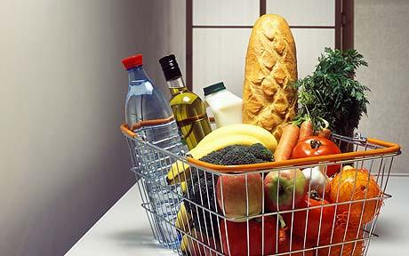 €30.00 vs €35.00
2015 2016
Formula we use to calculate inflation is: The increase in price in year 2/price in year 1 x 100
Causes of inflation
- An increase in the cost of producing the good is passed onto the consumer so the business can maintain a profit. Think of petrol prices.
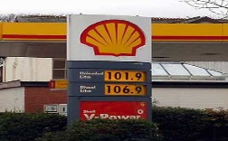
- Demand exceeds supply. Limited Edition Rolex Watch.
- The cost of importing the goods increase. This is known as imported inflation. We either pay the extra cost or do without the goods.
- Increases in indirect taxes. The budget at the end of the year will often raise prices in Ireland with the likes of VAT increases on certain products. An example would be a bottle of wine increased €1 in the budget 2013. 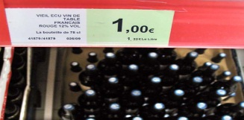
So what are the effects of inflation?
- The cost of living rises as goods become more expensive.
- Demand for wage increases due to inflation. This can have a knock on effect as producers may increase prices to recoup extra cost of the increased wages.
- Discourages saving as people will spend their income now before the goods get more expensive in the future.
- Price of exports will increase due to added cost arousing from inflation making it difficult to sell them.
- May cause Irish people to buy cheaper imports rather than home grown products to save money. This may make it difficult for Irish firms to compete with competitors in the market.
So what do we think deflation would be?

This is the decrease in the standard of living from one year to the next. E.g. A meal in a restaurant was €10, now costs €9.
Employment and Unemployment
On your I-Pad, conduct research into employment and unemployment trends and reasons for this for a class discussion.
Irelands Unemployment Forecast
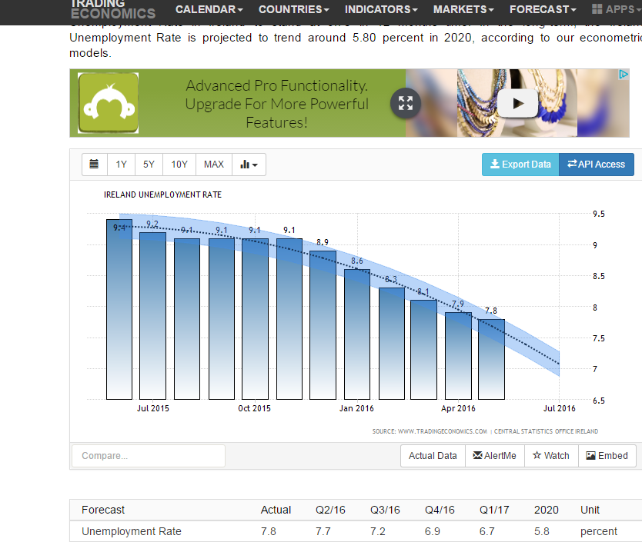
Question: What does this forecast tell you about unemployment in Ireland over the next 4 years?

Gross Domestic Product
Gross domestic product is the total amount of goods and services that is produced within a country from one year to the next. It is measured in money terms.
If Ireland produced 1,000 products at €5 each, the GDP would be €5,000.
Gross National Product
This is the Gross Domestic Product that is produced less the foreign direct investment in an economy plus profit sent back to a country from abroad.
In Ireland for example, it is all products made less all the profit made by Non-Irish firms that is sent back to the home country plus profit made by Irish firms that are operating abroad.
GNP= GDP - FDI + Profits made abroad
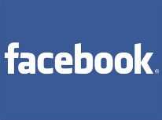
So why is the distinction between GDP and GNP important?

Well there may be a significant amount of money that is sent back from companies operating in a home country. Therefore the GDP reflects total goods produced while GNP is a true reflection of money left in a country for spending and saving.

Economic Growth vs. Negative Economic Growth
*Very Important*
Economic Growth occurs when we produce more goods in a country in one year than we produced in the previous year. So if we produce more goods in 2012 than in 2011, there would be a period of economic growth.
Example
Produce 1,000,000 (one million) products at €10 each in 2011, produce 1,100,000 products at €10 each in 2012.
2011- €10 x 1,000,000 products/services = €1,000,000 (GDP)
2012- €10 x 1,100,000 = €11,000,000 (GDP)
Economic Growth has occurred as GDP has risen by 1,000,000 (million) in 2012.
However if the average price of the good was to rise and not remain the same, i.e. the cost of the goods were €11 as opposed to €10 in 2012, this would not lead to economic growth as inflation would have caused the price of the goods to rise.
Negative economic growth would therefore be when we produce less goods and services from one year to the next.
The benefits of economic growth
Employment will rise: As the economy experiences growth, there is in turn more demand for people to work to produce the products and services.
More choices: As the economy grows, new businesses will come onto the market giving consumers more choice for products and services.
Rise in Standard of Living: People will have more money to spend and access to products and services.
Government Finance goes up: Revenue will increase as more people have money to spend and will therefore buy goods and services. This will lead to an increase in taxes collected by the government.

So what do we know about Ireland?
Do we have a period of economic growth or are we in what is known as a recession? Have we heard recession before and what do we know about it?

Answer:
The Central Statistics Office measures the amount of goods and services produced every 3 months. If less goods and services are being produced in 2 consecutive quarters then the economy of that country is in a recession.

