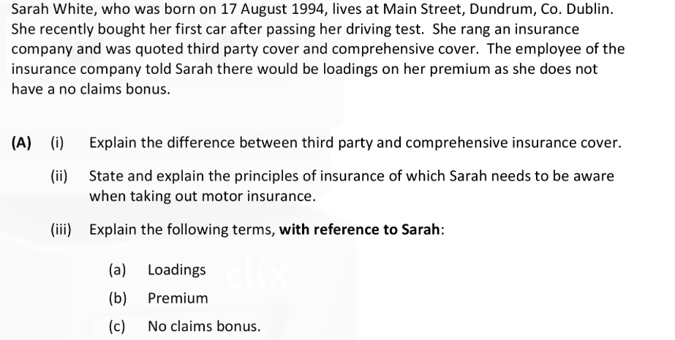
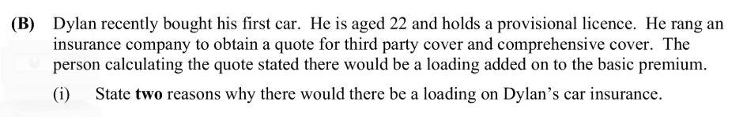
(ii) What is the name of the person working for the insurance company who calculates the premium?
(iii) Once Dylan takes out insurance, what is the name of the contract he will receive that states the insurance policy is now in place?
(iv) What is the name of the other type of car insurance that Dylan has not mentioned?
(C) (i) Ryan rang the insurance company to insure his house for €50,000. A fire occurs causing €20,000 worth of damage. The house is worth €200,000. How much compensation will Ryan receive? Show your workings.
(ii) Ciara rang the insurance company to insure her house for €150,000. A fire occurs causing €100,000 worth of damage. The house is worth €200,000. How much compensation will Ciara receive? Show your workings.
(D) Katy Perry wants to insure her house and contents. Her house is valued at €400,000 and contents at €40,000. She has a burglar alarm and is a member of a Community Alert Scheme.
On November 15th she received the following quotation from Property Insurance Ltd:
Insurance | Quote
Buildings | €10 per €40,000
Contents | €5 per €2000
Alarm Discount | 10%
Community Alert Scheme | 10%

