Why are Ratios prepared?
- Evaluate company performance from one year to the next
- Evaluate company performance comparative to other businesses in the same industry
- Determine size of dividends payable to Ordinary Shareholders
- Calculate corporation tax payable to the government based on profits made
- Determine ability to acquire debt/equity capital for expansion

Who uses Financial Information?
- Management
- They will want information to know how the business has performed over the year and to learn if any changes are needed. This will help make decisions if needed

- Shareholders
- They will want to know if the money that they have put into the business has been used wisely by the firm in order to generate profits and pay them a dividend
- They want to know how much they can expect in dividends and they also want to know the value and security of their investment

- Banks
- They want to know if the business is profitable enough to be able to make loan repayments and interest repayments

- Trade Unions
- They will keep an eye on the company’s profits because if they know the business is doing very well, they may look for wage increases. They are interested in the security of employment and the future prospects of the company (will it expand and take on more workers, what are the promotion prospects of the workers)

- Competitors
- They will examine a business’s sales and profits to see how big a threat the business is to them

- Suppliers
- These are interested in a business’s accounts in order to assess the firm’s credit-worthiness. I.e. can the firm can pay for goods supplied on credit?

- Employees
- Will want to see if the firm is performing well for job security and promotion prospects

- Government
- Will want to see the performance of the firm to assess how much tax it owes

Credit: Edco
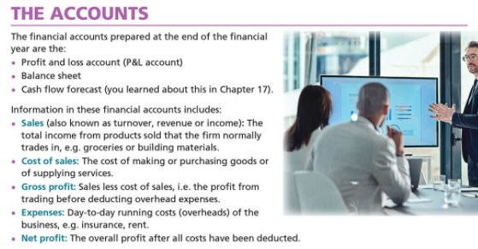
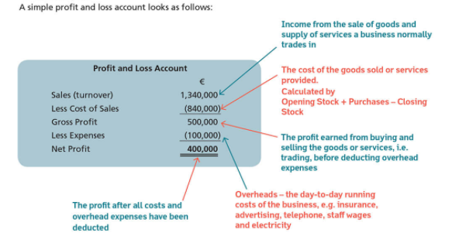

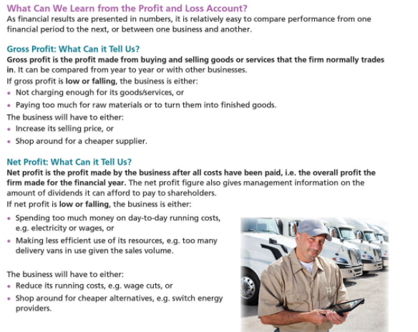
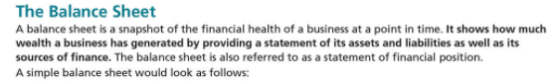

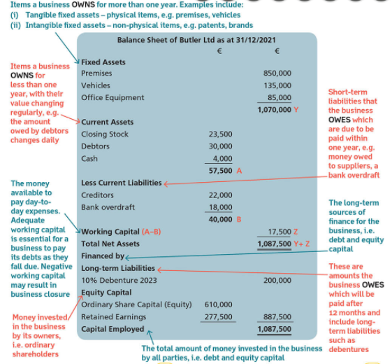

Limitations of Ratio Analysis
- Ratios do not take into account industrial relations issues in a business
- Ratios are based on past figures and not projected future ones
- Assets may not be shown to their full value
- Does not consider business environment, for example competitors or recession
- Inflation/deflation may impede comparisons from one year to the next
- Balance sheets are only true for the day they are written

