Budgets

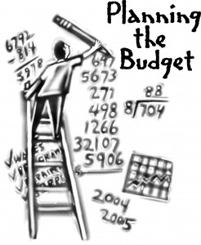

What is a budget?
A budget is a money plan where you can organise and control your finances. It will allow you to plan for the future and recognise times of surplus cash (extra money left over) or when you are in a deficit (negative) with your finances.
Types of Budgets

Monthly Budgets
Budget Estimates
Actual vs Difference
Revised Budget

Before we look at each type of budget, it is important to look at reasons why creating budgets are important.
- Take control of your finances- Know what is going on and what to do with your money.

- It will help you identify times of surplus or deficits when it comes to times of big purchases, e.g. buying a house or car.

- Examine your spending habits, e.g. are you spending too much on discretionary items.

- Enabling you to plan for the future. E.g. have enough money left over to go on holiday.

Remember from First Year:
What are the 3 types of Income and what are the 3 types of Expenditure?
Income:
Expenditure:
We record these Incomes and Expenditures in a Budget based on figures provided in a question.
Sample Monthly Budget
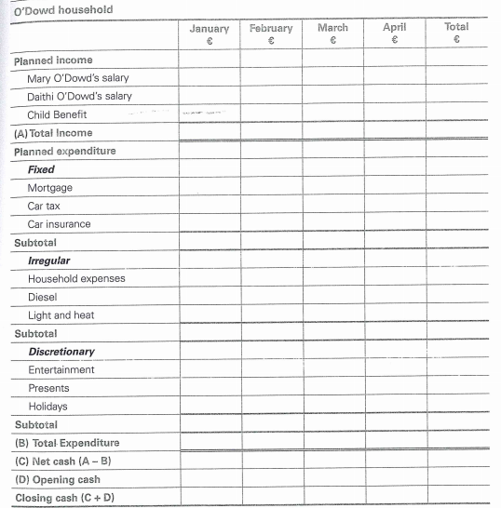

Net Cash/Opening Cash/ Closing Cash
Net Cash: This is the difference between Income and Expenditure- the money you are left with. Can be positive or negative.
Opening Cash: The money you bring forward from last month- last month’s Closing Cash.
Closing Cash: When we add Net Cash and Opening Cash together. The final figure for that time period.
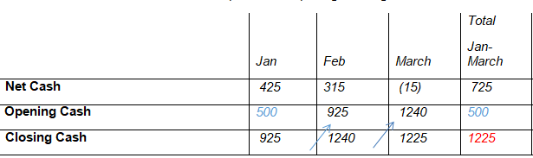
Please note the following rules
The opening cash for the first month is the opening cash in the total column also
The closing cash in a month becomes the opening cash in the next month
The last two closing cash figures should be the same- this shows that the budget has balanced
Don’t worry, these will become very clear as we move through the practice question.
The Financial Issues a budget will present:

- Budget Surplus- More income than expenditure. This is a positive and so the household should save to earn interest in a savings account rather than just sit at home. They could also look to invest this money, but beware of the risks

- Budget Deficit- More expenditure than income. This is a negative and so the household should look to correct this. They could reduce discretionary expenditure, get a short term finance to cover them, use previous savings, or try to source extra income like through overtime

- On-going financial deficit- Where the cash flow is constantly negative, they will need to make sure they can live within their means. They will need to closely monitor what they are spending and make the necessary cuts such as increasing income and reducing expenditure

- The need to keep records for managing finance- particularly if errors are constantly being recorded

Budget Estimates
Budget estimates are partially completed (small bit done already) type of budgets that you will complete for a household. Usually, the Jan-March parts of the budget will be completed and you will use the information in the question to complete for the remaining 9 months of the year (April to December).
Income | Jan | Feb | March | Total  Jan- Mar | Estimate  Apr-Dec | Total for Year
Salary | €1000 | €1000 | €1000 | €3000

Important information to remember:
- Read each part of the question carefully and look at what month the change happens.
For example, if a person’s salary of €1000 increases in October by €100, then April, May, June, July, August, and September will remain at the normal figure of €1000 and the change will come into effect in October (€1000 + €100)
1000 (Apr) + 1000 (May) + 1000 (June) + 1000 (July) + 1000 (August) + 1000 (September) + 1100 (October) + 1100 (November) + 1100 (December) = €9300.
Income | Jan | Feb | March | Total  Jan- Mar | Estimate  Apr-Dec | Total for Year
Salary | €1000 | €1000 | €1000 | €3000 | €9300

- Add your total figure for your new estimate (example of €9300 above) to your total figure in Jan- March (€3000 above) to get the year totals.
Income | Jan | Feb | March | Total  Jan- Mar | Estimate  Apr-Dec | Total for Year
Salary | €1000 | €1000 | €1000 | €3000 | €9300 | €12300

- The Opening Cash in Jan is my Opening Cash in my Year Total column and closing cash in Jan- March is my Estimate Opening Cash Figure.
 | Jan | Feb | March | Total  Jan- March | Estimate  Apr-Dec | Total  Jan-Dec
Net Cash | 425 | 315 | (15) | 725 | 18255 | 18980
Opening Cash | 500 | 925 | 1240 | 500 | 1255 | 500
Closing Cash | 925 | 1240 | 1225 | 1225 | 19480 | 19480
Niall O’Connor Salary- Workbook pg. 24
10% increase on August 1st. Therefore April, May, June, July all stay the same as the original estimate as there has been no change to these figures.
1200 (Apr) +1200 (May) +1200 (June) +1200(July) = €4800
To get the 10% increase in August we must increase €1200 by 10%.
1200 x 10% = 1200 multiplied by 10, divided by 100 on our calculators = 120.
1200 +120 = 1320- This is now our new figure for August, September, October, November and December.
1320 (Aug) + 1320 (Sep) + 1320 (Oct) + 1320 (Nov) + 1320 (Dec) = €6600
Remember the Bonus of €400 in December is then added on:
€4800 + €6600 + €400 =€11800
We then simply add our estimate of €11800 to our already completed Jan- March figure of €3600 to get a year total of €15400.

Mary O’Connor Salary
€500 in overtime between April and December.
Therefore, her wage will remain the same for these remaining 9 months of the year and she will just receive an extra €500 figure.
1000 (Apr) + 1000 (May) + 1000 (June) + 1000 (July) + 1000 (Aug) + 1000 (Sep) + 1000 (Oct) 1000 (Nov) + 1000 (Dec) = 9000
€9000 +€500 = €9500.
We then add our estimate of €9500 to our already completed Jan- March figure of €3000 to get a year total of €12500.
Child Benefit
Child Benefit is expected to increase by 10 euro per child and they have 2 children, therefore we know that child benefit will be increasing by €20.
Will come into effect in October, therefore Child Benefit will stay the same in April, May, June, July, August and September.
320 (Apr) + 320 (May) + 320 (June) + 320 (July) + 320 (Aug) + 320 (Sept) = €1920
Increases by €20 in October. 320 +20 = €340.
340 (Oct) + 340 (Nov) + 340 (Dec) = €1020. We then add the 2 figures (1920 +1020) = €2940
€2940 + €960 = €3900

Budget Comparisons

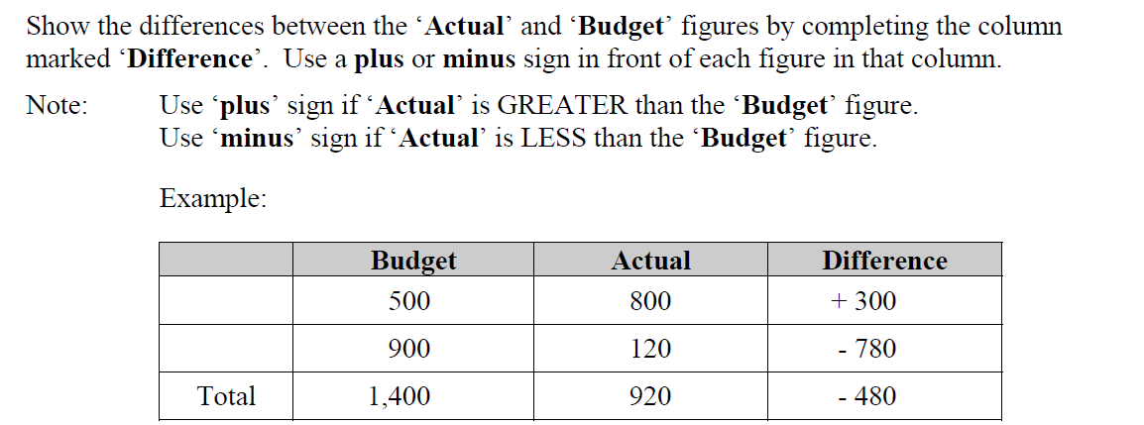

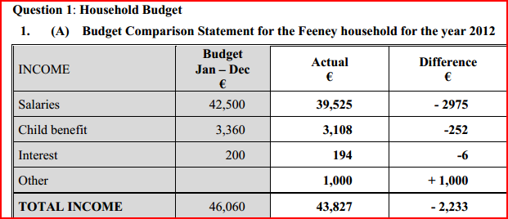

- Opening Cash will always be the same as the opening cash figure in the question given
- Always leave the opening and closing cash in the total column blank.

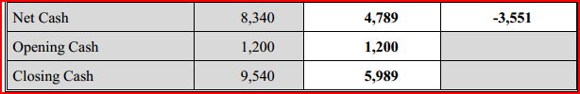
Revised Budgets
Read the question carefully as this budget asks you to revise an original budget (A budget that was made before). You are being asked to basically redo a budget for 3 months and make changes to what an original budget was meant to look like.

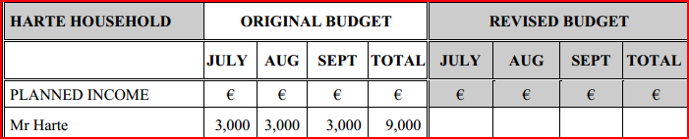

€31,200 divided by 12 months of the year = €2,600.
Mr. Harte now has a new/ revised salary of €2600 as opposed to the €3000 he thought he would have when the original budget was prepared.

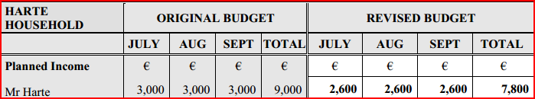

You will be told that for some of the workings all income and expenditure are to remain the same. This means that the figures stay as the original budget.

The opening cash figure will be the same as your first opening cash in January that was given to you and again in the total column.

