International Trade
Domestic trade involves the exchange of goods and services in a country. E.g. buying Brennan’s bread from the local shop.
International trade however is concerned with selling goods and services to, and buying goods and service from other countries. It involves exporting and importing.
When Irish businesses sell products and services to foreign countries, this is called exporting. The good/service leaves a country causing money to come in. We as a country export for many reasons such as increasing profit margins for Irish businesses and to diversify business portfolios. Ireland exports 23% to the USA and 16% to the UK.
Examples of Irish exports would be Lamb, beef, Guinness. We make it here, we sell abroad, and money comes into the country.
When Irish businesses and people buy products and services from foreign countries, this is called importing. The good/service comes into a country causing money to go out. We as a country import for many reasons such as having a unsuitable climate to produce certain goods, a lack of skills, or a lack of natural resources. Ireland imports 34% of trade with the UK.
Examples of Irish imports would be cars and phones. They are made abroad; we buy here, money going out of the country.
Example 1:
Produce goods/services- Export Abroad
Ireland produces and Export out of country (e.g. beef/ potatoes/pharmaceticals).
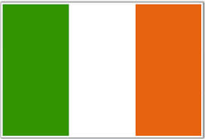 ------ 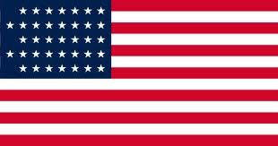
Example 2:
Produce Goods/Services Import from abroad
Foreign companies produce and we Import from abroad (e.g. cars).
-------
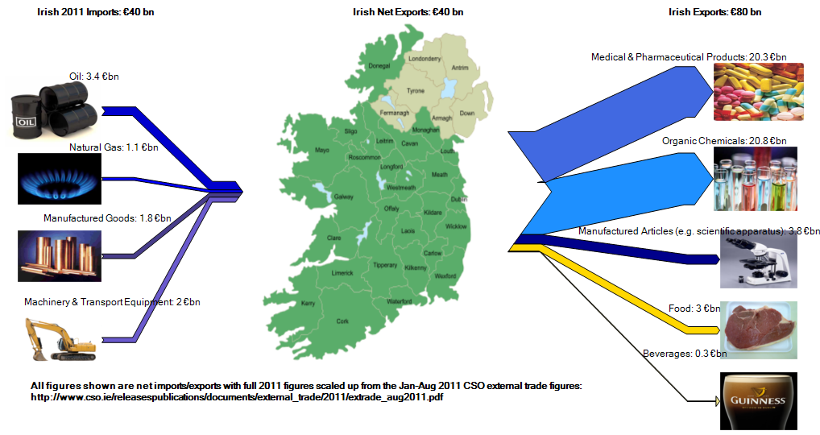
Visible Trade
These are visible products that can be seen going in and out of a country.
-Visible Exports and Visible Imports
Visible exports are goods produced by a country that causes money to come into a country. We can see them and so they are tangible. Remember: Exports are sold abroad meaning we get paid for producing them. Example- Jameson selling whiskey to U.S.A.
Visible Imports are goods produced by another country that need to be brought into our country. We can see them and so they are tangible.
This will cause money to leave our country. Remember: Imports are brought into a country meaning we have to buy them. Examples of visible imports would be German/Japanese Cars, an Irish shop buying oranges from abroad.
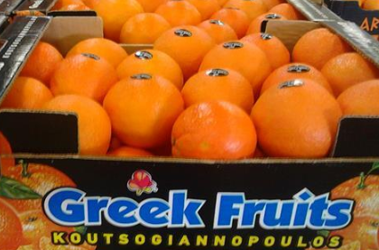
Invisible Trade
Invisible Trade deals with services. No physical product can be seen going in or out of a country. Money goes into or comes out of a country as a result of the sale or purchase of services.
-Invisible Exports and Invisible Imports
Invisible exports are services produced by a country that causes money to come into a country. Irish people produce the services and make earnings that are given to our country. Examples would be tourists using Irish hotels, or Irish bands like The Script playing a gig abroad.
Invisible Imports are services produced by residents in a country that cause money to go out of a country. Foreign people produce the services and Irish people use them causing money to go out of the country. Examples would include Irish people going on holidays or artists coming to perform in the 3Arena and sending the money abroad.
Reasons for Importing
- Countries import to obtain raw materials not available in their own country that are needed by their domestic industries
- Countries import to obtain capital goods (e.g. machinery) not available in their own country that are needed by their domestic industries
- Countries import to obtain consumer goods that cannot be made, or cannot be made at a reasonable price, in their own countries- e.g. bananas in Ireland
- The price is cheaper to import than it would be to make here
Reasons for Exporting
- Countries export to earn more money
- Countries export in order to create employment in their own countries that would not otherwise be created
- Countries export in order to sell off their surplus production. Selling the surplus goods abroad earns extra income for these countries
- To bring in foreign currency that can be used for exports
Problems for Irish firms in International Trade
- Language differences make communications more difficult
- Transport: all Irish exports must bear the additional cost of sea or air transport, as well as the normal road or rail transport
- Insurance costs are high due to the additional handling of goods arising from extra transport methods required
- Different countries set different minimum standards of production and different specifications for products
- Currencies change in value on a day to day basis adding greater risk for importers

Barriers to Trade
Quota
This is a limit on the number of units of a good that may be imported/exported. Quotas discourage imports and/or encourage sales of domestically produced goods. Example: The EU has placed a quota on the amount of clothes from China that can be imported into the EU
Subsidy
A subsidy is money that a government gives to its own domestic (indigenous) businesses to allow them to sell their products or services more cheaply. In international trade, it can help businesses to export more. Example: The EU has subsidised agriculture and aircraft manufacturing in the past protecting them from rival non EU competition
Embargo
To reduce the number of foreign imports and to help indigenous businesses, a country puts a complete ban (called an embargo) on all foreign imports (or imports from a specific country) into the country. Its consumers have no choice then but to buy from indigenous businesses. Example: EU countries placed a blanket embargo on the import of UK beef because of the high levels of BSE in the UK.
Tariff
This is a tax on the price of goods imported. As a result, imports are more expensive and they will be less expensive in a domestic market. Example Donald Trump is imposing a 25% tariff on steel imports to the USA.
Administrative regulations
Such as customs delays, excessive paperwork designed to exclude imports.

The Balance of Trade and Balance of Payments
The Balance of Trade is the difference between visible exports and visible imports. It is Visible Exports – Visible Imports
Balance of Trade
Visible Exports > Visible Imports = Surplus
Visible Exports < Visible Imports = Deficit
Balance of Payments
The Balance of Payments is the difference between Total Exports (Visible & Invisible) and Total Imports (Visible & Invisible). It is the total amount of money entering and leaving a country during the course of a year.
It includes the Balance of Trade plus the Balance of Invisible trade.
Balance of Payments
Total Exports > Total Imports = Surplus
Total Exports < Total Imports = Deficit
We will be practicing a lot of questions using worksheets for The Balance of Trade and Balance of Payments
Balance of payments surplus is the amount by which the money coming into a country is more than the money going out in a particular period of time.
Correcting the deficit
If a country’s balance of current account is a deficit this can be overcome by either increasing exports or decreasing imports.
Increasing Exports: This would require countries to increase the amount of products produced in a country that can be sold abroad. State owned companies such as Enterprise Ireland provide grants to help Irish firms expand to new markets.
Decrease Imports: This would require a country reducing the amount of products brought into the country and in turn implement an IMPORT SUBSTITUTION policy, which involves replacing imported goods with domestically produced products.

