Management Activity: Planning, Organising, and Controlling
Planning
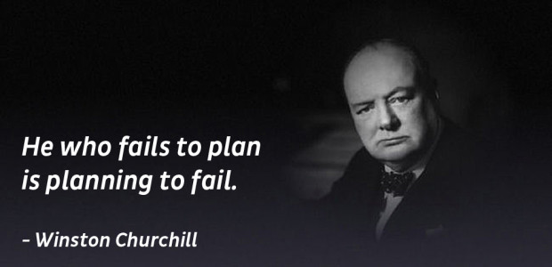
Planning means setting targets for the organisation and choosing the best course of action to achieve them. A business needs to map out a successful route to achieve its targets. It shows where the company wants to go and how it is going to get there.
For example, as a student of CNM you will make a study plan for your exams. It will show where you want to go and how you want to get there.
In business, it is obvious that if you do not plan effectively, you are likely going to be destined to fail, and this can have a huge impact on your business operations.
Effective Plans are SMART:
Specific
Measurable
Agreed
Realistic
Timing
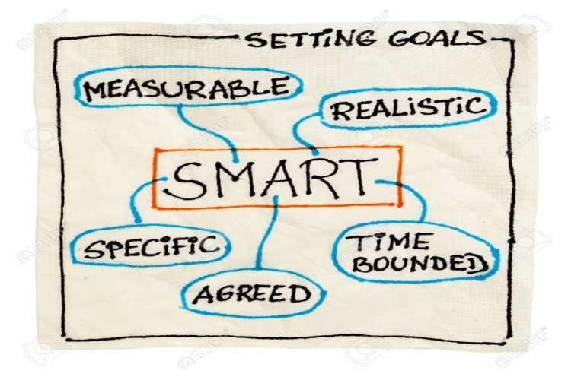
Example of SMART PLANNING: Coca-Cola
Specific
Very clear and specific aims. Everybody understands exactly where the business is going and there is no confusion in the direction the business is headed. Example: To be the market leader in soft drink distribution in Ireland for Coca-Cola is a specific aim.

Measurable
The target set can be evaluated- are we successful or not. In the business world you cannot afford to be making losses so you need to have measurable plans in place. Example: Coca Cola examine statistics against the industry average to analyse business performance.

Agreeable
All members of staff support the plan and so everybody involved is moving in the same direction. Performance Appraisal for hitting targets will help support this. Example: Coca- Cola outline their targets to staff at the beginning of the year.

Realistic
Objectives and targets that are too difficult to reach can de-motivate your staff if there is only a small chance that you can be successful. Example: Coca-Cola ask their sales team to try and get 10 new clients in Ireland to sell their products in each county over the next month, rather than 100.

Timing
Setting a clear time frame for achieving your goals are important. Plans should not be open ended as this can cause delays for decisions.
The example used in this question has a clear timeframe for the business to establish whether their goal has been met.
Steps in the Planning Process
- Assess your current situation
- Set your goal
- Decide your plan
- Implement your plan
- Review the plan

- Assess your current situation: SWOT Analysis
SWOT ANALYSIS
SWOT Analysis stands for:
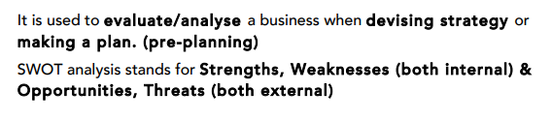
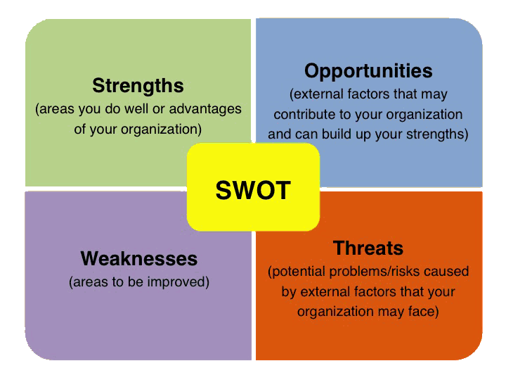

Sample Question: Conduct a SWOT Analysis for a business of your choice.
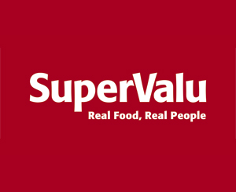
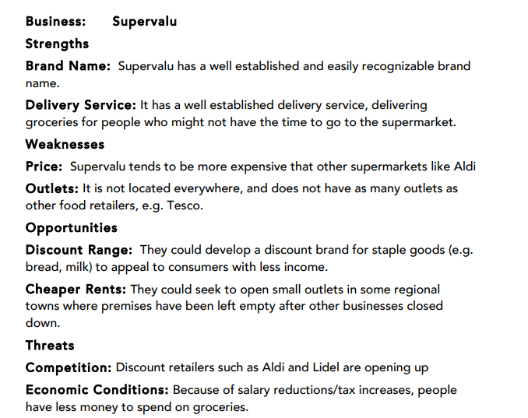
- Set a Goal
This is a visionary statement outlining who the business is, what the business does and where the business is going, containing the business’ values. It is the businesses most important goal.

Famous Mission Statements
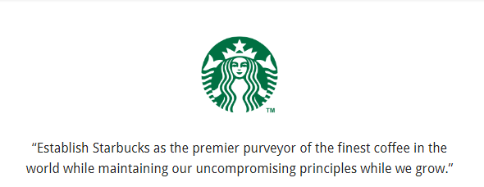
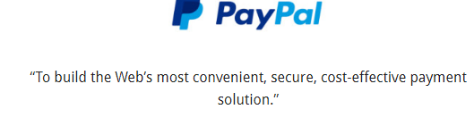
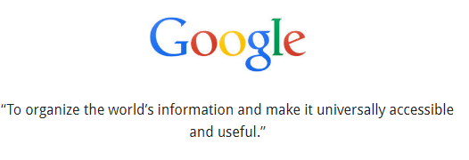
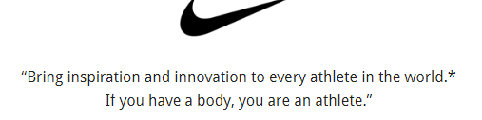

- Decide your Plan

To incorporate the mission statement, a business can put into place different types of plans.

Strategic Plans
This is long term planning covering a period of five years or more. It is usually drawn up by senior management and it outlines how the long term goals of the firm are to be achieved. Ideas are taken from the Mission Statement for them. It is important as it gives a long term picture and focus to work towards. The general outline is 1-5 years.
Example: An Irish start up may wish to expand to the UK market in the next 5 years and gain a 10 % market share over there

Tactical Plans
This is short-term planning which breaks the strategic plan into shorter more manageable periods, generally 1-2 years which is important as it helps the business achieve the strategic plan. It is usually drawn up by middle management.
Example: The Irish start up deploys UK agents in different parts of the UK to speak to retailers about distributing their products.

Operational Plan
This is the planning for the day-day running of the business, for example the annual marketing plan.
Example: The start-up creates a website or Facebook page to advertise its products and services.

Contingency Plans
This is back-up planning to cope with emergencies/ unforeseen events and unexpected circumstances. It is important to prevent disruptions to business and thereby prevents potential loss of profits and possible business collapse.
Example: Putting capital aside to set up more chains in Ireland if it becomes impossible to sell your product in the UK market at this time.

Manpower planning
This would involve having the right people with the right skills in the right place throughout the business. It involves doing a human resource audit and estimating future human resource needs.
Example: An Irish start up having the right number of staff to meet demand when business is booming and satisfy customer needs.

Financial Plans
This would involve preparing financial statements like Cash Flow Forecasts to predict the amount of income they will take in and expenditure they may have over a particular period of time.
Example: An Irish start-up will use their Cash Flow Forecasts when acquiring a loan in the bank to generate income.

- Implement the Plan
Management choses to put the plan in place and discusses with staff clearly. The goal is for everyone to buy into the plan

- Review the Plan
Regular meetings take place to review the plan and take action if needed.
Setting Goals
Organising
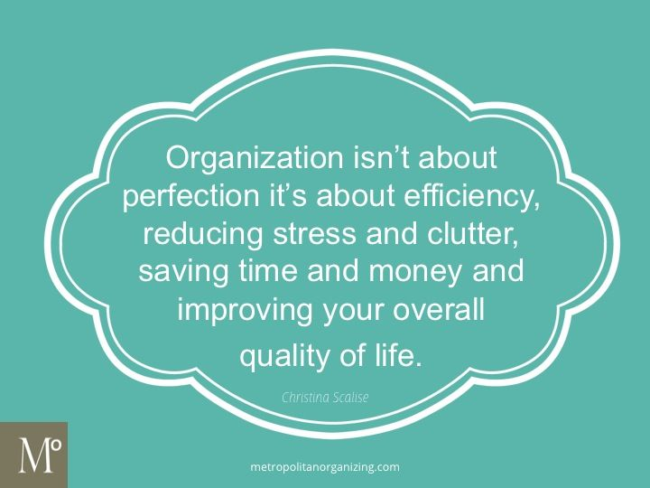
Organising involves a considered use of resources, so as to best achieve a firm’s objectives. It involves building an organisational structure for the business. This puts a specific shape on the business and helps to co-ordinate its activities.
Types of Organisational Structure
Types of Organisation structure.
- Functional structure.
Divided into departments. Clear chain of command.
Authority flows down and responsibility flows up
- Product Structure (music division, film division)

- Geographical structure. (branches in different countries)

- Matrix or Team structure. (different departments work as a team for duration of project

Functional Organisational Structure
The most popular structure with departments organised on the basis of who does what. All staff that do the same job are put in the same department.
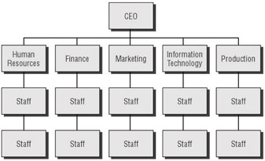
Benefits
- Due to specialisation, where each department concentrates exclusively on one function, e.g. marketing, production, sales or finance, employees and management build up high levels of skill and expertise through repetition and practice. This leads to efficiencies as tasks get done quickly and to a high standard
- The chain of command and line of authority are clear - clear lines of authority exist, and employees know whom to report to. There is a person in charge of each department, which improves coordination and motivation, as employees know what is expected of them and when
- There are clear communication channels - the structure helps create a clear communication line between the top and bottom of the business. Instructions flow downward from top management along the chain of command, and information is communicated upward. It may result in important information being communicated quickly, leading to quicker decision making
- Promotional paths - visible hierarchical ladder, providing career paths for employees / provides scope for promotion to the next level so the businesses can promote from within
Challenges
- As organisations get larger and top management needs to delegate more decision-making responsibilities to each functional area, the degree of autonomy may also increase, making coordination of activities more difficult
- If the company expands into new geographic areas, maintaining control of and managing the separate functions can be even more of a challenge
- Communications between departments can be slow and subject to misunderstandings - this can affect the speed at which an organisation can respond to events
Product Structure
A product structure divides business operations on the basis of the products that it sells.

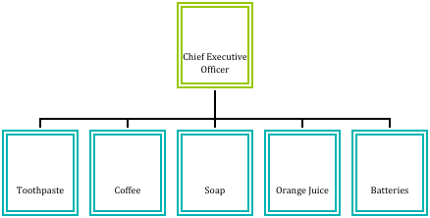
Benefits
- Focus is on consumer, so the producer can act faster to changes in consumer demand. This could result in increased consumer loyalty
- The business is able to monitor the performance and profit of each unit and make production decisions such as to increase or decrease
- Employees can develop expert knowledge which can be transferred when selling to consumers- this can lead to increased sales
Challenges
- Competition between departments may affect sales- look at car companies/beverages where they want to be the best at the expense of their own brand
- Lack of diversity for workers, job can become routine and demotivating with the inability to learn new skills in other areas- link to Maslow
- Time efficiency- a lot of people end up doing the same job- think when you go into a tech store, it may be better to have experts in each area

Geographic Structure
This is where the business divisions are based in geographic locations, rather than the products produced.
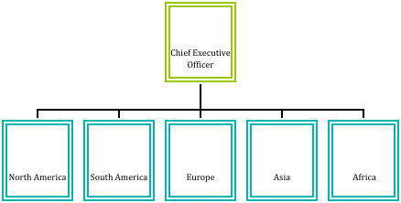

Benefits
- The managers know their market and so can make decisions that can be adapted to this market, such as taste and trends in one area over another
- Needs of local consumers can be dealt with quickly, leading to increased loyalty and sales

Challenges
- Decisions by senior managements can affect different departments, for example cutting costs could affect certain regions more
- Greater difficulty in maintaining consistent company image across lots of areas- there are more organisational structures to oversee
- Duplication of resources- same departments in different areas can increase costs, you may have various production factories in different markets rather than one central

Matrix Structure
A matrix type of organisational structure combines the traditional departments seen in functional structures with project teams. In a matrix structure, individuals work across teams and projects as well as within their own department or function.

For example, a project or task team established to develop a new product might include engineers and design specialists as well as those with marketing, financial, personnel and production skills.
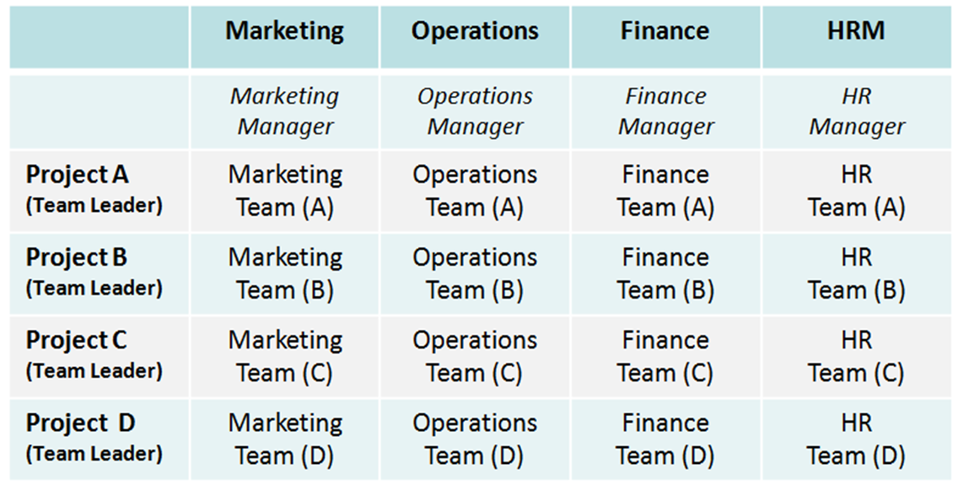
Benefits
- Personnel from various different departments bring new ideas / new ways of thinking to the project (innovation)
- Shared skills and expertise - employees can learn new skills from each other. It provides professional development / improved motivation for employees
- Responsibility is shared - although a team leader is appointed to control the project, the entire team shares responsibility for the task. All team members have an input into decision making and problem solving

Challenges
- Decision making may be slow as getting agreement at consultation stage could take time. Having all opinions considered may slow down the process
- Can be a conflicting pull on resources- a member from the sales team may be unwilling to agree extra funding for the production department
- Can be difficult to coordinate employees from different areas- being answerable to two different managers could lead to confusion and conflict. There could be a clash of loyalty between a team member’s own department and the project team
Choosing the Organisational Structure
The choice of which organisational structure to adopt rests with business management. They need to suit the best structure that meets the needs of the business.
Two important issues that may influence the choice of structure are:
- Chain of Command
- Span of Control

Chain of Command
Clear lines of authority exist and employees know who to report to.
There is a person in charge of each department, which improves coordination, as employees know what is expected of them and when. There is accountability as someone is responsible for each section.

Span of Control
Span of Control refers to the number of employees / subordinates that report directly to one manager/ supervisor in a hierarchy.
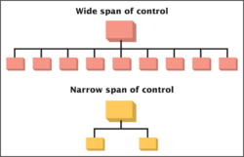
A wide span of control is when a manager is responsible for a large number of departments. It is where a manager is able to oversee a large group of employees and generally suits routine jobs that require little decision making or pressurised situations.
A narrow span of control is when the manager has responsibility for a smaller group of employees. It is suited to jobs where close supervision is required.

Factors affecting Span of Control
Trust:
If there is greater trust placed in staff, there tends to be a wide span of control. If there is little trust, there tends to be a narrow span of control

Type of Job:
Employees who perform routine tasks require less supervision, therefore management can use a wide span of control. Highly skilled work may need greater supervision and so a narrow span of control.

Skills of Workers:
Workers with a lot of skills and experience may be able to work freely at their duties and so have a wide span of control. Worker with few skills and no experience will need a narrow span of control.

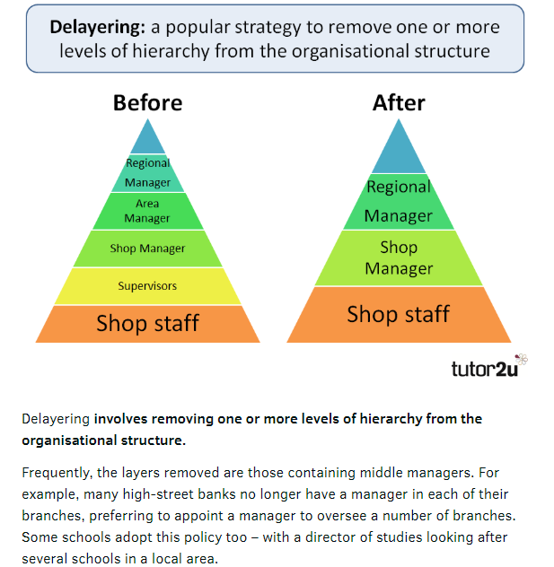

Advantages | Disadvantages
Messages pass through fewer levels which improves communication | Fear of losing a job may mean staff morale decreases
Wage costs reduced as managerial staff cut | A wider span of control for managers over numerous branches can lead to increased stress levels

Controlling
The control process involves comparing outcomes or results with the original plans and measuring performance. The firm may need to take corrective action to deal with deviations that are affecting objectives. For this reason the management activities of planning and control are clearly linked.

A business can achieve efficiencies with control as it:
- Minimises the costs and time associated with selling faulty goods to consumers/dealing with returns
- Avoids the loss of reputation and the ensuing lost sales in the future
- More satisfied customers
- Motivates staff and keeps them focused
- Helps managers evaluate business performance

The 4 main areas of business control are:
- Stock Control
- Quality Control
- Credit Control
- Financial Control

Stock Control
Amazon Example
https://youtu.be/zERrqLFotSY
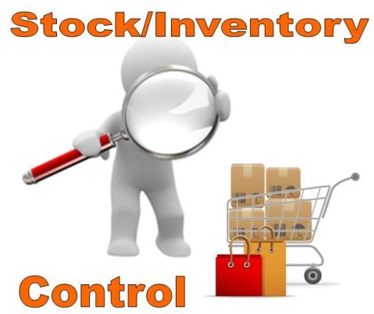
Stock Control is concerned with keeping optimum stock levels so that it doesn’t have too much stock or too little stock. Optimum stock levels lead to efficiencies because you have the right stock, in the right place, at the right time to meet production requirements and satisfy consumer demand.

Failure to have a good stock control system can result in consumers going elsewhere as you fail to meet their demand. It may also lead to increase storage costs, lower profits, theft, and production delays of units due to lower stock levels.

A good stock control system can increase efficiency and reduce costs for the business. It can increase consumer demand for your products due to reputation of meeting demand and it is also easier to identify theft as stock is accurately monitored.

Elements of a Good Stock Control System
- Minimum stock levels -buffer or safety stock as part of contingency planning. Will reorder stock when it drops to a certain amount
- Maximum stock levels- don’t go over
- Optimum stock level- this is the ideal stock level a business should have at a particular time, e.g. toys at Christmas v January
- Re-order level- the point at which new stock has to be ordered
- Lead time- day of ordering to day of delivery taken into account to ensure that there is enough stock on site

Managing Stock Levels
Stock Take
This is when employees physically count and record all stock in the business and compared to what is recorded on the business computer system. Any differences are identified for things like wastage or theft

Electronic Data Interchange
We have already learned that EDI allows firms to communicate information such as orders, invoices, and payments electronically rather than paper.
This helps to:
Lower costs- example staff costs reduced, goods not going past usage date
Lead times- easier to track stock in real time
Quicker reorders- very few instances of stock shortages

Just in Time
There are costs associated with overstocking and understocking and so some businesses will use the Just in Time System. This will mean that deliveries will arrive just as they are needed and in time for consumers. This will help to reduce costs such as storage and insurance for the business.

Quality Control
BMW Example
https://youtu.be/TiuaFwzJ4FU
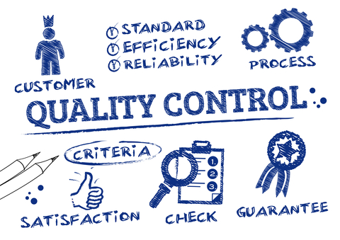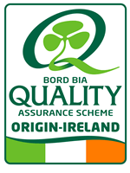
Quality Control is concerned with checking/reviewing/inspecting work done to ensure it meets the required standards.
With a good control system, consistently high quality products are being sold, resulting in repeat purchasing and consumer loyalty, cost savings, and a great reputation in the market place.

Implementing Quality Control

Focus on TQM
TQM is a management strategy designed to ensure 100% perfection and 100% customer satisfaction. It says that every person in the business is responsible for delivering quality to the customer. If a business follows the TQM principle, it will have perfect quality products.

Regular Inspections
Regular checks of products to ensure that standards are being met. Raw materials such as food will often have to be checked by kitchens before serving to customers.

Staff Training
Many times staff are the contact with customers and so it is important that they are correctly trained in the high quality standards and maintain their skill levels.
Businesses may also use quality circles which are discussion groups made up of workers in the business who discuss the job and make suggestions for improving performance.

Quality Awards
These are awards given by independent organisations to a business when they achieve a particular quality standard. Examples include the Q Mark, Bord Bia Quality Mark, and the ISO 9000 Series.
A Quality Award will allow a business to market their product more efficiently and charge a higher price as it is a brand that consumers can trust. Markets may also be opened up for exports as many symbols such as the ISO 9000 is recognised internationally.

Credit Control
Credit Control for Northgate Vehicle Hire Example
https://youtu.be/7MdhHIMX31k
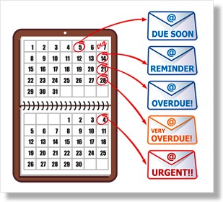
Buying on credit means Buy Now and Pay Later and credit control deals with your debtors and creditors. The debtors are people that owe you money and creditors are the people you owe money to.

The first step in an effective credit control system is to evaluate the credit worthiness of customers by getting a bank or trade reference.

Remember, debtors who are slow to pay can create liquidity problems for your business, and failure for a business to pay you can result in bad debts, so you must be careful with this. An effective credit control system will minimise liquidity problems and reduce the possibility of bad debts (bankruptcy). Setting realistic credit limits for customers can help achieve this.

Financial Control
Financial control for the business aims to ensure the business is keeping proper financial control and is profitable. A business that does not have proper financial control could risk losses and eventual closure. Tools such as Ratios and Cash Flow Forecasts will allow the business to manage finance correctly.

The steps involved in an effective financial control system are:
1. Set Targets
2. Compare results to targets
3. Investigate the differences
4. Take action

