Introduction to Management: Leadership and Management
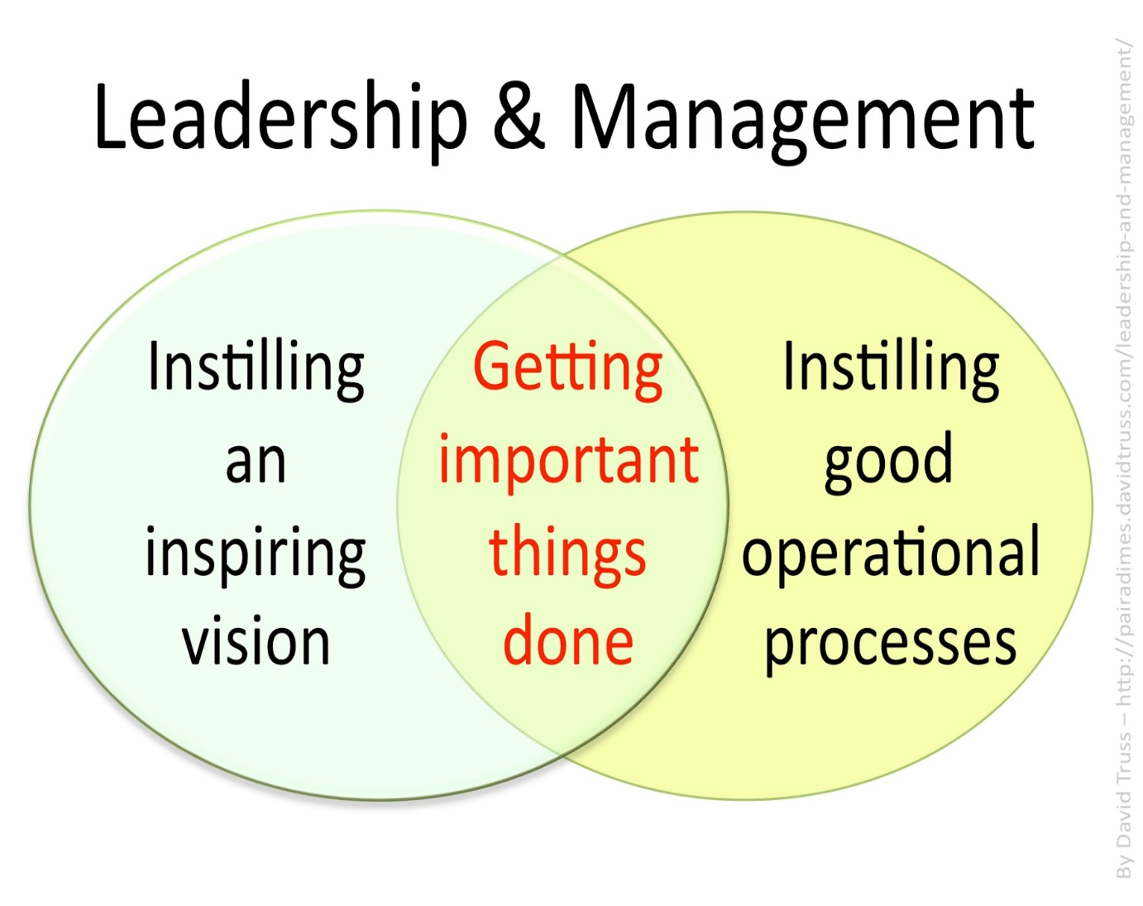
Management
Management is the process how plans are made and resources are organised to achieve objectives.
The management process will involve:
Management Activities
Planning---------------Organising---------------Controlling
Management skills
Leading---------------Motivating---------------Communicating
Management Characteristics
Time Management: Prioritise and delegate tasks- Example- delegate responsibility to your goalkeeping coach to work with the keepers while you sort out the rest of the team, ensure jobs get done on time, schedule and monitor jobs. This enables the business to be efficient and remain competitive
Decisiveness: Make decisions and take action if needed
Hard Working: Must be prepared to put in long hours, have a high work ethic, this will set an example for employees around them
Flexible: Capable to adapt to changing circumstances- example difficult customer, somebody needing emergency time off
People Person: Managers tend to spend a lot of time with employees, suppliers, other business owners, and customers. For this reason they need to be good with people
Differences between Entrepreneurs and Managers
 | Entrepreneur | Manager
Idea Genration | They are the ideas person, they spot a gap in the market. | They try and put the entrepreneurs idea in the practice.
Risk Taking | They ake both a personal and finacial risk. They could lose their money if the business is not successful. | Take fewer risks- if the business fails, they leave and look for a new job.
Running a Business | Focus on long term objectives, less time on day-day activities. | Look after day-day activities, are targets being met, delegate work to employees etc…
Control | Full control- do not need to consult with others. | Will have to consult with the entrepreneur before making big decisions.

Management skills around us:
ALWAYS LINK BACK TO:
Leading---------------Motivating---------------Communicating
In a Business
- Be a market leader in a competitive environment
- Day to day operations- leading your staff
- Employing staff-integration into the job
- Co-ordination/delegation of duties, motivate staff to succeed
- Stock control management
- Communicate changes to the workplace
In your Community
- Setting up clubs and societies
- Chair and lead meetings
- Delegation of roles and responsibilities
- Communicate any changes
- Plan and organise events
- Leadership to get people involved and motivated
In your home
- Plan events- e.g. holidays
- Control finances- e.g. budget for shopping/bills paid on time
- Ensure jobs get done around the home and on time-Delegation
- Communication
For the Government
- Provide high quality services for the public
- Communicate to the public any changes
- Lead the governance of the country- e.g. Government Budget
- Motivating ministers to complete jobs for the benefit of the country

Management Skills: Leadership
Leadership is the ability to influence the behaviour and actions of others in the pursuit of certain goals through guidance, communication, and delegation. Example- a team captain. It is very difficult to lead alone, and the real power of an effective leader is to have the ability to have a positive impact on the actions and behaviour of others around you.
It is very important for a leader to delegate responsibility as it will be near impossible to get all work done by themselves. Delegation means the assignment of authority/power to another person. It is generally assigned from a manager to a subordinate, to undertake a specific work task or project. Example- delegate responsibility to your goalkeeping coach to work with the keepers while you sort out the rest of the team in football.
Benefits of Delegation
- Manager is not required to do all the work and has more time for strategic planning.
- Task/project may be completed to a higher standard due to the level of personal care
- Work gets done faster
- Accountability provided by delegation
- Increased employee motivation from job enrichment/ improved staff morale
- Good way to train employees for management
The following three leadership styles are generally used in business management:
- Autocratic
- Democratic
- Laissez-Faire (Free Reign)

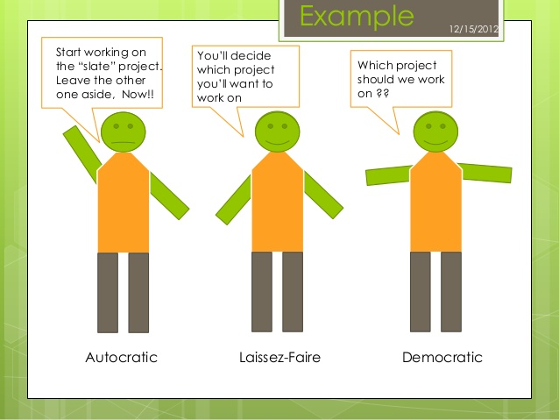
Autocratic Leader: My Way or the High Way
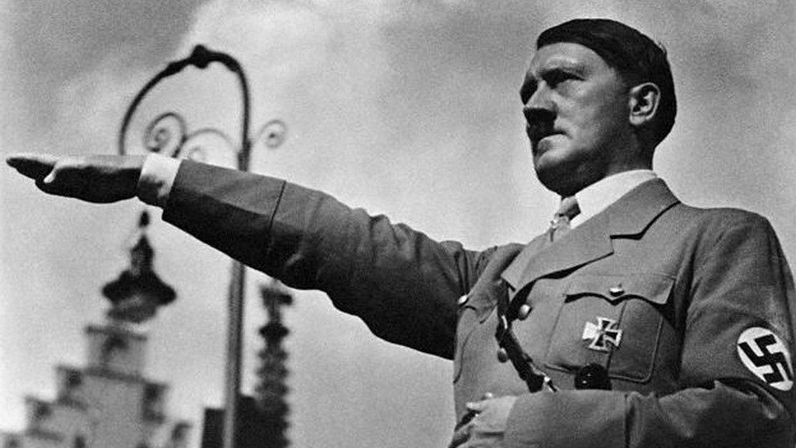
Autocratic Leadership is a leadership style characterized by individual control over all decisions and little input from group members. Autocratic leaders typically make choices based on their ideas and judgments and rarely accept advice from followers. They often motivate through fear and intimidation. Example: Hitler
There are very few examples of this leadership style today, although it does still exist. For example, in the army you would need to have autocratic leadership. Why?
Advantages | Disadvantages
Quick decisions are made- only one person in control which saves time | Frustration and low morale amongst staff- they are not being heard- output will also suffer
Provides strong motivation and job satisfaction to the leader who can dictate terms | Higher staff turnover- a lot of staff will not want to work under this management style where there voice is not heard
Good in routine situations where there is little scope for innovation | Work overload for the manager and time wasted on tasks others could complete

Democratic Leadership: Your opinion matters to me
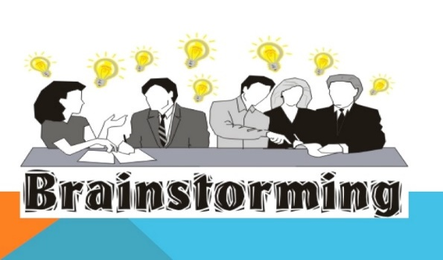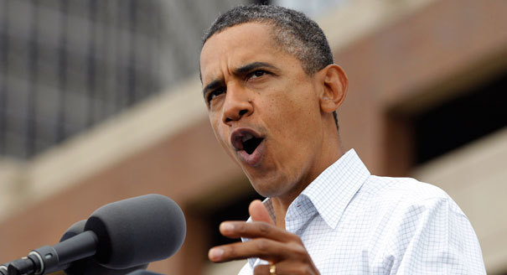
Advantages | Disadvantages
Because group members are encouraged to share their thoughts, democratic leadership can leader to better ideas and more creative solutions to problems | Slower Decision Making which can be a problem when a quick decision may be needed
Group members also feel more involved and committed to projects, making them more likely to be more motivated about the end results | Decisions can be overcomplicated as the views of too many people need to be taken into consideration  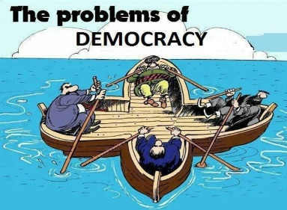
Improved Industrial Relations as employees are being listened to | The wrong decision may be reached in trying to keep certain people happy
Democratic Leadership is when workers take a more participative role in the decision-making process. Everyone is given the opportunity to participate, ideas are exchanged freely, and discussion is encouraged. While the democratic process tends to focus on group equality and the free flow of ideas, the lead of the group is still there to offer guidance and control. Democratic leadership tends to lead to higher staff morale and motivation. Example: Barack Obama

Laissez Faire Leadership (Free Reign)-Freedom to make choices
Laissez Faire Leadership is when leaders are hands-off and allow group members to make the decisions. Managers act as facilitators and provide targets and resources for the workers and then allow them to get on with the work themselves. Example: Warren Buffet
Warren Buffet is a well-known investor and businessman, who in 2008 was the richest man in the world.
Advantages | Disadvantages
High staff morale as people feel involved in the decision making process of a business | Not suitable for everyone-some people are not good at setting their own deadlines, managing their own projects and solving problems on their own
Ownership of decision making for staff will lead to decisions getting maid quicker | Not ideal in situations where group members lack the knowledge or experience they need to complete tasks and make decisions
Encourages intrapreneurship | Lack of control for managers- perhaps targets are not being met and regular meetings needed

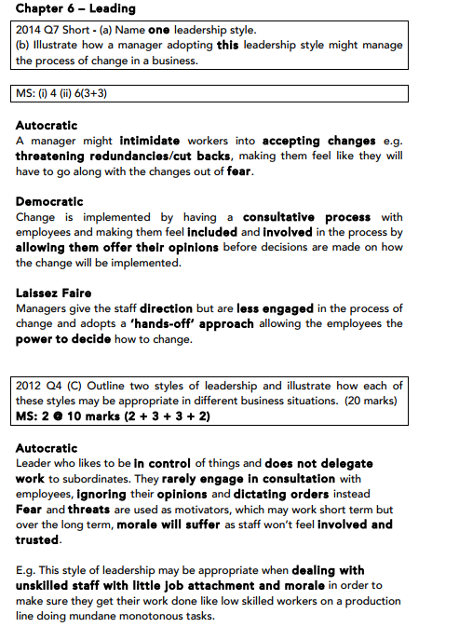
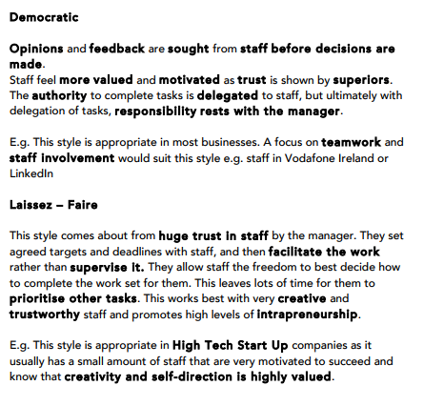
Management Skills: Motivation
Motivation is a way of getting people to do something. It can encourage people to work hard and give their best in a specific role if properly motivated.
In Business, there are two theories of motivation we will look at:
- Maslow’s Hierarchy of Needs
- McGregor’s Theory X and Theory Y
Both of these appear a lot on the Exam- can be asked to evaluate/illustrate/outline!!
Maslow’s Hierarchy of Needs
Maslow stated that people’s needs motivate them. Maslow put forward a theory on motivation based on a hierarchy of needs. As one need is satisfied then the need immediately above it on the pyramid becomes the dominant motivator/takes precedence.

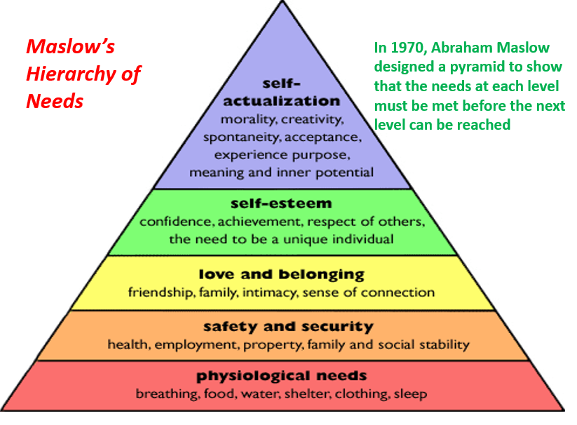
- Psychological Needs: These are the basic needs we need to stay alive such as food and water. A worker satisfies this need by spending their wage/salary on these goods and will be motivated to work to achieve support themselves at this level

- Safety and Security: These are the needs to feel safe and secure in our own lives. Our employers meet these needs by ensuring that we work in a safe environment
You will also start to look for job security in your position- perhaps through a long term contract as you start to look for a mortgage. For example, in teaching it is very difficult to get a long term contract and this is a huge issue in teaching today

- Love and Belonging: You begin to fit in in your job. We get along with our peers and feel part of the team. If you don’t have this in your job you may start to feel alone and isolated from everyone else and therefore may look to leave. For example, many businesses such as Facebook regularly have team bonding days to integrate all staff and ensure they feel part of the team

- Self-Esteem: You now want recognition for your work- you want to feel important and valued. This can come through the possibility of promotion or pay rises for work that is being done

- Self-Actualisation: You are fulfilling your true potential. You are motivated and are working in a job that is both challenging and fulfilling for you. Failure to know that this level is in reach may lead to demotivation amongst staff, however if you reach this stage you are being all you can be.

Evaluation of Maslow’s Hierarchy of Needs
Maslow’s motivational theory is useful as it shows managers how to find suitable ways to motivate employees and develop their careers. Businesses that are able to match these needs will generally retain staff.
However, in real life many employees need to satisfy more than one need at a time and the needs of staff will vary. The key will be to treat staff as individuals and identify which stage each employee is at.

McGregor Theory X and Theory Y – (Douglas McGregor 1960)
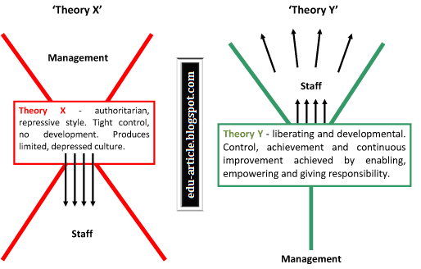

In 1960, American social psychologist Douglas McGregor developed a theory of motivation that suggests there are two opposite approaches to management: Theory X and Theory Y.
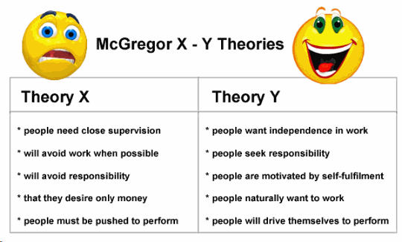
Theory X managers believe that their employees:
• Don’t like to work
• Are lazy
• Have no ambition
• Like to be told what to do
• Are only motivated for the money
Theory X managers keep a close eye on workers and uses threats and punishments to make sure they do their work or promises them more money.
Theory Y managers are the opposite. They believe their employees:
• Like working
• They have ambition
• Want responsibility
• Like more challenging work
Theory Y managers motivates by offering promotions, praises employees and delegates work to good employees.
Evaluation of McGregor Theory X and Theory Y
McGregor’s Theory X and Y is a good idea about motivation as it makes sense that in Theory Y employees will work harder and make a better contribution to the business if they are treated as responsible and valuable employees.
In Theory X, managers that adopt a Theory X approach could lead to poor levels of motivation in some cases as workers are not involved in decisions and are only told what to do.
The criticism is that there all managers can fit into just 2 categories which overall may be too simplistic but nonetheless gives an interesting insight into workers motivations.

