Managing my Income and Expenditure Day to Day
Unfortunately in life, we do not have unlimited access to income and must be wise when choosing our expenditure. It is therefore important to make sensible financial choices throughout our life so that we have enough money for when we need it
In Business Studies, we will learn how to manage finances properly and this will help us throughout our lives to:
- Make smart purchases and don’t waste money
- Grow our income
- Borrow wisely
- Reduce tax bills
- Understand services available from banks

As we keep a record of our income and expenditure, we usually use the money we have to spend on needs and wants
Needs: Essential items required to survive. Examples would be food and water
Wants: Items in addition to our needs, such as designer clothes, I-Pads
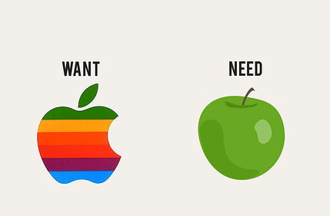

Spend a few minutes in pairs discussing your needs and wants as 1st Year Business Students at Coláiste Na Mí and draw up a list
Financial Life Cycle
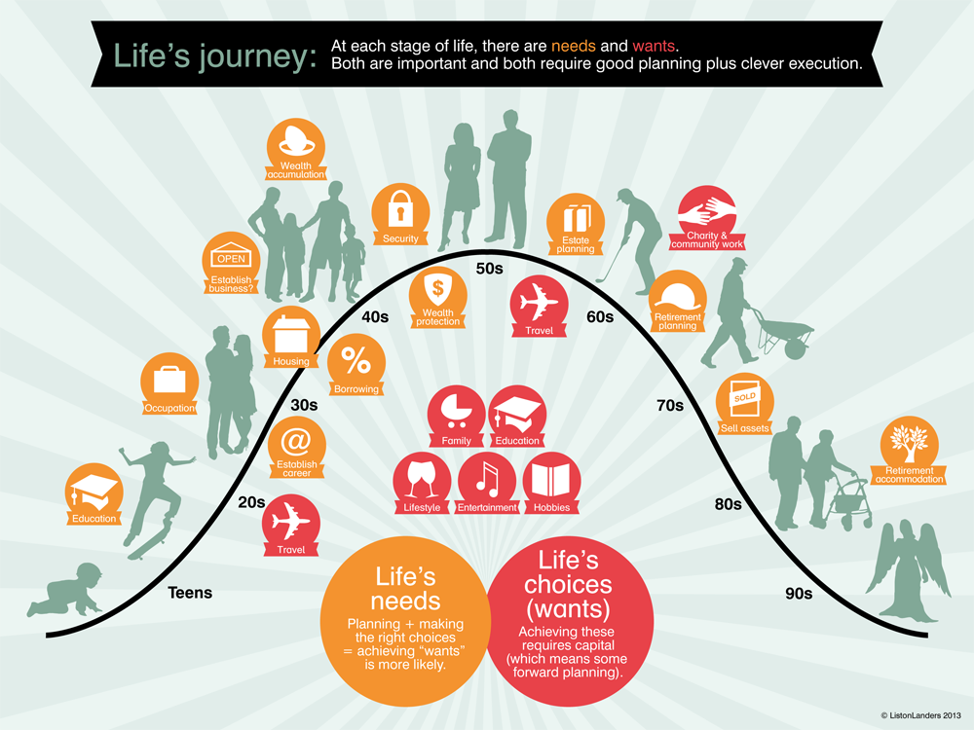
A financial life cycle is a series of stages which most people pass through during their lives. Each stage is different in terms of financial goals, income, spending, and risk
Financial Life Cycle
Stage 1- Childhood (0-12)
We live at home, our parents/guardians look after us. We have little income, other than gifts or pocket money

Stage 2- Teenage and young adult (13-20)
We still live at home, we might have additional income through pocket money/gifts or part-time jobs

Stage 3- Start a career/getting a place to live (20-30)
Most people have finished college and have their first full time jobs in their early 20’s and start to pay income tax. With regular income, you can start to buy the things you need and want. During this time, most people move out of the family home and get a place for themselves

Stage 4- Growing a career/family (30-65)
Having children and the expenses that go with that, this is usually the stage where people will earn most of their income

Stage 5- Retirement (65+)
Most people don’t work their entire adult lives and will retire. This is why having a pension plan is important- which people will have paid into during their adult working life
The Analysed Cash Book
The analysed cash book allows us to record our actual income and expenditure that happens in a given period (example a week in March) by preparing household accounts.
When completing cash accounts we:
- Record money coming in on the left side and call it a DEBIT
- Record money going out on the right side and call it a CREDIT
Our accounts are recorded in a T- Account style
Debit (+) this is anything we receive. Credit (-) this is anything we pay out.
Let’s take a look at a basic cash book for a family for the week 01-08 of March.
Debit: Money Coming In + Credit: Money Going Out -
Date | Details | F | Total | Date | Details | F | Total
01/03 | Wages |  | 600 | 02/03 | Groceries |  | 60
06/03 | Child Benefit |  | 350 | 04/03 | Esb |  | 150
08/03 | Wages |  | 600 | 07/03 | Mortgage |  | 300
 |  |  |  | 08/03 | Balance C/D |  | 1040
 |  |  | 1050 |  |  |  | 1550
09/03 | Balance B/D |  | 1040

Here you can see that all money received is on the debit side, and all payments or money going out is on the credit side. The balance c/d figure is the amount left over (closing cash for that time period). It is calculated by subtracting the total in the debit column from the total in the credit column and is then used to balance this account.
As you are familiar with from doing budgets, this closing cash (balance c/d)will be the next month’s opening cash (balance b/d).

Balance the following Cash Accounts
- Week ending 08/04
Date | Details | F | Total | Date | Details | F | Total
2014 |  |  | € |  |  |  | €
April 1 | Balance b/d |  | 225 | April 5 | Groceries |  | 95
April 4 | Wages |  | 370 | April 6 | Electricity |  | 110
 |  |  |  | April 7 | Clothes |  | 100

- Week ending 15/05
Date | Details | F | Total | Date | Details | F | Total
2014 |  |  | € |  |  |  | €
May 8 | Balance b/d | R 1 | 400 | May 9 | Groceries | Chq 1 | 100
May 10 | Salary | R2 | 220 | May 11 | Stationary | Chq 2 | 25
 |  |  |  | May 13 | Telephone | Chq 3 | 120
 |  |  |  | May 14 | TV Licence | Chq 4 | 200

- Week ending 19/04
Date | Details | F | Total | Date | Details | F | Total
2014
April 12 | Balance b/d |  | 100 | April 5 | Groceries |  | 195
April 14 | Wages |  | 270 | April 6 | Electricity |  | 210
 |  |  |  | April 7 | Clothes |  | 300

Practice Question 1
Now let’s attempt a simple T- Account question in our copies for the Smith Family for the week 14th -21st of October 2016.
14/10 Cash on Hand €300 (Balance b/d from last month)
15/10 Received Wages €1200
16/10 Paid for Insurance €100
17/10 Paid Groceries €100
17/10 Child Benefit €150
18/10 Childcare €140
20/10 Wages 600
21/10 Car Repayments €550
*Remember to use appropriate headings and columns
What does the final balance figure tell us?

Practice Question 2
The Leary Family have a weekly income of €200. For the 7 days ending 7 June 2016 their expenditure was as follows
June 1 Groceries €23
June 2 Rent €55
June 4 Groceries €15
June 6 Entertainment €20
June 6 Bought Skirt in TopShop €20
June 6 New pair of Kicks €50
*Remember to use appropriate headings and columns
What does the final balance figure tell us?

Categorising our Transactions using the Cashbook
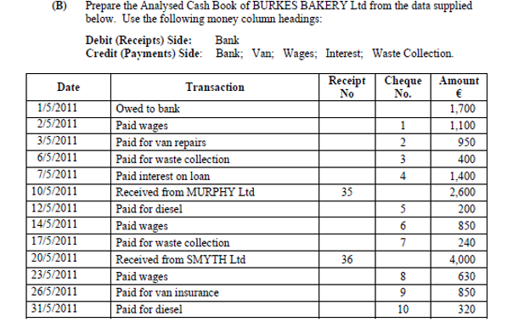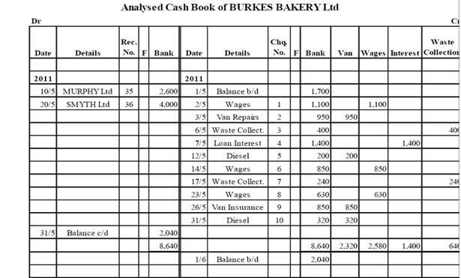

Practice Question 3
The Smith family lodge money into their bank account and pay all their bills by cheque. During the first two weeks of January 2014, the family had the following household transactions.
Write up an Analysed Cash Book using the following headings:
Debit: Bank
Credit: Bank, Groceries, Car, Light and Heat, Entertainment, Other

Jan 1 Opening Balance €625
Jan 2 Heating Oil €285 Cheque Number 1
Jan 3 Groceries €125 Cheque Number 2
Jan 5 Received Salary €1250
Jan 7 Went to the cinema and Nandos €90 Cheque Number 3
Jan 8 Paid Petrol €35 Cheque Number 4
Jan 9 Paid ESB Bill €125 Cheque Number 5
Jan 10 Paid €220 for new tyres Cheque Number 6
Jan 11 Paid doctors bill €85 Cheque Number 7
Jan 12 Receive Salary €1050
Jan 13 Paid Mortgage €650 Cheque Number 8
Contra Entries
These are entries that require us to make a debit entry and a credit entry for the one transaction.
For example, if you walk up to an ATM and withdraw €20 from your bank account, you would debit your own cash account (cause it to increase) as you now have an increase of €20 and credit your bank account (this is paid out of the bank) as it has now reduced by €20.

