Marketing

Marketing
Marketing means identifying consumer’s requirements and identifying how to supply these requirements at a profit. It is finding out what a customer wants and making a product to satisfy these needs profitably
The Marketing Strategy
A marketing strategy is a plan of setting out how a business achieves its marketing objectives
The Marketing strategy will set out a map of marketing goals and how these goals will be achieved. It is usually developed with the different stages of planning in place, and should have both strategic and tactical plans in place
A business Marketing Strategy is outlined below

- Identifying your Target Market
A Target Market refers to all people who might buy a particular good or service. The Target Market will have something in common and are targeted by the advertisers
Example Target Market for Ed Sheeran tickets would be Pop Music Fans, soccer jerseys would be football fans, Dora the Explorer would be children, etc..
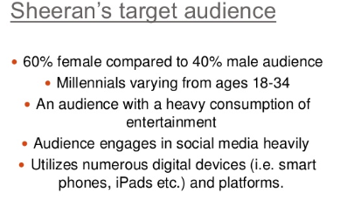

- Market Research
Once you have identified your target market, one of the most important tasks in business is to find out what products and services the consumer needs and wants. To do this they use Market Research, which is the collecting of information about a product and its market and then using that information to make business decisions.
This will give information for a business on important areas such as potential demand, consumer tastes, price sensitivity, competitors’ products, and feedback on existing products
Types of Market Research
Field Research
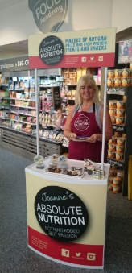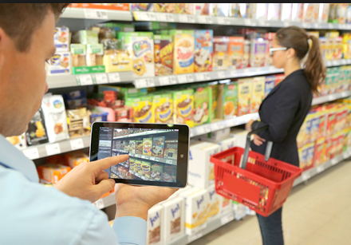
Field Research is primary research, and it involves going into the marketplace and gathering information by making direct contact with existing or potential customers.
Field Research can be expensive and time consuming, but it does allow a business the opportunity to design the questions they need answering themselves and also allows you to directly observe your target market.
Examples of Field Research include:
- Surveys
- Questionnaires
- Taste tests and free samples
- Focus Groups
- Direct Observations
Desk Research
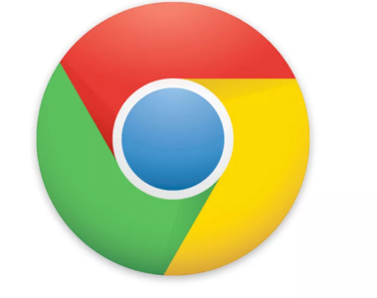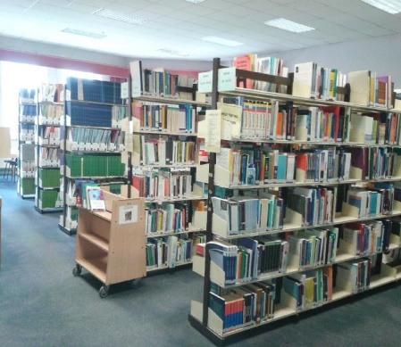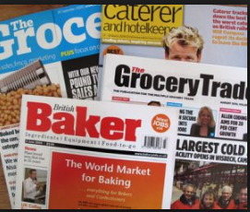
Desk Research is secondary research, where a business accesses information that has already been gathered. The information already exists, so the business does not have to go out to try and find it.
Desk research is relatively cheap, which keeps costs down as the data does not have to be collected. They must however be aware that data can go out of date quickly, and will have no guarantee to the accuracy of the research as there may have been mistakes in recording answers or leading questions
Examples of Desk Research include:
- The internet
- Central Statistics Office
- Trade Magazines
- Libraries
- Business Reports
Market Research Success
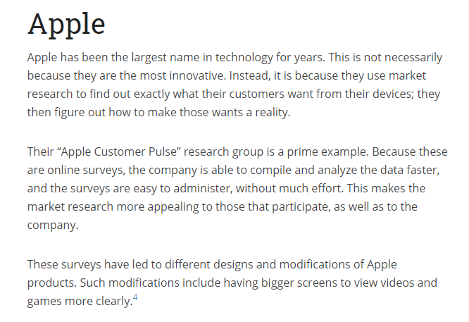
Market Research Failure
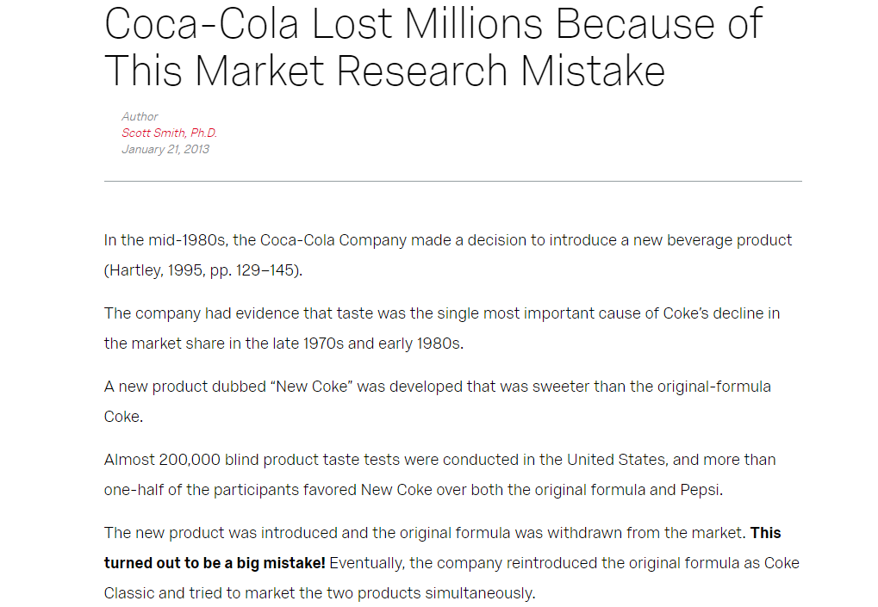
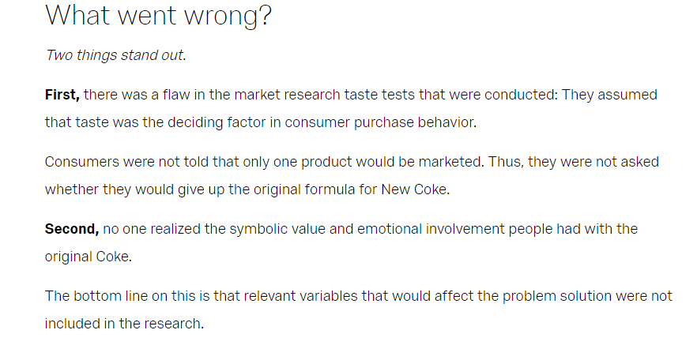

- Market Segmentation
Market Analysis can show that your target market can be divided into smaller segments. Market Segmentation involves dividing up the market into clearly identifiable segments that have common characteristics. It allows a firm to identify which segment their target market is by dividing the market into groups of consumers with common needs and then designing and implementing strategies to target them
Reasons for Market Segmentation include:
- Different segments have different spending patterns and disposable income and so segmenting will ensure that different price strategies can be used for the different segments that exist
- Market segmentation helps lower marketing costs as money is not wasted on advertising to segments not interested in their products
- It can help smaller businesses succeed as they can enter a segment of the market that can be highly competitive and try to become an expert- example wedding shoes for the wedding market
The most common ways of identifying a market would be through
- Geographic Segmentation: This is segmenting markets based on where a person is from, like country or county, urban v rural, climate, population growth etc… Think of radio stations like Spin 1038 or LMFM- they are segmented geographically based on where people are from and give local news about those areas

- Demographic Segmentation: This is segmenting markets based on characteristics, such as age, income, gender etc.. You are able to target demographics differently for the same or similar products. Think of Cadbury Chocolate Bars like Freddo, Dairy Milk, aimed at different demographics

- Behavioural Segmentation: This is segmenting our brand loyal v infrequent users. Multipack offers can be offered to frequent users, while individual packets can also be purchased, like Manhattan Popcorn or baked beans

- Psychographic Segmentation: This market is divided into segments based on beliefs, attitudes, social status, and lifestyle. Think about luxury cars or expensive clothes
Sample McDonalds Market Segmentation
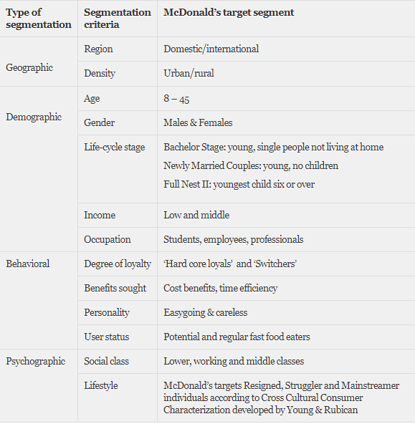
The market analysis may also highlight the existence of Niche Markets.
A niche market is a subset of a market segment which a specific product is focused and its features are aimed at satisfying a specific market segment’s needs, as well as price range, production quality, and demographic it is intended for. People may be willing to pay a higher price to satisfy this need.
It is usually a small market segment who is not satisfied with the mainstream products in the market because they have different, more specialised needs and are even prepared to pay a higher price for the product.
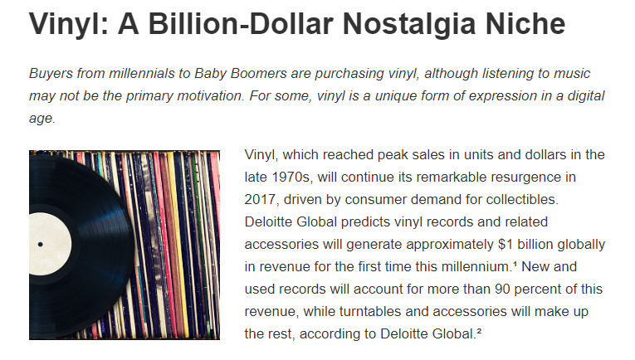
Advantages | Disadvantages
Less competition as market is focused on larger target markets which can lead to increased sales | Will not benefit from economies of scale
Consumer loyalty | If large competition enter the market the smaller business may not be able to compete
Ability to launch new products | Difficult to grow, profit margins lower than in other markets

4. Product Positioning
Product positioning means creating an image for the product in the minds of consumers in the target market. For example, what do you think when you consider Marks and Spencers v Aldi for food shopping?
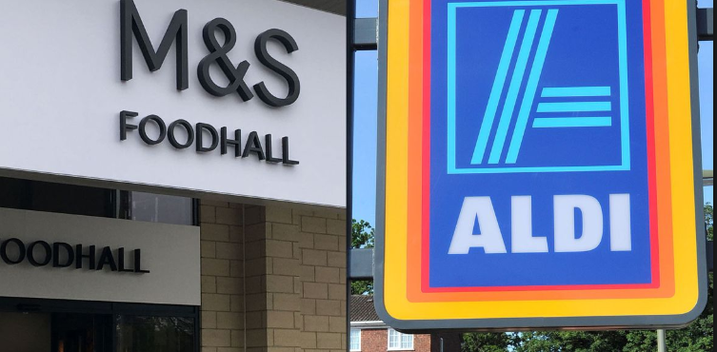
5. The Marketing Mix
The Marketing Mix consists of the 4 elements that a business can use to persuade consumers to buy their products. They are known in business as the 4 P’s, and they are:

Product
A product can be an idea, a service or a good. Consumer products such as clothes and TV sets are products purchased to satisfy personal and family needs.
Among the issues to be considered concerning product include:
- Branding
- Product Design
- Product Packaging
- Product Life Cycle
Branding
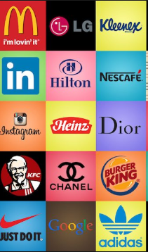
Branding involves the creation of a brand name (Coca Cola, McDonalds, Apple) which the company has the sole right to use. A business can register words, logos, letters and numbers to distinguish from competitors at the Irish Patents Office (e.g. Mr. Tayto).
Brands create a personality for a product, which allows consumers to develop a lifestyle relationship with the products they consume, and also helps the business stand out from their competitors
The Importance of Strong Branding
- Increase Sales
When consumers recognise a brand name, they are immediately drawn to it and it is easier for them to make up their mind to buy the product. Think about the amount of Starbucks there are all around the world- a strong brand name stands out from unknown competition to the buyer
2. Branding can help you win investment
A strong, well-known brand can help you to generate future business, and even increase your business’ value by giving you more leverage in your industry. This makes it a more appealing investment opportunity because of its firmly established place in the marketplace
3. Branding can help you win new customers
A good brand will make it easier for you to win referral business. Strong branding generally means there is a positive impression of your company among consumers, and they are likely to do business with you because of the familiarity and assumed dependability of using a name they can trust.
4. Branding can boost employee pride and satisfaction
When an employee works for a company with a well-respected brand, and they genuinely agree with what your brand stands for, they will be more satisfied with their job and have a higher degree of pride in the work that they do.
Branding your workplace and creating promotional merchandise for your employees to use can help to reinforce the strength of your brand and the values it stands for.
- Brand Loyalty
A well thought out brand will help you build trust with consumers, potential clients and suppliers.
People are more likely to do business with a company that has a polished and professional brand image and lead to brand loyalty and repeat customers
Own Brand Products
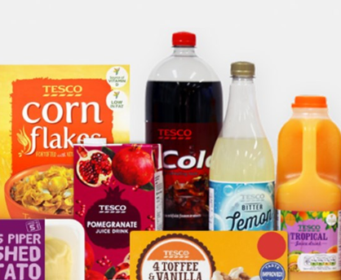
These are products sold by retailers under the retailer’s own name and logo to compete against existing products. Large multiples such as Tesco’s use own label brands e.g. Tesco Milk sold against Avonmore milk in Tescos. These products tend to be cheaper against the competitors.
Advantages of Own Brand Products
- Own Brand Products allow businesses to offer customers lower prices which in turn helps attract customers to do all their shopping in their store- this is known as a loss leader
- It gives retailers a competitive advantage against competition as their own brand products are not available anywhere else
- There is also more bargaining power for the retailer- suppliers compete for limited shelf space as the retailer stocks their own products and so more discounts can be obtained
- Product Specification is allowed as the own brand retailer has influence in shape, colour, and content
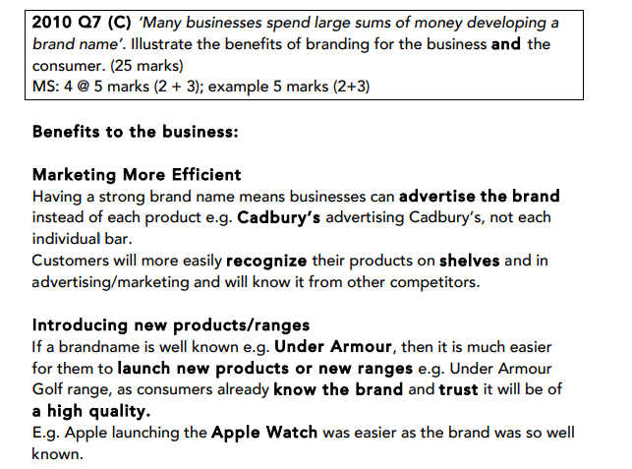
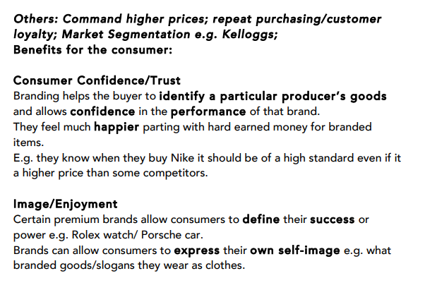
Product Design
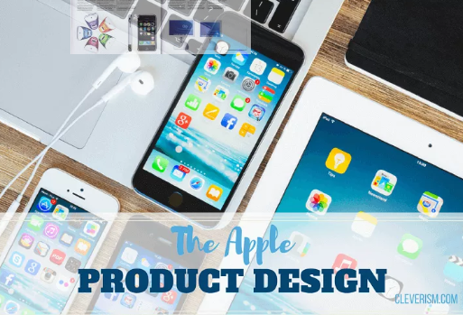
Product Design involves the creation of an attractive product which works. When designing a product, it must be able to do what it is set out to do, and also be aesthetically pleasing in terms of shape and colour etc... The success of Apple Computer's iMac can be attributed to its distinctive features and designs.
Particularly in today’s market where consumers are so self-aware, and with so much competition in the market place, making sure your product design suits the needs of consumers will increase sales and brand loyalty.
The product function and materials must also comply with The Sale of Goods and Supply of Services Act 1980
Product Packaging
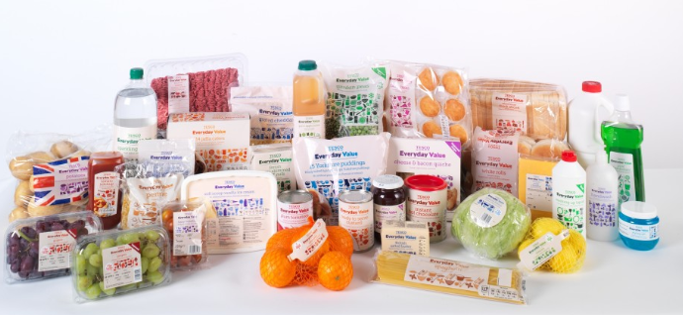
Product packaging serves many functions that are useful for a business:
- Protects the product during transit, storage and handling
- It also keeps the product fresh, preserving quality until it is used
- Packaging contains information on contents, ingredients, best before date…
- Products can be instantly recognisable due to the shape of the packaging
- Packaging draws attention through brands and logos, shape and colour
- Packaging can control the size and quantity of a product
- Packaging can increase brand loyalty and self-esteem/self-image for high end goods

Product Life Cycle
Product life cycle - This describes how the market for a product changes over time.
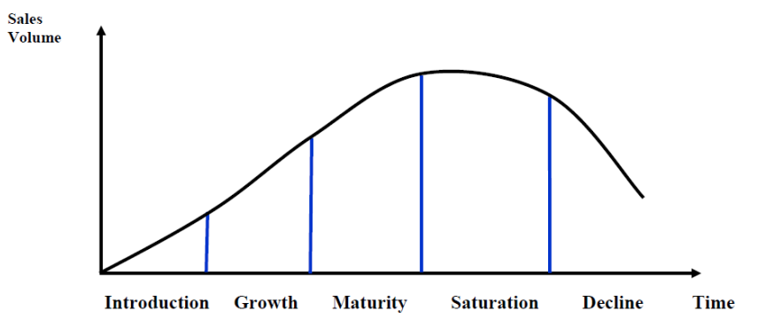
Introduction Stage – This stage of the cycle could be the most expensive for a company launching a new product. The size of the market for the product is small, which means sales are low, although they will be increasing. On the other hand, the cost of things like research and development, consumer testing, and the marketing needed to launch the product can be very high, especially if it’s a competitive sector
Growth Stage – The growth stage is typically characterized by a strong growth in sales and profits, and because the company can start to benefit from economies of scale in production, the profit margins, as well as the overall amount of profit, will increase. This makes it possible for businesses to invest more money in the promotional activity to maximize the potential of this growth stage
Maturity Stage – During the maturity stage, the product is established and the aim for the manufacturer is now to maintain the market share they have built up. This is probably the most competitive time for most products and businesses need to invest wisely in any marketing they undertake. They also need to consider any product modifications or improvements to the production process which might give them a competitive advantage
Saturation Stage- The market becomes full and sales fall for each individual seller. Costs rise as advertising and sales promotions are used to maintain the firm’s position in the market. Price wars may occur to try to keep customers
Decline Stage – Eventually, the market for a product will start to shrink, and this is what’s known as the decline stage. While this decline may be inevitable, it may still be possible for companies to make some profit by switching to less-expensive production methods and cheaper markets (Product Harvesting)
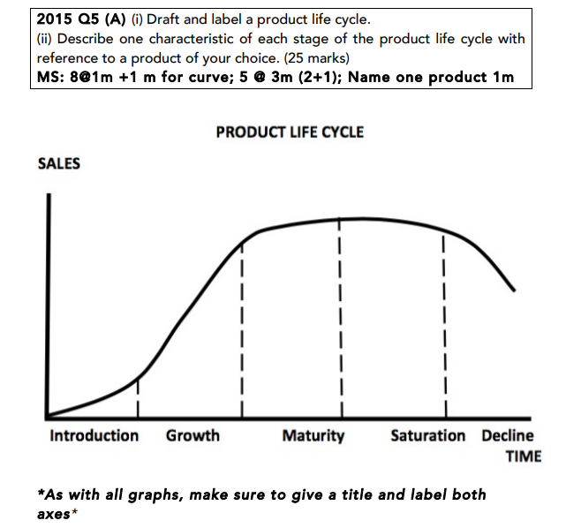
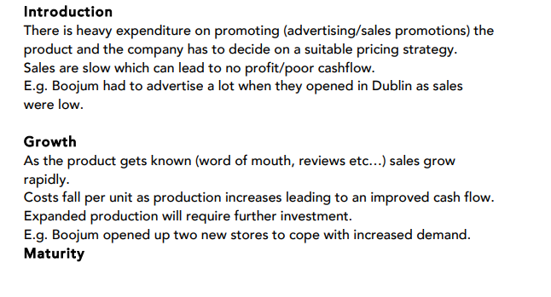
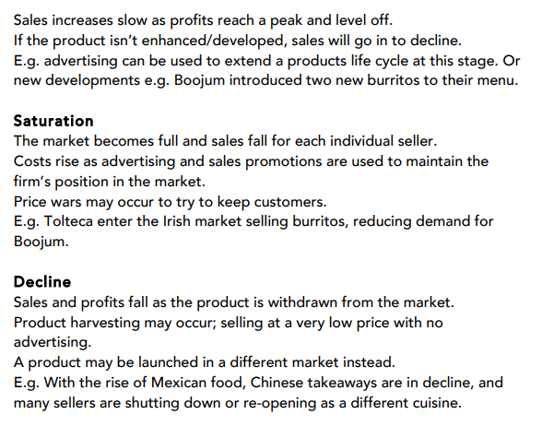
Extension Strategies to a Product Life Cycle
Update the Product
Businesses could update the product and launch it in new flavours or sizes or with different features. E.g. Coke launched different size bottles like the 1.25 litre to maintain sales
Change the Design
The business could improve the design of the product, tweaking a feature e.g. adding Bluetooth radio to a car. This might attract new customers or previous customers may retry the product to find out what has improved. E.g. The Honda Civic changed its design to be more modern cars

Change The Pricing Strategy
Changing the selling price can increase sales. Price drops can increase demand as consumers look for value e.g. The FAI lowering match tickets to encourage fans to buy tickets to increase overall revenue
Offer Loyalty or Discount cards
Offering loyalty cards with points or discounts can be a way of retaining customers that may be tempted to go to competition. E.g. Dunnes Stores give €10 off your next shop when you spend €50.

Price
This is how much the customer will pay for the product/service.
Among the issues to be considered concerning price include:
- Factors influencing prices
- Pricing strategies
- Breakeven Analysis
Factors influencing Price
Demand: When demand is high, prices will be high. Think of tickets to an All Ireland Final or an Ed Sheeran gig
Production Costs: The price will have to be higher than the cost of producing the product, for example raw materials, expenses, wages etc.. While a business may initially try to sell below cost price to attract customers, it will not be sustainable in the long run
Competitors: Prices will generally need to be in line with what competitors are charging, unless they actively choose an alternative pricing strategy such as premium pricing
Consumers: The type of buyer and their expectations can decide the market- income levels, spending habits etc..
Type of good: Smokers generally are price loyal, but in supermarkets, everyday goods such as bread and milk will generally sell on what is the cheapest
Pricing Strategies
-High Price Strategies
Premium pricing:
Price is set at a high rate than competitors to reflect consumer’s perception of a superior product. It is ideal for small businesses that sell unique products and develop high-quality products. Product may have a unique selling point (USP) or a distinct competitive advantage. Examples would include new BMW, Rolex Watch etc…
Price skimming:
Often most effective in the early days of a product life cycle/very few close rivals/setting high prices during the introductory phase to maximise revenues/help cover R&D costs and lowering the prices as competitor products appear on the market
It cannot last for long as rival products will come on the market. Example would be the new I-Phone when it comes onto the market.
-Low Price Strategies
Penetration Pricing:
Undercut competitors to attract customers. Over time the business may increase their price. Example would be when Tesco came onto the phone market
Predatory Pricing:
This is setting lower prices to push competitors out of the market. It can lead to price wars which is good for the consumer. Example would be Ryanair who reduce prices on popular routes
-Other Pricing Strategies
Bundle pricing: Selling multiple products together at a lower price. Sky packages/Vodafone
Cost plus pricing (mark-up pricing): Price set to cover costs (production, marketing, distribution) and include a target/fixed percentage profit margin.
Tiered pricing: Customers can choose the price level that best fits their budget. They can purchase the basic model car or the luxury model. Can help a business capture a larger portion of the market
Price discrimination: Charging different prices to different market segments for the same product. Cinema tickets/airline tickets

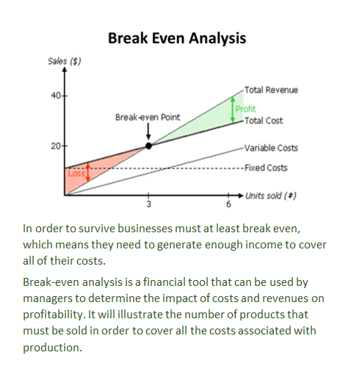
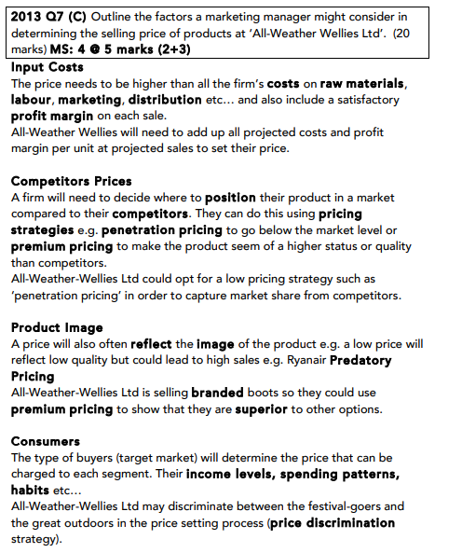
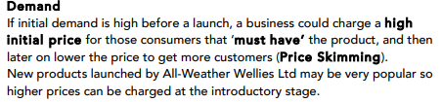

Place
This is about getting the final product to the consumer. It is important to choose a Channel of Distribution which is easily accessible to your target market
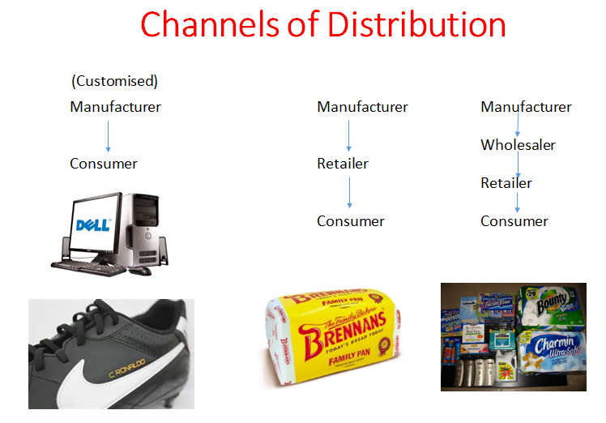
Factors to consider when choosing a Channel of Distribution:
Cost
More channels- more expense. Ryanair was motivated by cost factors when it cut travel agents out of its ticket sales distribution network.
Type of good/durability
What’s the shelf life? Fresh goods delivered directly to the retailer.
Market size
Cadburys distributes their products through wholesalers like Musgrave Group due to number of shops nationwide
Technological developments
Apps e.g. banking 365online for Bank of Ireland, less need for physical branches
The Wholesaler
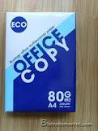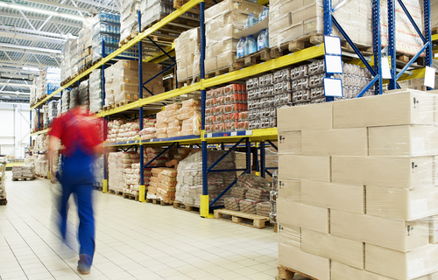
A wholesaler buys large quantities of goods from many manufacturers and sells them in smaller quantities to retailers. E.G. A school may need large stocks of paper, which it purchases directly through the wholesaler in order to receive a discount
Cash and carry wholesalers are different than general wholesalers as they act as supermarkets to retailers. Consumers are not permitted to shop in them. E.g. Musgraves.
2014 Question 7 B.
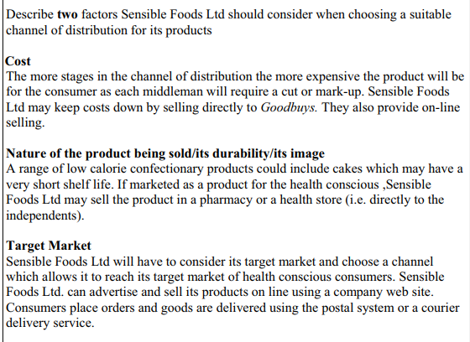
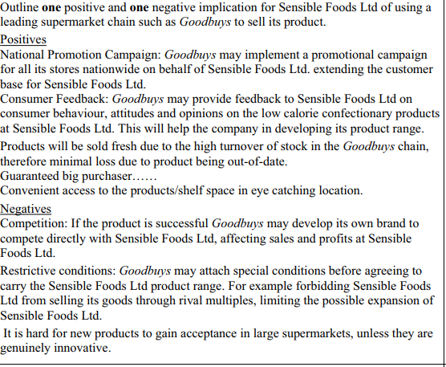

Promotion
This refers “to the method made by the business to communicate their product to the target market
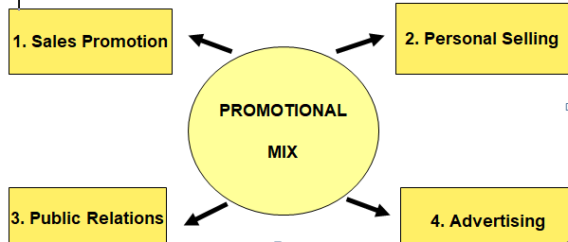
- Sales Promotion
Sales promotion is any initiative undertaken by an organisation to promote an increase in sales, usage or trial of a product or service
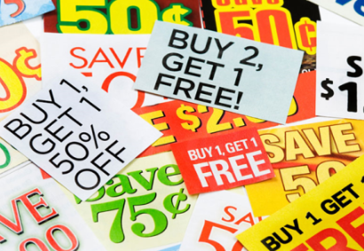

Examples of Sales Promotion
- Free gifts: e.g. Subway gave away a card with six spaces for stickers with each sandwich purchase. Once the card was full the consumer was given a free sandwich
- Merchandising: This is materials used to promote products in retail outlets, e.g. window displays, posters, and display stands. It is often placed at the point of sale where the customer buys the product
- Discounted codes: e.g. Budget airline such as EasyJet and Ryanair, e-mail their customers with the latest low-price deals once new flights are released, or additional destinations are announced
- Joint promotions between brands: For example fast food restaurants often run sales promotions where toys, relating to a specific movie release, are given away with promoted meals
- Free samples (aka. sampling) e.g. tasting of food and drink at sampling points in supermarkets. For example Red Bull (a caffeinated fizzy drink) was given away to potential consumers at supermarkets, in high streets and at petrol stations (by a promotions team).
- Vouchers and coupons: Often seen in newspapers and magazines
- Competitions and Prize Draws
- Special Offers: e.g. Buy one Get one Free
- Loyalty Cards

- Personal Selling
Personal selling is where businesses use people (the "sales force") to sell the product after meeting face-to-face with the customer. An example would be in stores such as PC World when buying a new computer or SMART TV.
The sellers promote the product through their attitude, appearance and specialist product knowledge. They aim to inform and encourage the customer to buy, or at least trial the product.
A good example of personal selling is found in department stores on the perfume and cosmetic counters. A customer can get advice on how to apply the product and can try different products. Products with relatively high prices, or with complex features, are often sold using personal selling.
- Public Relations
Public Relations refers to all activities e.g. press conferences/ sponsorship related to creating a good public image for the product or service amongst its stakeholders. Businesses often hire a Public Relations Officer (PRO) to protect and promote a positive image for the firm.
It aims to achieve favourable publicity and build a good corporate image for the business in the public eye in the long run.
Methods of PR
Publicity
Public Relations can take the form of press releases or press conferences where the media are given information about the company’s activities. The business can arrange photo shoots and provide pictures to media for them to use
Sponsorship
Businesses want to have people associate their brand with certain events or teams e.g. the Olympics.
They pay money so that their product name will be displayed by individuals, organisations or at particular events or stadia. It can be very effective at positioning a business (sponsoring of sports events or TV programmes).
e.g. 3arena in Dublin, Vodafone on the Irish Rugby Jersey
Newsletters
Sending newsletters – relevant information about the organisation or/and its products/services - directly to the target audience is also a common method to create and maintain a strong relationship with the public. Newsletters offering promotional products are also a common marketing strategy but PR specialists use it to share news and general information that may be of interest to the target audience rather than merely promoting products/services.
Blogging
To reach the online audience, PR specialists use the digital forms of press releases and newsletters but they also use a variety of other tools such as blogging and recently, microblogging. It allows them to create and maintain a relationship with the target audience as well as establish a two-way communication.
Social media marketing
Like its name suggests, it is used primarily by the marketing industry. Social media networks, however, are also utilised by a growing number of PR specialists to establish a direct communication with the public, consumers, investors and other target groups
- Advertising
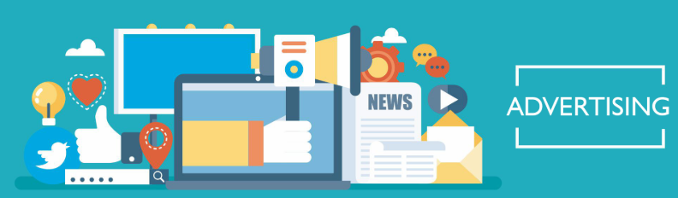
Advertising is when businesses communicate directly with consumers in an attempt to convince them to buy their products. The aim is to inform, persuade, remind, and compete while also trying to get as many customers as possible to buy your products/services.

Advertising Media
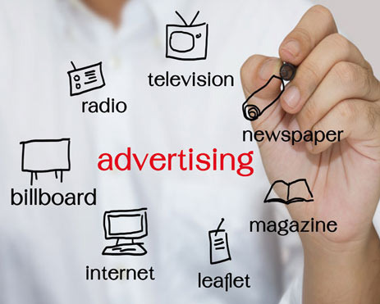
Note-In class we will form a class discussion on the advantages and disadvantages of each form for a business
Selecting an Advertising Medium
- When will the target audience see it- Example Dora the Explorer on tv during the morning
- Nature of the product – Example Washing Powder or cleaning products being seen to work
- The Message- Trade magazines for cars
- The Cost- Depending on size of the business, what is cost effective
- Stage of the Product Life Cycle

Guerrilla Marketing
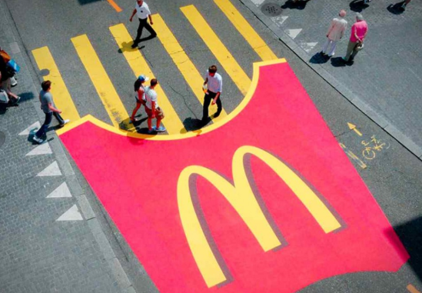
Guerrilla marketing is an advertisement strategy concept designed for businesses to promote their products or services in an unconventional way with little budget to spend. This involves high energy and imagination focusing on grasping the attention of the public at a more personal and memorable level.
2014 Question 7 A.
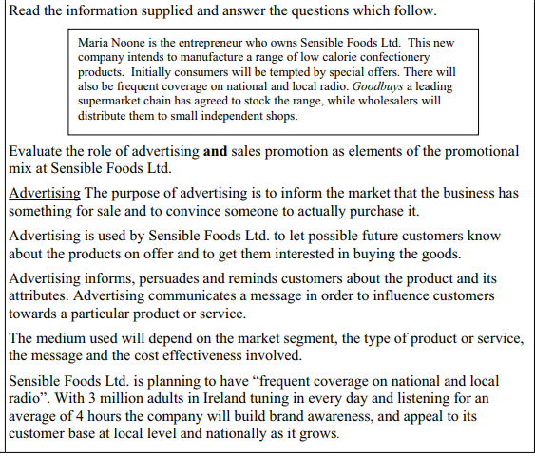
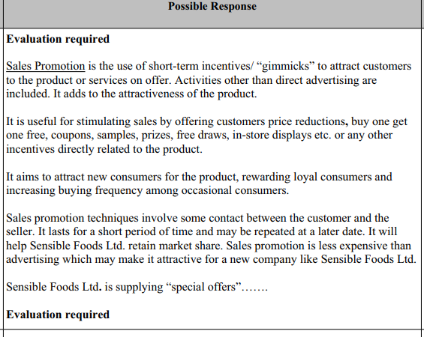
Protecting Consumers:
The CCPC- Illegal to make false claims about goods, services, prices
The Advertising Standards Authority of Ireland
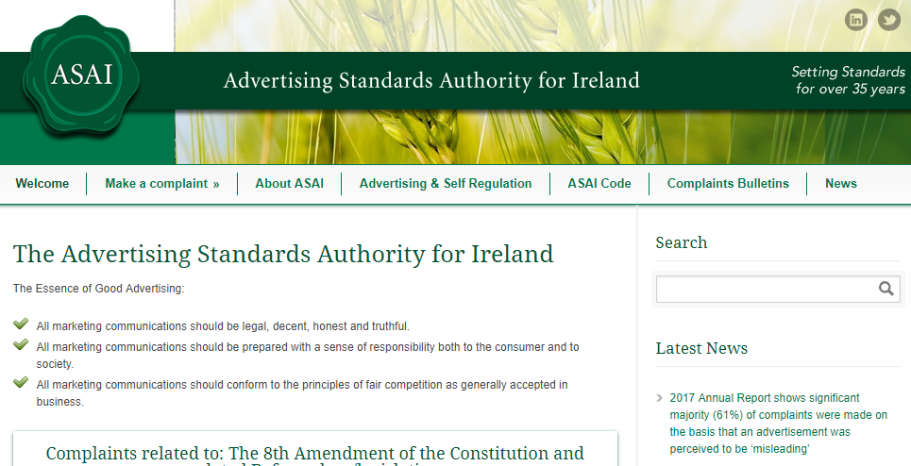
The Advertising Standards Authority of Ireland keeps an eye on the advertising industry to ensure that consumers are protected
Any member of the public can complain to the ASAI in writing. It will investigate the complaint and if it agrees with it, will ask the advertiser to take it down or change it