The Mini-Company Task Assignment
A mini-company is a business run by students who make the decisions and run the business themselves. Students will have to incorporate the knowledge and skills that they have learned throughout the Transition Year course in order for this enterprise to become successful.
The business will produce and sell goods and services for a profit, which will be shared by those who invest in it. It may be run in the same way as a limited company, with owners, directors, shareholders etc... Each idea must be pre-approved by your Enterprise teacher, and mini-company groups can have no more than 4 people per group.
The students will write a report for their company. Each student will hand up a copy of this report and will also outline his/her personal involvement as well as a reflection exercise. They must also come up with a creative advertisement using their I-Pads that should highlight the USP of their product as part of their Marketing Strategy.
Setting up and running your own company is a very exciting way to practically learn about the world of business, using key skills and qualities, dealing with very real problems and finding ways to overcome them, and at the end, hopefully make a profit.

Best of luck to all teams involved

Mini- Company Report
The following 8 headings will be submitted by each group and will be the same for each group member. Only the reflections will be individual and will be placed at the back of the report and signed by each group member. Please note that it is perfectly acceptable to use the same idea for both the mini-company and Student Enterprise Report.
Report must contain the following headings:
- Getting Started
The roles of the team/ issues or challenges in start-up /skills and talents of group
- Ideas
How did you come up with your idea? / Were there any alternatives? / Feel free to include pictures/sketches/ ideas of your product or alternatives (if there are any)
- Screening of Ideas
SWOT Analysis must go in here/ Breakdown of costs v alternative (if there are any) /why did you choose the idea? / is there a potential market for it? (Does not have to be full market research as that will come later)
- Set-Up
Your name and why you chose it/logo/slogan/ the roles and duties of people in the group- e.g. Managing Director/ Marketing Manager/ Finance Manager
- Marketing
Detailed information on market/ your chosen target market/ The Marketing Mix for your idea/ sample surveys or questionnaires/ data/ picture of sample products/prototypes
- Finance
Cash Flow Forecast/ Costing’s and Finance needed/ selling of shares
- Production and Sales
Equipment needed/ Market to sell/ Store facilities and stock control
- Winding up and Final Report
Profit/ Loss Calculated/ Trading, Profit and Loss Account/ Difficulties encountered as a group

- Reflection
Each team member will write their own individual reflection including
Involvement and role/ Challenges faced/ what they learned about business/ new skills developed/ would they do anything differently/ advice to students next year

Novus and Lace It came 2nd and 3rd respectfully in 2017/2018
Previous Mini-Company/Enterprise Ideas

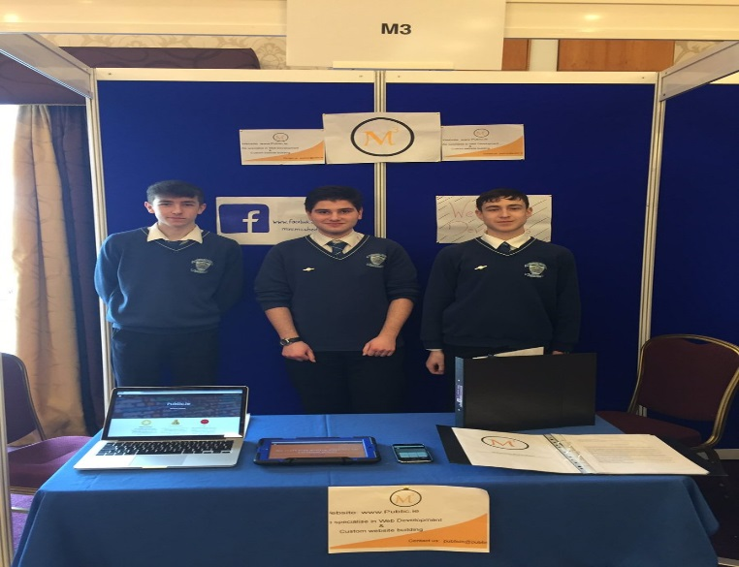

M3 Website Builders

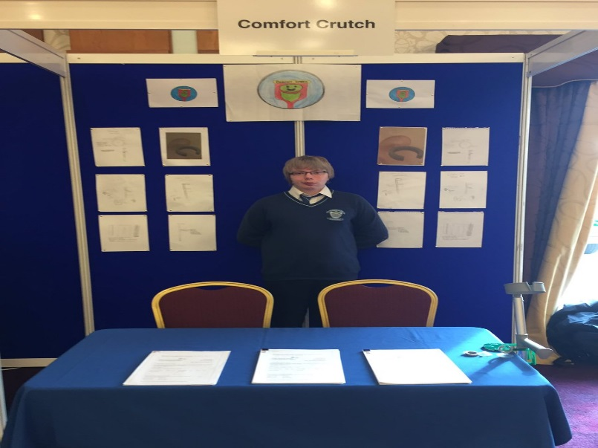

Comfort Crutch

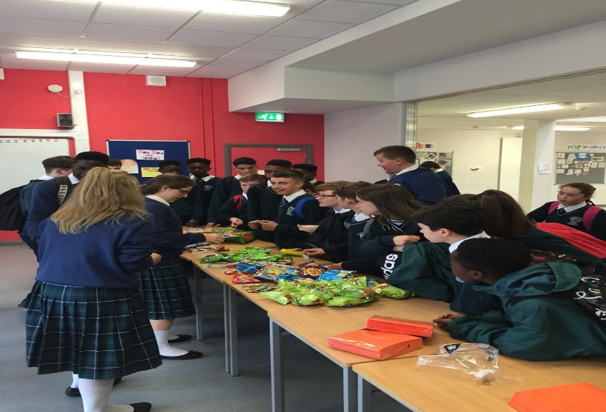

Bake Sale

