FINAL ACCOUNTS 2:
THE PROFIT AND LOSS ACCOUNT
And
The Appropriation Account
This chapter is divided into 2 parts- Part A deals with the Profit and Loss Account and Part B deals with the Profit and Loss Appropriation Accounts

PART A: The Profit and Loss Account
The Profit and Loss account records all the selling, distribution and administration expenses involved in the running of a business as well as any gains received from non-trading activity.
Gross Profit - Expenses = Net Profit
What are Gains?
Gains are any income a business receives apart from income relating to the sale of goods. Examples include rent received from leasing part of your premises, commission received from the selling on of goods by a third party or agent and interest received from money resting in a bank.
Gains are positive for a business as they bring money into the company.
What are Expenses?
Expenses are the regular, ongoing payments made by a business.
Examples include:
Wages and Salaries Depreciations
Commission Paid Carriage Outwards
Light and Heat Water Charges

Sample Question for Dowling LTD
Gross Profit | 95,050
Commission Received | 6,000
Wages | 31,000
Depreciation on Van | 10,400
Loan Interest | 1,400
Rent and Rates | 5,600

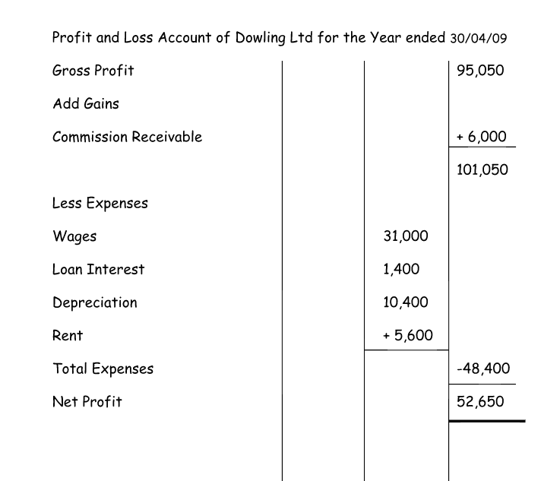
Sample Questions to Practice
Calculate Net Profit Using the following figures:
Gross Profit | 6,000
Commission Recieved | 400
Office Expenses | 1,000
Travel Expenses | 2,000
Tax | 700

Gross Profit | 204,000
Commission Recieved | 2,000
Interest Recieved | 13,000
Wages | 96,000
Depreciation on Van | 2,000
Carriage Outwards | 1800
Rent and Rates | 14,000
Postage | 6,000
Cleaning | 6,000

Gross Profit | 150,000
Commission Recieved | 1,600
Office Expenses | 30,000
Wages | 80,000
Depreciation on Machine | 16,000
Carriage Outwards | 800
Tax | 25,000
Postage | 11,100
Stationary | 7,500
Bank Interest Paid | 1,000
Bank Interest Received | 600

Now you will be asked to combine both the Trading Account and Profit and Loss Account of a question. -Textbook pg. 383, Question 15.
Details | Value
Sales | 400,000
Sales Returns | 15,000
Opening Stock | 36,300
Purchases | 200,000
Purchases Returns | 8,000
Carriage In | 11,100
Closing Stock | 25,000
Commission Received | 5,500
Light and Heat | 7,600
Cleaning | 1,200
Travel Expenses | 5,400
Bad Debts | 3,000

B. Calculate Gross Profit Per-Cent, Gross Profit Mark Up and Net Profit Per-Cent
Note- Net Profit Per-Cent = Net Profit
Sales x 100
(Should be compared with previous year figure to indicate performance)
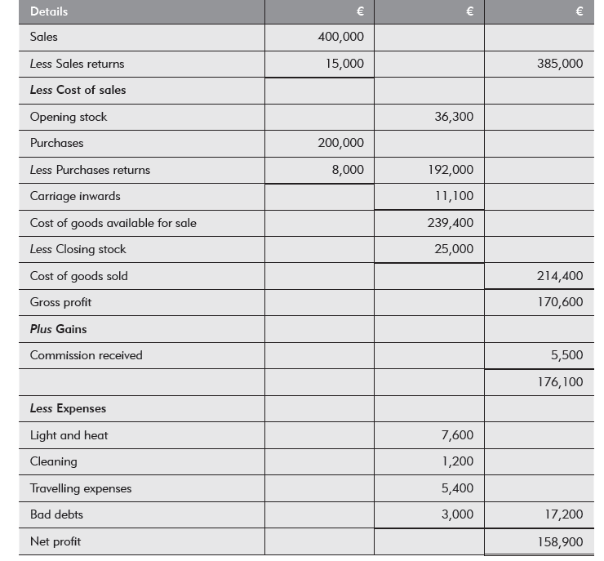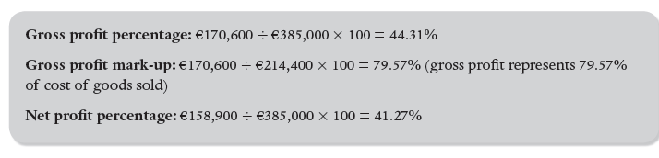
Now attempt your own questions from the textbook.- A Trading Profit and Loss Account

The Profit and Loss Appropriation Account
The Profit and Loss Appropriation Account is used to show how the Net profit is distributed (shared out). It goes underneath the Net Profit in the Profit and Loss Account.
Usually, Net Profit will either:
- Be used to pay dividends- this will reduce net profit in the account
- Reinvest back into the business- but the investors may not be happy- Why?
- Some reinvested, some given to owners
Example 1:- O.L. A business has a net profit of €50,000. It also has Issued Share Capital of €100,000 Ordinary Shares of €1 each with a dividend of 10% paid out. (This means investors will get a 10% return on capital invested)
100,000 x .1 = 10,000
50,000
-10,000
40,000- Retained Earnings
Practice
- A business has a net profit of €40,000. It also has Issued Share Capital of €50,000 Ordinary Shares of €1 each with a dividend of 5% paid out. (This means investors will get a 10% return on capital invested)
- A business has a net profit of €150,000. It also has Issued Share Capital of €96,000 Ordinary Shares of €1 each with a dividend of 8% paid out. (This means investors will get a 10% return on capital invested)
Example 2:
Net Profit + Reserves- Dividends= Retained Earnings
Are You Well Ltd has €250,000 Ordinary Shares and a Profit and Loss Reserve of €80,000. The net Profit for the year was €100,000. It declared dividends at 10%. Prepare the Profit and Loss Appropriation
100,000- Net Profit
+80,000 - Reserves
=180,000
-25,000 (250,000 x 10%) Dividend
155,000- Retained Earnings Figure

Now attempt your own questions from the textbook.- A Trading Profit and Loss Appropriation Account.

