Ratio Notes/Questions Booklet
Ainm:
Please complete the following tables for the six ratios you have studied in Leaving Cert Business.
- Profitability
Ratio | Formula | Definition | Advice
Gross Profit Margin/Percentage | Gross Profit/Sales x 100/1 | Gross Profit Margin shows the percentage of profit on all items sold before expenses are taken into account- it is the profit percentage from all trading (buying and selling) | Advice if problem: Sell more products to increase sales, charge a higher selling price to increase gross profit
Net Profit Margin/ Percentage | Net Profit/Sales x 100/1 | Net Profit Margin shows the overall percentage profit for the business after covering all costs, including expenses | Advice if problem: Reduce expenses- e.g. shop around for cheaper supplier of gas/electricity/increase selling price to make more profit
Return on Investment/Return on Capital Employed | Net Profit/Capital Employed x 100/1  Capital Employed made up of Long Term Loans + Issued/Ordinary Shae Capital + Retained Earnings/Reserves | The Return on Investment/Return on Capital Employed measures the level of profit the business can generate from money invested in it.  (Always compare to the BANKS  risk free interest rates). | High  Expansion opportunities  Attract investors  Potential wage increases  Low  Difficult to get loans to expand  High interest payments  Hard to attract investors  Job security issues for employees
- Liquidity
Ratio | Formula | Definition | Advice
Current Ratio | Current Assets: Current Liabilities | It compares current assets with current liabilities. The firm would want its current assets to be greater than its current liabilities.  Ideal Ratio: 2:1 | If below ideal or worsening trend, they may need to solve this problem by sourcing cheaper suppliers or stop selling goods on credit.
Acid Test Ratio | Current Assets- - Closing Stock: Current Liabilities | Ratio that takes into account the fact that stock may not always be easily and quickly converted into cash.  Ideal Ratio: 1:1 | If below ideal or acid test is worsening from last year than the trend indicates that the firm’s liquidity position is worsening, corrective action must be taken such as selling excess stock at a discount.
- Gearing
Ratio | Formula | Definition | Risk of High Gearing
Gearing Ratio | Debt Capital: Equity Capital  (Long Term Loans: Issued/Ordinary Share Capital + Retained Earnings/Reserves) | Examines the types of long-term finance or capital being used- what proportion of capital is made up of Long Term Loans and what proportion is made up of Retained earnings/Reserves and Ordinary/Issued Share Capital. | -High interest payments  -Will reduce its ability to get more loans- seen as a risk by the bank  -Greater chance of going bankrupt- loans have to be repaid  -May not be able to pay high return (dividend) to shareholders- they may go elsewhere  -Need to use collateral for loans
Theory Questions
- Give three reasons why ratios are prepared:
- Evaluate company performance from one year to the next
- Evaluate company performance comparative to other businesses in the same industry
- Determine size of dividends payable to Ordinary Shareholders
- Calculate corporation tax payable to the government based on profits made
- Determine ability to acquire debt/equity capital for expansion

- Explain why the following stakeholders may be interested in financial information.
Management | They will want information to know how the business has performed over the year and to learn if any changes are needed. This will help make decisions if needed.
Shareholders | •They will want to know if the money that they have put into the business has been used wisely by the firm in order to generate profits and pay them a dividend  •They want to know how much they can expect in dividends and they also want to know the value and security of their investment
Banks | They want to know if the business is profitable enough to be able to make loan repayments and interest repayments.
Trade Unions | They will keep an eye on the company’s profits because if they know the business is doing very well, they may look for wage increases. They are interested in the security of employment and the future prospects of the company (will it expand and take on more workers, what are the promotion prospects of the workers)
Competitors | They will examine a business’s sales and profits to see how big a threat the business is to them.
Suppliers | These are interested in a business’s accounts in order to assess the firm’s credit-worthiness. I.e. can the firm can pay for goods supplied on credit?
Employees | Will want to see if the firm is performing well for job security and promotion prospects.
Government | Will want to see the performance of the firm to assess how much tax it owes.

- Give three limitations of Ratio Analysis:
- Ratios do not take into account industrial relations issues in a business
- Ratios are based on past figures and not projected future ones
- Assets may not be shown to their full value
- Does not consider business environment, for example competitors or recession/Covid
- Inflation/deflation may impede comparisons from one year to the next
- Balance sheets are only true for the day they are written

Profitability
Sample Questions-OL Level- Gross Profit Margin and Net Profit Margin
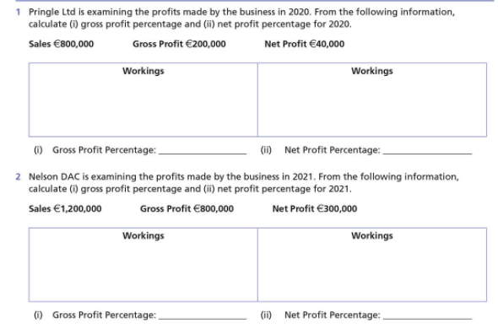

Gross Profit Margin = Gross Profit X 100
Sales 1
200,000/800,000 x 100/1 = 25%

Net Profit Margin = Net Profit X 100 =
Sales 1
40,000/800,000 x 100/1 = 5%

Gross Profit Margin = Gross Profit X 100
Sales 1
800,000/1,200,000 x 100/1 = 66.67%

Net Profit Margin = Net Profit X 100 =
Sales 1
300,000/1,200,000 x 100/1 = 25%

- Work out Gross Profit and Net Profit Percentage from the following figures presented in the year 2023.
Sales €400,000 Gross Profit €250,000 Net Profit €50,000
Workings | Workings

Gross Profit Margin = Gross Profit X 100
Sales 1
250,000/400,000 x 100/1 = 62.5%

Net Profit Margin = Net Profit X 100 =
Sales 1
50,000/400,000 x 100/1 = 12.5%
Profitability Higher Level
Sample Question
Gross Profit- Expenses = Net Profit

- In 2022 Value Ltd had a gross profit margin of 25%. Using the figures below calculate Value Ltd.’s gross profit margin for 2023.
Net Sales: €900,000
Expenses: €150,000
Net Profit: €150,000
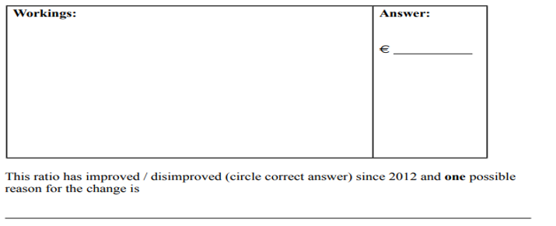
2022
Gross Margin (Gross Profit Percentage) =

Gross Profit x 100
Sales

Need to work backwards
Net Profit +Expenses = Gross Profit
€150,000 +€150,000 = €300,000

300,000
900,000 x 100 = 33.33%

The Gross Profit Margin has increased from 25% to 33.33%. This is an improving trend. A possible reason for this could be an increase in selling price that has not had an effect on demand for their products/ prices have risen/ costs fallen etc…(from above)

B.
In 2022 Risk Ltd had a gross profit margin of 30%. Using the figures below calculate Risk Ltd.’s gross profit margin for 2023.
Net Sales: €800,000
Expenses: €50,000
Net Profit: €150,000
2022
Gross Margin (Gross Profit Percentage) =

Gross Profit x 100
Sales

Need to work backwards
Net Profit +Expenses = Gross Profit
€150,000 +€50,000 = €200,000

200,000
800,000 x 100 = 25%

The Gross Profit Margin has decreased from 30% to 25%. This is a negative trend. A possible reason for this could be an decrease in selling price that has had an effect on demand for their products/ prices have fallen/ costs risen etc…(from above)

2014 Mock
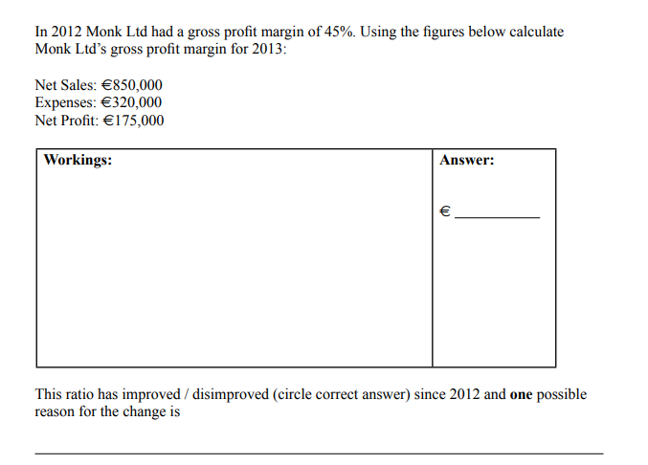
Gross Margin (Gross Profit Percentage)

Gross Profit x 100
Sales

Need to work backwards
Net Profit +Expenses = Gross Profit
€175,000 +€320,000 = €495,000

495,000
850,000 x 100 = 58%

The Gross Profit Margin has increased from 45% to 58%. This is an improving trend. A possible reason for this could be an increase in selling price that has not had an effect on demand for their products/ prices have risen/ costs fallen etc…(from above)

2023 Mock
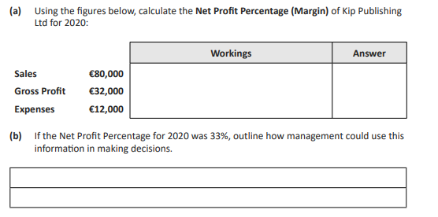
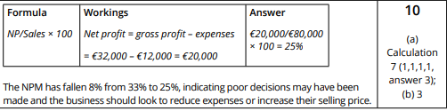
2015 LC
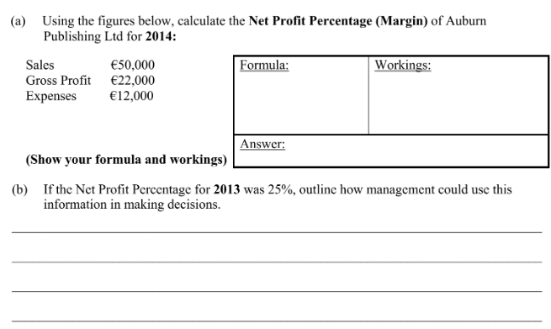
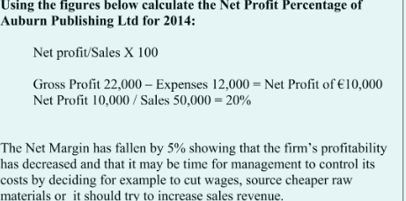
2017 Mock

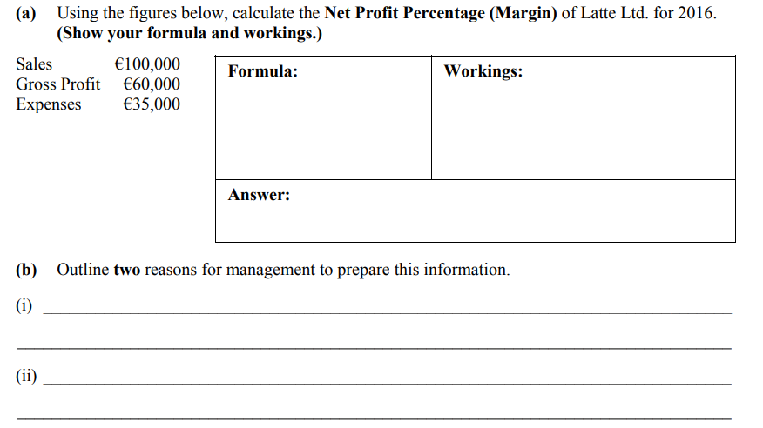
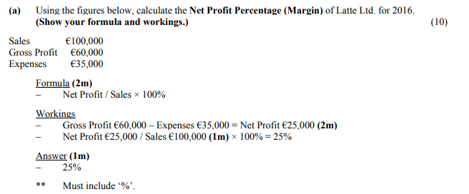
Reasons why Ratios are prepared
• Evaluate company performance from one year to the next
• Evaluate company performance comparative to other businesses in the same industry
• Determine size of dividends payable to Ordinary Shareholders
• Calculate corporation tax payable to the government based on profits made
• Determine ability to acquire debt/equity capital for expansion

Profitability- Return on Investment/Return on Capital Employed
2019 Mock
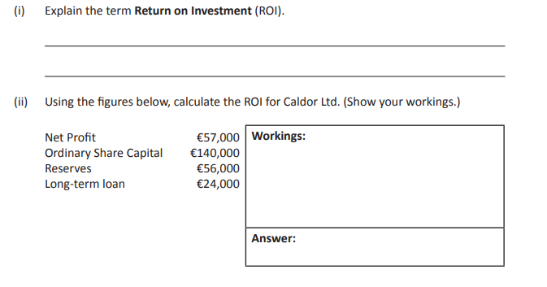
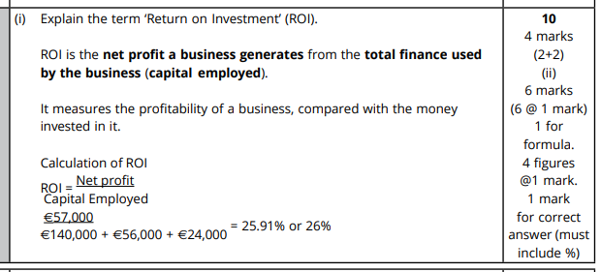
Sample Question
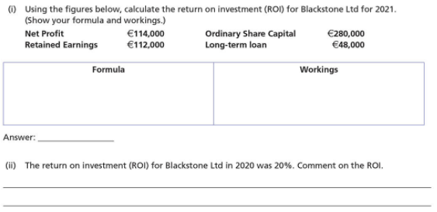
Net Profit X 100 =
Capital Employed 1
114,000 X 100 = 25.9%
(280,000 + 112,000 + 48,000) 1

Comment: 25.9 % for the given company is very satisfactory as it is well above the rate of interest that would be earned if money was invested in a bank- will be attractive to potential investors to the business.

2021 LC
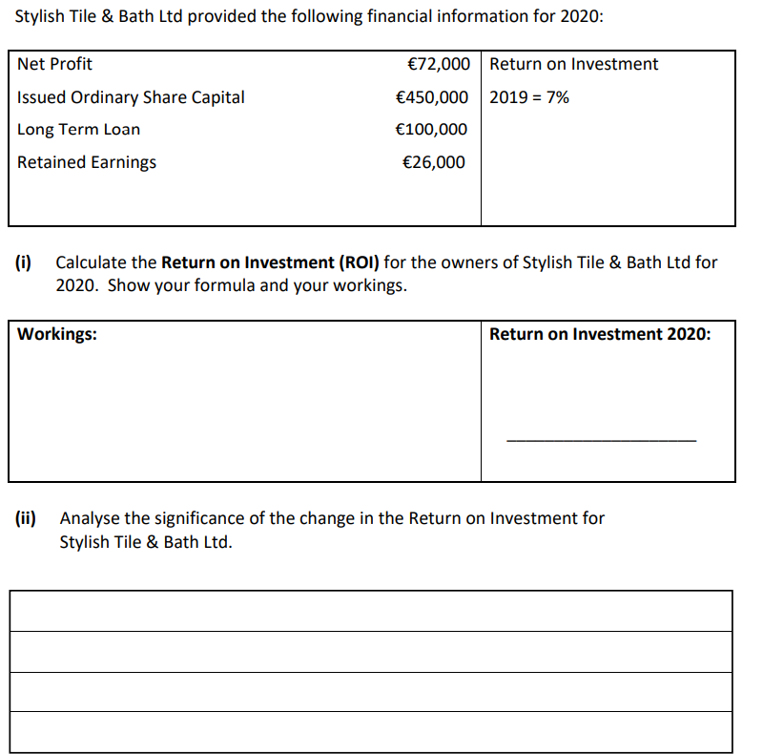
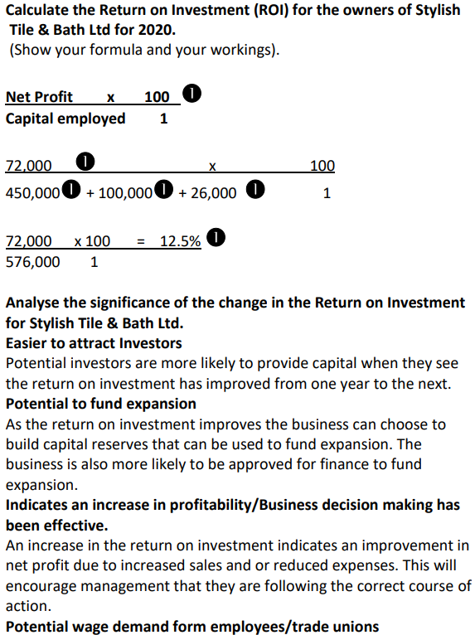
Profitability Ratio Long Questions

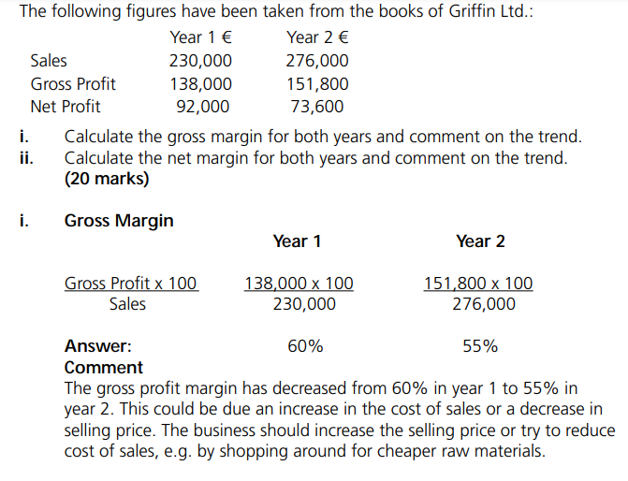
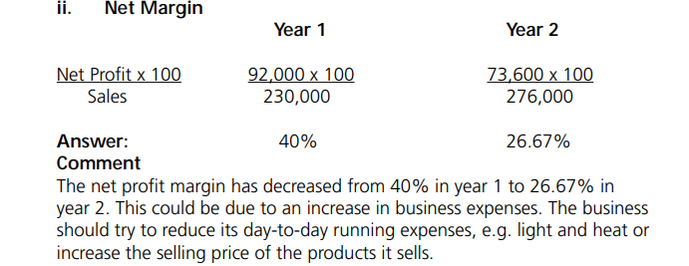

- The following figures have been taken from the Books of Foynes Ltd. Work out the Return on Investment from the figures presented and comment on the trend. (OL)
 | Year 1 € | Year 2 €
Net Profit | 1,100,000 | 825,000
Capital Employed | 2,200,000 | 3,300,000

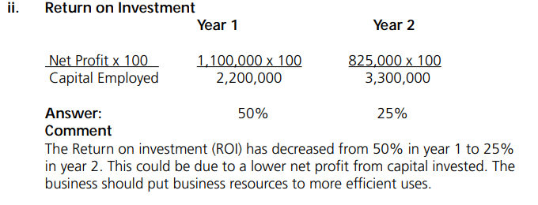

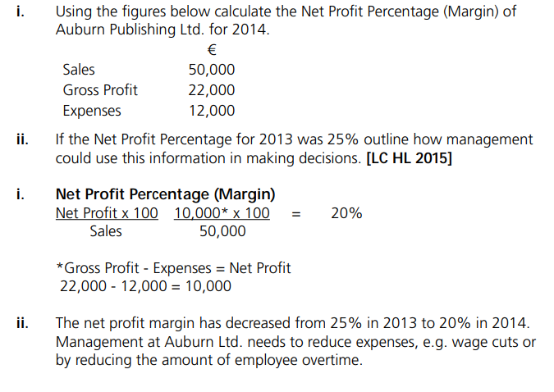

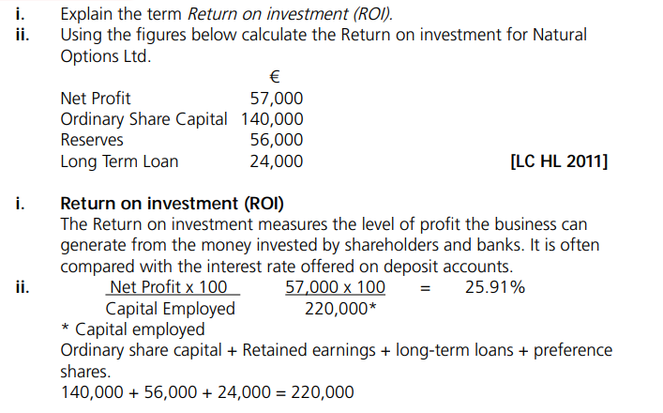

Liquidity
Sample Question
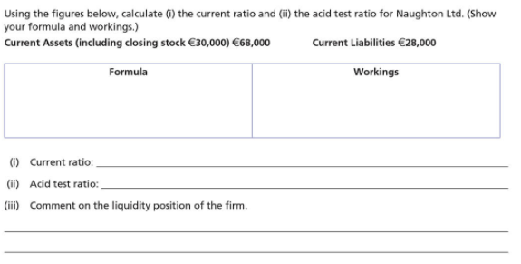
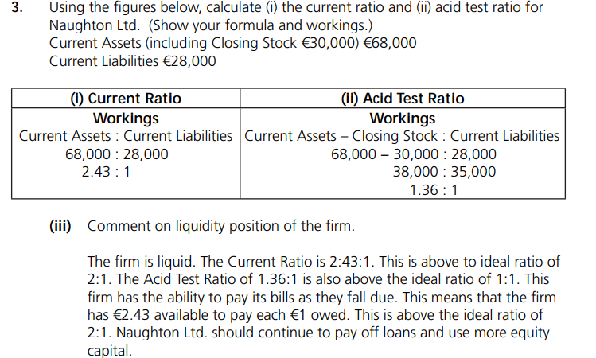

2023 LC
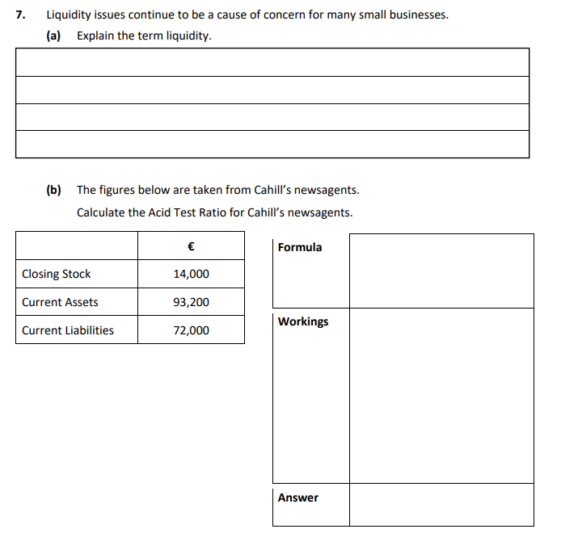
- The liquidity of a business is a measure of its ability to pay its short term debts (current liabilities) as they fall due for payment.
- Formula- Current Assets – Closing Stock: Current Liabilities
93,200- 14,000: 72,000
79,200: 72,000
1.1:1
2015 Mock
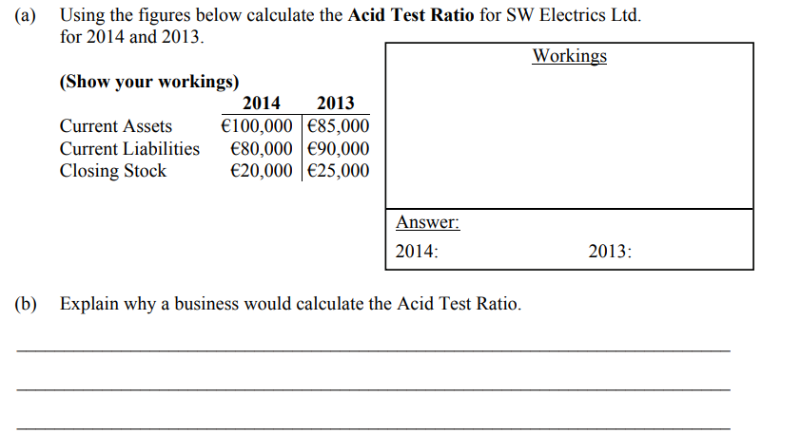
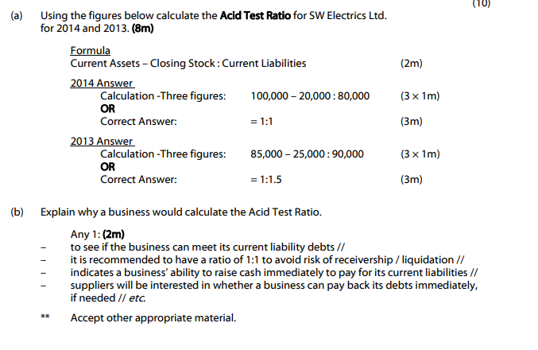
2020 Mock
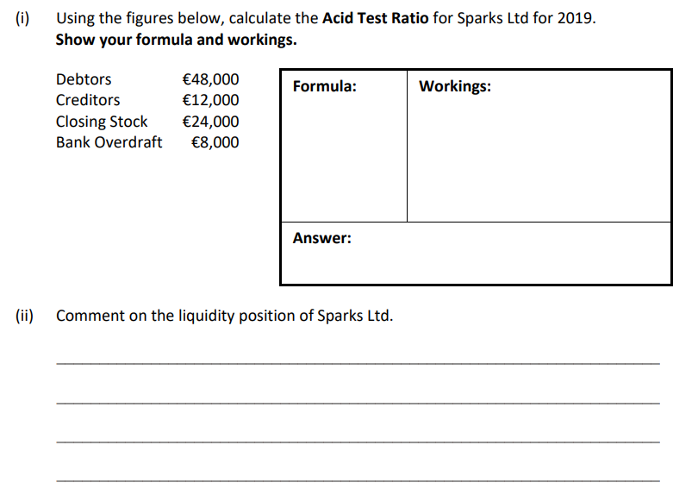
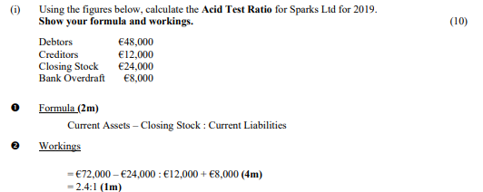
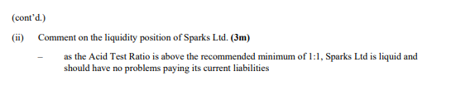
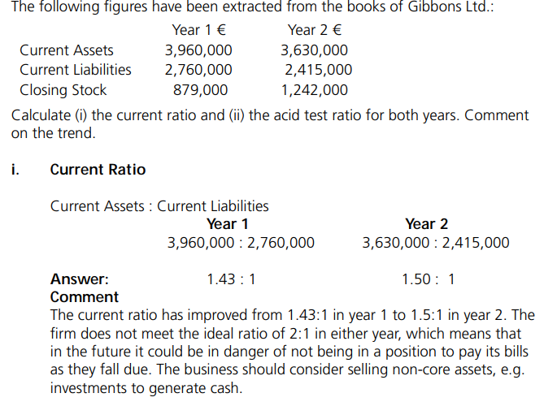
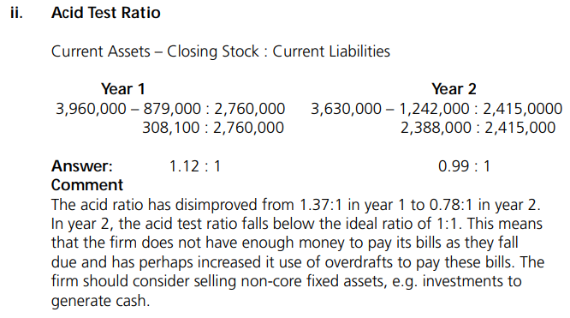

Gearing
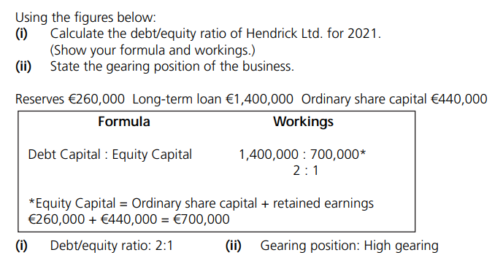
2006 LC
Debt: Equity Ratio =
Long Term Loan: Ordinary Share Capital + Reserves
2004 2005
270,000: 320,000+40,000 140,000: 420,000+30,000
270,000: 360,000 140,000:450,000
0.75:1 0.31:1
This trend is improving.
A possible reason could be:
- The value of the loan has been reduced from €270,000 to €140,000, perhaps the business made a big payment on the loan
- They have received another €100,000 in shares
2020 Mock
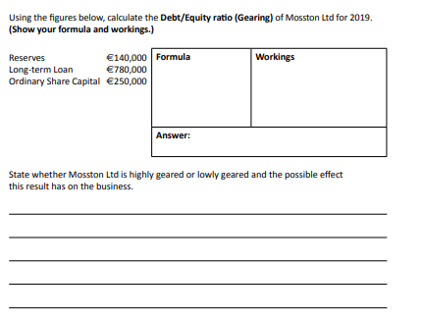
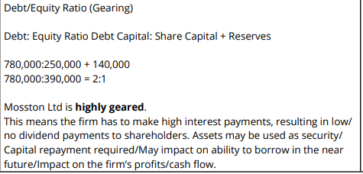

2023 Mock
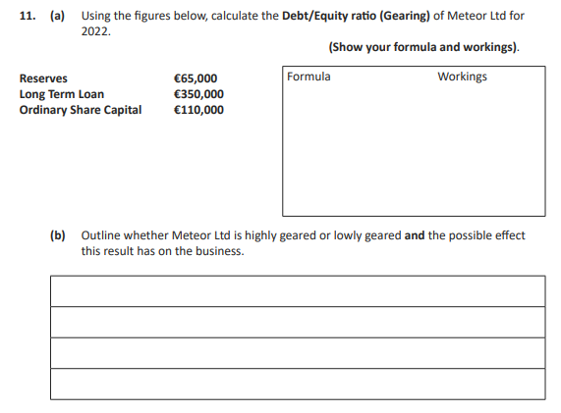
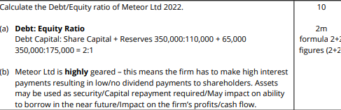
Sample Question
Calculate the Debt/Equity Ratio for Smiley Ltd using the figures below and comment on the trend
 | Year 1 | Year 2
Retained Earnings | 204,000 | 263,500
Equity (Ordinary) Share Capital | 1,190,000 | 1,190,000
Long Term Loans | 300,000 | 200,000

Formula
Debt (Long Term Loans): Equity Capital (Ordinary Share Capital + Retained Earnings)
Year 1 Year 2
300,000: 1,190,000 + 204,000 200,000: 1,190,000 +263,500
300,000: 1,394,000 200,000: 1,453,500
0.21:1 0.14:1
Analysis- Look at these 4 things
What happened: The debt/equity ratio decreased from 0.21:1 in year 1 to 0.14:1 in year 2. This means the business has low gearing.
Is this a positive for shareholders: It is a positive for shareholders as there is less debt in the business meaning a greater chance of a higher dividend.
Why: This is because the firm has reduced its long term loan by €100,000 by repaying part of the amount borrowed/ retained earnings rose by €59,500.
Solution: The business should look to continue to reduce borrowings through regular repayments
Therefore, this is the comment:
Comment on the trend (change from year-year)
The debt/equity ratio decreased from 0.21:1 in year 1 to 0.14:1 in year 2. This means the firm has low gearing. It is a positive for shareholders as there is less debt in the business meaning a greater chance of a higher dividend.
This is because the firm has reduced its long term loan by €100,000 by repaying part of the amount borrowed while retained earnings rose by €59,500. The business should continue to look to reduce borrowings through regular repayments.

2014 LC
