Ratios: What do I need to know:
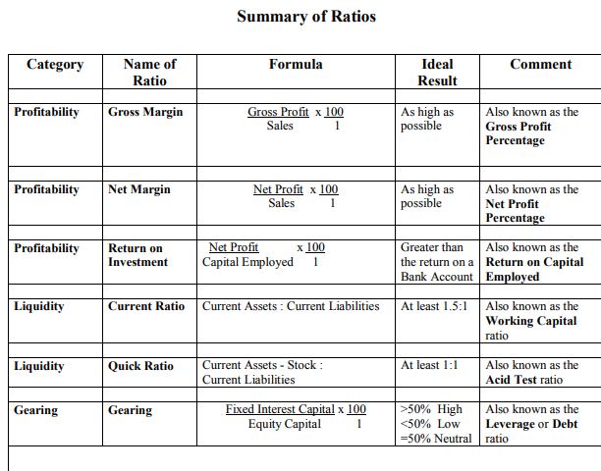
Notes for Ratios
Sales - Cost of Sales = Gross Profit
Gross Profit – Expenses = Net Profit
Capital Employed = Add Issued Share Capital/Retained Earnings/Long Term Loan
Debt Capital = Long Term Loan
Equity Capital= Retained Earnings + Reserves

You then must be able to comment on each Ratio, in particular identfying the followig:
- Definition of Ratio + use for stakeholders
- Comparison with previous year/industry and comment whether pleased or not
- Give recommendation
- Comment on the trend

