Rapid Revision: Ratio Analysis
Ainm:
- Write out the formula for each of the following Ratios:
Ratio | Formula | Important to Note
Gross Profit Margin  (Profitability) |  | Expressed as percentage, you want to be as high as possible
Net Profit Margin  (Profitability) |  | Expressed as percentage, you want to be as high as possible
Return on Investment/Return on Capital Employed  (Profitability) |  | Expressed as percentage, you want to be as high as possible
Current/Working Capital Ratio  (Liquidity) |  | Ideal 2:1 or higher
Acid Test/Quick Ratio  (Liquidity) |  | Ideal 1:1 or higher
Debt/Equity Ratio  (Gearing) |  | Ideal 1:1 or lower
- Circle the correct option from the following information
- A way to improve Net Profit Margin is to increase/reduce expenses such as staff wages or source cheaper suppliers
- Return on investment should always be compared with the risk-free investment offered by shareholders/the bank
- Liquidity/Profitability measures a business ability to pay short/long term debts as they fall due
- Making high interest payments and low dividends to shareholders is a result of being highly/lowly geared
- It is better for a business to have more/less debt capital than equity capital

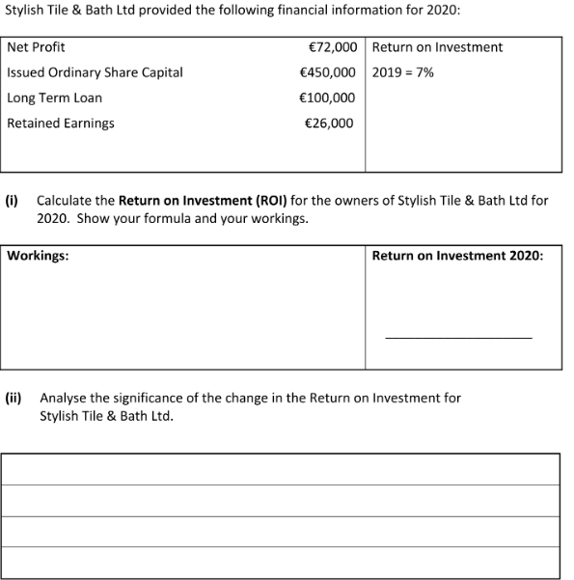

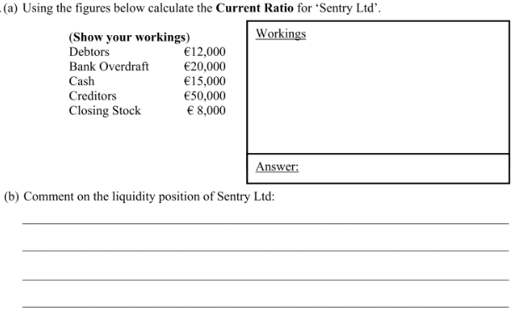

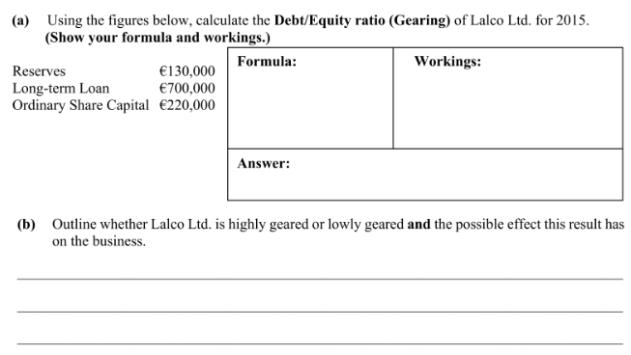
- Outline three limitations of using Ratio Analysis

