Profitability Ratios
Sample Question
Work out the Gross Profit Margin and Net Profit Margin for the above business, and make recommendations based on the figures.
Year | Sales | Gross Profit | Net Profit | Cost of Sales
2016 | 160000 | 50000 | 25000 | 110000
2017 | 180000 | 20000 | 8000 | 160000

- Draw box of all ratios
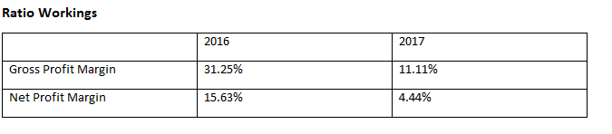
- Workings for your ratio. Ratio 1: Gross Profit Margin
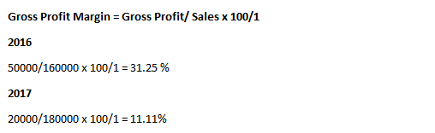
- Recommendations
Gross Profit Margin
- The Gross Profit Margin measures Gross Profit as a percentage of sales. It will tell a business whether it has a good Gross Profit depending on its size and against competition in the market.
- In 2016, Gross Profit Percentage was 31.25%, however in 2017, it fell to 11.11 %. The business and management would be very worried about this significant drop. Costs may have risen or prices may have fallen to cause this drop in Gross Profit Percentage.
- I would recommend that this business looks to correct this decline by using strategies such as sourcing a cheaper supplier from their Cost of Sales as it has risen significantly from €110,000 to €160,000
- Going forward, the business should continue to monitor the trend
Ratio 2: Net Profit Margin
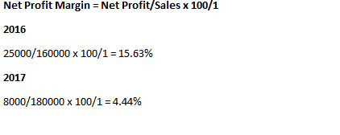Recommendations
Net Profit Margin
- The Net Profit Margin measures Net Profit as a percentage of sales after all expenses have been paid. It will tell a business whether it has a good Net Profit depending on its size and against competition in the market
- In 2016, Net Profit Percentage was 25.63%, however in 2017, it fell to 4.44%. The business and management would be very worried about this significant drop
- I would recommend that this business looks to correct this decline by using strategies such as reducing the expenses that the business has, perhaps wage cuts, and also looking to try and improve sales
- Going forward, the business should continue to monitor the trend

Question 2
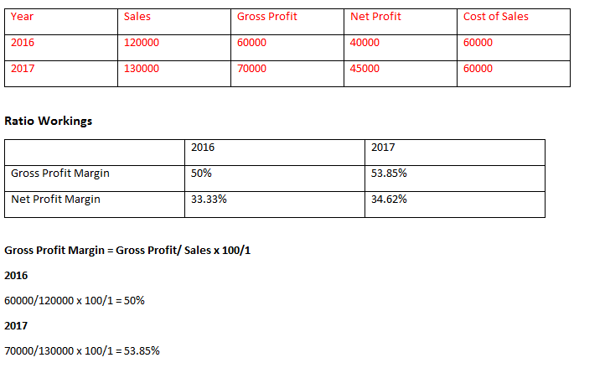
Recommendations
Gross Profit Margin
- The Gross Profit Margin measures Gross Profit as a percentage of sales. It will tell a business whether it has a good Gross Profit depending on its size and against competition in the market.
- In 2016, Gross Profit Percentage was 50%, however in 2017, it rose to 53.85 %. The business and management would be very happy about this rise. Costs may have fallen or prices may have risen to cause this rise in Gross Profit Percentage.
- I would recommend that this business to continue operating in this way as the Gross Profit has risen, but also monitor what competitors are doing
- Going forward, the business should continue to monitor the trend
Recommendations
- The Net Profit Margin measures Net Profit as a percentage of sales after all expenses have been paid. It will tell a business whether it has a good Net Profit depending on its size and against competition in the market
- In 2016, Net Profit Percentage was 33.33%, however in 2017, it rose to 34.62%. The business and management would be very happy about this increase
- I would recommend that this business continues to operate in this way, and perhaps could use a bit of their profits to reinvest and grow the business, while also keeping an eye on the industry competition
- Going forward, the business should continue to monitor the trend

Question 3
Year | Sales | Gross Profit | Net Profit | Cost of Sales
2016 | 150000 | 100000 | 50000 | 50000
2017 | 140000 | 70000 | 40000 | 70000

 | 2016 | 2017
Gross Profit Margin | 66.67% | 50%
Net Profit Margin | 33.33% | 28.57%

Gross Profit Margin = Gross Profit/Sales x 100/1
2016
100000/150000 x 100/1 = 66.67%
2017
70000/140000 x 100/1 = 50%
Recommendations
- The Gross Profit Margin measures Gross Profit as a percentage of sales. It will tell a business whether it has a good Gross Profit depending on its size and against competition in the market.
- In 2016, Gross Profit Percentage was 66.67%, however in 2017, it fell to 50%. The business and management would be very worried about this significant drop. Costs may have risen or prices may have fallen to cause this drop in Gross Profit Percentage.
- I would recommend that this business looks to correct this decline by using strategies such as sourcing a cheaper supplier from their Cost of Sales as it has risen significantly from €50,000 to €70,000
- Going forward, the business should continue to monitor the trend

Net Profit Margin = Net Profit/Sales x 100/1
2016
50000/150000 x 100/1 = 33.33%
2017
40000/140000 = 28.57 %

- The Net Profit Margin measures Net Profit as a percentage of sales after all expenses have been paid. It will tell a business whether it has a good Net Profit depending on its size and against competition in the market
- In 2016, Net Profit Percentage was 33.33%, however in 2017, it fell to 28.57%. The business and management would be very worried about this significant drop
- I would recommend that this business looks to correct this decline by using strategies such as reducing the expenses that the business has, perhaps wage cuts, and also looking to try and improve sales
- Going forward, the business should continue to monitor the trend

Question 4
Year | Sales | Expenses | Cost of Sales
2016 | 240000 | 24000 | 180000
2017 | 280000 | 36000 | 200000
Year | Sales | Expenses | Cost of Sales | Gross Profit | Net Profit
2016 | 240000 | 24000 | 180000 | 60000 | 36000
2017 | 280000 | 36000 | 200000 | 80000 | 44000

 | 2016 | 2017
Gross Profit Margin | 25% | 28.57%
Net Profit Margin | 15% | 15.71%

Gross Profit Percentage
Gross Profit/Sales x 100/1
2016
60000/240000 x 100/1 = 25%
2017
36000/240000 x 100/1 = 28.57%
Recommendations
- The Gross Profit Margin measures Gross Profit as a percentage of sales. It will tell a business whether it has a good Gross Profit depending on its size and against competition in the market.
- In 2016, Gross Profit Percentage was 25%, however in 2017, it rose to 25.87 %. The business and management would be very happy about this rise. Costs may have fallen or prices may have risen to cause this rise in Gross Profit Percentage.
- I would recommend that this business to continue operating in this way as the Gross Profit has risen, but also monitor what competitors are doing
- Going forward, the business should continue to monitor the trend

Net Profit Margin
Net Profit/Sales x 100/1
2016
36000/240000 x 100/1 = 15%
2017
44000/240000 x 100/1 = 15.71%
Recommendations
- The Net Profit Margin measures Net Profit as a percentage of sales after all expenses have been paid. It will tell a business whether it has a good Net Profit depending on its size and against competition in the market
- In 2016, Net Profit Percentage was 15%%, however in 2017, it rose to 15.71%. The business and management would be very happy about this increase
- I would recommend that this business continues to operate in this way, and perhaps could use a bit of their profits to reinvest and grow the business, while also keeping an eye on the industry competition
- Going forward, the business should continue to monitor the trend

Calculate the Return on Capital Employed for the following:
Sample Return on Capital Employed
2016= 13%
2017 figures below
Net Profit | 98000
Retained Earnings | 400000
Issued Share Capital | 300000
Long Term Loan | 105000

= Net Profit/ Capital Employed x 100/1
= 98000/ (400000 + 300000+105000)
98000/805000 x 100/1 = 11.80%
- Return on Investment shows the profitability of business compared to the money invested in it
- The figure of 11.80 % is an acceptable result since it is 3/4 times the return that could be expected on a risk-free investment. The debenture holders would certainly be happy to see that the performance of the company is positive and that the funds invested in the business are generating profits
- A concern however is that the result of 11.80% has fallen from last year’s figure of 13% (so the money invested is being used less efficiently this year) and if this trend were to continue it could put the firm under pressure to repay the debentures
- The business needs to ensure it continues to monitor the trend

Please note, if we are asked to make the same points regardless of the question being asked and obviously if the result is bad (roughly less than 10%) simply reverse the comments from positive to negative above. If the question was about buying shares or whether the shareholders would be happy, we just need to alter the last few words of the paragraph (“… if this trend were to continue it would reduce the firm’s ability to provide dividends to the shareholders”).

Sample Questions
2016 = 12%
Net Profit | 50000
Retained Earnings | 100000
Issued Share Capital | 200000
Long Term Loan | 200000

= Net Profit/ Capital Employed x 100/1
50000/500000 x 100/1
= 10%
- Return on Investment shows the profitability of business compared to the money invested in it
- The figure of 10 % is an acceptable result since it is 3/4 times the return that could be expected on a risk-free investment. The debenture holders would certainly be happy to see that the performance of the company is positive and that the funds invested in the business are generating profits
- A concern however is that the result of 11.80% has fallen from last year’s figure of 12% (so the money invested is being used less efficiently this year) and if this trend were to continue it could put the firm under pressure to repay the debentures
- The business needs to ensure it continues to monitor the trend

2016= 8%
Net Profit | 4000
Retained Earnings | 100000
Issued Share Capital | 200000
Long Term Loan | 100000

2016 = 15%
Net Profit | 20000
Retained Earnings | 10000
Issued Share Capital | 20000
Long Term Loan | 50000

Liquidity Ratios
Sample Question for Joe Bloggs Ltd €
Current Assets (including Closing Stock) 15000
Closing Stock 6000
Current Liabilities 10000

 | Joe Bloggs Ltd | Industry Average
Current Ratio | 1.5:1 | 2:1
Acid Test Ratio | 0.9:1 | 1.2:1

Current Ratio/ Working Capital Ratio =
Current Assets: Current Liabilities =
15000: 10000
1.5: 1
Recommendations
- The Current Ratio measures whether a business is able to pay off their debts as they fall due, and compares current assets with current liabilities by dividing the assets by the liabilities. The IDEAL figure should be 2:1.
- For Joe Bloggs Ltd, this figure is 1.5:1, which means it had €1.50 to pay every €1 owed, but it is below the ideal of 2:1, and the Industry Average of 2:1
- This would be concerning for Joe Bloggs Ltd, as although the firm is liquid at present as they have 1.5 times the amount of Current Assets to Current Liabilities, it does not take into effect Closing Stock. It may be in danger of running into liquidation if it cannot pay its liabilities on time
- Going forward, they should continue to monitor the trend

Acid Test/ Quick Ratio
Current Assets- Closing Stock: Current Liabilities
15000-6000:10000
9000:10000
0.9:1

Recommendations
- The Acid Test Ratio measures liquidity but takes into account the fact that stock may not always be easily and quickly converted into cash. Acid test does not include stock in current assets. The ideal for this is 1:1
- For Joe Bloggs Ltd, their Acid Test Ratio is 0.9:1, which is below the ideal of 1:1, and the industry average of 1.2:1
- This would be concerning for Joe Bloggs Ltd as they only have €0.90 for every €1 owed. They will have difficulty raising cash quickly to pay for their bills as they fall due, and failure to improve this will mean they will have difficulty buying on credit in the future
- I would recommend Joe Bloggs Ltd look to sell slow moving stock at a discount or improve their credit control system
- Going forward, they should continue to monitor the trend

Sample Question for Smith Ltd €
Current Assets (including Closing Stock) 50000
Closing Stock 10000
Current Liabilities 30000
Industry Average
 | Smith Ltd | Industry Average
Current Ratio | 1.67:1 | 2.1:1
Acid Test Ratio | 1.34:1 | 1.5:1

Current Ratio/ Working Capital Ratio =
Current Assets: Current Liabilities =
50000:30000
1.67:1
Recommendations
- The Current Ratio measures whether a business is able to pay off their debts as they fall due, and compares current assets with current liabilities by dividing the assets by the liabilities. The IDEAL figure should be 2:1.
- For Smith Ltd, this figure is 1.67:1, which means it had €1.67 to pay every €1 owed, but it is below the ideal of 2:1, and the Industry Average of 2.1:1
- This would be concerning for Smith Ltd, as although the firm is liquid at present as they have 1.67 times the amount of Current Assets to Current Liabilities, it does not take into effect Closing Stock. It may be in danger of running into liquidation if it cannot pay its liabilities on time
- Going forward, they should continue to monitor the trend

Acid Test/ Quick Ratio
Current Assets- Closing Stock: Current Liabilities
50000-10000:30000
40000:30000
1.34:1
Recommendations
- The Acid Test Ratio measures liquidity but takes into account the fact that stock may not always be easily and quickly converted into cash. Acid test does not include stock in current assets. The ideal for this is 1:1
- For Smith Ltd , their Acid Test Ratio is 1.34:1, which is above the ideal of 1:1, but below the industry average of 1.5:1
- Smith Ltd would be pleased with being above the ideal but must continue to monitor that they do not fall below the industry average. If they fall below the 1:1 ideal, they have difficulty buying on credit in the future
- Going forward, they should continue to monitor the trend

Gearing Ratios
Sample Question for Diamond Ltd
€
Long Term Loan 400000
Issued Share Capital 300000
Authorised Share Capital 600000
Retained Earnings/Reserves 60000
 | Diamond Ltd | Industry Average
Debt/Equity Ratio | 1.11:1 | 0.7:1

Debt/Equity Ratio =
Long Term Loan/ Issued Share Capital + Retained Earnings =
400000/300000+600000
400000/360000 =
1.11:1
Recommendations
- Debt/Equity Ratio examines the types of long term finance or capital being used by the firm. It is better for business to use more equity capital and less debt capital in order to keep the cost of finance as low as possible. The higher the ratio, the more fixed interest a business will have to pay, and the lower the ratio, the more attractive it will prove to shareholders to invest in
- For Diamond Ltd, its Debt/Equity Ratio is 1.11, which means it is highly geared compared to the industry average of 0.7:1
- This is something that Diamond Ltd will need to examine, perhaps they could look to reduce the number of loans they are taking in. New investors in ordinary shares may be put off by high levels of debt and lenders may be slow to give additional loans to a firm if it already has high debt commitments
- Going forward, they will need to continue to monitor the trend

