Recording Business Income and Expenditure
Keeping up to date and accurate financial records is essential for a business because:
- It can tell a business what debtors owe them money and avoid bad debts (Sorry Godfred)
- It can tell a business what creditors they owe money to
- It can show a business whether it needs to get source of finance to cover costs
- It can show how much the business has tied up in it
- It can show assets and liabilities- what it owes to the bank
- It can tell a business if they are making or losing money

How a business monitors its incomes and expenditures- The Return of The Analysed Cash Book
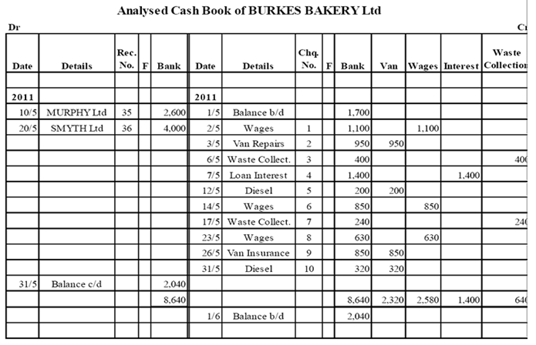

Like households, businesses also use Analysed Cash books to record the income and payments they received.
Remember the Rule-
*Debit Money Coming In To The Left
Credit Money Going Out To The Right
Note that with a business, there will be more headings for the Analysed Cash Book. These headings will be given to you in the question.
DOUBLE – ENTRY SYSTEM
****Double Entry Rule- Every Debit has a Credit****
In a double-entry transaction, an equal amount of money is always transferred from one account (or group of accounts) to another account (or group of accounts). Accountants use the terms debit and credit to describe whether money is being transferred to or from an account.
STEP 1:
- Write up the general journals, sales and sales returns books and purchase and purchase return books, if asked to do so
- Make sure to record dates (including the year), document numbers and folios
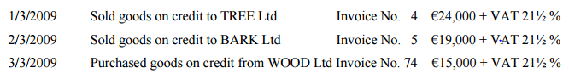
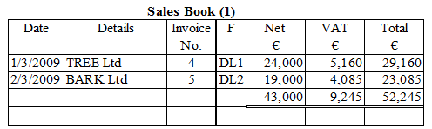
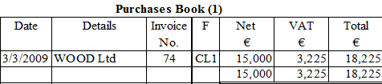
STEP 2:
- Post relevant figures to the ledgers
- Debit the receiving account, credit the giving account
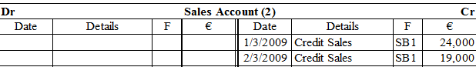
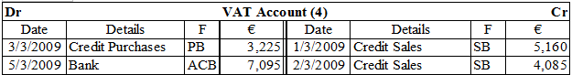
STEP 3:
- Write up the analysed cash book.
- Enter figures in the bank column and in the analysis column. Record the cheque and receipt numbers given
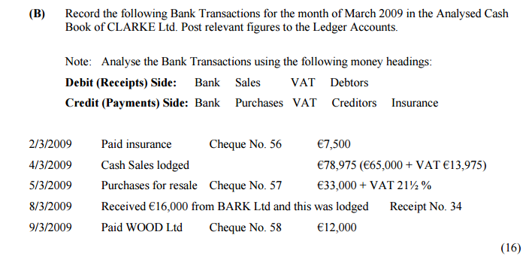
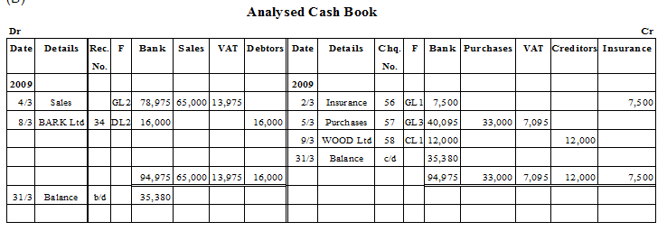
STEP 4:
- Post the figures to the relevant ledgers
- Debit the receiving account, credit the giving account
AND
STEP 5:
- Balance any accounts with entries on both sides (VAT, bank, debtors, and creditors accounts)
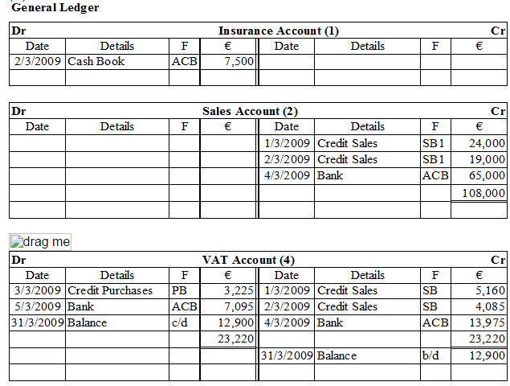

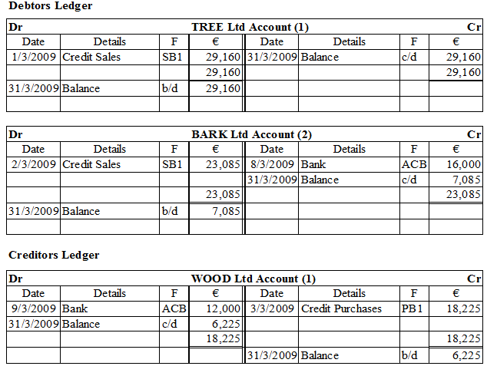
STEP 6:
- Extract a trial balance. This is a list of all balances standing on the ledger accounts and cash books at the end of this period. Debit balances go to the credit column, credit balances go to the credit column. Both debit and credit totals should be the same to show the accounts have been completed correctly
