Researching a Business
Every new business needs to come up with a new idea. It is hoped that the entrepreneur will be able to make a profit out of this idea and that the idea will become successful. However, this simply does not happen overnight and it is very important that the entrepreneur goes through the following stages:

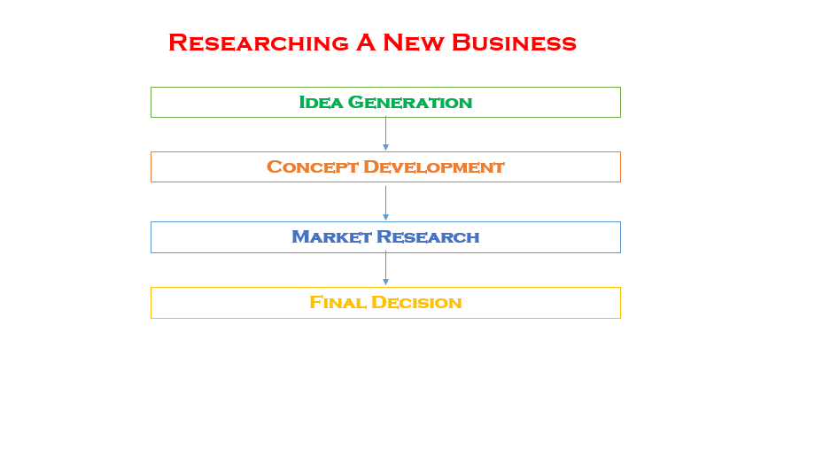
Idea Generation
This is the process of coming up with an idea. This can happen in the spur of the moment or it can be something that takes a lot of time and effort.
Two useful techniques for coming up with ideas are:
- Brainstorming
- A Personal SWOT Analysis

Brainstorming
Use the following tactics:
- Think about some ideas
- Write them all down
- Review the ideas and select the best one(s)
Task: Let’s brainstorm for a few minutes in small groups a new idea for a product or service to be sold in this school.
Once all the ideas are on the board, we will then use a tactic known as Screening to select the best idea to move forward with.

SWOT Analysis
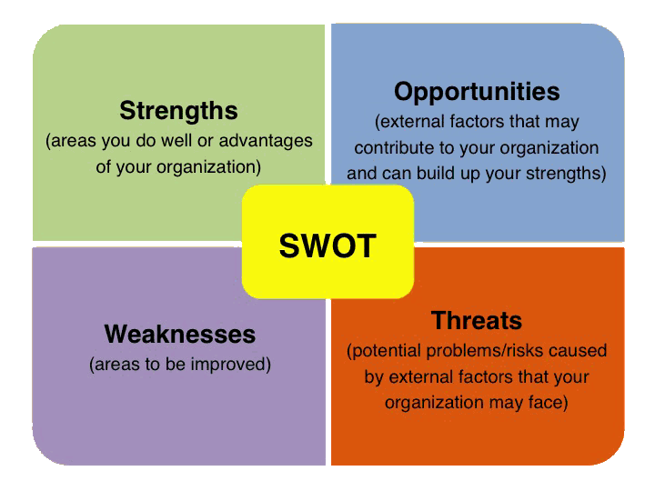
Strengths
What am I good at?
What am I interested in?
Weaknesses
What am I not good at?
What am I not interested in?

Opportunities
What can I work on?
Who do I know that could help me?

Threats
What are the risks?
What problems may arise?

Once you have completed the SWOT Analysis you should again try to use what you have found out to screen the best ideas and pick the one that you are most happy with.

Task: Conduct a SWOT Analysis of yourself in trying to come up with a new idea for a business.

Concept Development
You now have your idea and your next task is to work on the development of this idea. This is known as Concept Development. The entrepreneur will need to put a lot of time and energy into this stage and need to ask themselves questions such as:
- How much capital (start-up money) do I need?
- What skills will be needed to run this business?
- How does my product stand out?
- Where will I set this business up and do I need machinery/equipment?
- Do I need a prototype? ( sample product that shows how it works)

Market Research

We will spend a lot of time looking at the topic of Marketing and its importance for a business in the next chapter. It is important for the entrepreneur to be aware of their target market and to try and get as much income as possible and this will only be done with correct Market Research.

Final Decision

You have selected your product/service after completing the above steps and you are now ready to bring it to the market.

