Saving and Investing Your Money
Questions
- List 5 reasons to save or invest.
- How do banks operate? Which is the higher rate of interest and why?
- What does DIRT stand for and what does it mean?
- Give 2 reasons to save money in a financial institution.
- What does DIRT and AER mean in relation to saving?
- What is simple interest?
- What is compound interest?
- What does the term investing mean?
- What is a capital gain?
- What is a dividend?

As we have seen before in our Income and Expenditure Chapters, people can spend their income in various ways, whether it be Fixed, Irregular, or Discretionary either through current or capital expenditure.
Can you remember what these types of expenditures mean?
Some families may not spend all of their money and keep it for the future, and this is called SAVING. A wise consumer could put some of their savings to work to earn them more money, and this is called INVESTING. (Example: Shares)
Question:
What would a teenager need to save money for? Let’s make a list.
Why Bother Save or Invest?
- For safety- to have money for a rainy day
- To earn interest/make a profit
- Purchase an item that will last a long time (e.g. machinery)
- Prevent impulse buying (thrift purposes)
- Provide for retirement/ children’s education
- Obtain a good credit rating
Saving
It is very important that we are aware that there is a need to save and invest money wisely. In class, we will watch an episode of the TV Programme ‘How to be Good with Money’.
As part of this programme, it is important to look out for some of the money saving techniques such as:
- Shopping around for the best value
- Identifying our Discretionary expenses
- Cancel subscriptions you no longer use
- Downsizing
- Using cheaper methods of payments- avoid credit card interest
Financial Institutions and their role in Saving and Investing
As we have seen before in our banking chapter, some people save their money in deposit accounts, but some people need to borrow money. Therefore the banks will operate in the following way:
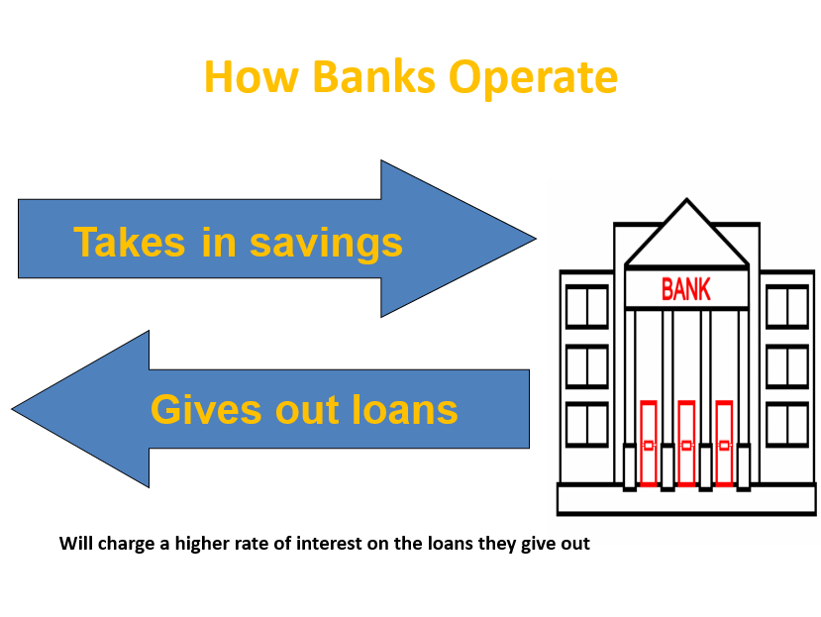
Example
You may put €100 into your deposit account in the bank and there may be 2% interest which means you would earn an extra €2 for saving it here. Your total for the year would now be €102.
The bank will charge a higher rate of interest on the loan it gives out. If the bank was to charge 4% on a €100 loan it would mean your total repayments on the €100 loan would be €104.

Why save in a Financial Institution?
- Your savings are in a safe place protected by the Central Banks Deposit Guarantee Scheme. This guarantees that you will get your money even if the banks fail
- Safety from robbery if your money is left at home
- You earn interest on your savings- way better than not earning interest leaving your money under the mattress at home
- Ability to get loan approval is a lot easier as you already have an account and credit history.
Financial Institutions: Choosing where to Save and Borrow?
The main reason people put their money here is in the hope of getting a loan to buy a house. This loan is called a mortgage, and it is to be repaid usually over a long period of time.
A Credit Union is a co-operative (members share common interest) who lend at an affordable rate of interest. Each credit union is run by volunteers from its membership and each member has an equal say in how it’s run.
Credit Unions offer customers a choice of Share Accounts that offers a share of profits and pay no DIRT or a Deposit Account which is similar to bank deposit accounts and pay DIRT.
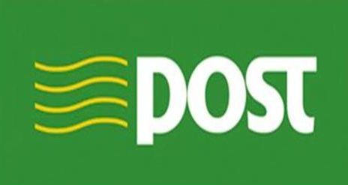
An Post is a limited company owned on behalf of the government. As well as offering postal services, they provide savings schemes such as Savings Bonds and Savings Certificates. No DIRT is charged.
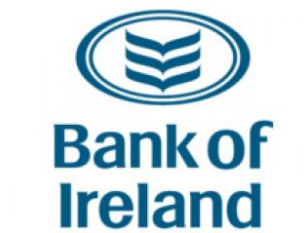
As we have previously studied, the banks in Ireland provide a range of services including borrowings and savings.

How much will I earn or pay when I save or borrow
First, two key terms
1. Deposit Interest Retention Tax
DIRT stands for Deposit Interest Retention Tax. This means that for all interest you earn, you have to pay a tax on it. It may influence where to save/borrow as some places have no DIRT.
2. Annual Equivalent Rate (AER)
To avoid any confusion when comparing simple and compound interest rates, many financial institutions display their interest using an AER percentage. This represents the true rate of interest on saving

Sample Question and Calculations
Calculate Interest Returns and Rates- Note: You will also be doing this in Maths
Interest can be calculated in the following ways:
Simple Interest: Interest is calculated as a percentage of an amount invested.
Compound Interest: This interest is calculated on the original investment plus any interest earned up to date. This is called CAR (Compound Annual Rate), and is what most investors will be interested in.

Q.1 Breda saves €500 per year in a deposit account for 5 years and earns 10% simple interest.
Tim saves €500 per year in a deposit account for 5 years and will earn 10% CAR.
Calculate the interest rates.
Breda Simple Interest Tim Compound Interest
Year 1 | 10% of 500 | €50 | Year 1 | 10% of 500 | €50
Year 2 | 10% of 500 | €50 | Year 2 | 10% of 550 | €55
Year 3 | 10% of 500 | €50 | Year 3 | 10% of 605 | €60.50
Year 4 | 10% of 500 | €50 | Year 4 | 10% of 665.50 | €66.55
Year 5 | 10% of 500 | €50 | Year 5 | 10% of 732.05 | €73.20
Total Interest |  | €250 | Total Interest |  | €305.25

Simple and Compound Interest Practice Questions
- Paul saves €400 per year in a deposit account for 5 years and earns 10% simple interest.
Paula saves €400 per year in a deposit account for 5 years and will earn 10% CAR.
Calculate the interest rates.
- Dave saves €200 per year in a deposit account for 5 years and earns 10% simple interest.
Ray saves €200 per year in a deposit account for 5 years and will earn 10% CAR.
Calculate the interest rates.
- Alison saves €100 per year in a deposit account for 5 years and earns 5% simple interest.
Louise saves €100 per year in a deposit account for 5 years and will earn 2% CAR for years 1 and 2, and 1% in years 3, 4, and 5.
Calculate the interest rates.

Investing
Investing means taking a risk and putting your money into things like shares on the stock market, property, and businesses in the hope of making a profit. People would invest in the hope of making a profit or that what they invest in’s value would rise meaning they could sell it on for more money than they paid for it.
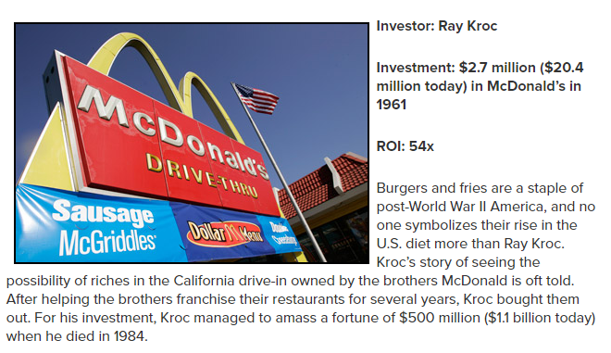
But unfortunately not every investment will make money
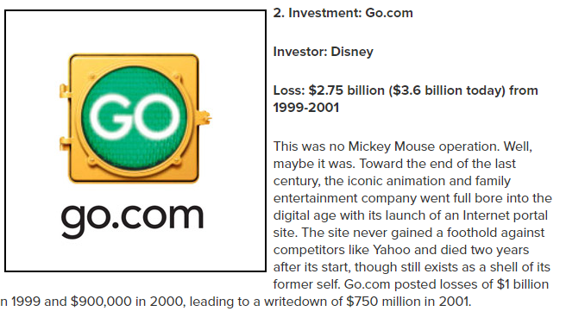
Types of Investments explained:
Stock Market
When you purchase shares on the stock market you are buying a stake in a business. You can choose to sell on your share as the value of it rises- this is called a Capital Gain, or keep the share in the business and earn a Dividend, which is a payment on the profit made by a business

Property Market
Some people invest their money in the housing market in the hope that the house will rise in value and resell it at a larger profit.

Endowment Policy
Taken out with an insurance company over an agreed period of time giving a lump sum to you as the insured person if you live past an agreed period of time or will pay an agreed amount if the insured person dies before a date.

