Statement of Financial Position: Ratios
Stakeholders affected by a business performance
Management
They will want information to know how the business has performed over the year and to learn if any changes are needed. This will help make decisions if needed

Shareholders
They will want to know if the money that they have put into the business has been used wisely by the firm in order to generate profits and pay them a dividend

Banks
They want to know if the business is profitable enough to be able to make loan repayments and interest repayments

Trade Unions
They will keep an eye on the company’s profits because if they know the business is doing very well, they may look for wage increases

Suppliers
These are interested in a business’s accounts in order to assess the firm’s credit-worthiness

Employees
Will want to see if the firm is performing well for job security and promotion prospects

So why does a business need Ratios?
In the same way that a doctor examines a patient to find out what is wrong with him, a business must examine their accounts to make sure that it is in a healthy position.

Ratio Number 1: Profitability
Profitability: This measures how successful the management of a business has been in making a profit
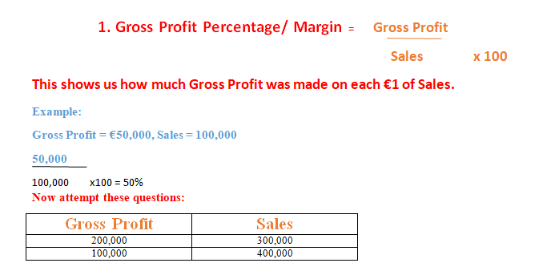
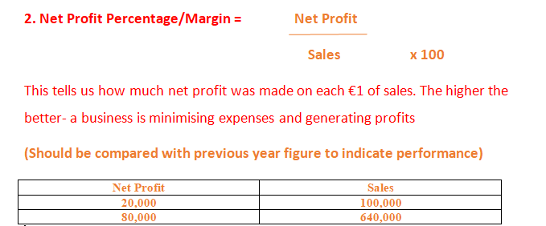

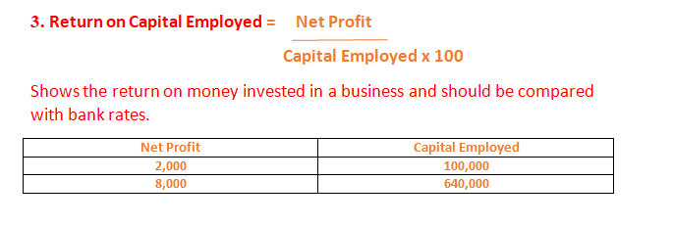
Ratio Number 2: Liquidity
Liquidity: This is the ability of a company to pay off its debts as they fall due

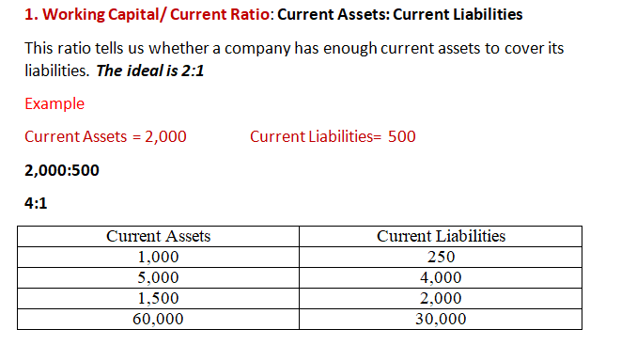
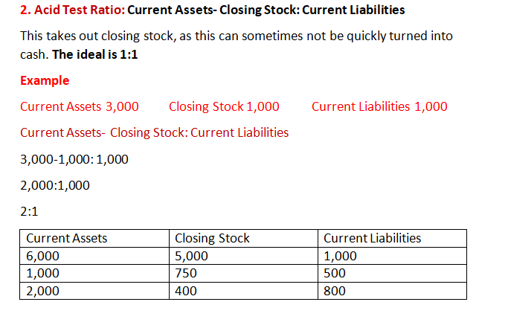

Ratio Number 3: Solvency
Solvency: This is a business’s ability to meet its liabilities. Its formula is:
Total Assets: All External Liabilities

Ratio Number 4: Stock
There are two ratios that are concerned with stock. They are
Average Stock: This is done by adding the values of stock at the start and the end of the year and getting its average. Its formula is:
Average Stock = Opening + Closing Stock
2
Stock Turnover: This shows how many times a business’s stock has been bought and sold throughout the year. Its formula is:
Stock Turnover = Cost of Sales
Average Stock

We will now put all of these ratios into practice in class.

