Statements of Financial Position: Ratios
Recap from 2nd Year
The trading period of a business is the time period when a business sells their products and services.
The income statement is a financial statement that reports a company's financial performance over this trading period. It contains sales, cost of sales, closing stock etc…
We have previously looked at Income Statements of Private Limited Companies- Known as Trading Profit and Loss, Appropriation Accounts in 2nd Year.
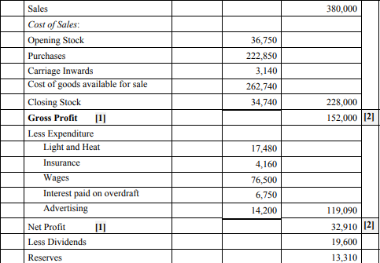

The statement of financial position, often called the Balance Sheet, is a financial statement that reports the assets, liabilities, and equity of a company on a given date. In other words, it lists the resources, obligations, and ownership details of a company on a specific day.
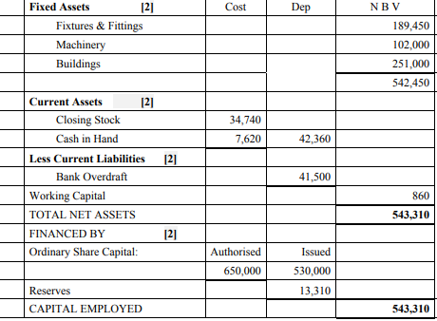
The next part of this chapter involves being able to examine who uses these accounts, as well as being able to assess the financial performance of businesses based on the information provided.
Stakeholders affected by a business performance
- Management
- They will want information to know how the business has performed over the year and to learn if any changes are needed. This will help make decisions if needed

- Shareholders
- They will want to know if the money that they have put into the business has been used wisely by the firm in order to generate profits and pay them a dividend
- They want to know how much they can expect in dividends and they also want to know the value and security of their investment

- Banks
- They want to know if the business is profitable enough to be able to make loan repayments and interest repayments

- Trade Unions
- They will keep an eye on the company’s profits because if they know the business is doing very well, they may look for wage increases. They are interested in the security of employment and the future prospects of the company (will it expand and take on more workers, what are the promotion prospects of the workers)

- Suppliers
- These are interested in a business’s accounts in order to assess the firm’s credit-worthiness. I.e. can the firm can pay for goods supplied on credit?

- Employees
- Will want to see if the firm is performing well for job security and promotion prospects

- Government
- Will want to see the performance of the firm to assess how much tax it owes to the Revenue Commission

Competitors are not regarded as stakeholders but they would like to know the competition performance as they will examine a business’s sales and profits to see how big a threat the business is to them

So why does a business need Ratios?
In the same way that a doctor examines a patient to find out what is wrong with him, a business must examine their accounts to make sure that it is in a healthy position.
Just like a doctor would examine basic things like blood flow, temperature etc… Ratios will be used to:
- Compare the performance of a business from one year to the next
- To identify problems at an early stage
A business must examine their accounts under the three following headings
- Profitability- The profit earned by the business
- Liquidity- The ability of the firm to pay its short term debts as they fall due
- Gearing (debt/equity)- examines the types of long term capital being used by the firm
Comparisons will be made with the previous year, other businesses in the industry and the industry average to see how a business is performing.

Profitability: This measures how successful the management of a business has been in making a profit

Gross Profit Percentage/ Margin = Gross Profit
Sales x 100
This shows us how much Gross Profit was made on each €1 of Sales.
Example:
Gross Profit = €50,000, Sales = 100,000
50,000
100,000 x100 = 50%
Now attempt these questions:
Remember, Sales Less Cost of Sales = Gross Profit
Gross Profit | Sales | Cost of Sales
200,000 | 300,000
100,000 | 400,000
150,000 | 600,000
3,000 |  | 27000
8,000 |  | 392000
 | 540,000 | 532000
200,000 | 1,000,000

(Note Gross Profit Mark Up = Gross Profit/Cost of Sales)

Net Profit Per-Centage/Margin = Net Profit
Sales x 100
This tells us how much net profit was made on each €1 of sales. The higher the better- a business is minimising expenses and generating profits
(Should be compared with previous year figure to indicate performance)
Net Profit | Sales
20,000 | 100,000
80,000 | 640,000

Gross Profit | Expenses | Sales
20000 | 10000 | 200000
500000 | 400000 | 800000

Return on Capital Employed = Net Profit
Capital Employed x 100
Shows the return on money invested in a business and should be compared with bank rates.
Net Profit | Capital Employed
2,000 | 100,000
8,000 | 640,000
12,000 | 144,000
3,000 | 240,000

Compare with banks offer of 2-4% interest.

Liquidity
Liquidity: This is the ability of a company to pay off its debts as they fall due
Current Ratio: Current Assets: Current Liabilities
Tells us whether a company has enough current assets to cover its liabilities. The ideal is 2:1

Example
Current Assets = 2,000 Current Liabilities= 500
2,000:500
4:1
Current Assets | Current Liabilities
1,000 | 250
5,000 | 4,000
1,500 | 2,000
60,000 | 30,000

Quick/Asset Test Ratio: Current Assets- Closing Stock: Current Liabilities
Takes out closing stock, as this can sometimes not be quickly turned into cash. The ideal is 1:1
Example
Current Assets 3,000 Closing Stock 1,000 Current Liabilities 1,000
3,000-1,000: 1,000
2,000:1,000
2:1
Current Assets | Closing Stock | Current Liabilities
6,000 | 5,000 | 1,000
1,000 | 750 | 500
2,000 | 400 | 800

Gearing: How much long term debt has been borrowed versus how much equity finance has been invested
Low Gearing = Low risk. Relatively small amount of loans.
High Gearing = High risk. Relatively high amount of loans.

Debt/Equity Ratio: Debt Capital X 100 = %
Equity Capital 1
Long Term Loan 400000
Issued Share Capital 300000
Authorised Share Capital 600000
Retained Earnings/Reserves 60000
 | Diamond Ltd | Industry Average
Debt/Equity Ratio | 1.11:1 | 0.7:1

Debt/Equity Ratio =
Long Term Loan/ Issued Share Capital + Retained Earnings =
400000/300000+600000
400000/360000 =
1.11:1

We will be practicing sample questions in class combining all ratios and analysing business trends.

